**Cluster ordering of Mg-LPSO**

S. Morishita, S. R. Nishitani

Dept. Informatics, Kwansei Gakuin Univ., Hyogo 669-1339, Japan

Two possible scenarios, solute ordering and stacking fault induced, have been discussed for the formation mechanisms of the long period stacking ordered (LPSO) structure in Mg based alloys. Very recently, the authors have reported the solute ordering of mini clusters [1]. In this talk, we will show the first principles calculations of the interaction energy between a L12 cluster and a mini cluster, and discusses the diffusion mechanism of this mini cluster.

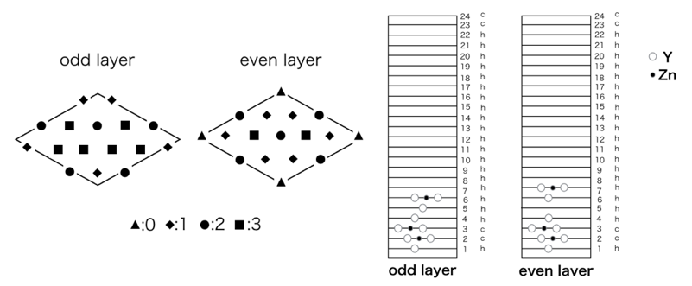The target mini cluster was reported by Kiyohara et al.[2], where the horizontally split L12 cluster shows relatively stable energy in the hcp lattice. The distance dependency of interaction energy between L12 cluster and a mini cluster are calculated by VASP. The calculated models are shown in Fig.1. The marks in the top view indicate the equivalent site of the location of a mini cluster in a- and c- layers of hcp stacking.

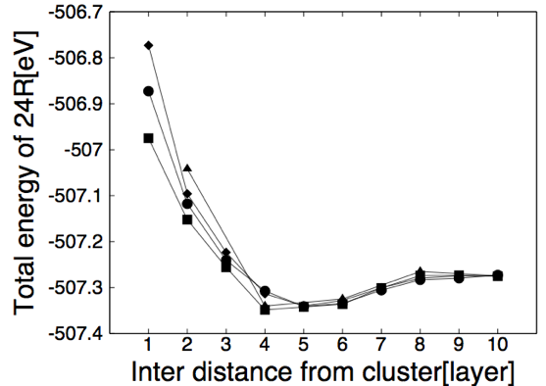Fig.2 shows the total energy changes depending on the vertical distance between L12 cluster and a mini cluster. A mini cluster shows a minimum around 4-5 layers, which is about 0.1eV lower than the far end. This energy minimum indicates that the solute ordering is a strong candidate to induce the formation of the LPSO structure.

Fig.1 Schematic drawings of slab models.

If we accept the energetic stability of solute ordering by a mini cluster, we have to discuss the kinetics of the solute movement. For two possibilities of an isolated solute diffusion or a cluster diffusion, we are calculating the stability of the vacancy and multi-vacancies around the mini cluster.

Fig.2 Energy dependency on vertical distance between L12 and mini clusters.

1. [1] S Morishita, et al., LPSO2016, (Kyoto, 2016), p.805.

Shinya Morishita, Mr.

He is registered Informatics of Kwansei Gakuin Univ. He studies about the formation mechanism of LPSO structure. He tries to reveal this mechanism from an energetically point of view and use VASP for energetically calculation. And He studies Ruby programming, web applications by Ruby on Rails and system configuration by chef.

1. [2] M. Kiyohara, et al., proceedings of PRICM, (Kyoto 2016), p.805.