**变速流水灯项目**

**引脚设置：**

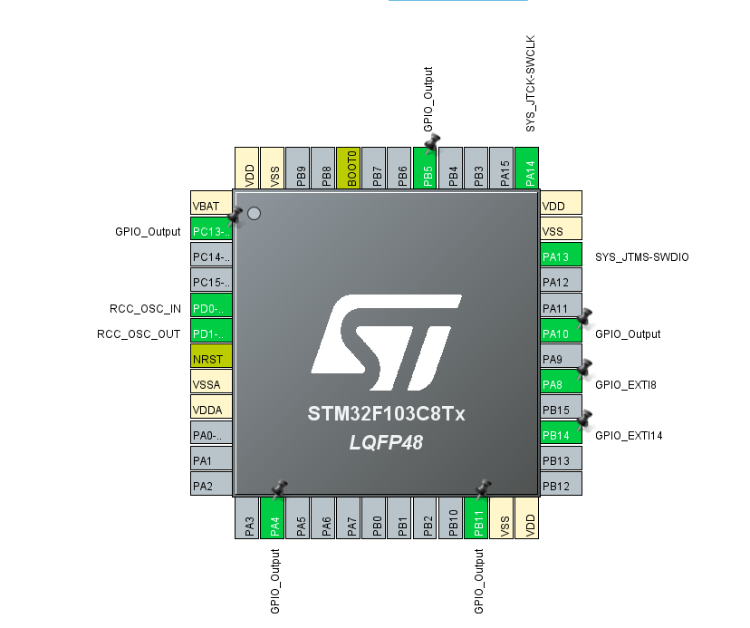

**硬件图片：**

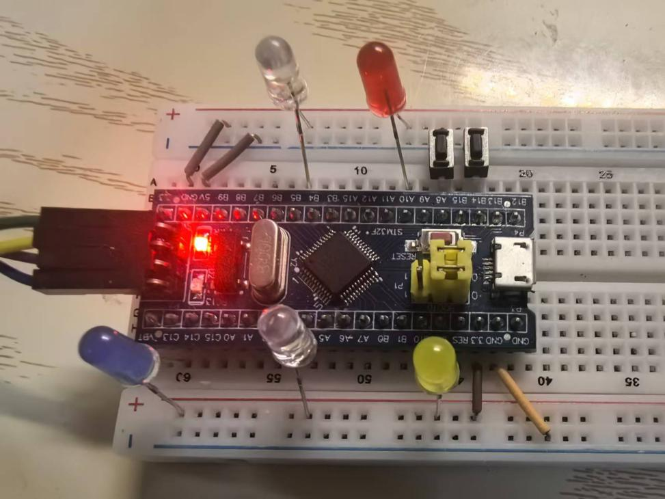

**关键代码：**

**注释：按钮A8为启动按钮，低电平触发中断函数HAL_GPIO_EXTI_IRQHandler(GPIO_PIN_8)，开启变速流水灯。按钮B14为关闭按钮，低电平触发中断函数HAL_GPIO_EXTI_IRQHandler(GPIO_PIN_14)，关闭变速流水灯并进入while死循环恢复初始设置speed(速度参数)=1，stage(状态计数器)=0，并不断读入引脚A8电平。当读到A8电平为低电平(按下A8处按钮)后，break跳出死循环，继续执行HAL_GPIO_EXTI_IRQHandler(GPIO_PIN_8)。**

void EXTI9_5_IRQHandler(void)

{

/* USER CODE BEGIN EXTI9_5_IRQn 0 */

/* USER CODE END EXTI9_5_IRQn 0 */

**HAL_GPIO_EXTI_IRQHandler(GPIO_PIN_8);**

/* USER CODE BEGIN EXTI9_5_IRQn 1 */

while(1){

if(stage >= 1 && stage <= 3){

HAL_GPIO_WritePin(GPIOC, GPIO_PIN_13, 0);

}else{

HAL_GPIO_WritePin(GPIOC, GPIO_PIN_13, 1);

}

if(stage >= 2 && stage <= 4){

HAL_GPIO_WritePin(GPIOA, GPIO_PIN_4, 0);

}else{

HAL_GPIO_WritePin(GPIOA, GPIO_PIN_4, 1);

}

if(stage >= 3 && stage <= 5){

HAL_GPIO_WritePin(GPIOB, GPIO_PIN_11, 0);

}else{

HAL_GPIO_WritePin(GPIOB, GPIO_PIN_11, 1);

}

if(stage >= 4 && stage <= 6){

HAL_GPIO_WritePin(GPIOB, GPIO_PIN_5, 0);

}else{

HAL_GPIO_WritePin(GPIOB, GPIO_PIN_5, 1);

}

if(stage >= 5 && stage <= 7){

HAL_GPIO_WritePin(GPIOA, GPIO_PIN_10, 0);

}else{

HAL_GPIO_WritePin(GPIOA, GPIO_PIN_10, 1);

}

stage ++;

if(stage > 7){

stage = 1;

speed +=1;

}

HAL_Delay(1200 / speed);

if(speed == 100){

while(1){

speed -= 2;

break;

}

}

}

/* USER CODE END EXTI9_5_IRQn 1 */

}

/**

* @brief This function handles EXTI line[15:10] interrupts.

*/

void EXTI15_10_IRQHandler(void)

{

/* USER CODE BEGIN EXTI15_10_IRQn 0 */

/* USER CODE END EXTI15_10_IRQn 0 */

**HAL_GPIO_EXTI_IRQHandler(GPIO_PIN_14);**

/* USER CODE BEGIN EXTI15_10_IRQn 1 */

speed = 1;

HAL_GPIO_WritePin(GPIOC, GPIO_PIN_13, 1);

HAL_GPIO_WritePin(GPIOA, GPIO_PIN_4, 1);

HAL_GPIO_WritePin(GPIOB, GPIO_PIN_11, 1);

HAL_GPIO_WritePin(GPIOB, GPIO_PIN_5, 1);

HAL_GPIO_WritePin(GPIOA, GPIO_PIN_10, 1);

while(1){

if(HAL_GPIO_ReadPin(GPIOA,GPIO_PIN_8) == 0){

speed = 1;

stage = 1;

break;

}

}

/* USER CODE END EXTI15_10_IRQn 1 */

}