**Handout – Team Fridgify**

**Team Members**

Dennis Rein ([dennis.rein@outlook.com](mailto:dennis.rein@outlook.com))  
 Joschua Götz ([joschua.goetz@gmail.com](mailto:joschua.goetz@gmail.com))  
 Duc Vo Ngoc ([duc.vongoc01@gmail.com](mailto:duc.vongoc01@gmail.com))

**Time Sheet**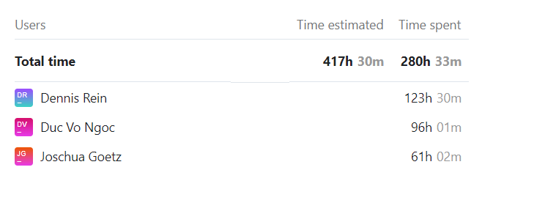

Dennis Rein – **Project Manager,** Business Designer, Requirement Specifier, Designer, Change Control Manager

Duc Vo Ngoc – **Tool Specialist, Configuration Manager,** Business Designer, Requirement Specifier, Designer, Change Control Manager

Joschua Götz – **Scrum Master, Deployment Manager,** Business Designer, Requirement Specifier, Designer, Change Control Manager

**Overall Use Case Diagram**

