Title – Project 1 Phase 3

Suyash Ghimire , ID#1001529962

D Donna Safaddin, ID#1001417235

04/24/2020

COURSE NAME – Database System and File Structures

CSE 3330-001/003

This Assignment is submitted towards and in support of the partial completion of the requirements for the Database course.

To run the project, download and extract the zipped file and copy the folder into xampp/htdocs/(your_folder_name).

After copying the document start your xampp control panel for phpMyAdmin and MySQL.

To run the query go your internet browser application and type “localhost:/(your_folder_name)/homepage.html”

Since phpMyAdmin in my machine is running on port ‘3356’ and we have specified the port number explicitly on our php file in the ‘$host’ variable for every controller php file. So, If you want to run the file in your machine you should change the variable $host to your port number in every controller.php file.

For query 1- We have to insert a new instructor into our Doctoral database. For this purpose, instructor.php page handles all the http requests and the html view. The user will be prompt to ask all the details about the attributes of the instructor and submit. Upon clicking the ‘submit’ button, the controller.php page takes the controls and handles all the database queries. So, as long as the connection is established the query is executed. So, if the instructor is successfully added to the table then the instructor is also successfully added to the existing course. To add the instructor to the phd committee, make sure to enter the student ID that already exists on the phd student table.

Test case: Instructor Id – sxg9962 , First name = Suyash , Last name = Ghimire , Start Date “04/01/2020” , Degree = PhD , Rank = NTT , Type = Adjunct , CourseID = CSE1310 , StudentID = AA1234

For query2- ‘Q2update.php’ pages handle the http request and control html view. The html page will ask you to enter the GRA student name that you wish to update and the new first name and the new last name for that GRA. Update.controller.php file takes the user input and executes the sql query to update the GRA. If you put any PhD student who is not GRA it is going to catch it.

Test case: GRA student = “Abdurrahman” , New fname = Donna , New LName = Safaddin

For query 3- run ‘Q3.display.php’ file. Enter the valid GTA student ID from the GTA table. The user input is then passed to Q3display.controller.php and the corresponding CourseID, sectionID and Course name is displayed on the screen.

Test case: AB2903

4. For deleting a Self-Support student type that required to know what studentId in SELFSUPPORT table that has not passed any milestone. So, by doing JOIN these tables we can see that clearly.

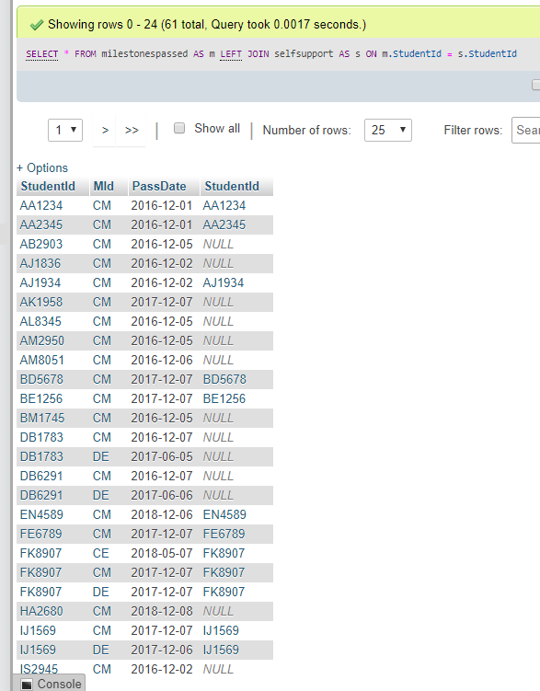

As long as our query should also reflect changes in the Phdstudent table, we should know which self-support students are there to make sure it will be deleted in both tables. So, I joined the PHDSTUDENT table and SELFSUPPORT table.

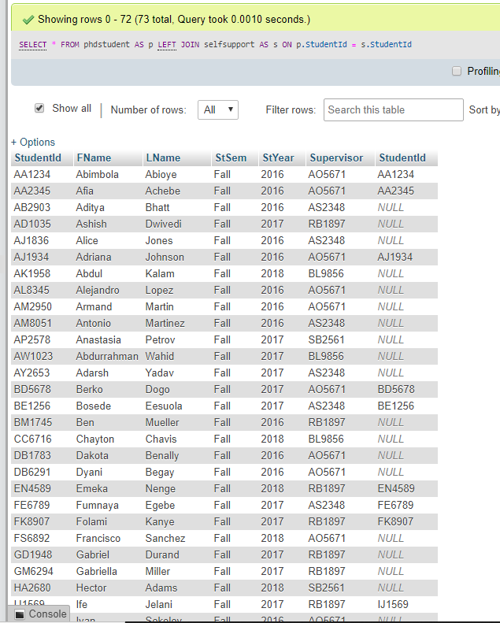

Test case: a. delete a student id (AA1234) that has a milestone passed as we can see in the first image, and it does not delete, which is correct.

The best way to delete a student record is to create a record manually. For example I added a student record to PHDSTUDENT table and to SELFSUPPORT table:

Test case : ABC123 , Fname = Donna , Lname = Safaddin , StSem = Fall , StYear= 2016, Supervisor = MA4567.

To delete: Test case: ABC123

Test case: b. delete student id (ABC123). It was deleted successfully.

