Donnie Newell

Muhammed Yanhaona

HW4 Graphs

Problem 1: (i):

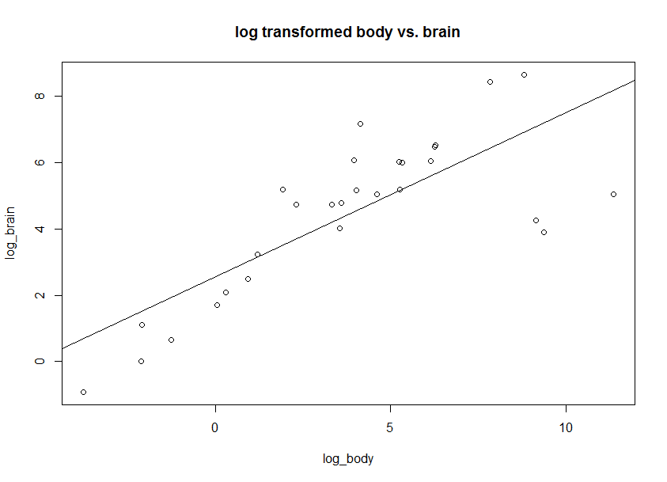

Problem 4:

