Donnie Newell

Den4gr

4Sep12

Homework #1

From the 3rd Edition:

2.18

(a) causal, because u[n] = 0 when n < 0

(b) causal, because u[n] = 0 when n < 0 and h[0] = (1/2)^n u[-1]

(c) non-causal, because h[-1] = (1/2)^1 = .5 ~= 0

(d) non-causal, because h[-1] = u[1] – u[-3] = 1 – 0 = 1 ~= 0

(e) non-causal, because h[-1] = 3\*u[-1] + (1/3)\*u[0] = (1/3) ~= 0

2.21

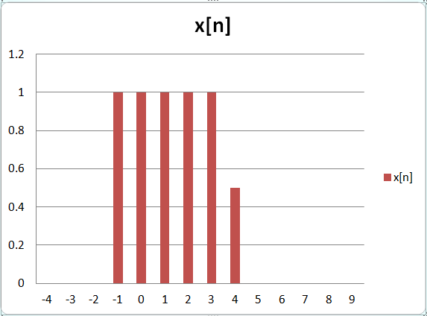

(a)

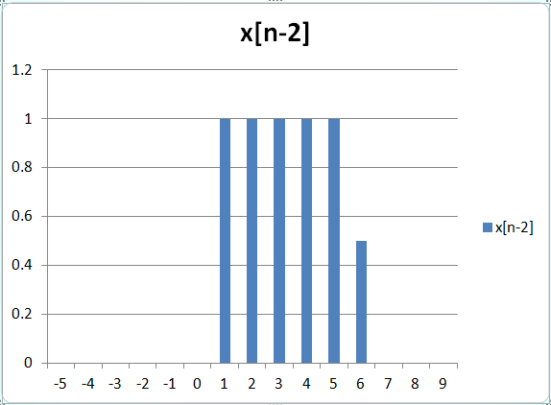

(b)

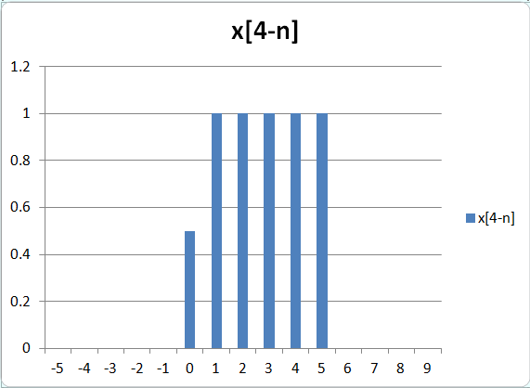

(c)

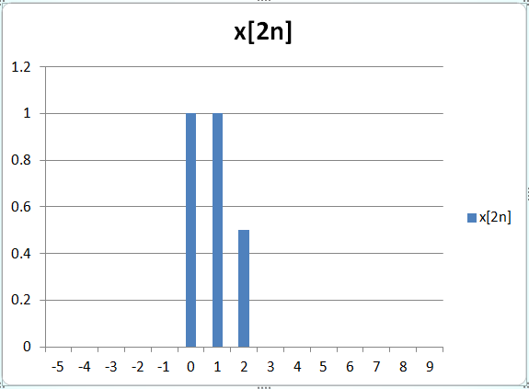

(d)

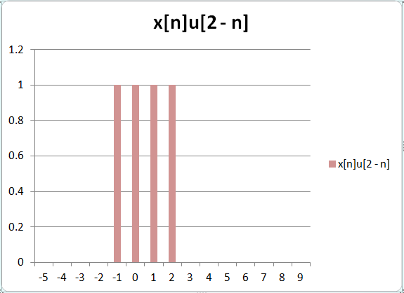

(e)

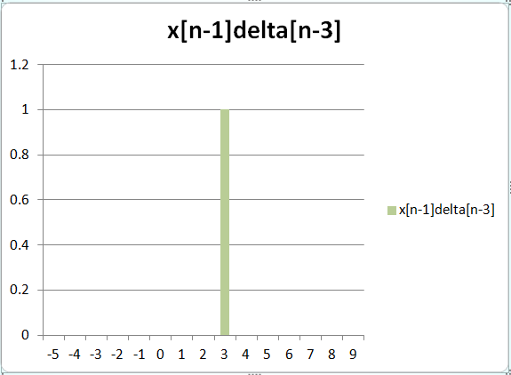

2.49

(a) I understand the definition of LTI systems, but I could not find any examples that illustrated how to approach this question in the book or slides. I could not attend recitation, and Clive tried to help over email with little success. My confusion is centered around not understanding how to combine the inputs into a single input.

(b)

2.58

(a)

h[n] = delta[n] + 2 \* delta[n - 1] + delta[n – 2]

n < 0 : h[n] = 0

n == 0 : h[n] = 1

n == 1 : h[n] = 2

n == 2 : h[n] = 1

n > 2 : h[n] = 0

(b) Yes. It is stable because h[n] is absolutely summable to 4.

(c)

H(e*jw*) = ∑ (delta[n] + 2 \* delta[n - 1] + delta[n – 2]) \* e*-jwn*

H(e*jw*) = (1) \* e*-jw0* + (2) \* e*-jw1* + (1) \* e*-jw2*

H(e*jw*) = 1 + 2e*-jw* + e*-jw2*

H(e*jw*) = 1 + e*-jw* (2 + e*-jw*)

The only trigonometric identity I saw used in the text was converting e*jwx* – e*-jwx* to sin[ωx] but that doesn’t seem to apply here.

(d)

(e)