

Student Full Name Dolgorsuren Ochirsuren
Student Number
2026423
Module Title
Strategic Thinking
Assessment Title
CA1 – Capstone Project Proposal
Lecturer/Supervisor
Taufique Ahmed
GitHub Repository:
https://github.com/Donnnaa/Strategic-thinking-sep26.git
Assessment Due Date
25/10/2026
Date of Submission
25/10/2026

Use of AI Tools
I acknowledge the use of Microsoft Copilot for guidance on the project proposal and assistance with understanding the assignment requirements.
Declaration
By submitting this assessment, I confirm that I have read the CCT policy on academic misconduct and understand the implications of submitting work that is not my own or does not appropriately reference material taken from a third party or other source.
I declare it to be my own work and that all material from third parties has been appropriately referenced.
I further confirm that this work has not previously been submitted for assessment by myself or someone else in CCT College Dublin or any other higher education institution.

Capstone Project Proposal

Predicting Corporate Bankruptcy Using Financial Ratios: A Machine Learning Approach

1. Project Title
Predicting Corporate Bankruptcy Using Financial Ratios: A Machine Learning Approach
2. Introduction
Corporate bankruptcy is a serious problem because it can cause losses for banks, investors and employees. Companies may have financial problems because of high debt, low profits or poor cash flow. Financial ratios can help us understand a company’s financial situation. This project will use data analytics and machine learning to predict bankruptcy and find the main financial factors that can cause it.
3. Problem Definition
Companies may have financial problems before they go bankrupt. Finding these problems early is important because banks and investors can lose money. Data analytics and machine learning can help predict bankruptcy by studying financial information. This project will use financial ratios to predict company bankruptcy. It will compare different machine learning models to find the best one. It will also study important factors, such as debt, profit and cash flow. The results may help banks and investors find companies with a high risk of bankruptcy and make better financial decisions.
4. Aim and Objectives
The aim of this project is to build and test machine learning models to predict company bankruptcy using financial ratios.
Objectives
- To collect and prepare financial data about companies.
- To analyse the data and find patterns related to bankruptcy.
- To build and compare three models: Logistic Regression, Decision Tree and Random Forest.
- To test the models and find which one gives the best results.
- To identify important financial factors and suggest ways to help businesses manage risks.
Business Hypothesis
Companies with lower profits, less cash and higher debt are more likely to go bankrupt.

5. Scope
This project will use past financial data from Taiwan to predict if a company may go bankrupt. It will study profits, cash and debt. Three machine learning models will be tested and compared to find the best one. A simple dashboard may also be created to show the results. The models may make mistakes, and the results may not apply to all countries. The project will be completed over two semesters.
6. Methodology
This project will use Python and machine learning to predict company bankruptcy. Pandas, NumPy, Matplotlib and Seaborn will be used to clean and analyse the data. Three models, Logistic Regression, Decision Tree and Random Forest, will be built and compared using accuracy, precision, recall, F1-score and ROC-AUC. Finally, the best model and key financial factors will be identified. A simple dashboard may be created using Streamlit, and the results will be explained in the final report.
High Level System Architecture
Financial Dataset

Data Cleaning and Preparation
(Python, Pandas)

Exploratory Data Analysis (EDA)
(Charts, Summary statistics)

Training and Testing Split

Machine Learning Models
Logistic Regression  Baseline classification model | Decision Tree  Rule based model | Random Forest  Ensemble of decision trees

Model Evaluation
(Compare Recall, F1 score, ROC-AUC)

Best Model and Key Findings

Dashboard and Final Report
The system begins with data collection and preparation, followed by data analysis and model training. The models are evaluated and compared to select the most suitable approach. Finally, the results are presented through the dashboard, if developed, and the final report.
7. Data Sources
The main dataset for this project will be the Taiwanese Bankruptcy Prediction dataset from the UCI Machine Learning Repository (2020).
Dataset link: https://archive.ics.uci.edu/dataset/572/taiwanese+bankruptcy+prediction
The dataset contains 6,819 records and 95 financial features. It uses data from Taiwan Economic Journal from 1999 to 2009. The “Bankrupt?” column shows whether a company went bankrupt. This dataset is useful because it can help train and test machine learning models. It is public and uses a licence that allows people to use and change the data if they give credit to the original source.
This project will follow the licence rules and clearly name the original source in the report. If other datasets are needed, their licences will also be checked before use.
8. Expected Deliverables
By the end of Semester 2, the project will produce:
- A clean and organised dataset.
- A report with charts and data analysis.
- Three machine learning models.
- A comparison of the model results.
- A study of important financial factors.
- Business recommendations based on the results.
- A simple dashboard, if time allows.
- A GitHub page with the code and project files.
- A final report explaining the methods, results and limits.
- A final presentation of the project and its findings.
9. Project Timeline
The project will be completed over 2 semesters.
Semester 1
Weeks 1-3 Choose the topic and read related studies.
Weeks 3-5 Choose the dataset and check it.
Weeks 5-8 Study and analyse the data.
Weeks 9-12 Finish the proposal and build a basic model.
Semester 2
Weeks 1-3 Clean and prepare the data.
Weeks 3-5 Build three machine learning models.
Weeks 5-7 Test and compare the models.
Weeks 7-9 Create a dashboard and make business recommendations.
Weeks 9-11 Study the results and write the final report.
Week 12 Present and submit the project.
End of Semester 1: The proposal and dataset will be ready. The first data analysis and a basic model will be completed.
End of Semester 2: The models will be tested and compared. The final report, recommendations and presentation will be completed. A dashboard will be created if time allows.
10. Ethical and Legal Considerations
This project will use public data from the UCI Machine Learning Repository. I will check the licence and give credit to the original source.I will keep my project files safe and check permission before using extra data. The machine learning models may make mistakes. I will explain that the results are predictions and describe the limits of the data. The models will not be the only way to make important financial decisions. I will follow my university’s rules on data safety, ethics and AI use. I will also complete the required forms.
Harvard references
Alaminos, D., del Castillo, A. and Fernández, M.Á. (2016) ‘A global model for bankruptcy prediction’, PLOS ONE, 11(11), article e0166693. Available at: https://doi.org/10.1371/journal.pone.0166693.
Altman, E.I. (1968) ‘Financial ratios, discriminant analysis and the prediction of corporate bankruptcy’, The Journal of Finance, 23(4), pp. 589–609. Available at: https://doi.org/10.1111/j.1540-6261.1968.tb00843.x.
McKinney, W. (2010) ‘Data structures for statistical computing in Python’, in Proceedings of the 9th Python in Science Conference, pp. 56-61. Available at: https://doi.org/10.25080/Majora-92bf1922-00a.
Pedregosa, F. et al. (2011) ‘Scikit-learn: Machine learning in Python’, Journal of Machine Learning Research, 12, pp. 2825-2830. Available at: https://www.jmlr.org/papers/v12/pedregosa11a.html.
scikit-learn developers (n.d.) Model evaluation: Quantifying the quality of predictions. Available at: https://scikit-learn.org/stable/modules/model_evaluation.html (Accessed: 20 October 2026).
Streamlit (n.d.) Streamlit documentation. Available at: https://docs.streamlit.io/ (Accessed: 20 October 2026).
UCI Machine Learning Repository (2020) Taiwanese Bankruptcy Prediction [Dataset]. Available at: https://doi.org/10.24432/C5004D (Accessed: 20 October 2026).

Appendix

AI Tool Used
Microsoft Copilot.

Purpose of Use
I used Microsoft Copilot for guidance on my project proposal and to help me understand the assignment requirements.

Prompts Used
I used Microsoft Copilot to ask questions about the project proposal structure, assignment requirements, and how to organise the main sections of the report.
Screenshots of my actual prompts and Copilot responses are included below.

Figure A1 Screenshot of a prompt entered into Microsoft Copilot.
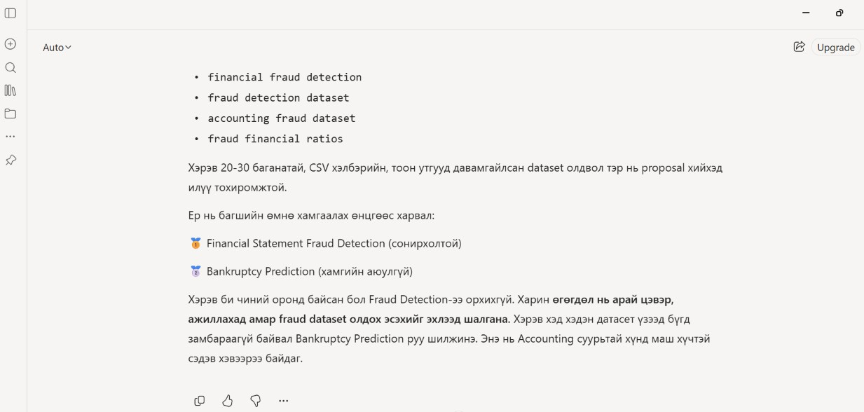
Figure A2 Screenshot of the response from Microsoft Copilot.
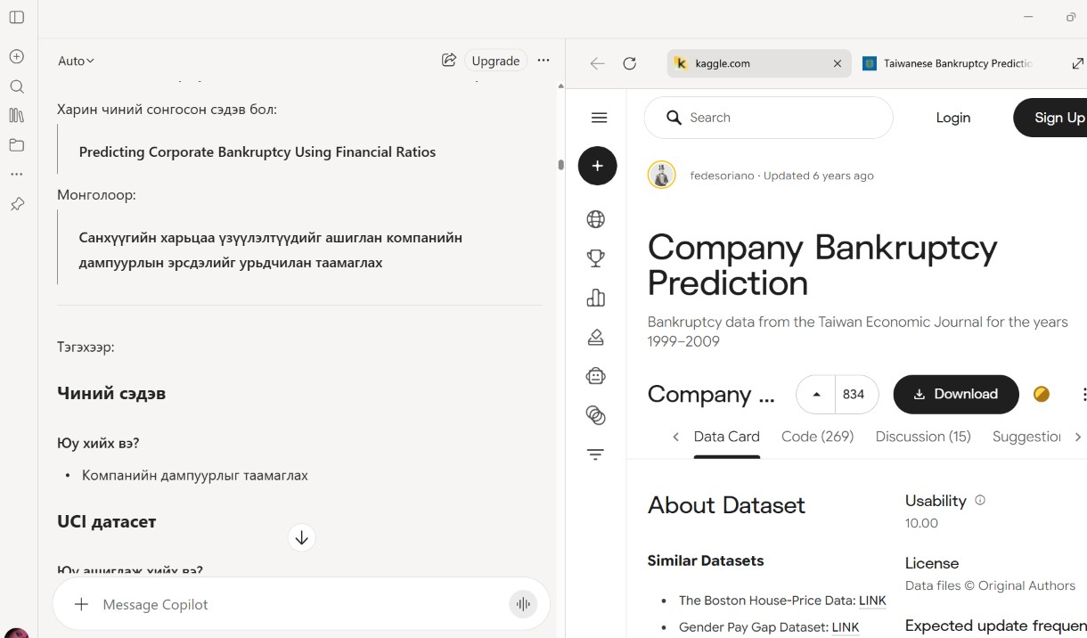

Evaluation of AI Output
I reviewed the suggestions provided by Microsoft Copilot and used them as guidance. I made my own decisions about the project and checked the information before including it in my work.

Responsible Use of AI
Microsoft Copilot was used to support my understanding and planning. I am responsible for the final content of my project proposal.

