Dongping Guo ao7171

Problems 1 : Write the details on a word document

Problems 2,3: Paste the screenshot of the Simulator highlighting the register with final value on word document. Also paste the RISCV code on word document

PROBLEMS

1. Find the below details for your laptop/Desktop **5 points**

Processor: Apple M2

Graphics Processor(If exists)： Apple M2

Clock speed: high performance @3.49 GHz; energy-efficient @2.42 GHz

No.of Cores: 8 cores (4 high-performance and four energy-efficient)

RAM Size: 24 GB

Storage: 1 TB

Typical TDP in Watts: 20 W

Cache per CPU Package( optional):

|  |  |
| --- | --- |
| L1 cache | Performance cores: 192+128 KB per core Efficiency cores: 128+64 KB per core |
| L2 cache | Performance cores: 16 MB Efficiency cores: 4 MB |
| L3 cache | 8 MB |

2) Write an RISCV code that takes in two numbers b and p, and returns the result of below expression.  **10 points**

x= ((b+5) * (p-2) * 10) / 4;

.text

.globl main

**main**:

**li** x5, 3 *# load 3 to x5 (represents number b)*

**li** x6, 4 *# load 4 to x6 (represents number p)*

**li** x7, 10 *# load 10 to x7*

**addi** x28, x5, 5 *# x28 = b + 5; Expected: 8*

**addi** x29, x6, -2 *# x29 = p - 2; Expected: 2*

**mul** x30, x28, x29 *# x30 = (b + 5) * (p - 2); Expected 16*

**mul** x30, x30, x7 *# x30 = x30 * 10; Expected: 160*

**srli** x30, x30, 2 *# x30 = x30 >> 2; Expected: 40*

**done**:

**li** a0, 10

**ecall**

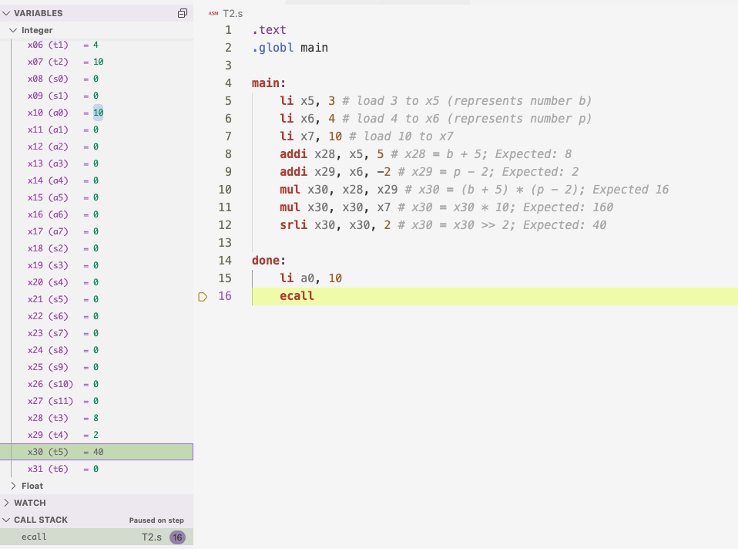

3) Convert pseudocode given below into RISCV code. **15 points**

int A[]={4, 8, 12, 16, 20, 24, 28}

int sum=0

for( int i=0;i<7;i++)

{

if i%2==0 {

sum+=A[i]

}

}

.data

**array**: .word 4, 8, 12, 16, 20, 24, 28

**length**: .word 7

.text

.globl main

**main**:

**li** t0, 0 *# i = 0*

**lw** t1, length *# t1=7*

**la** t2, array *# t2 = address of array*

**li** t3, 0 *# sum = 0*

**loop**:

**beq** t0, t1, done *# check if i == 7*

**lw** t6, 0(t2) *# load word from array*

**andi** t4, t0, 1 *# t4 = t0 AND 1 = t0 % 2*

**beqz** t4, addition *# if t4 == 0, jump to addition*

**j** continue

**addition**:

**add** t3, t3, t6 *# add to sum*

**j** continue

**continue**:

**addi** t0, t0, 1 *# update counter i*

**addi** t2, t2, 4 *# update address to for next word in array*

**j** loop

**done**:

**li** a0, 10

**ecall**

