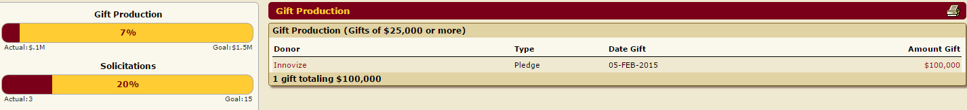

|  |
| --- |
| * Test 16 : Total $100K. SQL checked and amount verified –***GOOD*** |
| * Test 17 : drilled gift total and total matched: $100K –***GOOD*** |
| * Test 18 : Drilled total and sum of individual gift matched: *$91,666.65* (pledge balance) . ( 5 payments of $1,666.67 = *$8,333.35* ) –***GOOD*** |
| * Test 19 : Gift production of (gift of $25,000 or More $100K is showing up –***GOOD*** |
| * Test 20 : Yes, Ashley Lawson is showing up as solicitor --***GOOD*** |
| * Test 21: SKIPPED |
|  |
| * Test 22: Unit Gift verified as $39,693,753 & 3,080 –all matched. –***GOOD*** |
| * Test 23: Unit Gift production verified in SQL ($39,693,753) –***GOOD*** |
| * Test 24 : Verified total amount matched all across four areas. –***GOOD*** |
| * Test 25 : verified drill total against sql code (Gift by: size/source/use/type – with exception of total # summary, but Mike confirmed it is just our script. Individual total for each type MATCH --***GOOD*** |
| * Test 26 : donors count match counting individual totals --***GOOD*** |
|  |
| * Test 27 : 61 gifts totaling $247,112 – SQL Script matched both—***GOOD*** |
| * Test 28 : 61 gifts totaling $247,112 – Drilled down & matched --***GOOD*** |
| * Test 29 : total matched |
| * Test 30 : Individual gifts checked (5) and all gifts are there okay with correct CORRIDOR (CH) |
| * Test 31 : All donors checked and are all managed by Ashley Lawson * DISCREPENCY: popup windows does not close after clicking close window icon --***Filed SIR*** |
|  |
| * Test 32 : all 4 totals matched –total# 66,771/ total dollar: $322,097,951 |
| * Test 33 : Total by Gift Size ok. |
| * Test 34 : Total good |
| * Test 35: good |
| * Test 36 : good |
| * Test 37: good |
|  |
| * Test 38: done |
| * Test 39: done |
| * Test 40 - good |
| * Test 41 - good |
| * Test 42 - good |
| * Test 43: good |
| * Test 44: good |
| * Test 45: blank |
| * Test 46 : blank |
| * Test 47 : newsfeed - ok |
| * Test 48 : ok. |
| * Test 49: ok |
| * Test 50 : blank |
| * Test 50 |
| * Test 50 |
| * Test 50 |
| * Test 50 |
| * Test 50 |
|  |