Abstract—This paper describes an application that converts raster images to vector images (vectorization). The application is capable of extracting polygons as well as curved shapes from color images to form a vector math model. The application is capable of exporting the model data to the Scalable Vector Graphics (SVG) format. Region tracing and cubic Bezier fitting are the main techniques employed to achieve the conversion.

Method of image vectorization
Scott Stevenson, Student Member, IEEE, Donovan Benoit

Terms—Image processing, image decomposition, vector graphics

INTRODUCTION
Vector graphics is the use of geometric primitives based on mathematical equations represent images. These primitives include points, paths, and polygons. Since vector graphics are rendered using mathematical equations, the quality of the rendered image is independent of its scale. This contrasts with the more commonly used raster formats, which represent images as pixels. Pixelation occurs in these formats when they are enlarged. Vector formats are frequently used for images that are meant to appear on a variety of mediums and at different sizes (e.g. fonts, logos, blueprints and maps). Vector formats usually have a smaller file size than raster formats, although this is proportional to the complexity of the image.


Fig 2. Quantized sphere split into binary images.

This paper presents one method of converting raster graphics to vector graphics (a process known as vectorization). This method was implemented in MATLAB. The implementation consists of a GUI to load raster images, set parameters and export the vectorized images. The scope of the method was constrained to the extraction of polygons and cubic beziergons (closed paths composed of cubic Bezier curves).

Polygon Extraction
Polygons are identified in the image using the process of color quantization, median filtering and then region tracing.
The number of colors in the input image is first quantized to a low number. This number is usually between 2 and 20. Vector images normally contain a low number of colors. Vector formats are generally not useful for representing images with a high number of colors, unless the colors can be simply described by a mathematical model. This vectorization implementation is only concerned with the extraction of uniformly colored shapes. After color reduction, a median filter is applied to the resultant image, in order to remove small colored regions. Fig. 1 shows how an image of a sphere might be quantized.

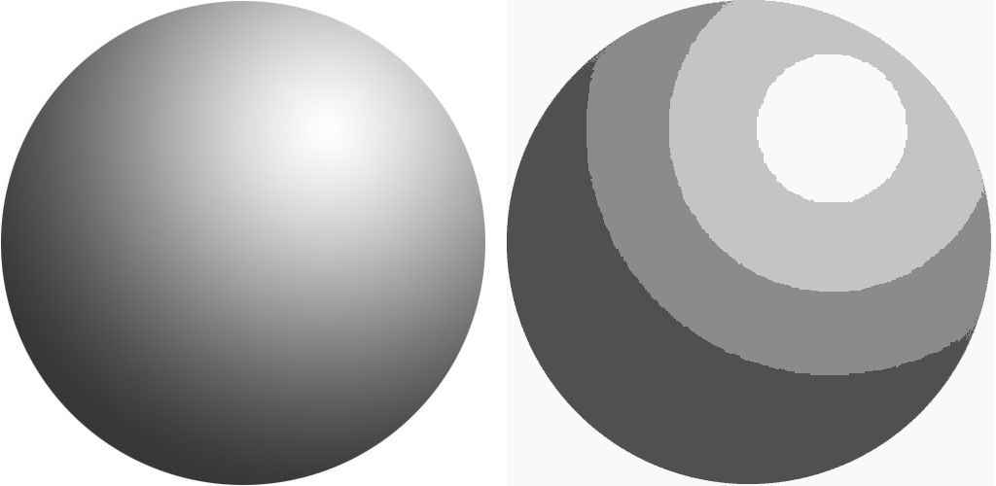
Fig 1. A shaded sphere (left) and a 4-color quantization of it (right).

After color quantization, the image is separated into several binary images- one for each color. The resultant images are shown in Fig. 2.

Region tracing is then performed on the binary images, giving arrays of co-ordinates that outline each shape. This data can then be sampled at different frequencies, to obtain the vertices that can be used to represent the image as a set of colored polygons. The optimal amount of positions sampled highly depends on the resolution and complexity of the original image. If the sampling frequency is too low, the polygon will become distorted, and if the sampling frequency is too high, the non-idealities of the image will be captured by the polygon (such as the shape of the pixels themselves). The percentage of trace points used as polygon vertices can be specified by the user of the application, and the optimal percentage can be easily found through trial and error.

The extracted colored polygon data is now enough to generate a vector image. This works well on images composed of straight lines, but does not work as well on images that contain curves.

Beziergon Fitting
Cubic beziergon fitting works well to approximate curved traces. Most vector formats allow the rendering of Bezier paths, which are a superset of beziergons.
In the implementation, an open source library was used for the fitting of beziergons, which is found at [1]. MATLAB’s spline fitting functionality was initially used, but the library was found to be better suited to the application.
Cubic Bezier curves are represented by (1), where P₀ and P₃ are the curve start and end points, P1 and P2 are the curve control points (controlling the curve shape), t_{i} is an index between 0 and 1 and q(t_{i}) is the respective interpolated point for the index. P₁ and P₂ need to be determined during fitting.

(1)

P1 and P2 can be determined using least-square fitting, which minimizes S, in (2), where p_{i} is the ith actual data value.

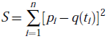 (2)

This is done by solving (3) and (4) for P1 and P2:
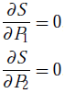
(3)

(4)

The creation of a beziergon requires the fitting of Bezier curves to all segments of each polygon. The strategy that was used for the segmentation is as follows:
- Try to fit a curve to increasingly larger segments of the polygon, until the minimized S becomes greater than the inputted square error threshold.
- Save this curve and start a new curve from its end point. Fit a new segment as in step 1.
- Stop when the full polygon is covered.

Fig. 3 shows how beziergons are fitted to the sketch of a human skull. Simpler images can result in a lot less segment breakpoints.
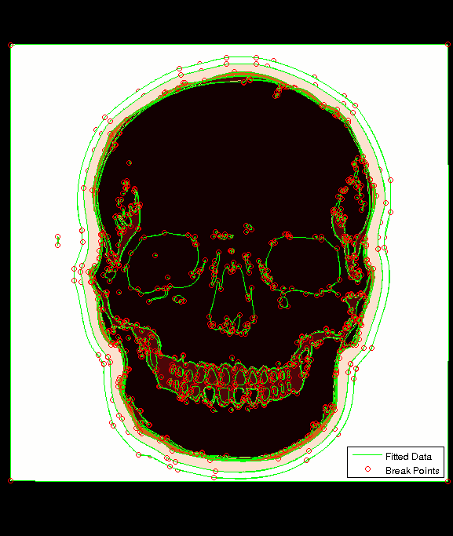Fig 3. Cubic beziergon fitting on the sketch of a human skull.

Export
To complete the vectorization process, the vectorized image model has to be exported. The application will export the combined results of the last polygon and the curve model extraction.
The Scalable Vector Graphics format (SVG) [2] was chosen for exporting as this format is open, widely used and can be edited in a simple text editor. The SVG 1.1 standard is XML-based and is maintained by the World Wide Web Consortium. Polygons, cubic Bezier paths and fill colors are exported to an SVG file.

Results
The method worked well for the vectorization of simple colored shapes and sketches. It also worked well to vectorize some photographs, but more so as an artistic technique than for accuracy. Fig. 4 shows how polygon vectorization and beziergon vectorization performed on a portion of a raster letter ‘D’.


Fig 4. (a) The top left corner of a stylized letter ‘D’ in raster format. (b) A polygon representation of the letter, sampling 100% of the trace points, rendered from an SVG file. (c) The beziergon-fitted letter ‘D’.

Polygon conversion works well for images with straight lines, but is not very useful for images composed of curved shapes. Bezier spline fitting worked well curved shapes. However, it was usually necessary to manually adjust the maximum square error threshold to achieve optimal results.
When the threshold is too low, it often causes the non-idealities of the image to be fitted (such as the shape of pixels themselves). It causes curves to become choppy because of the high number of breakpoints. When the threshold is too high (approximately greater than 50), it causes the shapes to be approximated extremely poorly.
The image compression results showed significant reduction in file sizes for some images (up to 1/6 compression), however some images required a larger file size after conversion. Results were proportional to the number and complexity of objects in the image.

Improvements
One improvement that could be made to the method is the ensuring that corner points are sampled when polygons are extracted. This would require the use of corner detection. It would improve the output of polygon vectorization, allowing the fewest number of trace points to be used to describe the shape.
Another improvement that could be made is the fitting of other primitives such as circles, rectangles and lines of varying widths. This would ensure that if these shapes are present in the image, that they are represented with maximum accuracy.

Line Identification
The Hough transform method of line detection was initially tested as a way of extracting lines. However, it did not perform as well as expected.

The Hough Transform method first involves pre-processing of the image by converting it to grayscale and using Canny edge detection, which results in a binary image. The next step is to compute the Standard Hough Transform (SHT). Next, peaks are identified in the SHT. The final step is to compute Hough Lines using the information obtained in the previous steps.

The results from this method were inadequate because most lines and edges in images did not get detected. It was not included in the final vectorization process.

Conclusion
The generalized vectorization of raster images can be achieved using color reduction, region tracing and Bezier curve fitting. The method works well on simple shapes with few colors. It does not work perfectly on more complex images, but with some adjustments in a vector image editing program after export, ideal results can be achieved. Automated vectorization significantly speeds up the process of converting raster images into vector format.
References
- M. Khan. (2007, July 10). Cubic Bezier least square fitting [Online]. Available: http://www.mathworks.com/matlabcentral/fileexchange/15542
- World Wide Web Consortium. (2011). Scalable Vector Graphics (SVG) [Online]. Available: http://www.w3.org/Graphics/SVG/
- [13] Wikimedia Foundation, Inc (2011). Hough Transform [Online]. Available: http://en.wikipedia.org/wiki/Hough_transform

  S. Stevenson is with Memorial University of Newfoundland, St. John's, NL, A1C 5S7 (phone: 709-746-4060 e-mail: sstevenson@mun.ca). D. Benoit, is with Memorial University of Newfoundland, St. John's, NL, A1C 5S7. (e-mail: t44djb@mun.ca).

