Treasure Row

Donovan Griffin, Jonah Goodwine, Cameron Ridgley, Chi Martin, Ricki Davis, Chase Jones, Noah Higgs



Requirements

Table of Contents
Table of contents — section titles only (page numbers removed because the reviewed pagination changed)
1.0 Introduction
1.1 Goals and objectives
1.2 Statement of scope
1.2.1 Student Validation
1.3 Software context (Noah Higgs)
1.3.1 AWS Services (Noah Higgs)
1.4 Major constraints (Noah Higgs)
2.0 Usage scenario
2.1 User profiles
2.2 Use-cases
2.3 Special usage considerations
3.0 Data Model and Description
3.1 Data Description
3.1.1 Data objects
3.1.2 Relationships
3.1.3 Complete data model
3.1.4 Flow Diagram
3.1.5 Data dictionary
3.1.6 Database schema(Chase Jones)
3.1.7 Referential Integrity
3.1.8 Indexing (Chase Jones)
4.0 Functional Model and Description
4.1 Description for Function n
4.1.1 Processing narrative (PSPEC) for function n
4.1.2 Function n flow diagram
4.1.3 Function n interface description
4.1.4 Function n transforms
4.1.4.1 Transform 1 description (processing narrative, PSPEC)
4.1.4.2 Transform 1 interface description
4.1.4.3 Transform 1 lower level flow diagrams
4.1.4.4 Transform 2 description
4.1.4.5 Transform 2 interface description
4.1.4.6 Transform 2 lower level flow diagrams
4.1.4.7 Transform 3 description
4.1.4.8 Transform 3 interface description
4.1.4.9 Transform 3 lower level flow diagrams
4.1.5 Performance Issues (Noah Higgs)
4.1.6 Design Constraints (Noah Higgs)
4.1.7 Storefront Management (Chase Jones)
4.1.8 Wishlist Management
4.1.9 Transaction Processing
4.1.10 Return Request Processing
4.2 Software Interface Description (Noah Higgs)
4.2.1 External machine interfaces (Noah Higgs)
4.2.2 External system interfaces
4.2.3 Human interface
4.2.4 Environment configuration (Chase Jones)
4.3 Control flow description
5.0 Behavioral Model and Description
5.1 Description for software behavior
5.1.1 Events
5.1.2 States
5.2 State Transition Diagrams
5.3 Control specification (CSPEC)
6.0 Restrictions, Limitations, and Constraints
6.1 User and Access Restrictions (Noah Higgs)
6.2 Functional Limitations
6.3 Technical and Platform Constraints (Noah Higgs)
6.4 Security and Data Handling Constraints
6.5 Resource and Schedule Constraints
6.6 Collaboration and Tooling Constraints
6.7 Scalability Constraints
7.0 Validation Criteria (Noah Higgs)
7.1 Classes of tests
7.2 Expected software response
7.3 Performance bounds (Noah Higgs)
8.0 Code Contributions and Description
8.1 David Jackson Code Contributions
8.2 Elali McNair Code Contributions
8.3 Madison Boyd Code Contributions
8.4 Ryan Grimes Code Contributions
8.5 Day Ekoi Code Contributions
8.5.1 Day Ekoi Coding Contributions - I4
8.5.2 Day Ekoi Coding Contributions - I5
8.6 Kaila Roberts Code Contributions
9.0 Revision Log (Noah Higgs)

REVIEW EDITION — 27 OCTOBER 2026
How to read this copy: BRIGHT GREEN highlighting marks every new or rewritten passage introduced in this review, including this section and the appended acceptance criteria. Existing yellow, turquoise, and red highlighting belonged to the source document and has been preserved. Original database tables and historical code-contribution narratives remain unless specifically corrected or annotated.
Review basis: the supplied “Requirements_I3_Before.docx” (66-page source). The document describes later I4/I5 additions, including 16 tables and Treasure Tokens. No repository, running database, source code, or actual AWS account was provided for independent verification. “Reported/current” refers only to what the source document describes. “Proposed” is a recommended requirement pending approval.

Key findings and dispositions
P1 — CONTRADICTORY PAYMENT SCOPE (1.2, 3.1.6, 4.1.9, 6.2): the early document claims no payment processing, while later text specifies token wallets, escrow, ledger and pickup codes. Rewritten as internal token processing with unresolved cash/redemption policy; approval required before live use.
P1 — DATA INTEGRITY AND DELETION (3.1.6–3.1.7, 8.1): user deletion can cascade into orders and a supposedly append-only token ledger; admin contributor notes discuss permanent deletion. Added a block on destructive deletion pending retention and audit design.
P1 — RETURNS OWNERSHIP (3.1.6, 4.1.10): returns.order_number is accepted as typed and is not validated against orders. Proposed authenticated buyer/order ownership checks and foreign-key relationship. Requires code and schema change.
P1 — AUTHENTICATION/SECRETS (1.2.1, 6.4): school email domain is not verified student identity; admin password is documented as plaintext configuration; SECRET_KEY description contradicts itself. Added explicit controls, release blockers, and validation tests.
P1 — ATOMICITY/DOUBLE-SPEND (4.1.9, token tables): checkout must reconcile order creation, inventory, wallet debit, escrow and ledger in a single transaction; avoid negative stock/balance and double-release. Added concurrency and rollback acceptance criteria.
P2 — OUTDATED SCHEMA AND FIGURES (3.0–3.1.5): early two/three-table descriptions and diagrams contradict the later 16-table schema. Corrected narrative, labeled legacy figures, and requested a regenerated ERD.
P2 — MISSING FEATURE STATUS (3.1.6, 2.2): reviews table exists but interface does not; messaging and tokens appear after initial use cases. Reconciled current-scope language and flagged review as schema-only.
P2 — AMBIGUOUS API CONTRACTS (4.1.3, 4.2): “JSON is a list” and generic HTTP codes omit method/path/auth/ownership/errors; localhost https URL may be wrong. Rewritten as actionable route-contract requirements.
P2 — VAGUE NONFUNCTIONAL TESTS (4.1.5, 7.0–7.3): “under 200ms query,” “high volumes,” and “automatic recovery” lack workload and observable metrics. Added proposed, measurable targets and reproducible testing expectations.
P2 — CLOUD BUDGET/CONFIGURATION (1.4, 6.3): $200 per team member and AWS Free Tier are not universal entitlements. Current AWS terms describe up to $200 for qualifying new accounts; verify actual account balance, region, expiring credits, and service eligibility.
P2 — PRIVACY/ACCESSIBILITY (6.4, 7.0): document misstates that only usernames/passwords are collected although buyer contact, meeting location, messages, and photos are stored. Added data-handling and WCAG 2.2 test recommendations.
Decision policy: Unresolved issues are labeled “REVIEW NOTE”, “PRODUCT DECISION”, “INTEGRATION GAP”, or “PROPOSED”. No such language is evidence of an implemented fix. Appendix A contains the proposed acceptance checklist and Appendix B the explicit open decisions.

1.0 Introduction

Treasure Row is a cloud-hosted, browser-based campus marketplace prototype for Hampton University users. Authenticated shoppers can browse student-brand clothing, save items, message sellers, and submit checkout orders. A user may establish one storefront and manage its listings; administrators have separate moderation privileges. Later iterations also document a Treasure Tokens wallet and escrow workflow, whose status and treatment must be reconciled with the checkout specification before release.

This specification records the proposed system requirements, documented schema, functional workflows, constraints, and acceptance criteria. Statements about code or database implementation are based on the project document, not an independent repository or deployment audit. The review annotations identify inconsistencies, security risks, and decisions requiring confirmation; they are not claims that changes have already been implemented.

1.1 Goals and objectives

The main goals of Treasure Row are to:
- Require authenticated access for account-specific features; store user passwords only as salted, adaptive password hashes and protect session cookies.
- Allow users to manage storefront and listings
- Allow users to browse listings and view item details
- Allow customers to maintain a wishlist of desired products
- Preserve buyer order history and seller order visibility without relying on an unlinked, duplicate purchase record.
- Allow a buyer to submit a return request associated with an order they own; provide administrators with an auditable review workflow.
- Store listing images securely using Amazon S3
- Maintain structured data in a cloud-based PostgreSQL database
- Provide a responsive and user-friendly web interface
- Support secure cloud deployment on AWS
- Support a single coherent checkout flow that records an order for in-person exchange and, if Treasure Tokens are enabled, atomically holds funds in escrow until verified pickup or cancellation.

Objectives:
- Apply authorization checks on every protected server endpoint, using authenticated account roles and storefront ownership.
- Allow users to gain seller capabilities by creating a storefront
- Support listing inventory management, including size-based inventory tracking
- Track available quantities by listing and selected size; prevent inventory from becoming negative when multiple checkouts occur concurrently.
- Provide buyer order history and seller views limited to order lines belonging to storefronts they own.
- Preserve data integrity using soft-action logic where appropriate
- Define a documented data-retention and deletion policy that protects order, audit, escrow, and ledger records before adding account deletion.
- Establish testable security, reliability, accessibility, and performance criteria rather than relying solely on general design goals.

1.2 Statement of scope

Treasure Row supports discovery and in-person fulfillment of clothing sold by student-operated storefronts. The documented system includes account registration and login; one storefront per account; listing and image management; size-based inventory; browsing/search; wishlists; direct messaging; persistent carts; orders and history; return requests; and administrative moderation. Storefront reviews have a database table but are explicitly not an operational feature in the documented iteration.

The system uses a single standard user account. Shopper and seller capabilities are not separate registration roles: an authenticated user becomes the owner of a storefront upon its creation. A distinct administrator role receives narrowly scoped moderation permissions.

Users may function as:
- Shoppers can browse permitted catalog content, save listings, message other users, maintain a cart, submit orders, and view their own orders and return requests.
- Storefront owners can create and manage listings and inventory for the single storefront they own, and may see only the seller-relevant portions of orders.

Creating a storefront grants ownership-based management capabilities for that storefront only; it does not change the account into an unrestricted administrator or permit edits to another owner’s listings.

Administrators may moderate content and returns through protected endpoints. Any account-deletion capability must be separately specified because the documented foreign-key cascade could delete order, wallet, and ledger history.

1.2.1 Student Validation

Registration shall accept only email addresses with an exact, case-insensitive domain match to my.hamptonu.edu or hamptonu.edu after normalization. A substring or suffix-only test that accepts extra domains (for example, hamptonu.edu.evil.example) is insufficient.

The system must require that registered email addresses end with one of the following domains:
- @my.hamptonu.edu
- @hamptonu.edu

On invalid format or an unapproved domain, the registration endpoint shall reject the request without creating an account and return a clear, non-sensitive validation message.

Domain restriction is a demonstration eligibility filter, not verification of current enrollment or control of a university mailbox. Until institution sign-in or an email challenge is implemented, the application must not describe these accounts or storefronts as “verified students.” Confirm whether an email-verification step is in scope.

Major Inputs:
- User login credentials for authentication
- Storefront information (name, description, owner association)
- Storefront image uploads including banner, logo, and up to four preview images (stored in S3)
- Listing information (title, description, price, fulfillment type, inventory details)
- Listing image uploads (stored in S3 and referenced by URL)
- Cart actions including adding and removing items from the persistent shopping bag
- Checkout submission data including buyer contact details and meeting location
- Wishlist selections by customers
- Return request data including order number, reason, damage status, and optional damage image
- User actions such as creating, editing, deleting, browsing, purchasing, or requesting returns

Processing Functionality:

The system must:
- Validate login credentials against stored password hashes, establish a secure authenticated session, and authorize actions independently of client-side controls.
- Enforce domain-based email validation for Hampton University accounts during registration.
- Enforce server-side role and resource ownership rules: admin permissions for administrators; storefront/listing changes for the owner or an authorized administrator only.
- Create, store, retrieve, update, and soft-delete storefront records, including brand name and descriptive information, ownership association, and active/inactive status.
- Create, store, retrieve, update, and soft-delete listing records, including title and description, price and fulfillment type, inventory quantity and availability status, and association to a specific storefront.
- For inventory-controlled listings, reject invalid quantities, check the selected size, and update stock within the same transaction as checkout; prevent concurrent overselling.
- Manage size-based inventory records for applicable listings.
- Store listing images in Amazon S3 and maintain image URLs within the database.
- Maintain persistent cart records per user and load cart state on login.
- At checkout, re-read current listing prices and availability, validate buyer fields, generate a unique order confirmation, atomically create order lines and inventory changes, and clear the cart only on success. If tokens are enabled, the same transaction must also create ledger and seller-escrow entries and verify the buyer’s available balance.
- Maintain and retrieve wishlist records associated with user accounts.
- Return buyer order history from orders and order_items; specify how seller history is derived and whether the separate purchases table is retained or deprecated.
- Associate each return request with a verified order owned by the requester; validate the reason and optional damage photo. Current returns.order_number is unvalidated free text, so this is a proposed corrective requirement, not a documented implemented control.
- Enforce ownership rules so that users can only modify their own listings.
- Provide search and filter features for browsing listings.

Major Outputs:
- A public catalog of active marketplace listings viewable by authorized users.
- Authenticated account views showing the user’s storefront/listings, private wishlist, cart, eligible order history, token balance and escrow status where enabled, and return-request status.
- Order confirmation showing a unique order number, line items, quantity, price snapshot, meeting information, and token hold state where applicable; never imply fulfillment or payment settlement merely because an order was submitted.
- Admin management access for storefronts, listings, and returns.
- Error messages for invalid or unauthorized actions.

Scope Limitations:
- The system will not integrate with any other external marketplaces or platforms.
- Scope clarification: no external card processor or bank details are documented. The later iteration DOES include an internal Treasure Tokens wallet, ledger, escrow, and pickup-code release. The team must decide whether these are strictly non-redeemable demonstration credits or have real financial value; the earlier statement “payment processing is not implemented” is outdated in relation to the documented token workflow.
- Out of scope unless separately approved: external marketplaces, bank/card payments, recommendations or AI, cross-campus rollout, and operational storefront reviews (schema present only).

The overall focus of this application is on delivering a secure, cloud-based, and user-friendly marketplace that meets the functional requirements for Hampton University students while remaining scalable for possible future expansion.

1.3 Software context (Noah Higgs)

Treasure Row is documented as a Flask web application with a browser interface, PostgreSQL data in Amazon RDS, and media assets in Amazon S3. AWS Elastic Beanstalk and Gunicorn are described as the deployment arrangement. Actual production readiness, active AWS region, configuration, and environment status require deployment evidence.

Strategic Context:
- Treasure Row will promote student-owned brands and provide an easy way for students to discover and purchase items
- Security, usability, and accessibility are top priorities to ensure trust and adoption by the student community
- The system is designed to be scalable, allowing for future expansion to include additional product categories or features

Technical Context:
The system will utilize the following features and technologies:

Software/Tool | Description | Type
AWS | Cloud platform for hosting the application, database, and backend services | Cloud Service
Python | Programming language for backend development. Will handle user authentication, database communication, and server-side processing. | Language
Flask | Python web framework used to build backend REST API, define routes, handle HTTP requests and responses, and enforce application logic | Framework
Javascript | Programming language to manage the frontend interface, enabling users to communicate with backend API endpoints through a web browser. | Language
HTML | Markup language used to structure and organize the content of the web pages, including forms, buttons, listings, and layout elements displayed in the user interface. | Language
CSS | Styling language used to control the visual design and layout of the web interface, including colors, spacing, alignment, and responsiveness. | Language
PostgreSQL | Relational database for storing structured system data, including users, storefront, listings, purchases, and related records. | Database
GitHub | Repository for version control and collaboration | Collaboration Tool
VS Code | Development environment used for coding, debugging, and testing the application | Application
Jira | Project management tool for tracking tasks, iterations, and milestones | Project Management
Google Drive | Cloud-based storage and collaboration platform for team documentation | File Sharing/Collaboration
python-dotenv | Python library that loads configuration values from a local .env file into environment variables, so secrets stay out of source code. | Library
Gunicorn | Production WSGI server used to run the Flask application on elastic beanstalk | Server
pytest | Python testing framework used for the unit, integration, and security tests. | Testing Tool

1.3.1 AWS Services (Noah Higgs)

The documented deployment is a multi-tier AWS architecture: a Flask/Gunicorn application layer, an RDS PostgreSQL data layer, S3 object storage, IAM permissions, and VPC/security-group network controls. Connectivity and encryption settings must be verified in the deployed environment rather than assumed from architecture descriptions.

Service | Description | Implementation
AWS Elastic Beanstalk | Managed cloud service used to deploy and run the backend web application | Hosts the flask-based backend API that handles authentication, storefront and listing management, purchase logic and communication with AWS RDS and Amazon S3. Receives HTTPS requests from users’ browsers and executes server-side processing. Runs the application under Gunicorn. Environment variables (secret key, database settings, S3 settings, admin credentials) are set in the Elastic Beanstalk environment configuration, not in the code.
AWS RDS (PostgreSQL) | Manages relational database service used for structured data storage | Stores persistent data including Users, Storefronts, Listings, Listing Images, Listing Sizes, Orders, Order Items, Cart Items, Wishlist records, and Return records. The backend application communicates with RDS using SQL queries to create, retrieve, update, and delete records.The database host, port, name, user, and password are supplied through environment variables.
Amazon RDS Endpoint | Network connection endpoint provided by AWS RDS for secure database access | Supplies the hostname and port used by the Flask backend application to establish a secure connection to the PostgreSQL database instance
Amazon S3 | Cloud-based object storage service for storing unstructured files | Stores listing images separately from the database. The backend uploads images to S3 and saves the image URL in RDS for retrieval and display. The bucket name and region are supplied through environment variables.
AWS IAM (Identity and Access Management) | Identity and access management service used to control permissions within AWS | Manages administrative access to AWS resources and ensures that only authorized roles can access RDS, S3, and deployment environment. AWS access credentials are never committed to the repository. They are provided through environment variables or IAM roles.
Amazon VPC (Virtual Private Cloud) | Isolated virtual networking environment within AWS | Provided network-level separation between infrastructure components and ensures controlled communication between the application and database layers.
Security Groups | Virtual firewall controls within AWS networking. | Restricts database access so that only the Elastic Beanstalk application environment can communicate with the RDS instance, preventing public access.

1.4 Major constraints (Noah Higgs)

The development and deployment of Treasure Row must operate within several technical, resource, and collaborative constraints to ensure successful delivery within the given timeline.

Technical Constraints:
- Cloud budget: the document reports promotional AWS credits per team member; this is an account-specific fact that must be checked in each AWS Billing console. Current AWS public terms offer eligible new accounts $100 at sign-up and up to an additional $100 through activities, not a guaranteed $200 for every team member. Record the active account plan, credits, expiration dates, supported services, alerts, and responsible billing owner.
- Cloud Infrastructure Configuration: The application relies on proper AWS configuration. Any misconfiguration of database access rules or IP restrictions may prevent successful deployment or connectivity.
- Secrets Management: All secrets like session secret key, database credentials, AWS keys, admin credentials must be loaded from environment variables or a local .env file that is excluded from version control. The .env.example file lists the required variable names without real values. Also no credential may be hardcoded in source files, and any credential that was previously exposed must be rotated (see 6.4).
- Authorization: protected endpoints shall verify the current user’s role AND ownership of the requested storefront/listing. Client controls, listing IDs, and URLs are never sufficient authorization.
- Browser compatibility: test the latest stable Chrome, Firefox, Safari, and Edge on supported desktop/mobile viewports; document minimum supported versions before release.
- Security Requirements: User passwords must be hashed and stored securely, secrets must be kept out of the repository, and cloud deployment must follow basic security principles for access control and data protection.

Resource Constraints:
- Project Timeline: Treasure Row must be completed within the defined course timeline, with all development, testing, and documentation completed according to given deadlines
- Team Management: The team must utilize their time efficiently across development, testing, and documentation to ensure progress and on time deliverables

Collaboration Constraints:
- Documentation & File Sharing: All team members will use Google Drive for document storage and collaboration.
- Version Control & Task Management: GitHub will be used for source code management, and Jira will track tasks, iterations, and milestones
- Communication: Team members will communicate via iMessage and scheduled meetings to ensure accountability and coordination

These constraints guide the design, development, and deployment of Treasure Row, ensuring that the final application is reliable, user friendly, secure, and maintainable, while remaining exclusive to the Hampton University student population.

2.0 Usage scenario

Treasure Row is a browser-based prototype. Eligible users register with approved email domains, authenticate with an application account, browse clothing listings, and interact with sellers. A user creates at most one storefront to obtain seller management capabilities. Checkout creates an order for physical handoff; in the documented token-enabled workflow, a wallet balance is held in escrow until pickup confirmation or cancellation. Administrative moderation is accessed using an authorized admin session, not by public self-registration.

2.1 User profiles

Treasure Row is made to support multiple user categories. Each category consists of different roles, permissions, and goals.
Student shopper — An authenticated standard user can browse active listings, use filters, save wishlist items, send messages, maintain a cart, submit orders, and view only their own private order and return information. A shopper cannot edit another user’s storefront or listings.
Student storefront owner — A standard user with an owned storefront may update that storefront and its listings, images, prices, and size quantities. Each account may own at most one storefront according to the documented unique owner_id constraint. Seller-specific order and escrow data must be limited to that seller’s order lines.
Administrator — An explicitly authorized account may view and moderate user-generated content, process return states, and resolve locked escrows. Permission checks must execute server-side. The ability to permanently delete users or alter token balances requires separate audit, authorization, and retention controls.

2.2 Use-cases

The primary use cases are listed below; for completion and test coverage, the detailed acceptance criteria in Appendix A supersede any earlier shorthand.
- Register using an approved campus email domain; reject invalid domains and duplicates; validate email ownership if that feature is approved.
- Log in or log out using secure sessions and an authenticated user role.
- Browse, search, filter, and inspect available listings; contact sellers through direct messages.
- Create a storefront (if none exists), then add listings with images, fulfillment type, and size inventory.
- Edit only the storefront and listings owned by the requesting account.
- Deactivate/reactivate or soft-delete owned listings while maintaining historical order information.
- Administrators moderate permitted content, review returns, and resolve locked escrows with audit records.
- Maintain a wishlist/cart, submit an order, see confirmation and history, request a return, and—if tokens are enabled—confirm or cancel escrow-mediated pickup.

2.3 Special usage considerations
All authorization must be checked on the server for each endpoint and object. A campus email suffix does not establish verified enrollment. AWS credit and service limits vary by account and must be monitored. Sessions, uploads, order contact details, and token transactions require distinct security controls described in Sections 6 and 7.

3.0 Data Model and Description
The documented schema covers 16 PostgreSQL tables: users, storefronts, listings, listing_images, listing_sizes, cart_items, orders, order_items, purchases, wishlist, returns, messages, reviews, wallets, order_escrow, and token_ledger. This supersedes the original two/three-table concept. Order records, meeting/contact details, token balances, messages, and media URLs are additional data categories beyond usernames and listings.

(Chase Jones)
The current schema inventory and column-level details appear in Section 3.1.6. Counts are reported by the project document and should be regenerated from the deployed database before treating them as verified.

3.1 Data Description

Principal data categories are account and authorization data; storefront and catalog data; inventory and image metadata; cart/wishlist associations; buyer and seller order records; return requests; messages; schema-only reviews; and token-wallet, escrow, and ledger records. Passwords must be stored as adaptive hashes, not plaintext.

3.1.1 Data objects

Users, storefronts, listings, and order items are structured PostgreSQL records. User.password stores a password hash. Image objects reside in S3 with identifiers/URLs in database rows. Orders capture immutable purchase-time details; wallets and escrow support the later token workflow.

3.1.2 Relationships
REVIEW NOTE [Outdated diagram]: The relationship diagram represents early credentials/listings only. It omits storefront ownership, 16-table relationships, purchases/orders, and token escrow. Do not use it as the current ER diagram; replace with an export of the deployed PostgreSQL schema.
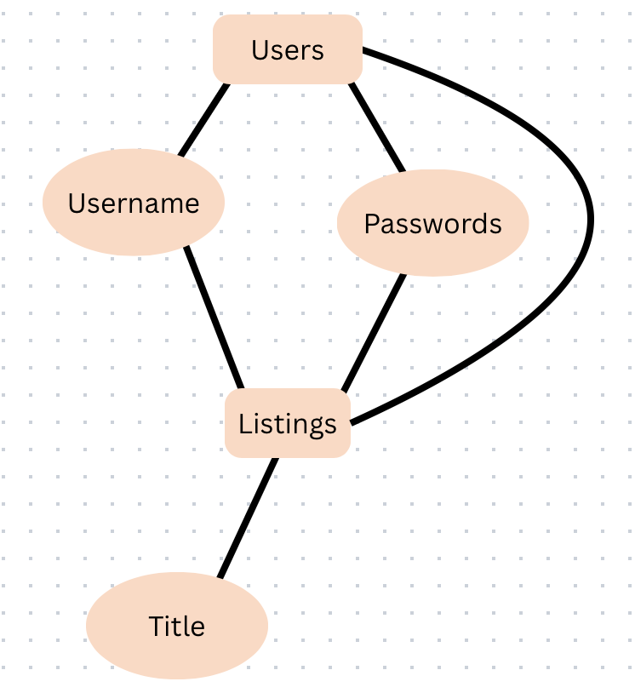

3.1.3 Complete data model
REVIEW NOTE [Incomplete diagram]: The “complete data model” illustration does not represent the documented 16-table schema. A current ERD must show owner_id, listing/storefront links, order/escrow/ledger links, optional relationships, and foreign-key delete actions.

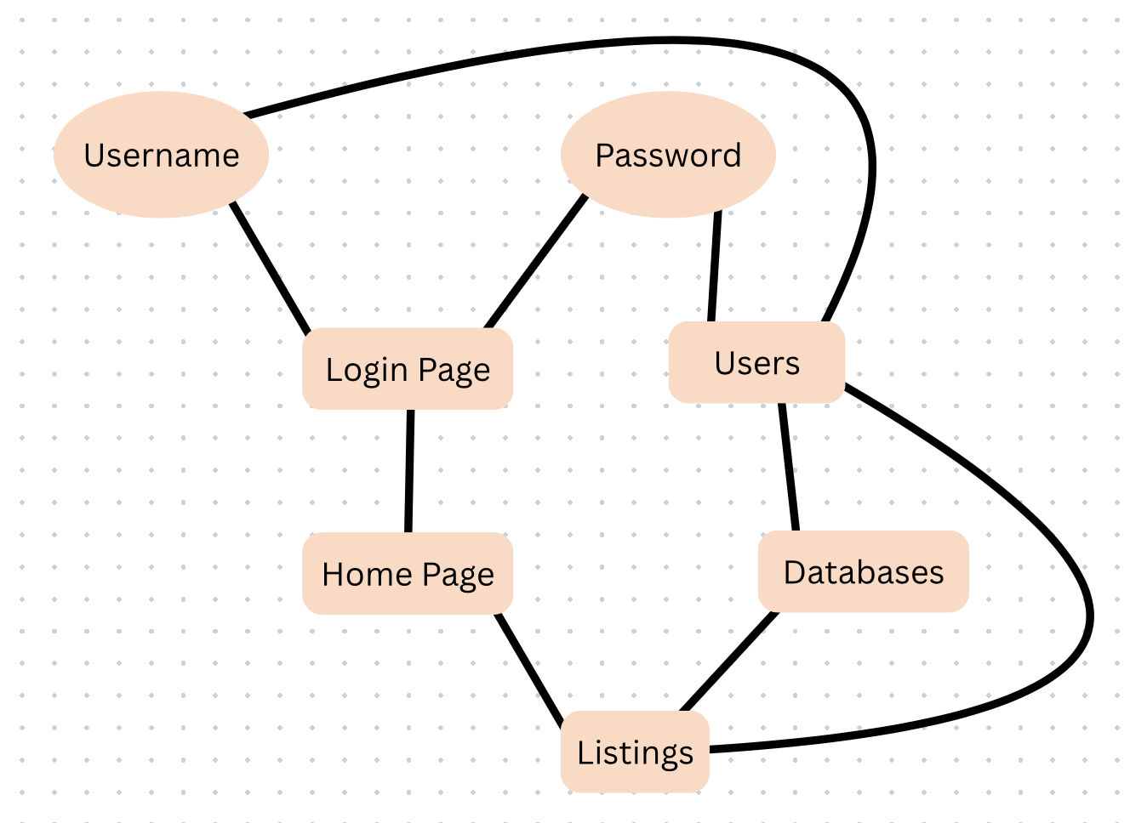

3.1.4 Flow Diagram
REVIEW NOTE [Superseded flow]: The following legacy login/buy/sell diagram omits storefront ownership, messaging, wishlist/cart persistence, returns, and token escrow. The corrected textual flow below controls until the diagram is redrawn.

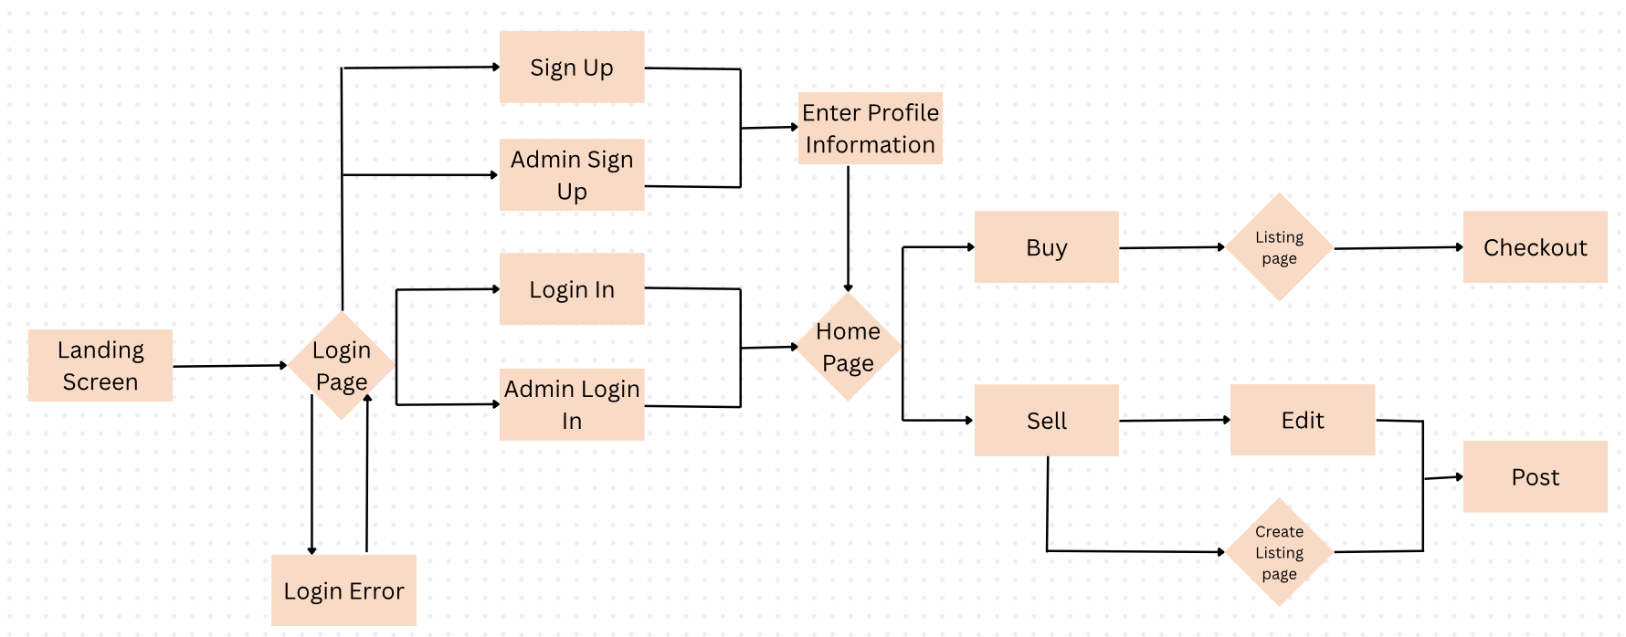

Current user flow (text supersedes the earlier diagram): register or log in → browse catalog → optionally message, save, or add items to cart → submit checkout details → validate inventory and, if enabled, token balance → atomically create the order and seller-specific escrow holds → show confirmation → hand off goods in person → release the corresponding escrow after pickup-code verification, or cancel/refund the held tokens according to the approved policy. Seller management requires storefront ownership; administrator access is never self-registered.

3.1.5 Data dictionary

- users — accounts and password hashes; role is user/admin. The existing schema shows no unique constraint for username or email; duplication must be guarded by a documented database migration and tests.
- storefronts/listings/listing_sizes/listing_images — ownership, item details, availability, per-size stock, and image metadata.
- cart_items/orders/order_items/wishlist/purchases — saved carts, authoritative order totals and line snapshots, wishlist selections, and a separate purchase API record whose canonical role remains unresolved.
- returns/messages/reviews — buyer requests, direct messages, and a reviews table that is not yet wired to user interfaces.
- wallets/order_escrow/token_ledger — token balances, per-seller held amounts and pickup-code verification state, and append-only balance movements.
- Prices are numeric fields in listing, cart, and order-line records, not a separate Prices table. The application must define whether cart prices are advisory and ensure the final checkout total uses current validated listing prices.

3.1.6 Database schema (documented iteration)
Database inventory reported by the project: 16 tables after the addition of Treasure Tokens; the document states 127 columns and 65 constraints (16 primary keys, 24 foreign keys, 8 unique, 17 checks). Treat these as an iteration-specific schema snapshot until rechecked against the deployed database. This section describes existing columns; recommendations to add constraints or foreign keys elsewhere in this review are proposed changes, not statements that migrations have been completed.
SCHEMA VERIFICATION REQUIRED: 16-table inventory is reported by the document, not independently verified here. Required remediation includes unique username/email constraints; validated returns.order_id; careful deletion semantics for orders, wallets and ledgers; and a decision on whether purchases is canonical or legacy. Do not alter the live schema without migrations and tests.

The tables below are listed parents first, so a table always appears before anything that points at it.

Users
Column | Type | Nullability | Constraints and notes
id | INTEGER | NOT NULL | Auto-increment. Primary key
username | VARCHAR(50) | NOT NULL
password | TEXT | NOT NULL | Werkzeug hash, never the plaintext password
email | VARCHAR(100) | NOT NULL
role | VARCHAR(10) | nullable | Default 'user'. Either 'user' or 'admin'; this is what gates the admin pages
created_at | TIMESTAMP | nullable | Default CURRENT_TIMESTAMP.

Storefronts

Column | Type | Nullability | Constraints and notes
id | INTEGER | NOT NULL | Auto-increment. Primary key
owner_id | INTEGER | NOT NULL | UNIQUE, which is what limits a user to one storefront
brand_name | VARCHAR(80) | NOT NULL
bio | TEXT | nullable
logo_url | TEXT | nullable
banner_url | TEXT | nullable
contact_info | TEXT | nullable
preview_image_1 | TEXT | nullable
preview_image_2 | TEXT | nullable
preview_image_3 | TEXT | nullable
preview_image_4 | TEXT | nullable
categories | TEXT | nullable | Comma-separated; the service trims this down to three tags
is_active | BOOLEAN | nullable | Default true. Setting this false hides the storefront and pauses its listings
created_at | TIMESTAMP | nullable | Default CURRENT_TIMESTAMP.
updated_at | TIMESTAMP | nullable | Default CURRENT_TIMESTAMP.

Listings
A listing belongs to a storefront via storefront_id; storefronts.owner_id identifies its owner. Size inventory belongs to listing_sizes. Ownership and the admin role must be enforced in application routes and database queries.

Column | Type | Nullability | Constraints and notes
id | INTEGER | NOT NULL | Auto-increment. Primary key
storefront_id | INTEGER | NOT NULL
title | VARCHAR(120) | NOT NULL
description | TEXT | nullable
price | NUMERIC(10,2) | NOT NULL
fulfillment_type | VARCHAR(20) | NOT NULL | CHECK: 'IN_STOCK' or 'PREORDER'
quantity_on_hand | INTEGER | nullable | CHECK >= 0; recalculated from listing_sizes
sizes_available | TEXT | nullable | Free text for display only; listing_sizes holds the real counts
status | VARCHAR(20) | nullable | Default 'ACTIVE'. CHECK: 'ACTIVE', 'INACTIVE', 'SOLD_OUT' or 'DELETED'
storefront_restore_status | VARCHAR(20) | nullable | Remembers the old status while the storefront is inactive
deleted_restore_status | VARCHAR(20) | nullable | Remembers the old status while the listing is soft-deleted
created_at | TIMESTAMP | nullable | Default CURRENT_TIMESTAMP.
updated_at | TIMESTAMP | nullable | Default CURRENT_TIMESTAMP.
is_made_to_order | BOOLEAN | nullable | Default false. If true, checkout skips the availability check for this listing

Listing_images
Listing images are stored in S3 and referenced in listing_images. An optional is_primary flag determines a listing-card image; validate type, size, permissions, and the one-primary-image rule before release.
Column | Type | Nullability | Constraints and notes
id | INTEGER | NOT NULL | Auto-increment. Primary key
listing_id | INTEGER | NOT NULL
image_url | TEXT | NOT NULL
is_primary | BOOLEAN | nullable | Default false. The image shown on the listing card
created_at | TIMESTAMP | nullable | Default CURRENT_TIMESTAMP.

Listing_sizes
How many of each size a listing has.
Column | Type | Nullability | Constraints and notes
id | INTEGER | NOT NULL | Auto-increment. Primary key
listing_id | INTEGER | NOT NULL
size | VARCHAR(20) | NOT NULL
quantity | INTEGER | NOT NULL | CHECK >= 0
created_at | TIMESTAMP | nullable | Default CURRENT_TIMESTAMP.

Cart_items
Cart data is persisted per user in cart_items, so it may be reloaded after a new authenticated session. Treat stored prices as display snapshots: checkout shall re-read authoritative listing prices, sizes, and availability.
Column | Type | Nullability | Constraints and notes
id | INTEGER | NOT NULL | Auto-increment. Primary key
user_id | INTEGER | NOT NULL
item_id | INTEGER | nullable | Points at a listing by value; there is no foreign key on this column
item_name | VARCHAR(255) | NOT NULL
price | NUMERIC(10,2) | NOT NULL | CHECK >= 0
quantity | INTEGER | NOT NULL | Default 1.
size | VARCHAR(50) | nullable
created_at | TIMESTAMP | nullable | Default CURRENT_TIMESTAMP.

Orders
An order records a submitted checkout, buyer contact/meeting details, order total, and an initial SUBMITTED status. Under the token-enabled design, order submission also creates escrow holds; it must not be described as final delivery or external payment settlement.
Column | Type | Nullability | Constraints and notes
id | INTEGER | NOT NULL | Auto-increment. Primary key
user_id | INTEGER | NOT NULL
confirmation_number | VARCHAR(50) | NOT NULL | UNIQUE; format VAULT-YYMMDD-XXXXXX
buyer_first_name | VARCHAR(100) | NOT NULL
buyer_last_name | VARCHAR(100) | NOT NULL
buyer_email | VARCHAR(255) | NOT NULL
buyer_contact | VARCHAR(100) | NOT NULL
buyer_meeting_location | TEXT | NOT NULL | Free text, since the handoff is arranged in person
total_amount | NUMERIC(10,2) | NOT NULL
order_status | VARCHAR(20) | nullable | Default 'SUBMITTED'. Starts out as 'SUBMITTED'
created_at | TIMESTAMP | nullable | Default CURRENT_TIMESTAMP.

Order_items
The lines inside the order. We copy the price and the selected size into this table at the moment of purchase, so that if a seller later edits the listing the order still shows what the buyer actually paid.
Column | Type | Nullability | Constraints and notes
id | INTEGER | NOT NULL | Auto-increment. Primary key
order_id | INTEGER | NOT NULL
listing_id | INTEGER | nullable | No foreign key here, so an order survives its listing being deleted
item_name | VARCHAR(255) | NOT NULL
quantity | INTEGER | NOT NULL | CHECK > 0
price_at_purchase | NUMERIC(10,2) | NOT NULL | Copied at checkout; later price edits do not change it
selected_size | VARCHAR(50) | nullable

Purchases
The purchases table is written by a separate purchase API. Its relationship to orders/order_items is unclear and must be resolved to avoid two competing sources of purchase history.
Column | Type | Nullability | Constraints and notes
id | INTEGER | NOT NULL | Auto-increment. Primary key
user_id | INTEGER | NOT NULL
listing_id | INTEGER | NOT NULL
quantity | INTEGER | NOT NULL | CHECK > 0
purchase_price | NUMERIC(10,2) | NOT NULL | CHECK >= 0
purchase_date | TIMESTAMP | nullable | Default CURRENT_TIMESTAMP.

Wishlist
Listings a user has saved for later.
Column | Type | Nullability | Constraints and notes
id | INTEGER | NOT NULL | Auto-increment. Primary key
user_id | INTEGER | NOT NULL
listing_id | INTEGER | NOT NULL | UNIQUE together with user_id, so nothing is saved twice
added_date | TIMESTAMP | nullable | Default CURRENT_TIMESTAMP.

Returns
Return requests are currently stored with an unverified, user-entered order_number string and are not linked to orders by a foreign key. Proposed correction: validate ownership and link returns to orders.id; never treat an arbitrary typed number as proof of purchase.
Column | Type | Nullability | Constraints and notes
id | INTEGER | NOT NULL | Auto-increment. Primary key
user_id | INTEGER | NOT NULL
order_number | VARCHAR(120) | NOT NULL | Saved exactly as typed; nothing checks it against orders
reason | TEXT | NOT NULL
has_damage | BOOLEAN | NOT NULL
damage_image_url | TEXT | nullable
status | VARCHAR(20) | NOT NULL | Default 'pending'. CHECK: 'pending', 'reviewed' or 'resolved'
created_at | TIMESTAMP | nullable | Default CURRENT_TIMESTAMP.
updated_at | TIMESTAMP | nullable | Default CURRENT_TIMESTAMP.
is_deleted | BOOLEAN | nullable | Default false. Soft delete; hidden from the admin queue

Messages
Direct messages between two users.
Created by Jonah GoodWine.
Column | Type | Nullability | Constraints and notes
id | INTEGER | NOT NULL | Auto-increment. Primary key
sender_id | INTEGER | NOT NULL | CHECK sender_id <> receiver_id, so nobody can message themselves
receiver_id | INTEGER | NOT NULL
listing_id | INTEGER | nullable | Optional. ON DELETE SET NULL, so a conversation outlives its listing
body | TEXT | NOT NULL
is_read | BOOLEAN | nullable | Default false. Drives the unread indicator
created_at | TIMESTAMP | nullable | Default CURRENT_TIMESTAMP.

Reviews
The reviews table models storefront ratings and written comments but does not imply an active review feature.
Status at the documented iteration: the review schema exists; service, controller, validation, moderation, and interface remain out of scope until a later iteration is approved.
Column | Type | Nullability | Constraints and notes
id | INTEGER | NOT NULL | Auto-increment. Primary key
storefront_id | INTEGER | NOT NULL | UNIQUE together with reviewer_id: one review per user per storefront
reviewer_id | INTEGER | NOT NULL | Nothing stops this being the storefront’s own owner (see note below)
rating | INTEGER | NOT NULL | CHECK between 1 and 5
comment | TEXT | nullable
created_at | TIMESTAMP | nullable | Default CURRENT_TIMESTAMP.

Reviews are schema-only in this documented version. Do not advertise live storefront ratings or allow review submissions until routes, ownership/self-review policy, input validation, presentation, moderation, and tests exist.
Treasure Tokens are documented as an internal unit with a nominal 1 token = 1 USD listing-price conversion. The document does not establish how tokens are obtained, whether they are redeemable, or what legal/payment terms apply. Treat tokens as proposed closed-loop demonstration credits until the project owner explicitly approves their value, redemption rules, and user disclosures. “No card processor” does not mean “no funds-handling logic.”
PRODUCT DECISION REQUIRED: define token issuance, redemption/cash value (if any), financial/legal review, pricing disclosure, cancellation and dispute policy. The reviewed document must not present demonstration credits as cash equivalents without an explicit product decision.
In the documented token flow, checkout debits a buyer wallet and creates one HELD escrow per seller in the same database transaction as order creation; ledger entries must reconcile each balance movement. A seller with a valid buyer-provided pickup code can release only their own HELD escrow; cancellation can return eligible held tokens to the buyer. Define allowed actors and states, code attempt limits, replay prevention, partial delivery, disputes, and refund rules before release.

Wallets
One wallet belongs to one user (wallets.user_id is its primary key). The documented starting balance is configurable (default 200 test tokens), recorded in the ledger. The project must make clear whether any starting credits are simulated, whether they expire, and who may grant further credits.
Column | Type | Nullability | Constraints and notes
user_id | INTEGER | NOT NULL | Primary key. References users(id); deleting a user deletes the wallet. This table has no surrogate id column: using user_id as the key is what makes one wallet per user structural rather than a rule in code.
balance | NUMERIC(12,2) | NOT NULL | Default 0. CHECK >= 0, so a balance can never go negative.
created_at | TIMESTAMP | nullable | Default CURRENT_TIMESTAMP.
updated_at | TIMESTAMP | nullable | Default CURRENT_TIMESTAMP.

Order_escrow
Tokens held between checkout and pickup, one row per seller in an order. The row records the amount, its current state, and the material needed to check the buyer’s pickup code.
Column | Type | Nullability | Constraints and notes
id | INTEGER | NOT NULL | Auto-increment. Primary key
order_id | INTEGER | NOT NULL | References orders(id), cascading on delete. UNIQUE together with seller_id, so one order holds at most one escrow per seller.
buyer_id | INTEGER | NOT NULL | References users(id), cascading on delete. The account refunded if the order is cancelled.
seller_id | INTEGER | NOT NULL | References users(id), cascading on delete. Only this account may release the escrow.
amount | NUMERIC(12,2) | NOT NULL | CHECK > 0. The seller’s share of the order total.
status | VARCHAR(20) | NOT NULL | Default 'HELD'. CHECK: 'HELD', 'RELEASED', 'REFUNDED' or 'LOCKED'.
code_nonce | VARCHAR(64) | NOT NULL | Random value from which the pickup code is derived. The code itself is never stored; see the note below.
failed_attempts | INTEGER | NOT NULL | Default 0. At five the escrow moves to LOCKED and only an administrator can resolve it.
created_at | TIMESTAMP | nullable | Default CURRENT_TIMESTAMP.
resolved_at | TIMESTAMP | nullable | Set when the escrow is released or refunded.

Token_ledger
The token ledger is intended as an append-only record of all balance movements. However, token_ledger.user_id has a cascading foreign key on user deletion; this undermines a durable audit history. Account deletion must therefore be disabled or redesigned with legally appropriate retention/anonymization before claiming the ledger is immutable in practice.
Column | Type | Nullability | Constraints and notes
id | INTEGER | NOT NULL | Auto-increment. Primary key
user_id | INTEGER | NOT NULL | References users(id), cascading on delete. The account whose balance changed.
amount | NUMERIC(12,2) | NOT NULL | CHECK <> 0. Signed: negative for a debit, positive for a credit.
entry_type | VARCHAR(30) | NOT NULL | CHECK: 'STARTING_BALANCE', 'ADMIN_GRANT', 'ESCROW_HOLD', 'ESCROW_RELEASE' or 'ESCROW_REFUND'.
order_id | INTEGER | nullable | References orders(id) ON DELETE SET NULL, so an entry outlives the order it refers to.
escrow_id | INTEGER | nullable | References order_escrow(id) ON DELETE SET NULL, for the same reason.
note | TEXT | nullable | Free text recorded with the entry.
created_by | VARCHAR(50) | nullable | Username of the administrator, where an administrator caused the entry.
created_at | TIMESTAMP | nullable | Default CURRENT_TIMESTAMP.

The code is derived from a per-escrow nonce and an application HMAC signing key; it is not stored verbatim in the described schema. Security requirements: show it only to the authenticated buyer, accept it only for the intended seller and HELD escrow, use constant-time verification, limit failed attempts, expire or invalidate it on release/refund, and never disclose code material in logs. Confirm the exact code-generation and handling implementation by test.

3.1.7 Referential Integrity
The document reports 24 foreign keys, with 21 ON DELETE CASCADE. Cascading user deletion can erase storefronts, orders, messages, wallet balances, and token-ledger records; this conflicts with historical order retention and audit expectations. Do not enable permanent user deletion until an explicit retention, anonymization, and foreign-key strategy is approved and tested.
SECURITY PRIORITY: token_ledger.user_id ON DELETE CASCADE and order_escrow foreign-key cascades can destroy financial audit history. Until a retention design is approved, disable destructive user deletion in the application. Consider anonymization, retention-safe relationships, and immutable audit logging in a migration reviewed by the team.

3.1.8 Indexing (Chase Jones)
INDEXING RECOMMENDATION: add query-plan evidence before creating indexes. Candidate foreign-key indexes include listings(storefront_id), listing_sizes(listing_id), order_items(order_id), cart_items(user_id), and wishlist(user_id), as originally noted; test each against the actual workload.
PostgreSQL creates an index automatically behind every primary key and every unique constraint, which accounts for sixteen and eight of them respectively. Beyond those, the database carries three indexes that the project declares for itself, all added with the Treasure Tokens tables in this iteration:
idx_token_ledger_user on token_ledger(user_id); idx_order_escrow_seller on order_escrow(seller_id, status); and idx_order_escrow_buyer on order_escrow(buyer_id, status).
Each one matches a query the application makes on nearly every page. A wallet summary reads the whole ledger for one user, and the two escrow indexes are composite because the queries behind them filter on an account and a status together rather than on either alone, which is what lets a single index serve the request.
No other foreign key column in the database is indexed. PostgreSQL does not create those indexes on its own, so joining listings to a storefront, order items to an order, or wishlist entries to a user is still a sequential scan. At the row counts of a course project that is not observable, but Section 1.4 identifies query efficiency as a Free Tier constraint, and the same treatment the token tables received would apply to listings(storefront_id), order_items(order_id), cart_items(user_id), wishlist(user_id) and listing_sizes(listing_id).

4.0 Functional Model and Description

This section describes the functional breakdown of the Treasure Row system, including processing logic, interfaces, data flow, performance considerations, and constraints. The system follows a client-server architecture deployed on AWS using Elastic Beanstalk for application hosting and Amazon RDS (PostgreSQL) for database services.

4.1 Core system functions
This section defines the end-to-end functions: account registration/authentication; storefront and listing ownership; catalog/search; cart/wishlist; token-aware checkout and history; return requests; messaging; moderation; and pickup-code escrow resolution. Use Sections 4.1.7–4.1.10 plus Appendix A as the normative acceptance baseline; earlier transform narratives are historical drafts where they conflict.
The major system functions include:

User registration:

Registration must validate required fields, allowable email domains, and uniqueness constraints; hash passwords with a supported adaptive password-hashing implementation before storage. A domain match alone does not verify actual enrollment.

The system ensures that:
- No duplicate accounts exist
- Passwords are securely hashed before storage

Successful registration creates an account and grants access to authentication services(login/logout). If validation fails, appropriate error messages are returned.

User authentication (login/logout):
Authentication compares a supplied password with the stored adaptive hash using the framework verifier; it must never decrypt a password or compare it with an encrypted plaintext copy.
The User Authentication function manages secure access to the marketplace. It verifies user credentials by comparing submitted login information with encrypted records stored in the database.

Once authenticated:
- Users gain access to the system
- A secure session is created

Create listing:

The Create Listing function allows authenticated users to post fashion items for sale within the marketplace. Users provide item details such as name, description, price, category, and upload an image.

The system:
- Validates all required fields
- Stores listing information in the database
- Makes the listing visible in the marketplace feed

Edit/delete listing:

The Edit Listing function allows users to modify the details of listings they have previously created. The system verifies listing ownership before permitting changes. The Delete Listing function allows the user to permanently delete the listing from the marketplace.
Listing creation is available to the authenticated owner of an existing storefront or an authorized administrator. Each listing shall define price, fulfillment type, ownership, status, and applicable size inventory; image uploads require validation.
User can update/edit:
- Item description
- Price
- Category
- Availability status
(Chase Jones)
Once deleted:
- The listing status is set to DELETED and the record is retained, preserving the historical reference for any order that cites it
- The item no longer appears in search results or the marketplace feed

Browse & search listings:

Deletion of a listing is a soft-delete that sets status to DELETED and removes the item from public search while preserving existing order snapshots. Physical database deletion is a separate, restricted administrative operation and is not implied here.

Listings can be sorted by:
- Most recent postings
- Price
- Category

Users will be able to search:
- Item name
- Price range
- Category
- Availability status

Admin management:

The Admin Management function allows authorized administrative users to moderate the platform.

Admins can:
- Remove inappropriate listings
- Suspend user accounts
- Monitor system activity

Purchase & checkout:

The Purchase or Checkout function allows a buyer to confirm interest in purchasing an item. When triggered, the system:
- Verifies item availability
- Sets the listing status to SOLD_OUT once its recomputed quantity across all sizes reaches zero
- Prevents overselling through pre-flight availability validation and per-size inventory decrement
- Records the order against the seller’s storefront for review on the storefront dashboard

(Chase Jones)
Note: All highlighted text in this document indicates content added or corrected in Revision 6.0 / Iteration 2, which brings the requirements into agreement with the delivered build.
See the Revision Log in Section 9.0.
Storefront management:
The Storefront Management function allows an authenticated user to establish and maintain a branded seller presence. Treasure Row operates a unified account model: users do not register as sellers. A user acquires seller capability by creating a storefront, after which that user may create and manage listings beneath it. Each user may own at most one storefront. Detailed requirements appear in Section 4.1.7.
Wishlist management:
The Wishlist Management function allows an authenticated user to save listings for later consideration and to retrieve, inspect, and remove those saved items. A wishlist is private to the account that owns it, and entries are stored as associations rather than copies so that a saved item always reflects the listing’s current price and availability. Detailed requirements appear in Section 4.1.8.
Transaction processing:
The Transaction Processing function carries a purchase from cart accumulation through order confirmation. It comprises a persistent shopping cart held against the user account, a checkout operation that validates availability and creates order records, and an order retrieval facility serving confirmation and history views. Detailed requirements appear in Section 4.1.9.
Return request processing:
The Return Request Processing function allows a buyer to raise a request against a completed order and allows administrators to review and resolve those requests. Detailed requirements appear in Section 4.1.10.

4.1.1 Processing specifications for primary functions

The following processing narratives describe major operations. For detailed error responses and authorization, use the explicit requirements and acceptance tests in Appendix A.

User registration:

When a user selects “Register,” the system:
- Accepts input data (name, email, password)
- Validates email format and ensures it belongs to the Hampton University domain
- Checks for duplicate accounts in PostgreSQL (RDS)
- Hashes the password using a modern adaptive password-hashing function; never “encrypts” it for later decryption.
- Stores user information in the Users table
- Returns confirmation or error message

User authentication(login/logout):

- User submits email and password.
- The system retrieves the stored password hash from RDS.
- Compares the input password with the hashed value.
- Creates or rotates an authenticated session, sets Secure/HttpOnly/SameSite cookies as appropriate to the deployment, and enforces CSRF defenses on state-changing browser actions.
- Grants access to marketplace features.

Create listing:

- Authenticated user selects “Create Listing.”
- User inputs:
  - Item name
  - Description
  - Price
  - Category
  - Image upload
- System validates required fields
- Stores listing in Listings table in RDS
- Uploads image to AWS storage (S3). Displays listing in the marketplace feed

Edit/delete listing:

- User selects the listing they own
- System verifies ownership
- Allows modification or deletion
- Soft-deletes or updates the owned listing; a deleted listing is hidden from search while existing order-line snapshots remain readable.

Browse & search listings

- User accesses homepage
- System retrieves active listings from RDS
- Displays listings sorted by most recent
- Search filters apply SQL query filters (price, category, keyword)

Admin management:

Admin users can:
- View all listings
- Moderate permitted content and review privileged actions with audit records.
- Suspend access only if the user-account schema, policy, and endpoint support suspension; the currently shown users table contains no account-status field.

Purchase & checkout:

- User selects item
- Confirms purchase
- System verifies listing availability
- Checks the requested size/quantity and current listing price using transaction-safe inventory handling.
- Creates an order, order items, and (when tokens are enabled) balance/ledger/escrow changes atomically; it shall not mark all inventory “sold” unless the relevant quantities reach zero.

4.1.2 User journey and legacy flow illustration
REVIEW NOTE [Legacy figure]: verify that any process diagram under this heading includes inventory transactions and token escrow. If not, label it historical or replace it before release.

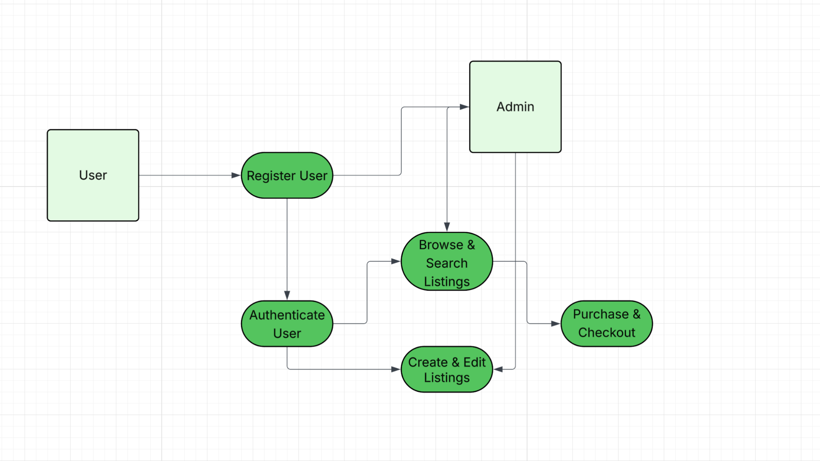

4.1.3 API and browser interface contracts

The application exposes browser pages and Flask endpoints. For each route, specify HTTP method, path, authentication, role/ownership, request schema, success response, error codes, and side effects. UI validation is supplementary; all input rules must also be checked server-side.

- Registration receives username, email, and password; login receives the established account identifier and password (confirm whether username or email is supported). Validate JSON schema server-side and never rely on the browser to reject invalid email formats.
- A successful API authentication may return 200 with a server-established session; invalid credentials should return 401 without disclosing whether an account exists. Browser page navigation is not itself a JSON response contract. Use 400/422 for malformed inputs, 403 for insufficient permission, and 404 for inaccessible resources, with consistent payloads.
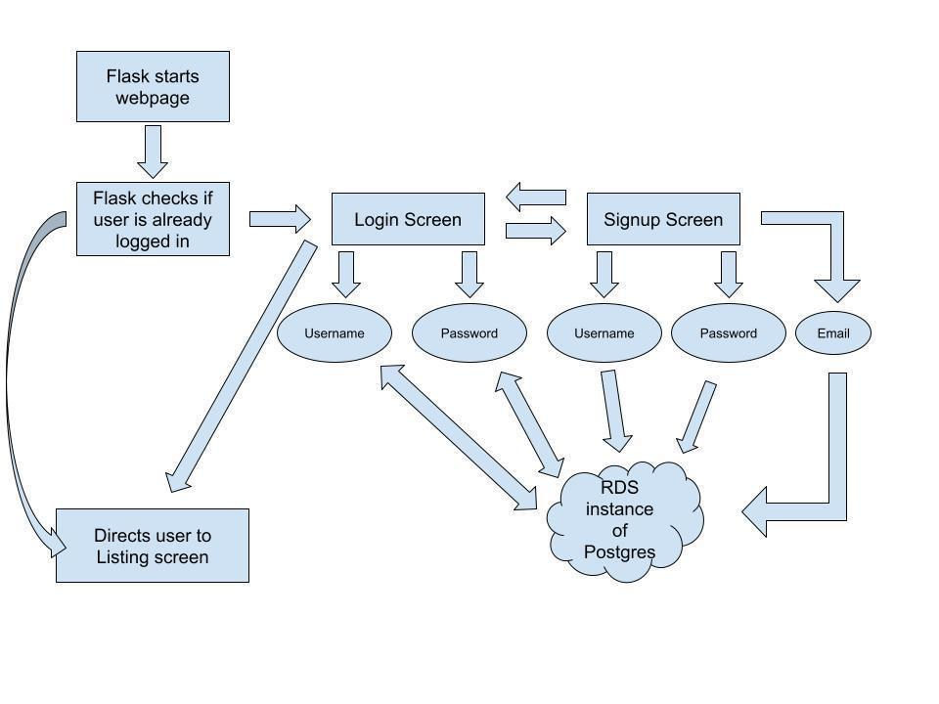

4.1.4 Detailed workflow transformations
REVIEW NOTE: Legacy transform narratives under 4.1.4 were drafted before token escrow and may not describe implemented behavior. Appendix A acceptance criteria and Section 4.1.9 take precedence where wording conflicts.

These are explanatory workflow narratives, not a complete replacement for route-level API contracts or the token-aware checkout rules in Section 4.1.9.

4.1.4.1 Registration and authentication

This transform manages how students join and enter the marketplace.

Registration collects documented user fields, validates exact approved email domains and duplicate identifiers, hashes passwords, and creates a standard account. Email control is not established without a separately implemented verification step.
When logging in, the system retrieves the stored hash and compares it to the input password. If they match, a secure session token is generated to grant access to the site’s features.

4.1.4.2 Transform 1 interface description

Inputs and outputs must be specified per endpoint, including required fields, status codes, rate limiting, session cookies, and authentication errors. Registration is not identical to login and must not share an assumed three-field JSON schema.
For the output interface, a “200” success code is returned during a successful login and routes the user to the listing screen. A failed login sends a “401” error code.

4.1.4.3 Transform 1 lower level flow diagrams

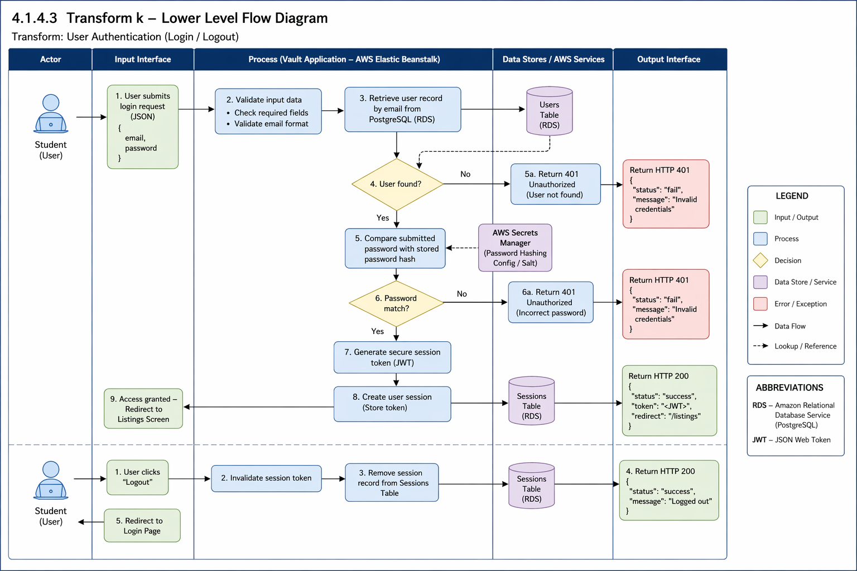

4.1.4.4 Storefront and listing management

This transform handles how brand owners control their products.

Only a storefront owner or authorized administrator may create, update, or soft-delete listings within that storefront. Validate price, fulfillment type, size counts, uploaded files, and visibility.
Deleted listings are marked DELETED and hidden publicly; historical order snapshots are preserved. The documented source does not support an unconditional hard-delete requirement.

4.1.4.5 Transform 2 interface description

For the input interface, item details (title, price, availability status) are provided during listing creation. For the output interface, a public catalog of active listings and updated user dashboards showing their managed storefront is displayed.

4.1.4.6 Transform 2 lower level flow diagrams

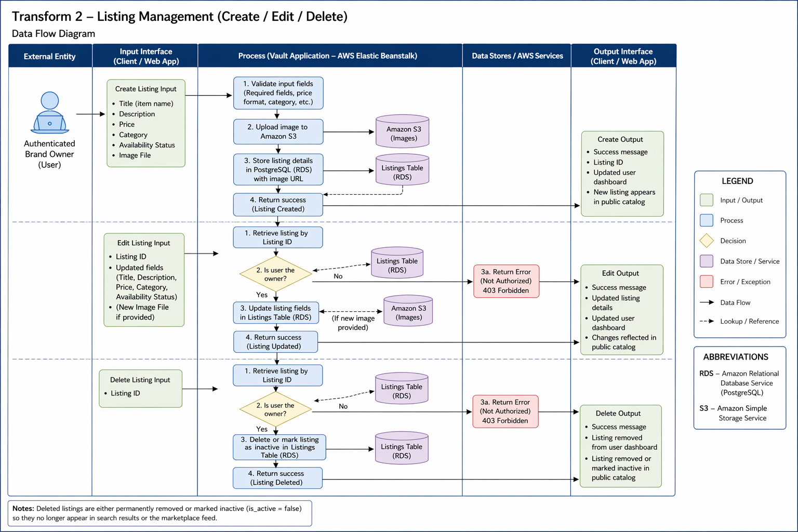

4.1.4.7 Cart, checkout, and escrow

Checkout is a transactional order-submission operation with in-person fulfillment. The documented later iteration adds token holds and code-mediated escrow release; it is not accurately described as a simple “mark item sold” update.

The backend must validate each cart line and buyer detail, reprice against current listings, update size inventory without overselling, create the order and its line snapshots, and (if enabled) commit wallet, escrow, and ledger changes together. If any step fails, roll back the entire checkout and keep the cart recoverable.

4.1.4.8 Transform 3 interface description

The response contains the confirmation number, order lines, total, and token escrow state where enabled. A listing becomes SOLD_OUT only when its applicable available inventory is exhausted. A seller notification is not guaranteed until its channel and delivery behavior are specified.

4.1.4.9 Transform 3 lower level flow diagrams

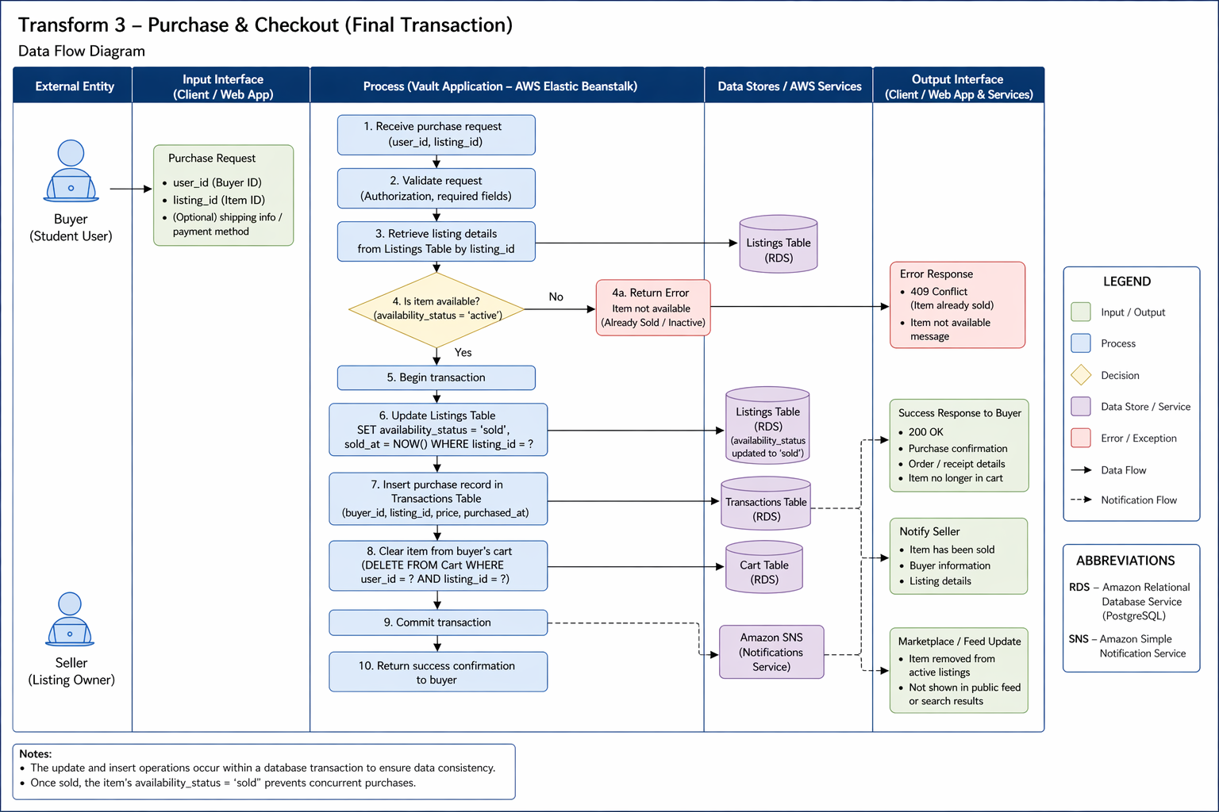

4.1.5 Performance targets

Special performance required for the subsystem is specified.

- Performance target (proposed): at least 95% of authenticated catalog and detail requests complete within 2 seconds, measured at the application boundary under an agreed test load. Database query response time is a diagnostic metric, not a complete end-user latency metric. Confirm the AWS region and traffic profile before finalizing this service-level objective.
- Concurrency: concurrent checkouts against the same size inventory must not oversell or create a negative balance. Use database transactions and appropriate row locking/conditional updates; “without locking rows” is not a realistic correctness requirement.

4.1.6 Design and security constraints

Any design constraints that will impact the subsystem are noted.

- Network security: RDS shall not be publicly exposed for production. Allow database traffic only from approved application security groups and narrowly scoped administrative access. Use TLS for browser/application and application/database connections where supported and configured.
- Sessions: Flask signed cookies must use a strong SECRET_KEY configured securely, with Secure, HttpOnly, and appropriate SameSite attributes and CSRF protection for state-changing requests. A missing secret should cause startup failure or a health-check failure, never silent fallback to an insecure value.

4.1.7 Storefront Management (Chase Jones)
The Storefront Management function allows authenticated users to establish one storefront and maintain its brand information, imagery, and up to three category tags. Only that storefront’s owner or an authorized administrator can mutate it. Deactivation hides the storefront and suspends public visibility of its listings without destroying order history.
Creating a storefront:
- An authenticated user submits the storefront creation form.
- The system verifies that the user does not already own a storefront. If one exists, the request is rejected with "Storefront already created."
- The system validates that a brand name has been supplied and is not blank after trimming.
- The system normalizes submitted categories: values are trimmed, empty values discarded, and duplicates removed without regard to letter case. If more than three distinct categories remain, the request is rejected.
- Uploaded storefront images must pass size/MIME/content validation and be stored with least-privilege S3 access. Do not trust client-submitted public URLs as unrestricted image destinations.
- A storefront record is inserted with its active flag set to true and associated with the owner by user identifier.
- The user is redirected to the storefront dashboard and may now create listings.
Updating a storefront:
- The system retrieves the storefront and confirms the requester is either its owner or an administrator.
- Only documented editable fields may be accepted; the server must reject or ignore unauthorized owner_id, is_active, and role changes. Uploaded media must be validated and mapped to trusted S3 object identifiers.
- If a brand name is supplied it must remain non-empty after trimming; a blank value is rejected.
- Categories are re-normalized under the same rules applied at creation.
- The record is updated and the modification timestamp advanced.
Deactivating and reactivating a storefront:
- The system confirms the requester is the owner or an administrator.
- On deactivation the active flag is set to false and the system will also pause every listing beneath the storefront that is currently ACTIVE or SOLD_OUT. Each paused listing records its prior state so that it can be restored.
- A deactivated storefront remains reachable by its owner and by administrators but is withheld from public browsing.
- On reactivation the active flag is set to true and only those listings carrying a recorded restore state are returned to it. Listings deactivated individually by the owner, or deleted, are not disturbed.

Interface description
Category | Detail
Inputs | Brand name (required, up to 80 characters); biography; contact information; category selections (up to three); logo, banner, and up to four preview image files
Outputs | Storefront record; public storefront page; owner dashboard; error messages for duplicate, unauthorized, or invalid requests
Data stores | storefronts table (PostgreSQL); Amazon S3 for image objects
Endpoints | POST /api/storefronts, GET /api/storefronts, GET /api/storefronts/{id}, GET /api/storefronts/me, PUT /api/storefronts/{id}, PATCH /api/storefronts/{id}/deactivate, PATCH /api/storefronts/{id}/reactivate

Functional requirements
Req. ID | Requirement | Enforced by
SF-01 | The system shall permit each user account to own at most one storefront. | Service check and UNIQUE constraint on owner_id
SF-02 | The system shall require a non-empty brand name for storefront creation and shall reject a brand name that is blank after trimming. | Service validation
SF-03 | The system shall limit a storefront to three category tags and shall remove duplicate tags without regard to letter case. | Service normalization
SF-04 | The system shall store storefront images in Amazon S3 and retain only the resulting URLs in the database. | S3 utility module
SF-05 | The system shall permit only the storefront owner or an administrator to update, deactivate, or reactivate a storefront. | Service authorization guard
SF-06 | The system shall restrict update operations to an explicit list of permitted fields and shall discard any other submitted field. | Service field whitelist
SF-07 | The system shall treat an inactive storefront as hidden from public browsing while remaining accessible to its owner and to administrators. | Query filter
SF-08 | When a storefront is deactivated, the system shall pause every listing beneath it whose status is ACTIVE or SOLD_OUT, recording each listing’s prior status. | Storefront deactivation routine
SF-09 | When a storefront is reactivated, the system shall restore only those listings that carry a recorded storefront restore status, leaving individually deactivated and deleted listings unchanged. | Storefront reactivation routine
SF-10 | The system shall delete a user’s storefront when that user account is deleted. | Foreign key ON DELETE CASCADE
SF-11 | The system shall derive the requesting user’s identity and role from the server-side session when evaluating storefront permissions. | Session (see Section 4.1.12)

Error conditions
- Unauthenticated request — "Error! Unauthorized user."
- The user already owns a storefront — "Storefront already created."
- Brand name missing or blank — "brand_name is required" or "brand_name cannot be empty."
- More than three categories submitted — "You can select up to 3 storefront categories."
- Requester is neither owner nor administrator — "Unauthorized action."
- Storefront identifier not found — "Storefront not found."

4.1.8 Wishlist Management

Function description
Wishlist entries are private user–listing associations; adding an existing pair must be handled consistently. Wishlist inclusion must not override listing visibility, buyer authorization, or seller deactivation rules. Purchasing an item may remove it from the wishlist after successful checkout.

Processing narrative
- An authenticated user selects the save action on a listing.
- The system confirms the listing exists. If it does not, the request is rejected with "Listing not found."
- The system attempts to insert a wishlist association for the user and listing.
- If the pair is already present, the uniqueness constraint prevents a duplicate and the system responds "Item already in wishlist" rather than raising an error.
- On retrieval, the system returns the user’s saved listings joined to current listing detail.
- On removal, the system deletes the association and confirms; if no association existed, it reports "Item not found in wishlist."
- During checkout, the system removes from the wishlist every listing contained in the completed order.

Interface description
Category | Detail
Inputs | Authenticated user identity; listing identifier
Outputs | Wishlist collection with current listing detail; membership status for a given listing; confirmation and error messages
Data stores | wishlist table (PostgreSQL)
Endpoints | POST /api/wishlist, GET /api/wishlist, DELETE /api/wishlist/{listing_id}, GET /api/wishlist/{listing_id}/check, GET /api/wishlist/items/{wishlist_id}

Functional requirements
Req. ID | Requirement | Enforced by
WL-01 | The system shall allow an authenticated user to save an existing listing to a wishlist held against that user’s account. | Wishlist service
WL-02 | The system shall prevent a listing from appearing more than once in a given user’s wishlist. | UNIQUE (user_id, listing_id)
WL-03 | When a user attempts to save a listing already present, the system shall report that condition without treating it as an error. | Wishlist service
WL-04 | The system shall reject an attempt to save a listing that does not exist. | Listing existence check
WL-05 | The system shall permit a user to save a listing whose status is inactive or sold out. | Deliberate omission of status filter
WL-06 | The system shall expose a user’s wishlist only to that user. | Identity scoping (see Section 4.1.12)
WL-07 | The system shall allow a user to remove a saved listing and shall report the outcome where no such entry existed. | Wishlist service
WL-08 | The system shall report whether a specified listing is present in the requesting user’s wishlist. | Wishlist service
WL-09 | On successful checkout, the system shall remove from the buyer’s wishlist every listing included in the order. | Checkout service
WL-10 | The system shall delete wishlist entries when either the owning user account or the referenced listing is deleted. | Foreign keys ON DELETE CASCADE

- Listing identifier does not resolve — "Listing not found"
- Listing already saved — "Item already in wishlist"
- Removal requested for an entry that does not exist — "Item not found in wishlist"
- Unauthenticated request — rejected before reaching the service layer

4.1.9 Transaction Processing
INTEGRATION GAP: return and order history are documented but purchases is a separate table. Define one canonical order service and make wishlist, history, escrow, and return flows depend on the same order ID to prevent diverging records.
The transaction function connects cart persistence, transactional checkout, purchase-time line snapshots, order history, and the documented Treasure Tokens escrow design. The earlier “no payment” description is retained only as a statement that external card/bank processing is not documented.
There is no documented external payment provider. The later iteration explicitly implements or proposes an internal token hold-and-release workflow; avoid saying the platform has no payment-related processing. Goods are exchanged in person, and an order is SUBMITTED at checkout rather than necessarily delivered or fully settled.
Cart maintenance:
- A user adds a listing to the cart, optionally specifying a size and quantity.
- The system records the item against the user’s account in the cart_items table, capturing item name, unit price, quantity, and size.
- Because the cart is stored server-side rather than in the browser, it survives logout and is restored on the user’s next authenticated session.
Checkout:
- The system confirms an authenticated session is present; an unauthenticated request is redirected to the login page.
- The system rejects an empty cart with "Cart is empty."
- On checkout, validate each line against the current listing, storefront visibility, selected size, quantity, current price, and made-to-order rule. Reject the whole transaction if a required line fails. Concurrency-safe checks must prevent negative inventory or wallet balances.
- The system requires all five buyer detail fields — first name, last name, email address, contact method, and meeting location — and rejects the submission if any is blank.
- Compute the payable total using validated current listing prices (not stale cart snapshots), quantity and defined currency precision. Clarify shipping/taxes/fees as excluded unless specifically implemented.
- Create a collision-resistant, unique confirmation identifier; the documented format is VAULT-YYMMDD-XXXXXX. Verify uniqueness at the database boundary and retry on a conflict.
- In one database transaction create the order and line snapshots; perform inventory changes; and, if tokens are enabled, validate buyer balance, debit the buyer, write matching ledger entries, and create one seller-specific escrow per order. On failure, roll back all changes.
- For each purchased item having a size, the system decrements the corresponding per-size quantity and recomputes the listing’s total quantity on hand as the sum across all sizes.
- Where the recomputed total reaches zero the listing transitions to SOLD_OUT; where a previously sold-out listing is replenished above zero it returns to ACTIVE.
- Only after the order transaction commits shall the system clear the cart and remove purchased listings from the wishlist. Record and recover gracefully if later ancillary cleanup fails.
- Display order number, line snapshots, submitted meeting details, and token hold status (if applicable). Do not claim payment settlement or delivery before pickup verification.
Order retrieval:
- A request for an order by confirmation number returns the order and its items only if the requesting user owns that order; otherwise the system denies access.
- A request for order history returns all orders belonging to the requesting user, most recent first.
Category | Detail
Inputs | Cart additions and removals (listing, size, quantity); buyer first name, last name, email, contact method, and meeting location
Outputs | Confirmation number; order summary with line items and total; order history; availability and validation error messages
Data stores | cart_items, orders, order_items, listing_sizes, listings (PostgreSQL)
Endpoints | POST /api/checkout/complete, GET /api/orders/by-confirmation/{confirmation_number}, GET /api/orders/my

Req. ID | Requirement | Enforced by
TX-01 | The system shall persist each user’s cart in the database so that cart contents survive logout and are restored on the next authenticated session. | cart_items table
TX-02 | The system shall require an authenticated session for access to the checkout and order confirmation pages. | Session guard in route handlers
TX-03 | The system shall reject a checkout submitted with an empty cart. | Checkout service
TX-04 | The system shall validate the availability of every cart item before creating any order record, and shall abort the entire checkout if any item is unavailable. | Pre-flight availability loop
TX-05 | The system shall treat a listing as unavailable when it cannot be found, when its status is SOLD_OUT, or when its quantity on hand is less than the quantity requested. | Availability check
TX-06 | The system shall exempt listings flagged made-to-order from availability validation. | Availability check
TX-07 | The system shall require buyer first name, last name, email address, contact method, and meeting location, rejecting the submission if any is blank. | Checkout service
TX-08 | The system shall compute the order total as the sum of unit price multiplied by quantity across all cart lines, rounded to two decimal places. | Checkout service
TX-09 | The system shall assign each order a unique confirmation number of the form VAULT-YYMMDD-XXXXXX. | Generator and UNIQUE constraint
TX-10 | The system shall record the unit price and selected size at the moment of purchase on each order item, so that subsequent listing changes do not alter the historical record. | order_items.price_at_purchase
TX-11 | The system shall decrement per-size inventory for each purchased item and recompute the listing’s total quantity on hand as the sum across all sizes. | Inventory update routine
TX-12 | The system shall set a listing’s status to SOLD_OUT when its recomputed quantity reaches zero, and shall return a sold-out listing to ACTIVE when its quantity rises above zero. | Inventory update routine
TX-13 | The system shall clear the buyer’s cart upon successful order creation. | Checkout service
TX-14 | The system shall remove purchased listings from the buyer’s wishlist upon successful order creation. | Checkout service
TX-15 | The system shall release an order to a requester only when that requester is the user who placed it. | Ownership check on retrieval
TX-16 | The system shall assign each new order an initial status of SUBMITTED. | orders.order_status default
TX-17 | The system shall not process payment; the transaction record shall support an in-person exchange model only. | Scope constraint

Error conditions
- Empty cart — "Cart is empty."
- Item sold out — "{item} is sold out."
- Insufficient stock — "{item} only has {n} in stock (you requested {m})."
- Listing no longer present — "Item (ID {id}) is no longer available."
- Missing buyer details — "All buyer details are required."
- Order requested by a user who does not own it — "Access denied."
- Confirmation number not found — "Order not found."

4.1.10 Return Request Processing
REVIEW NOTE [Missing enforcement]: returns.order_number does not currently reference an order; a valid-looking order number must not allow a user to submit a request against another buyer’s order. Ownership and permitted return states require explicit implementation and tests.

Function description
A buyer can request a return concerning a submitted order that they own; administrators may mark requests pending, reviewed, or resolved. The documented returns table currently stores free-text order_number without a foreign key or ownership check. Before deployment, the submission flow must validate that the order exists and belongs to the requester; additionally define item eligibility, request windows, dispute ownership, and how token refunds interact with escrow.

Processing narrative
- An authenticated buyer opens the return form and supplies the order number, a reason, and a damage declaration.
- Proposed required validation: requester is authenticated, order lookup succeeds and belongs to the requester, reason is nonblank, damage flag is Boolean, and any attached image meets upload policy. The existing free-text data model cannot guarantee these checks by itself.
- The system interprets the damage declaration permissively, accepting the values true, yes, y, and 1 as affirmative and false, no, n, and 0 as negative; any other value is rejected.
- Store only validated image uploads in a private or controlled-access S3 location; return photos may contain sensitive personal information and should not default to public-read.
- The system creates the return record with status pending and stamps the creation time.
- Administrators retrieve the outstanding request queue, which excludes any request previously soft-deleted.
- Only an administrator may move a request to an allowed state; record actor, timestamp, decision reason, and associated order. Define whether only forward transitions are permitted and whether resolved requests can reopen.
- Where the identified request does not exist, the system reports "Return not found."

Interface description
Category | Detail
Inputs | Order number; reason for return; damage declaration; optional damage photograph
Outputs | Return record with assigned status; administrative request queue; validation and error messages
Data stores | returns table (PostgreSQL); Amazon S3 for damage photographs
Endpoints | POST /returns (submit); GET /admin/returns (administrative queue); PATCH /admin/returns/{return_id} (status update). GET /returns serves the returns page, not the request queue.

Functional requirements
Req. ID | Requirement | Enforced by
RT-01 | The system shall require an authenticated user to submit a return request. | Return service
RT-02 | The system shall require an order number, a reason, and a damage declaration on every return request. | Return service validation
RT-03 | The system shall accept the damage declaration in any of the forms true, yes, y, 1, false, no, n, or 0, and shall reject any other value. | Normalization routine
RT-04 | The system shall accept an optional damage photograph in PNG, JPG, JPEG, GIF, or WebP format only, shall store it in Amazon S3, and shall retain only the resulting URL. | Controller extension check and S3 utility module
RT-05 | The system shall assign every new return request the status pending. | Service default and column default
RT-06 | The system shall restrict return status to the values pending, reviewed, and resolved. | Database CHECK constraint (see Section 4.1.12)
RT-07 | The system shall reject an attempt to set a status outside the permitted set and shall return a client error rather than a server error. | Database CHECK constraint (see Section 4.1.12)
RT-08 | The system shall report an error where a status update names a request that does not exist. | Return service
RT-09 | The system shall support soft deletion of return requests and shall exclude soft-deleted requests from the administrative queue. | returns.is_deleted flag
RT-10 | The system shall record the creation time of every request and shall update the modification time whenever the status changes. | Timestamp columns
RT-11 | The system shall delete a user’s return requests when that user account is deleted. | Foreign key ON DELETE CASCADE
RT-12 | The system shall restrict the administrative return queue and the status update operation to an authenticated session holding the administrator role, returning 401 where no session is present and 403 where the session is not an administrator. | require_admin guard
RT-13 | The system shall verify that a submitted order number corresponds to an existing order placed by the requesting user. | Not yet implemented (see Section 4.1.12)

Error conditions
- Unauthenticated request — "Unauthorized."
- Order number missing — "order_number is required."
- Reason missing — "reason is required."
- Damage declaration missing or unrecognized — "has_damage is required."
- Status outside permitted set — "status must be pending, reviewed, or resolved."
- Request identifier not found — "Return not found."

Supporting data requirements
These workflows reference the 16-table schema documented in Section 3.1.6. The earlier count of seven supporting relations was a partial snapshot and should not be used as the current data inventory.
Relation | Purpose and notable constraints
storefronts | One per user, enforced by a UNIQUE constraint on owner_id. Holds brand name, biography, contact information, logo and banner URLs, four preview image URLs, comma-delimited category tags, and an active flag. Cascades from users.
wishlist | Association between a user and a listing with an added date. UNIQUE (user_id, listing_id) prevents duplicates. Cascades from both users and listings.
cart_items | Persistent cart lines holding item identifier, name, unit price (at least zero), quantity, and size. Cascades from users.
orders | One row per completed checkout. Holds a UNIQUE confirmation number, the five buyer detail fields, the order total, and an order status defaulting to SUBMITTED. Cascades from users.
order_items | One row per order line. Records item name, quantity (greater than zero), unit price at purchase, and selected size. Cascades from orders.
listing_sizes | Per-size inventory for a listing. UNIQUE (listing_id, size); quantity constrained to at least zero. Cascades from listings.
returns | Return requests holding the order number, reason, damage flag, optional damage image URL, a status constrained to pending, reviewed, or resolved, and a soft-delete flag. Cascades from users.

4.2 Software interface description

Describe each supported browser and service interface in a route inventory, including version, authentication, input/output schema, and errors. Placeholder template language has been replaced with concrete design requirements.

4.2.1 External machine interfaces (Noah Higgs)

The Flask server communicates with PostgreSQL through psycopg2 on its configured database port (commonly 5432). Enforce network restrictions, TLS settings, secret management, connection lifetime, and error handling; verify actual configuration in the deployed environment.

- The database connection is configured through environment variables; application-level database access must use least-privilege credentials, parameterized queries, and TLS. Do not rely on allowed IP addresses alone as proof of database security.

4.2.2 External system interfaces

External interfaces include AWS RDS/PostgreSQL, S3 object storage, the browser over HTTPS, and AWS hosting and IAM services. No external card processor or institutional single-sign-on service is documented.

- AWS RDS: the backend uses a configured PostgreSQL connection and security groups permitting only authorized application/admin network paths. Production RDS shall not accept unrestricted internet traffic; require database authentication and encryption in transit.
- Browser: page responses use HTML/CSS/JavaScript and API endpoints use JSON where specified. Protect session cookies, validate server inputs, and apply CSRF defenses to state-changing browser requests.

4.2.3 Human interface

Human interfaces include responsive browser pages for authentication, browsing, storefront management, cart/checkout, orders, messaging, and admin moderation. Specify accessibility requirements and test them against WCAG 2.2 Level AA as an aspirational release target.

- Local development URL: http://127.0.0.1:5000 (unless HTTPS is explicitly configured). A loopback address is not a public production URL; the production application must be accessed through its own HTTPS hostname and certificate.
- The init_db.py script is a developer schema initialization/migration utility, not a user-facing “Admin CLI.” Restrict database-admin privileges to authorized operators.

4.2.4 Environment configuration (Chase Jones)
REVIEW NOTE [Configuration]: the environment-variable matrix below must be verified against the current repository and cloud environment. Do not include real values for secrets in shared documentation.
The application reads its database, admin and cloud settings from environment variables. The table below lists the names the code actually calls taken from the source rather than from the .env.example.

Variable | Required | Read by | Purpose
DB_HOST | Yes | backend/db.py, backend/config/db.py | Hostname of the PostgreSQL server: the RDS endpoint when deployed, or 127.0.0.1 against a local instance.
DB_NAME | Yes | backend/db.py, backend/config/db.py | Database name.
DB_USER | Yes | backend/db.py, backend/config/db.py | Database user.
DB_PASSWORD | Yes | backend/db.py, backend/config/db.py | Database password.
DB_PORT | Yes | backend/db.py, backend/config/db.py | PostgreSQL port; 5432 in every environment so far.
DB_SSLMODE | Deployment only | backend/db.py only | Set to require for AWS RDS. Left unset for a local instance, which has no certificate to present.
DB_SSLROOTCERT | Optional | backend/db.py only | Path to a certificate authority bundle, where certificate verification is wanted.
SECRET_KEY | Yes | app.py | Signs the Flask session cookie.
ADMIN_USERNAME | Yes | auth_controller.py | Username accepted at the administrator login route.
ADMIN_PASSWORD | Yes | auth_controller.py | Password for that account.
AWS_ACCESS_KEY_ID | Optional | backend/utils/s3.py | IAM access key for S3. If this, the secret key or the bucket is missing, uploads fall back to local storage.
AWS_SECRET_ACCESS_KEY | Optional | backend/utils/s3.py | IAM secret key.
AWS_S3_BUCKET | Optional | backend/utils/s3.py | Bucket holding storefront, listing and damage images.
AWS_REGION | Optional | backend/utils/s3.py | Bucket region; falls back to us-east-2 when unset.
TOKEN_STARTING_BALANCE | Optional | backend/services/wallet_service.py | Tokens a wallet is opened with. Defaults to 200 where unset, and an unreadable value falls back to the same default.
SESSION_COOKIE_SECURE | Deployment only | app.py | Set to 1 to restrict the session cookie to HTTPS. It defaults to off, so it must be set explicitly once the site is served over HTTPS or session cookies will travel unprotected.
PORT | Optional | app.py | Port the development server binds to. Defaults to 5001, because macOS reserves 5000 for AirPlay Receiver.

4.3 Control flow description

The request lifecycle is browser → Flask route/blueprint → controller validation and access control → service transaction logic → PostgreSQL/S3 integrations → authorized response. Explicitly identify commits/rollbacks for checkout and token ledger operations, and ensure failures return safe errors without disclosing infrastructure secrets.

- Entry: Requests go to app.py.
- Routing: app.py delegates to a routing blueprint.
- Logic: The controllers validate the formatting of the requests and hand it to the services.
- Data: The services request data from the models, the models execute the SQL commands on the AWS RDS.
- Exit: Data flows back up the chain and is returned to the user as JSON.


VIEW
MODEL
CONTROLLER

5.0 Behavioral Model and Description
REVIEW NOTE [State-model completeness]: Add explicit state transitions for listing (ACTIVE/INACTIVE/SOLD_OUT/DELETED), escrow (HELD/RELEASED/REFUNDED/LOCKED), returns (pending/reviewed/resolved), and sessions. Do not interpret a page name as a persisted business state.

The behavioral model below is a high-level description, not proof that every state transition has been coded. Token escrow and return states added in later sections must be modeled explicitly in the release acceptance tests.

Treasure Row must handle authentication, listing visibility, cart/order submission, escrow and pickup verification (where enabled), returns, and administrative actions as stateful processes with server-enforced transitions.

5.1 Description for software behavior

The system reacts to authenticated user actions and backend events. Server-side rules determine which transitions are permitted; navigation between browser pages does not independently grant access or change ownership.
Treasure Row operates as an event-driven, web-based system in which user inputs initiate system processing. The system transitions between defined operational states based on authentication status, user activity, and administrative privileges.

5.1.1 Events

Event | Description
Register Submitted | User provides information to register
Login Submitted | User tries logging in
Create listing clicked | User begins creating their listing
Submit listing | User submits their listing
Edit listing clicked | User edits their listing
Delete listing clicked | User removes their listing
Search performed | User searches for specific listings
Purchase confirmed | User confirms purchase
Admin remove | Admin removes a listing
Logout | User ends session and leaves the webpage

5.1.2 States

The system operates under the following primary states:
- Unauthenticated State
- Authenticated State
- Viewing Marketplace
- Creating Listing
- Editing Listing
- Checkout State
- Admin State

5.2 State Transition Diagrams
REVIEW NOTE [Required diagrams]: The current section lacks a complete, testable state-transition matrix for token escrow and returns. The Appendix A tests define critical permitted/forbidden transitions until diagrams are updated.

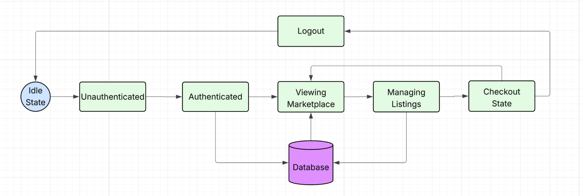

5.3 Control specification (CSPEC)

Control rules must be expressed as valid state transitions with explicit actors, preconditions, atomic side effects, and error outcomes.
- User input triggers events.
- Backend validates state.
- If valid, state transition occurs.
- If invalid, error state is returned.
Security control rules:
- Only an authenticated storefront owner or authorized administrator may alter that storefront’s listings.
- Only an authorized administrator may perform administrative moderation; users may edit or soft-delete their own resources where permitted.
- Session expiration or logout invalidates authentication and denies further protected actions; sensitive transactions must not depend on client-side state alone.

6.0 Restrictions, Limitations, and Constraints

This section identifies platform constraints and implementation risks. Any statement describing production-grade protection must be supported by configuration and test evidence; the existence of AWS components alone is not evidence of compliance.

6.1 User and Access Restrictions (Noah Higgs)

User registration currently relies on two university email domains: my.hamptonu.edu and hamptonu.edu. This is an eligibility filter, not verified student identity. Standard accounts must not access admin endpoints; role and resource-ownership checks are mandatory even when the UI hides admin controls.
The original design describes admin credentials supplied by environment configuration. Storing a plaintext administrator password in environment variables may avoid repository exposure but is still a security risk; migrate to an authenticated admin account with an adaptive password hash, rotation, and audit trails before production use.

6.2 Functional Limitations

Current scope is a single-campus clothing marketplace with no external e-commerce integrations, AI recommendations, or confirmed operational reviews. Direct messaging, tokens, and escrow appear in the later design and must not be omitted from current-scope summaries. Support beyond these features requires formal approval.

These functional limitations ensure the project is manageable and meets course requirements and deadlines.

6.3 Technical and Platform Constraints (Noah Higgs)

Secret material such as Flask SECRET_KEY, database passwords, and AWS credentials must be supplied through protected deployment configuration; .env is for local development only and shall be excluded from version control. Prefer instance roles to long-lived AWS access keys. Enforce startup validation for required variables.
AWS constraints the team is working around:
- AWS budget and eligibility: validate credits and account plans in AWS Billing; “up to $200” is not the same as $200 granted per team member. Enable cost alerts and name a resource owner.
- AWS Free Tier varies by account type, service, credits and time. Confirm that Elastic Beanstalk, RDS, and S3 usage are within the actual account’s terms; deprovision unused services.
- Connectivity: in production, RDS shall accept connections only from application security groups and an approved administrative path; local developer access must be time-limited and narrowly scoped.
- Shared deployment: a shared RDS/Elastic Beanstalk environment requires named maintainers, change control, individual least-privilege access where possible, backups, and procedures for credential rotation.
- Environment configuration: variables must be set separately in the Elastic Beanstalk environment, because the local .env file is not deployed.

6.4 Security and Data Handling Constraints

Required protections include adaptive password hashing, authorization on every protected endpoint, secure cookies, CSRF protection, rate limiting on login/pickup attempts, upload validation, parameterized SQL, least-privilege IAM, encrypted transport, and review of error/log data. Whether the current code satisfies these controls must be demonstrated by tests.

Personal data includes usernames, email addresses, buyer names/contact details, meeting locations, messages, uploaded return photographs, and potentially token transaction records. Define lawful collection purpose, access, retention, deletion/anonymization, and incident response. The source document does not establish institutional compliance.
Local secret files shall not be committed; deployment secrets shall not appear in documentation, screenshots, logs, or client JavaScript. Use managed secret storage or protected environment settings and rotate exposed credentials.
If a credential or signing key was exposed, revoke or rotate it and assess affected sessions, database access, token-code generation, and deployed environments. Document who completed the rotation and when.
SECRET_KEY is mandatory. The original text simultaneously claims there is no default key and that a default key is committed; this contradiction must be resolved by code inspection. Release requirement: fail startup or readiness checks if the key is missing/weak; never run a public deployment with a known or hardcoded session-signing key.
The document reports plaintext admin credentials in environment settings. This is a documented implementation concern, not an acceptable long-term design. Use a hashed admin identity, restrict provisioning, enforce strong authentication, and record privileged actions before production release.

6.5 Resource and Schedule Constraints

The prototype is constrained by course iteration deadlines. Set a documented release gate requiring the high-priority security and data-integrity findings in the review summary to be resolved, with a named reviewer and test evidence.

6.6 Collaboration and Tooling Constraints

GitHub is the code system of record, Jira is the work-tracking system, and Google Drive hosts project documentation. Require reviewed pull requests for changes affecting authentication, database migrations, escrow, and infrastructure; include the migration version and test result in each release entry.

6.7 Scalability Constraints

The current system targets one campus and a limited deployment budget. Expansion requires load testing, data retention design, IAM/network review, and query/index tuning; broad claims of scalability are not proven by hosting on AWS.

7.0 Validation Criteria

Authentication and account setup — acceptance must cover valid registration, rejected domains and duplicates, invalid login responses, session controls, and access denial on protected resources.
- Authorized users can register with a supported domain; if email verification is not implemented, registration must not claim verified enrollment.
- Users with correct credentials can authenticate; invalid credentials are denied with a generic error and no user enumeration.
- The database stores account identifiers and password hashes only, never plaintext login passwords.
- Authenticated users reach the permitted landing page; unauthorized users are redirected or receive a 401/403 API response.
Catalog and seller management
- Only active storefront listings with permitted visibility appear in public catalog responses.
- An authenticated user with no storefront may create one, then create properly validated listings.
- Only owners and authorized administrators may update a storefront/listing.
- Shoppers may add permitted listings to a persistent cart; checkout fails safely on insufficient stock/balance.
- Stored listing data and size inventory are consistent with storefront ownership and transaction history.
- Checkout atomically records the order and line snapshots and, when enabled, token holds/ledger entries.
Checkout and token redemption
- A successful checkout returns a unique confirmation number, submitted buyer contact/meeting details, and an accurate escrow state; pickup code release/refund and failure paths must be tested separately.

7.1 Classes of tests

- Unit tests: assert validation, amount/quantity calculations, listing state transitions, HMAC/code verification, and error handling using isolated services and deterministic fixtures.
- Integration tests: run against an isolated PostgreSQL test schema with migrations; verify foreign keys, rollback on failures, S3 upload handling, cart persistence, ledger reconciliation, and per-seller escrow.
- System/end-to-end tests: cover a full buyer/seller journey through registration, storefront/listing, checkout, pickup or cancellation, order history, and administrative review. End-to-end tests are required for any feature advertised as complete.
- Black-box tests: use externally observable inputs and responses, preferably reviewed by a teammate who did not implement the route. Validate HTTP codes, access control, input errors, and user-visible state.
- White-box tests: test all major conditional branches, transaction and exception handling, authorization paths, and concurrent checkout edge cases; record coverage and deficiencies.
- Security tests: verify unauthorized access denial, object ownership, CSRF defenses, session cookie flags, missing SECRET_KEY failure, password hashing, input sanitization, non-public uploads, and pickup-code brute-force controls. Perform risk-based manual review where automated testing is insufficient.
- Functional regression: test every accepted requirement ID in Appendix A and rerun critical paths after database or controller changes.
- Usability/accessibility: test navigation, validation errors, keyboard-only use, visible focus, labels, responsive layout, and WCAG 2.2 AA criteria relevant to the interface.
- Load/stress testing: execute a reproducible test with stated dataset, concurrent virtual users, duration, AWS region, and measured p50/p95 latency and error rates. Do not assert high scalability without results.

7.2 Expected software response

- Availability/performance target (proposed): at the agreed prototype load, at least 95% of catalog and item-detail requests shall complete within 2 seconds at the HTTP boundary; report sample size, environment, and failures. Final target requires project-owner sign-off.
- Security: 100% of tested protected routes reject unauthenticated/unauthorized requests; no plaintext passwords or secrets are in the repository; concurrency tests produce no negative balances or inventory.
- Usability/accessibility: common flows are operable by keyboard and validated against relevant WCAG 2.2 AA checks; critical and high-severity accessibility defects are closed before release.
- Fault handling: failed checkout/escrow transactions leave the database consistent, do not clear an unsuccessful cart, and return non-sensitive errors; restart/recovery and backup behavior require explicit tests.

7.3 Performance bounds
- Administrative acceptance: every admin route denies ordinary-user sessions; privileged actions are audited; escrow lockout/recovery and account deletion are separately approved and verified.

8.0 Code Contributions and Description
HISTORICAL RECORD NOTE: Section 8 is a contributor narrative rather than a verified present-day code inventory. Filenames, feature-completion claims, and administration behavior should be cross-checked against the repository and Jira; historical authorship statements were deliberately retained rather than rewritten as verified current behavior.

8.1 David Jackson Code Contributions
Iteration 3 code contributions include three backend files added and one modified in order to support administrative functionality in the Treasure Row project. These updates allow authorized administrators to monitor activity on the platform and remove inappropriate users or listings. The purpose of these changes is to implement a structured admin control system using the existing backend architecture.
Files created/added to:
- admin_controller.py
- admin_service.py
- admin_model.py
- app.py

admin_controller.py
This file defines the API endpoints that allow administrators to interact with the system. It creates a Flask Blueprint called admin_bp, which groups all admin-related routes under the /admin URL prefix. The controller receives HTTP requests from the frontend and calls the appropriate service functions to process the request. These routes allow administrators to retrieve all users, delete users, retrieve all listings, delete listings, and view storefronts. The controller also ensures that only authorized administrators can perform these actions before forwarding requests to the service layer. Once the request is processed, the controller returns the results to the frontend in JSON format.

admin_service.py
The service layer contains the business logic that supports administrative actions. It acts as the middle layer between the controller and the model. The service validates input parameters, enforces any rules for administrative operations, and calls the model functions that interact with the database. For example, when an admin requests to delete a user or listing, the service verifies that the required ID was provided before passing the request to the model. This separation helps maintain clean architecture by keeping validation and system rules out of the database layer.

admin_model.py
This file manages all database-level operations related to administrative functionality. It connects to the PostgreSQL database using the shared database connection defined in db.py. The model executes SQL queries to retrieve or modify data in the database. The functions in this file allow administrators to retrieve all users, retrieve all listings, retrieve storefronts, and permanently delete users or listings. The model layer focuses strictly on database interaction and does not contain any business logic.

app.py
The app.py file was modified to register the new admin routes with the Flask application. Specifically, the file imports the admin_bp Blueprint from controllers.admin_controller and registers it using app.register_blueprint(admin_bp). This step is necessary because Flask applications must explicitly register Blueprints before their routes become accessible. Without this change, the admin endpoints such as /admin/users or /admin/listings would not be recognized by the application. Registering the Blueprint integrates the admin functionality into the existing backend API structure alongside the listing and storefront routes.

Iteration 4:
Iteration 4 code contributions include three frontend files added and two modified in order to support administrative functionality in the Treasure Row project. These updates created the frontend for the previous admin backend files created in the last iteration. Allow authorized administrators to monitor platform activity and remove inappropriate users or listings. The purpose of these changes was to implement a user-friendly UI that users with admin access can use to effectively complete admin activities.

Files created/added to:
- admin_dashboard.html
- admin.css
- admin.js
- auth_controller.py
- admin_controller.py

admin_dashbaord.html
This file defines the structure and layout of the admin dashboard interface. It creates a simple webpage with three main sections: Users, Listings, and Storefronts. Each section includes a button that lets the administrator load data from the backend, and a table that displays it dynamically. The file links to the external CSS file for styling and the JavaScript file for functionality. Overall, this file serves as the main user interface that administrators interact with after logging in.

admin.css
This file controls the visual styling of the admin dashboard. It defines the overall look and feel of the page, including the light gray background, white section containers, table formatting, and button styles. It also includes specific styling for delete buttons, making them red. The purpose of this file is to improve the readability and organization of the dashboard without affecting its functionality.

admin.js
This file handles the dynamic functionality of the admin dashboard by interacting with the backend API. It contains functions that send HTTP requests to retrieve users, listings, and storefronts, as well as functions to delete users and listings. After receiving data from the backend, the JavaScript dynamically updates the HTML tables to display the information. This file makes the dashboard interactive and ensures administrators can perform actions without reloading the page.

Iteration 5:
Iteration 5 code contributions included 2 completely new files, admin_login.html and test_admin.py. It also included updates or modifications made to 8 other code files with the purpose of improve both functionality and appearance of the admin dashboard. The purpose of these new files and updates were to incorporate a login page for admin users of Treasure Row, as well as expand on our previous version of the admin dashboard that was lacking in depth.
Files created/added to:
- test_admin.py
- admin_login.html
- Auth_controller.py
- admin_model.py
- admin_dashboard.html
- login.html
- admin.css
- admin.js
- auth_controller.py
- admin_controller.py

test_admin.py
This file contains both unit tests and integration tests for the admin dashboard functionality. The unit tests verify that routes, authentication, and API responses behave correctly by simulating requests and using controlled test data. The integration tests connect to the real PostgreSQL database and confirm that operations such as deleting users, listings, and storefronts actually modify the database as expected.

admin_login.html
This file defines the structure and layout of the administrator login page. It provides a dedicated interface separate from the standard user login, allowing administrators to securely authenticate before accessing the admin dashboard. The page includes input fields for username and password, styled consistently with the existing application theme to maintain a unified user experience.

8.2 Elali McNair Code Contributions

Elali was responsible for creating the backend portion of the wishlist and purchase history features for Treasure Row marketplace product. Due to the frontend portion of the features not being ready to be implemented yet, the code will have to remain unused and inoperational for now.
Files Created/Added to:
- Init_db.py
- app.py
- wishlist_service.py
- purchase_service.py
- wishlist_model.py
- purchase_model.py
- wishlist_controller.py
- purhcase_controller.py
The service, model, and controller files were created not only for connectivity with the corresponding data tables but also serves as a setup placement for the frontend portion of the code. The wishlist and purchase history features will be active in nearly every part of the marketplace, either due to UI design or data recall with the listing data structures. Since both features will be created and regularly updated by the user they were added to the services folder and perform similar to the listing_service.py file. With the same reasoning and purpose, these features were added to the model and controller folders as well due to the constant potential editing or updates the user will make. The additions to the init_db.py were to serve as the initial data tables the user’s entered information will be saved as, while the app.py additions were made to check the features functionality during the creation of the application.

Iteration 4
Elali was responsible for creating the front end portion of the “Create Listing" feature, “Wishlist” feature, and “Purchase History” feature for Treasure Row marketplace product. Now that the frontend portion of code has been created and implemented the backend portion of code for all three of these features is operational along with the frontend portion.
Files Created/Added to:
- app.py
- listing_controller.py
- Storefront_controller.py
- create_listing.py
- create_storefront.css
- storefront_view.css
- create_listing.js
- storefront_view.js
- account.html
- create_listing.html
- storefront.html
- storefront_view.html
App.py, listing_controller.py, storefront_controller.py, create_storefront.css, storefront_view.css, storefront_view.js, account.html, storefront.html, and storefront_view.html were all edited to route properly to my backend portion of code and the files I created. Create_listing.py, create_lisitng.js, and create_listing.html were created this Iteration to complete the frontend portion of these features. The “storefront” files, along with account.html and app.py, were edited to properly implement the “Wishlist” feature. The “listing” files, along with account.html, app.py, and listing_controller.py were edited if not created to properly implement the “Create Listing” feature.

Iteration 5
Elali was responsible for creating the test files for the “Create Listing” and “Wishlist” features. Along with the test files, Elali also made functional edits to both of these features as well.
Files Created/Added to:
- Listing_controller.py
- Requirements.txt
- Storefront_view.css
- Create_listing.js
- Storefront_view.js
- Create_listing.html
- Test_create_listing_feature.py
- Test_wishlist_feature.py
Listing_controller.py, Requirements.txt, Storefront_view.css, Create_listing.js, Storefront_view.js, and Create_listing.html were all edited to change the wishlist icon to make it more appealing and to make sure the listings being created or edited were saved and properly updated regularly. The new files created were test_create_listing_feature.py and test_wishlist_feature.py. They were test files created to check if both features were working properly and performing their tasks.

8.3 Madison Boyd Code Contributions

Madison was responsible for the User Settings, implementing a modular design the manage user preferences and application configuration. She created the module using the MVC (model view controller) and service pattern to ensure separation and modularization of the application. She created a data model to define settings attribute, a controller to manage user driven requests, and a service layer to facilitate file I/O operations and persistence. Additionally, she implemented a testing file to validate data integrity, ensuring the application correctly handles both valid user inputs and invalid edge cases during file operations.

Files Created/Added to:

- usersettings.py the core service file responsible for reading, writing, and persisting user configuration data to the local file system, added usersettings.py file in models to define the structure and data attributes for the user settings object. Added a usersettings.py file in controller to manage the interface between the user/UI and the settings logic, routing requests to the correct services. I added a usersettings.py in the services folder which summarizes the logic and file handling procedures for the settings module.
- usersettingstest.py testing file that validates the settings logic, including input validation and file integrity checks

Iteration 4

Madison was responsible for designing and implementing the Account Screen for Treasure Row front-end, focusing on creating an intuitive and user-friendly interface for managing user activity. She developed the account.html file to structure and display key user information, including listings, wishlist, purchases, and sales history. The interface was designed using a tab-based navigation system, allowing users to seamlessly switch between different categories of their account data.
She ensured the layout clearly presents the user’s username at the top of the screen, showing personalization and user context. Additionally, she incorporated navigation functionality that allows users to easily return to the storefront or log out of their account.
Files Created/Added to:
- account.html – Core front-end file responsible for structuring the Account Screen UI, including tab-based navigation for user listings, wishlist, purchases, and sales history. Also includes display elements for the username and navigation options such as returning to the storefront and logging out.
Iteration 5:
Madison expanded her contributions by enhancing the testing and validation of the Settings functionality for Treasure Row, with a focus on ensuring reliability and integration with other account features. She updated the usersettingstest.py file to include additional unit and integration tests that verify both core settings behavior and its interaction with the broader application.
She implemented tests to confirm that account screen buttons displayed within the settings page correctly navigate users to their respective sections, ensuring consistency between the Settings interface and the Account Screen. This helped validate that the front-end navigation she previously developed functions properly across multiple components of the application.
In addition, she developed tests to verify that purchase history updates are accurately reflected within the user interface after transactions are completed. This ensures that user data remains synchronized between the settings, account screen, and backend systems.
Files Created/Added to:
- usersettingstest.py – Updated to include additional unit and integration tests for Settings functionality, including validation of account screen button navigation and purchase history updates.

8.4 Ryan Grimes Code Contributions

Ryan was responsible for the user registration and signup backend logic. He was able to create a file that connects the IDE (VS Code Studio) to the AWS RDS PostgresSQL instance, a file that initializes the user table with attributes (unique ID, username, email, password, role [admin or user]), a file that tests the IDE’s connection to the database, a file that tests if users’ credentials are being stored in the database, a file that tests the cart’s functionality, a file that registers users and checks Hampton University association, a file that verifies a user’s credentials during the login process by fetching the username from the database and uses an imported file that compares the password hashes, and a file that routes users between pages based on interactions and permissions. When it comes to user interface, Ryan designed the screens for the sign up and log in process in addition to the cart screen and backend.

Files Created/Added to:
- App.py: Executes the software.
- auth_utils.py: Hashes passwords and verifies hash comparisons.
- test_user.py: Tests if the database is storing user credentials.
- test_db.py: Test if the IDE is connected to the AWS RDS PostgresSQL instance.
- auth_services: Register user and validate login.
- auth_controller.py: Routes user based on permissions.
- db.py: Connects IDE to AWS RDS.
- init_db.py: Creates table schemas.
- Index.html: Front-end for welcome screen
- Signup.html: Front-end for sign up screen
- Login.html: Front-end for login screen
- Cart.html: Front-end for cart screen
- test_user_driver.py: Tests ability to store and retrieve credentials
- test_db_driver.py: Tests database connection
- test_cart_functionality_driver.py: Tests cart functions

8.5 Day Ekoi Code Contributions
Iteration 3 Code contributions include files added to the backend development of Treasure Row by implementing the core components responsible for storefront and listing management within the system.
Files Created/ added to:
- Listing_model.py
- Listing_controller.py
- Listing_service.py
- Storefront_model.py
- Storefront_service.py
- Storefront_controller.py
- db.py
- Init_db.py
- app.py
- mock_data.py
Focused on enabling users to create storefronts, publish listings for their products, and manage inventory while making sure everything works correctly with the database.
More specifically, the development of the storefront management functions (storefront_models.py, storefront.services.py, and storefront_controller.py). These files allow a registered user to create and maintain a storefront associated with their account. The storefront stores information such as the brand name, description, and any visuals such as logos or banners. Regarding the database structure, I designed it in a way that each storefront is tied to a specific user account through a foreign key relationship which ensures proper ownership and prevents unauthorized access.
The development of the listing management functionality (listing_model.py, listing_service.py, listing_controller.py) allows storefront owners (which are now considered brand owners) to create and manage listings within their storefront. Listings contain attributes such as title, description, price, and inventory information. It was designed for the system to support both inventory-based listings and pre-order listings, allowing brand owners to either manage existing stock or accept orders that are produced after purchase. Additional listing features implemented were listing image functionality and size based inventory tracking. The system allows multiple images to be associated with each listing and the system stores image URLs that reference files stored in S3. The system also now allows for clothing items in each listing to have different stock quantities depending on size, so each listing can track available quantities for individual sizes and it also auto updates to SOLD_OUT once quantity reaches 0. This makes the inventory system a lot more realistic.
Contributions to the database schema design, with creating several key tables including:
- Storefronts
- Listings
- Listing_images
- listing_sizes
Which were all implemented in the init_db.py file as well.
Lastly, there were additional files such as db.py, and mock_data.py added in order to successfully connect our new code structure to the database and test it.

8.5.1 Day Ekoi Coding Contributions - I4
Iteration 4 code contributions include files added to the frontend development of Treasure Row, implementing the core components responsible for the storefront browsing and creation experience.
Files Created/Added to:
- Storefront.html
- Storefront.css
- storefront.js
- Storefront_view.html
- Storefront_view.css
- Storefront_view.js
- Create_storefront.html
- Create_storefront.css
- Create_storefront.js
- Storefront_controller.py (updated)
storefront.html Serves as the main skeleton and entry point for the storefront homepage. Defines the page structure including the top navigation bar with bag and profile icon routing, a side navigation pane with Create Storefront and Create Listing buttons, a logo and search section, and the storefront card grid container where cards are injected dynamically by JavaScript. The pagination controls at the bottom of the page are also defined here.
storefront.css Handles all styling and layout for the storefront homepage. Styles the top navigation bar, menu button, side navigation pane, brand title, search bar, storefront cards, listing preview images, Add to Bag and Enter Storefront buttons, and pagination controls. Includes responsive design considerations to maintain consistent layout across different screen sizes.
storefront.js Dynamically generates storefront cards by fetching data from the backend API. Renders each card with the store logo, brand name, listing previews, and an Enter Storefront button that routes to the individual storefront view.
storefront_view.html Defines the page structure for the individual public-facing storefront page. Includes the banner, overlapping logo, store description section, and listing grid container.
storefront_view.css Controls the styling and layout of the storefront view page. Styles the banner, overlapping logo, back button, brand info, store description, and listing grid.
storefront_view.js Fetches and renders individual storefront data dynamically using the storefront ID from the URL. Populates the banner, logo, description, and listing grid with live data from the API.
create_storefront.html Defines the page structure for the storefront creation form. Includes input fields for brand name, description, logo, banner, contact info, categories, and preview images.
create_storefront.css Handles all styling for the create storefront form page. Styles the form fields, upload sections, category checkboxes, and action buttons.
create_storefront.js Captures form input on submission and sends it to the backend to create a new storefront. On success, the new storefront is reflected as a card on the homepage.
storefront_controller.py (updated) Updated to add Flask page routing for the storefront homepage, storefront view, and create storefront pages. Routes are registered under the storefront_pages_bp blueprint.

8.5.2 Day Ekoi Coding Contributions - I5

Iteration 5 code contributions include files added and updated to complete the storefront system, S3 image upload integration, listing lifecycle management, returns system, and database schema migrations for Treasure Row.
Files Created/Updated:
- utils/s3.py
- storefront_controller.py (updated)
- storefront_service.py (updated)
- storefront_model.py (updated)
- storefront.html (updated)
- storefront.css (updated)
- storefront.js (updated)
- storefront_view.html (updated)
- storefront_view.css (updated)
- storefront_view.js (updated)
- my_storefront.html
- my_storefront.css
- my_storefront.js
- create_storefront.html (updated)
- create_storefront.css (updated)
- create_storefront.js (updated)
- edit_storefront.html
- edit_storefront.js
- listing_controller.py (updated)
- return_controller.py
- return_service.py
- return_model.py
- returns.html
- returns.js
- init_db.py (updated
utils/s3.py
Created to handle all image upload functionality for the application using boto3. Provides the upload_image_to_s3() function which uploads image files to the configured S3 bucket and returns a public URL, used across storefront creation, listing creation, and return submissions.
storefront_controller.py
Updated to add the S3 image upload endpoint, page routing for the edit storefront page, edit listing page, and my storefront dashboard. Also added the storefront reactivation endpoint to restore a previously deactivated storefront and its associated listings.
storefront_service.py
Updated to add reactivate_storefront_service(), normalize_storefront_categories(), and support for the new storefront fields including contact info, preview images, and categories in both the create and update service functions.
storefront_model.py
Major refactor to support the expanded storefront schema, updating all model functions to include the new fields added to the storefronts table and fixing get_active_storefronts() to correctly filter by active status.
storefront.html / storefront.css / storefront.js
Updated to pull live storefront data from the database via the backend API, replacing the previous static implementation. Added real-time search functionality to filter storefronts based on user input.
storefront_view.html / storefront_view.css / storefront_view.js
Updated to dynamically fetch and render storefront data using the storefront ID from the URL, including banner, logo, store description, contact info, and listing grid. Added a lightbox image viewer for listing image previews.
my_storefront.html / my_storefront.css / my_storefront.js
New files created to implement the My Storefront dashboard page where brand owners can manage their storefront and listings. Includes buttons to edit, create listings, view the public storefront, and deactivate.
create_storefront.html / create_storefront.css / create_storefront.js
Updated to support the expanded storefront creation form including contact info, categories, and up to four preview images. The JavaScript was updated to handle S3 image uploads before form submission.
edit_storefront.html / edit_storefront.js
New files created to implement the edit storefront page, pre-populating all existing storefront fields on load and allowing the brand owner to update any field including uploading new images to S3.
listing_controller.py
Updated to integrate S3 image uploads into the listing creation flow supporting up to four images per listing. Added deactivate, reactivate, and restore endpoints for listing lifecycle management.
return_controller.py / return_service.py / return_model.py
Created to implement the full returns system backend, handling return form submissions including optional damage image uploads to S3, service-layer validation, and database record creation.
returns.html / returns.js
New files created to implement the returns page frontend where users can submit a return request with order number, reason, damage status, and an optional damage image upload.
init_db.py
Updated to add the orders, order_items, and cart_items table schemas and ALTER TABLE migration statements for new columns added to the storefronts and listings tables, executed on every application startup.

8.6 Kaila Roberts Code Contributions

For iteration 3, my code contributions consist of constructing and adding to the following files: listings.py, account_controller.py, and accountscreen.py.

listing.py
- This file is a part of our front-end development. Its purpose is to create a browser listing screen that will hold all listings created that are readily purchasable or available for pre-order. It allows users to view all listings in addition to our additional screen, which will be used to allow customers to view personal stores. Just like that, the screen, once a listing is chosen, will create a pop-up box and allow the user to view the listing's information. Creating this file, I used Python Tkinter for functionality. It also uses the requests library to communicate with the backend controller (listing_controller.py) and fetches the JSON data to build the marketplace grid.

Account_controller.py
- This file is a part of our back-end development. It supports the student dashboard or account screen, which will manage all user-specific data transactions. This file was made to process requests that involve student personal information and utilizes SQL queries that have parameters to fetch data based on the user_id for each user. In this document I was able to implement multi-table inquiry logic that will assist in verifying if the specific user has a storefront and any listings. Upon further testing, I will ensure the account management system will be able to be scaled independently as more features are added.

AccountScreen.py
- This file is a part of our front-end development. It serves as a centralized dashboard for managing account presence and more within the application. Using the Tkinter library, I created a modular layout that organizes user data into sections while using LabelFrame widgets. In this screen, users will be able to view five primary attributes: name, verified student email address, saved payment methods, purchase history, and (if applicable) personal listings. The interface is to be responsive and would update its view once navigated to, which ensures users are viewing their most recent/current account status.

Iteration 4 Contribution - Kaila Roberts
For iteration 4, my code contributions consist of constructing and adding to the following files: checkout.html, checkout.css, checkout.js, and app.py.
checkout.html This file is a primary component of our front-end web development. Its purpose is to provide a dedicated "Finalize Purchase" interface where users can complete their transactions after browsing the marketplace. I structured this page to include a dual-column layout: one section for collecting essential buyer data such as full name, campus email, and physical meeting location and a sidebar for the order summary. I implemented Flask's Jinja2 templating to include dynamic navigation, specifically adding a "Back to Cart" function that allows users to return to their bag without losing their session data.
checkout.css The checkout experience's visual architecture is managed by this file. I used CSS Flexbox and custom linear gradients to match the storefront's gold-on-black theme in order to preserve brand coherence with "Treasure Row" aesthetic. I used metallic borders and semi-transparent backgrounds to create particular "glass-morphism" effects for the form containers. To make the interface feel responsive and high-end for the user, I also created unique hover states and transitions for the "Complete Transaction" and "Back to Cart" buttons.
Checkout.js The client-side logic needed for a working marketplace is handled by this file. It acts as a link between the user interface and the browser's storage. In order to dynamically create the list of purchased items and determine the final order total, I wrote scripts to retrieve JSON data from localStorage. In order to manage form submission, which clears the user's cart upon a successful transaction and initiates a confirmation alert, I also implemented event listeners. This guarantees that the purchase process is interactive and gives the student buyer instant feedback.
app.py My contributions to this back-end file involved managing the routing and integration of the checkout module within the Flask framework. I defined the @app.route(‘/checkout’) function to render the checkout template and ensured all static assets were correctly linked. I worked on the integration logic to ensure that navigation between the Cart, Listing Screen, and Checkout remained seamless. By managing merge conflicts on the development branch, I successfully integrated my new web routes with the team's existing codebase, ensuring a stable environment for further testing.
Iteration 5 Contribution - Kaila Roberts

For this iteration, my code contributions consist of constructing, refining, and integrating multiple components related to the checkout system, including backend logic, controller functionality, testing, and post-transaction features. I contributed with the following files: checkout_models.py, checkout_service.py, checkout_controller.py, order_confirmation.html, and test_checkout.py.
checkout_models.py
This file serves as the data access layer for the checkout system. Its purpose is to handle direct communication with the database and retrieve all necessary information required during the checkout process. I structured this file to support retrieving user information, cart contents, and item pricing. This includes pulling stored user data for existing accounts so their information can be automatically populated during checkout, as well as retrieving all items currently in the cart.
checkout_service.py
This file contains the business logic that drives the checkout process. I corrected and implemented the functionality responsible for calculating the total price of items in the cart, ensuring accurate accumulation of item prices and quantities. Additionally, I developed logic to manage the checkout workflow, including processing cart data, validating user input, and preparing order details for completion. Lastly, I also implemented functionality that clears the user’s cart once a purchase is successfully completed.
checkout_controller.py
This file is responsible for handling the flow of data between the frontend and backend during the checkout process. I contributed to structuring controller logic that connects user actions, such as initiating checkout and completing a transaction, with the appropriate service functions. This includes routing users through the checkout process and ensuring that once a transaction is completed, they are redirected to the order confirmation page. This file plays a key role in maintaining a smooth and functional user experience.
order_confirmation.html
This file provides the user interface displayed after a successful transaction. Its purpose is to confirm that an order has been processed and to provide the user with clear feedback. I contributed to designing this page to display confirmation messaging and relevant order details, ensuring consistency with the overall checkout design. This page completes the transaction flow by giving users reassurance that their purchase was successful.
test_checkout.py
This file was created to support testing and validation of the checkout system. Its purpose is to ensure that all major checkout functionalities perform correctly. I designed and implemented test cases to verify total cost calculations, validate correct retrieval of user and cart data, and ensure that the checkout process executes without errors. This establishes a foundation for automated testing and improves overall system reliability.

9.0 Revision Log (Noah Higgs)
2026-10-27 | Requirements review edition | Reviewer: ChatGPT | Revised contradictory scope, data and security requirements; added green-highlighted review summary, rewritten requirements, acceptance criteria and unresolved decisions. Review is not a substitute for code/schema verification.

Revision | By | Date | Description
1.0 | Treasure Row | 1/13/26-1/22/2026 | Initial documentation edits, focused on familiarization with the project and the requirements we will be addressing to complete it.
2.0 | Treasure Row | 1/23/26-2/12/2026 | Corrected a few restrictions and filled in sections 4 & 5. Added section 1.3.1
3.0 | Treasure Row | 2/12/2026- 3/5/26 | Updated section 3 to include diagrams and relationship models and added a section 8 to include code contributions and description
4.0 | Treasure Row | 3/5/26-3/26/26 | Added code contributions for iteration 4
5.0 | Treasure Row | 4/23/2026 | Added Code contributions for iteration 5. Updated 4.1.4.1-4.1.4.9
6.0 | Chase Jones | 9/30/2026 | Added Sections 4.1.7-4.1.12 documenting storefront management, wishlist management, transaction processing, and return request processing, which were implemented but undocumented. Added the four functions to the Section 4.1 function list and corrected four statements in Section 4.1 that contradicted the delivered build. All added and corrected text is highlighted.
7.0 | Treasure Row | 10/1/2026 | Moved secrets to environment variables, removed hardcoded secret key and admin login, added credential rotation and AWS constraints. Updated 1.3, 1.3.1, 1.4, 4.1.5, 4.1.6, 4.2.1, 6.1, 6.3, 6.4, 7.0, 7.1, 7.3. Added section 8.7.
8.0 | Chase Jones | 10/27/2026 | Documented the Treasure Tokens payment system: added the wallets, order_escrow and token_ledger tables to Section 3.1.6, with the token flow and the handling of pickup codes. Corrected the Section 3.1.6 counts to sixteen tables, 127 columns and 65 constraints, and Section 3.1.7 to twenty-four foreign keys of which twenty-one cascade. Recorded the status of the reviews table under Section 3.1.6. Added TOKEN_STARTING_BALANCE, SESSION_COOKIE_SECURE and PORT to Section 4.2.4. Added Section 3.1.8 recording the three indexes introduced with the token tables and the foreign key columns that remain unindexed. Rebuilt the table of contents from the headings actually present, which had not listed Sections 3.1.6, 3.1.7 or 4.2.4, and carried the section attributions into it. Text added in this revision is highlighted in cyan; the yellow highlighting from Revision 6.0 is left in place so the two iterations can be told apart.

Appendix A — Proposed Requirements and Acceptance Checklist
Status: Recommendations for review, not verified implementation. P1 = must resolve before enabling a live token/payment-like flow; P2 = required for a credible tested prototype. IDs support traceability and Jira work items.
ID / priority | Requirement | Acceptance test | Source section
AUTH-01  P1 | Accept exact allowed email domains; reject other or spoofed suffixes. | Given an email with an invalid/suffixed domain, registration returns a validation error and creates no user. | 1.2.1; 6.1
AUTH-02  P1 | Store only adaptive password hashes; protect session cookies. | Database check reveals no plaintext passwords; invalid login is 401; cookies are Secure and HttpOnly in HTTPS deployment. | 4.1; 6.4
AUTH-03  P1 | Fail safely when SECRET_KEY missing or compromised. | Startup/readiness fails with absent key; known old key is rotated and no accepted session can be forged with it. | 6.4
AUTH-04  P1 | Enforce object/role authorization on the server. | A user cannot modify another owner’s listing or view another buyer’s order; standard account receives 403/404 for admin routes. | 1.2; 4.1.7
DATA-01  P1 | Preserve auditable orders and token history under deletion rules. | Deleting/deactivating an account does not silently erase required order and ledger history; retention policy and cascade migration pass review. | 3.1.7
DATA-02  P2 | Enforce unique account identifiers in the database. | Concurrent duplicate username/email registrations cannot create duplicates; uniqueness is migration-backed. | 3.1.6
LIST-01  P1 | Require storefront ownership for listing edits. | Owner can update own storefront; nonowner cannot; a user cannot create a second storefront. | 1.2; 4.1.7
LIST-02  P1 | Make inventory updates concurrency-safe. | Two simultaneous checkouts competing for last size cannot both succeed; no negative size quantity. | 4.1.9
CART-01  P2 | Persist per-user carts and revalidate before checkout. | Cart reloads after a new authenticated session; changed price/availability is revalidated on submit. | 4.1.9
ORDER-01  P1 | Perform checkout atomically. | Forced failure after inventory or wallet debit leaves no partial order, stock loss, escrow, or unmatched ledger entry. | 4.1.9
ORDER-02  P1 | Prevent duplicate submission and preserve line snapshots. | Duplicate/retried checkout does not create duplicate debits; later listing edits do not change order history. | 4.1.9
TOKEN-01  P1 | Enforce balance and ledger reconciliation. | Wallet never falls below zero; every committed movement has correct ledger entries and reconciled balance. | 3.1.6
TOKEN-02  P1 | Restrict escrow state changes and pickup codes. | Only rightful seller can release HELD escrow; wrong/replayed code fails; five failures lock as documented; repeat release never credits twice. | 3.1.6
TOKEN-03  P1 | Make cancellation/refunds idempotent and bounded. | Cancellation of eligible HELD escrow returns exactly held amount once, never both releases and refunds, and records actor/time. | 3.1.6
RET-01  P1 | Validate return against a buyer-owned order. | Unknown and other-user order numbers are rejected; valid owner/order and reason create a pending request. | 4.1.10
RET-02  P2 | Protect uploaded damage imagery. | Non-image/oversized uploads are rejected; buyer-uploaded photos are not publicly listable. | 4.1.10; 6.4
REVIEW-01  P2 | Do not expose storefront reviews until the feature is implemented. | UI and routes are absent/disabled or have complete auth, owner policy, moderation and tests. | 3.1.6
UX-01  P2 | Validate accessible critical flows. | Registration, search, cart, checkout, and admin forms meet defined WCAG 2.2 AA checks and keyboard navigation. | 7.0
PERF-01  P2 | Measure the agreed API response target. | At agreed load, p95 for catalog and detail HTTP requests <= 2 seconds, with error rate reported and environment recorded. | 4.1.5; 7.3

Appendix B — Open Decisions and Required Evidence
Owner / product lead: Treasure Tokens: demo credits only or redeemable value? How issued, refunded, redeemed, expired, and disclosed?
Backend / database lead: Is orders/order_items canonical for purchases, or is purchases also authoritative? What reconciliation/migration is required?
Database / security lead: What data must survive account closure? Remove dangerous cascading deletes or define legally appropriate retention and anonymization.
Backend lead: Should returns reference orders.id (and possibly order_items.id)? Define ownership, allowed time window, refund eligibility and escalation.
Security lead: Is there a hardcoded/default SECRET_KEY in any branch? Are admin credentials plaintext in environment? Capture a secret-scanning result.
Backend lead: Is email ownership verified or merely domain-matched? Can graduates, faculty, or nonstudents register with the second domain?
Payments/flows lead: Are partial pickup, multiple sellers, disputes, locked-code resolution, cancellation by each actor, and escrow refunds supported?
UX/QA lead: Are direct messaging and reviews public-facing? Review table exists but no route/interface is documented.
DevOps lead: Confirm deployed AWS region, actual account type/credit balance, RDS connectivity/TLS, backup/restore, and observability.
Team lead / QA: Agree supported browsers, P95 load, test dataset, accessibility baseline, release date, defect severity criteria, and sign-off owner.

Appendix C — Reference Checks (as of 27 October 2026)
AWS Free Tier account and credits: https://docs.aws.amazon.com/awsaccountbilling/latest/aboutv2/free-tier.html — up to USD 200 for eligible new accounts; verify the actual account.
OWASP Password Storage Cheat Sheet: https://cheatsheetseries.owasp.org/cheatsheets/Password_Storage_Cheat_Sheet.html — adaptive salted hashing, not reversible encryption.
OWASP Session Management Cheat Sheet: https://cheatsheetseries.owasp.org/cheatsheets/Session_Management_Cheat_Sheet.html — cookie and session hardening concepts.
W3C WCAG 2.2 Recommendation: https://www.w3.org/TR/WCAG22/ — reference for proposed accessibility tests.
Review methodology: specifications were reconciled against their later chapters only. Neither the source repository nor the live database or deployment was provided, so implementation claims remain unverified.

