The Vault

Donovan Griffin, Jonah Goodwine, Cameron Ridgley, Pilar Cumming, Chi Martin, Ricki Davis, Chase Jones, Noah Higgs



Requirements

Table of Contents

1.0 Introduction (Day Ekoi) 4
1.1 Goals and objectives 4
1.2 Statement of scope 5
1.2.1 Student Validation 5
1.3 Software context 7
1.3.1 AWS Services 8
1.4 Major constraints 9
2.0 Usage scenario ( Kaila Roberts) 10
2.1 User profiles 11
2.2 Use-cases 11
2.3 Special usage considerations 12
3.0 Data Model and Description (Elali McNair) 12
3.1 Data Description (Elali McNair) 12
3.1.1 Data objects (Elali McNair) 12
3.1.2 Relationships (Elali McNair) 13
3.1.3 Complete data model (Elali McNair) 13
3.1.4 Flow Diagram (Elali McNair) 14
3.1.5 Data dictionary (Elali McNair) 15
4.0 Functional Model and Description (David Jackson) 15
4.1 Description for Function n 15
4.1.1 Processing narrative (PSPEC) for function n 17
4.1.2 Function n flow diagram 19
4.1.3 Function n interface description (Ryan Grimes) 19
4.1.4 Function n transforms 20
4.1.4.1 Transform 1 description (processing narrative, PSPEC) (Ryan Grimes) 20
4.1.4.2 Transform 1 interface description (Ryan Grimes) 20
4.1.4.3 Transform 1 lower level flow diagrams 21
4.1.4.4 Transform 2 description (Ryan Grimes) 21
4.1.4.5 Transform 2 interface description (Ryan Grimes) 21
4.1.4.6 Transform 2 lower level flow diagrams (Ryan Grimes) 21
4.1.4.7 Transform 3 description (Ryan Grimes) 22
4.1.4.8 Transform 3 interface description (Ryan Grimes) 22
4.1.4.9 Transform 3 lower level flow diagrams (Ryan Grimes) 22
4.1.5 Performance Issues (Ryan Grimes) 23
4.1.6 Design Constraints (Ryan Grimes) 23
4.2 Software Interface Description (Ryan Grimes) 23
4.2.1 External machine interfaces (Ryan Grimes) 24
4.2.2 External system interfaces (Ryan Grimes) 24
4.2.3 Human interface (Ryan Grimes) 24
4.3 Control flow description (Ryan Grimes) 24
5.0 Behavioral Model and Description (David Jackson) 25
5.1 Description for software behavior 25
5.1.1 Events 25
5.1.2 States 26
5.2 State Transition Diagrams 26
5.3 Control specification (CSPEC) 26
6.0 Restrictions, Limitations, and Constraints 27
6.1 User and Access Restrictions 27
6.2 Functional Limitations 27
6.3 Technical and Platform Constraints 27
6.4 Security and Data Handling Constraints 28
6.5 Resource and Schedule Constraints 28
6.6 Collaboration and Tooling Constraints 28
6.7 Scalability Constraints 28
7.0 Validation Criteria (David Jackson) 28
7.1 Classes of tests (David Jackson and Ryan Grimes) 29
7.2 Expected software response 30
7.3 Performance bounds 30
8.0 Code Contributions and Description 30
8.1 David Jackson Code Contributions 30
8.2 Elali McNair Code Contributions 33
8.3 Madison Boyd Code Contributions 35
8.4 Ryan Grimes Code Contributions 36
8.5 Day Ekoi Code Contributions 37
8.5.1 Day Ekoi Coding Contributions - I4 38
8.5.2 Day Ekoi Coding Contributions - I5 39
8.6 Kaila Roberts Code Contributions 42
9.0 Revision Log (Madison Boyd) 45

1.0 Introduction (Day Ekoi)

This document provides an overview of The Vault, a Cloud-Based Campus Marketplace for Hampton University students. The system enables all users to securely login in, and more specifically student brand owners to create and manage storefront and listings, while allowing other students to browse through available items through a secure web interface.

The purpose of this document is to formally outline the data, functional, and behavioral requirements of The Vault. This document specifies what the system must accomplish, the constraints under which it operates, and the scope of the current project.

1.1 Goals and objectives

The main goals of The Vault are to:
- Provide users with a secure login system, with passwords stored using hashing.
- Allow users to manage storefront and listings
- Allow users to browse listings and view item details
- Allow customers to maintain a wishlist of desired products
- Maintain a record of products bought and sold by users (Purchase History)
- Support a return-handling process for completed purchases
- Store listing images securely using Amazon S3
- Maintain structured data in a cloud-based PostgreSQL database
- Provide a responsive and user-friendly web interface
- Support secure cloud deployment on AWS
- Support a complete checkout and order tracking system using an in-person exchange model

Objectives:
- Enforce consistent role-based authorization rules throughout the system
- Allow users to gain seller capabilities by creating a storefront
- Support listing inventory management, including size-based inventory tracking
- Maintain order history records for buyers and sellers
- Define a workflow for processing returns
- Preserve data integrity using soft-action logic where appropriate
- Provide consistent and structured error handling for invalid or unauthorized actions
- Prioritize security, maintainability, and usability throughout development

1.2 Statement of scope

The Vault provides Hampton University students with a centralized platform for promoting, browsing, and purchasing clothing items offered by student-owned brands.

The system operated under a unified account model where all users register under a single account type.

Users may function as:
- Shoppers, who can browse listings, maintain wishlists, complete purchases, and view purchase history
- Sellers, who gain additional permission after creating a storefront

Users are not required to create separate accounts to act as sellers. Upon successful storefront creation, that is when seller permissions are granted to the user for that storefront.

Admin users have higher privileges and permissions where they are allowed to manage storefronts and listings regardless of ownership.

1.2.1 Student Validation

To restrict system access to Hampton University students, user registration will enforce domain-based email validation rules.

The system must require that registered email addresses end with one of the following domains:
- @my.hamptonu.edu
- @hamptonu.edu

If the provided email does not meet this requirement, registration will be rejected and an error message will be returned.

This validation serves as a simplified access control mechanism appropriate for demonstration. Full institutional authentication is outside the scope of this project.

Major Inputs:
- User login credentials for authentication
- Storefront information (name, description, owner association)
- Storefront image uploads including banner, logo, and up to four preview images (stored in S3)
- Listing information (title, description, price, fulfillment type, inventory details)
- Listing image uploads (stored in S3 and referenced by URL)
- Cart actions including adding and removing items from the persistent shopping bag
- Checkout submission data including buyer contact details and meeting location
- Wishlist selections by customers
- Return request data including order number, reason, damage status, and optional damage image
- User actions such as creating, editing, deleting, browsing, purchasing, or requesting returns

Processing Functionality:

The system must:
- Authenticate and authorize users securely using hashed passwords.
- Enforce domain-based email validation for Hampton University accounts during registration.
- Authorize user actions using role-based access (user vs admin).
- Create, store, retrieve, update, and soft-delete storefront records, including brand name and descriptive information, ownership association, and active/inactive status.
- Create, store, retrieve, update, and soft-delete listing records, including title and description, price and fulfillment type, inventory quantity and availability status, and association to a specific storefront.
- Automatic inventory logic enforcement.
- Manage size-based inventory records for applicable listings.
- Store listing images in Amazon S3 and maintain image URLs within the database.
- Maintain persistent cart records per user and load cart state on login.
- Process checkout transactions by validating buyer details, generating a confirmation number, creating order and order item records, decrementing size inventory, clearing the cart, and removing purchased items from the wishlist.
- Maintain and retrieve wishlist records associated with user accounts.
- Maintain and retrieve purchase history records for buyers and sellers.
- Process and store return requests including optional damage image uploads to S3.
- Enforce ownership rules so that users can only modify their own listings.
- Provide search and filter features for browsing listings.

Major Outputs:
- A public catalog of active marketplace listings viewable by authorized users.
- User dashboards displaying managed storefronts and listings, wishlist items, purchase history, and account settings.
- Order confirmation page displaying confirmation number, order summary, and total amount.
- Admin management access for storefronts, listings, and returns.
- Error messages for invalid or unauthorized actions.

Scope Limitations:
- The system will not integrate with any other external marketplaces or platforms.
- Payment processing is not implemented. The checkout system uses an in-person exchange model where buyers submit contact details and a meeting location. Sensitive payment data is never collected or stored.
- Advanced analytics, AI features, and broader systems are outside the scope of this project/iteration.

The overall focus of this application is on delivering a secure, cloud-based, and user-friendly marketplace that meets the functional requirements for Hampton University students while remaining scalable for possible future expansion.

1.3 Software context (Noah Higgs)

The Vault is designed to support Hampton University's student community by providing a centralized platform for buying and selling student brand clothing items. The Vault functions as a cloud-hosted web application prototype.

Strategic Context:
- The Vault will promote student-owned brands and provide an easy way for students to discover and purchase items
- Security, usability, and accessibility are top priorities to ensure trust and adoption by the student community
- The system is designed to be scalable, allowing for future expansion to include additional product categories or features

Technical Context:
The system will utilize the following features and technologies:

Software/Tool | Description | Type
AWS | Cloud platform for hosting the application, database, and backend services | Cloud Service
Python | Programming language for backend development. Will handle user authentication, database communication, and server-side processing. | Language
Flask | Python web framework used to build backend REST API, define routes, handle HTTP requests and responses, and enforce application logic | Framework
Javascript | Programming language to manage the frontend interface, enabling users to communicate with backend API endpoints through a web browser. | Language
HTML | Markup language used to structure and organize the content of the web pages, including forms, buttons, listings, and layout elements displayed in the user interface. | Language
CSS | Styling language used to control the visual design and layout of the web interface, including colors, spacing, alignment, and responsiveness. | Language
PostgreSQL | Relational database for storing structured system data, including users, storefront, listings, purchases, and related records. | Database
GitHub | Repository for version control and collaboration | Collaboration Tool
VS Code | Development environment used for coding, debugging, and testing the application | Application
Jira | Project management tool for tracking tasks, iterations, and milestones | Project Management
Google Drive | Cloud-based storage and collaboration platform for team documentation | File Sharing/Collaboration
python-dotenv | Python library that loads configuration values from a local .env file into environment variables, so secrets stay out of source code. | Library
Gunicorn | Production WSGI server used to run the Flask application on elastic beanstalk | Server
pytest | Python testing framework used for the unit, integration, and security tests. | Testing Tool

1.3.1 AWS Services (Noah Higgs)

The Vaults architect includes using a cloud-based, multi-tier design hosted within AWS infrastructure. The application layer, data layer, storage layer, and networking/security layers work together to provide controlled access, data persistence, and scalable deployment.

Service | Description | Implementation
AWS Elastic Beanstalk | Managed cloud service used to deploy and run the backend web application | Hosts the flask-based backend API that handles authentication, storefront and listing management, purchase logic and communication with AWS RDS and Amazon S3. Receives HTTPS requests from users’ browsers and executes server-side processing. Runs the application under Gunicorn. Environment variables (secret key, database settings, S3 settings, admin credentials) are set in the Elastic Beanstalk environment configuration, not in the code.
AWS RDS (PostgreSQL) | Manages relational database service used for structured data storage | Stores persistent data including Users, Storefronts, Listings, Listing Images, Listing Sizes, Orders, Order Items, Cart Items, Wishlist records, and Return records. The backend application communicates with RDS using SQL queries to create, retrieve, update, and delete records.The database host, port, name, user, and password are supplied through environment variables.
Amazon RDS Endpoint | Network connection endpoint provided by AWS RDS for secure database access | Supplies the hostname and port used by the Flask backend application to establish a secure connection to the PostgreSQL database instance
Amazon S3 | Cloud-based object storage service for storing unstructured files | Stores listing images separately from the database. The backend uploads images to S3 and saves the image URL in RDS for retrieval and display. The bucket name and region are supplied through environment variables.
AWS IAM (Identity and Access Management) | Identity and access management service used to control permissions within AWS | Manages administrative access to AWS resources and ensures that only authorized roles can access RDS, S3, and deployment environment. AWS access credentials are never committed to the repository. They are provided through environment variables or IAM roles.
Amazon VPC (Virtual Private Cloud) | Isolated virtual networking environment within AWS | Provided network-level separation between infrastructure components and ensures controlled communication between the application and database layers.
Security Groups | Virtual firewall controls within AWS networking. | Restricts database access so that only the Elastic Beanstalk application environment can communicate with the RDS instance, preventing public access.

1.4 Major constraints (Noah Higgs)

The development and deployment of The Vault must operate within several technical, resource, and collaborative constraints to ensure successful delivery within the given timeline.

Technical Constraints:
- AWS Credit Limitation: Each team member has access to $200 in AWS promotional credits. While this expands the total available cloud budget, deployment and testing must be coordinated across accounts to ensure efficient use of credits. Resources must be carefully configured and monitored to avoid unnecessary spending and to prevent exceeding individual credit limits.
- Cloud Infrastructure Configuration: The application relies on proper AWS configuration. Any misconfiguration of database access rules or IP restrictions may prevent successful deployment or connectivity.
- Secrets Management: All secrets like session secret key, database credentials, AWS keys, admin credentials must be loaded from environment variables or a local .env file that is excluded from version control. The .env.example file lists the required variable names without real values. Also no credential may be hardcoded in source files, and any credential that was previously exposed must be rotated (see 6.4).
- Listing Ownership & Role Enforcement: Users can only modify storefronts and listings associated with their account, while administrators have full access to manage all listings. Role-based access control must be consistently enforced at the application level.
- Cross-Platform Compatibility: The application must function consistently on modern web browsers across macOS and Windows
- Security Requirements: User passwords must be hashed and stored securely, secrets must be kept out of the repository, and cloud deployment must follow basic security principles for access control and data protection.

Resource Constraints:
- Project Timeline: The Vault must be completed within the defined course timeline, with all development, testing, and documentation completed according to given deadlines
- Team Management: The team must utilize their time efficiently across development, testing, and documentation to ensure progress and on time deliverables

Collaboration Constraints:
- Documentation & File Sharing: All team members will use Google Drive for document storage and collaboration.
- Version Control & Task Management: GitHub will be used for source code management, and Jira will track tasks, iterations, and milestones
- Communication: Team members will communicate via iMessage and scheduled meetings to ensure accountability and coordination

These constraints guide the design, development, and deployment of The Vault, ensuring that the final application is reliable, user friendly, secure, and maintainable, while remaining exclusive to the Hampton University student population.

2.0 Usage scenario ( Kaila Roberts)

Users of The Vault will consist of Hampton University students who will be able to access the platform through a browser and application. All users will gain access to the application by registering for an account using verified university credentials and a secure username and password. Once authenticated, users will be directed to our homepage, where they will be able to browse the catalog for available clothing items from verified student brands. Shoppers will also be able to view details for each item as well as filter through the items. Student brand owners will be able to create an account for their businesses and create new listings by entering all the information on the clothing. Users are able to edit and delete any listing that they created, while administrators have permissions to manage all listings. After a user has successfully finished any task of their choosing, they can log off of the system securely.

2.1 User profiles

The Vault is made to support multiple user categories. Each category consists of different roles, permissions, and goals.
Student Shopper
The student shopper is a Hampton University student who will use the platform to browse the clothing listings given by the student brand owner. The goal of this user is to discover and view any available items posted by the brand owners. Shoppers can view listings, search and filter items, and message sellers, but they cannot modify listings.
Student Brand Owner
A student brand owner is a Hampton University student who manages and owns a clothing brand and contributes their brand to The Vault. The user is able to create, edit, delete, and add to the browser listing. Brand owners are responsible for maintaining the information for their products and managing their listings.
Administrator
An administrator is a user given privileges and responsibilities to oversee the system. Administrators are given access to all listings and can modify them (i.e., edit, remove, etc.) if any listings violate platform guidelines. This role ensures the system's integrity, policy is enforced, and overall platform management.

2.2 Use-cases

The following use-cases represent the primary interactions users have with The Vault:
- User registers for an account using Hampton University credentials or similar
- User logs into the system using a secure username and password
- Student shopper browses and searches marketplace listings
- Student brand owner creates a new clothing listing
- Student brand owner edits an existing listing they own
- The student brand owner deletes a listing they own
- Administrator views, edits, or deletes any listing
- User logs out of the system securely

2.3 Special usage considerations
Users may only modify or remove any entries or listings that they created, whereas administrators have full access to modify any listing created. Due to deployment on the AWS Free Tier, the system performance, storage, and security must remain efficient. Any security consideration, such as access control, password hashing, and session management are enforced so user data remains secure and protected.

3.0 Data Model and Description(Elali McNair)
The two sets of data our system will be collecting is the user’s login information and the listings the users will create or edit. The user’s login information will consist of their usernames and passwords.

(Chase Jones)
Our system stores eleven related sets of data: user accounts, storefronts, listings along with their images and per-size inventory, shopping cart lines, orders and order items, purchases, wishlist entries, and return requests. Section 3.1.6 goes through each table as it is actually built.

3.1 Data Description (Elali McNair)

Although the usernames and passwords will be saved to allow the feature of creating an account, the listings will be the primary data that will be regularly created, edited, or deleted by the users or the staff.

3.1.1 Data objects (Elali McNair)

The usernames and passwords collected will be string data types while the listings will be objects created by the users or staff of the system.

3.1.2 Relationships (Elali McNair)
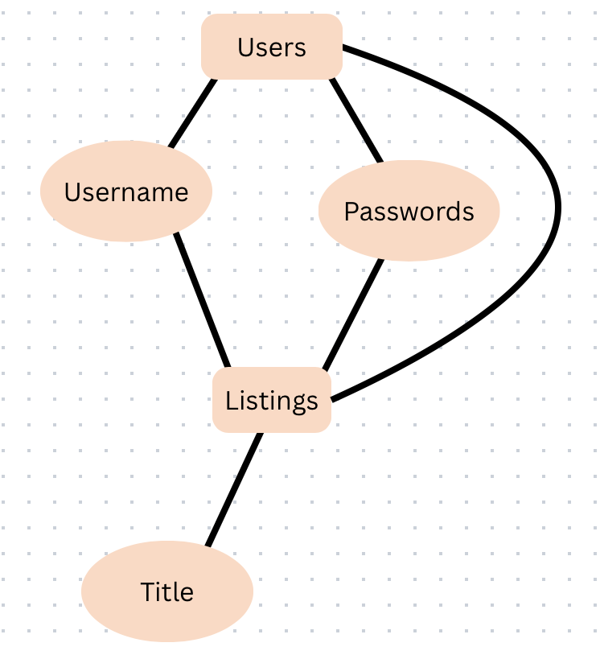

3.1.3 Complete data model (Elali McNair)

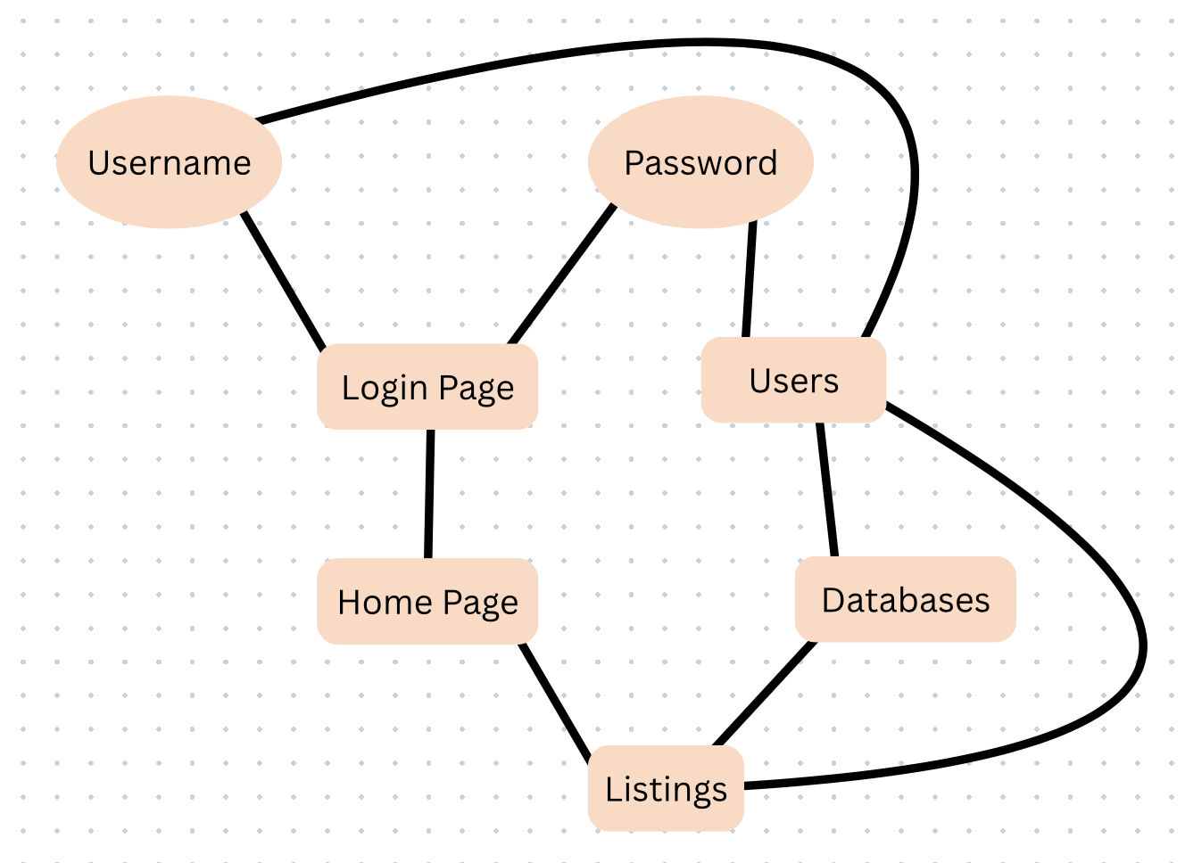

3.1.4 Flow Diagram (Elali McNair)

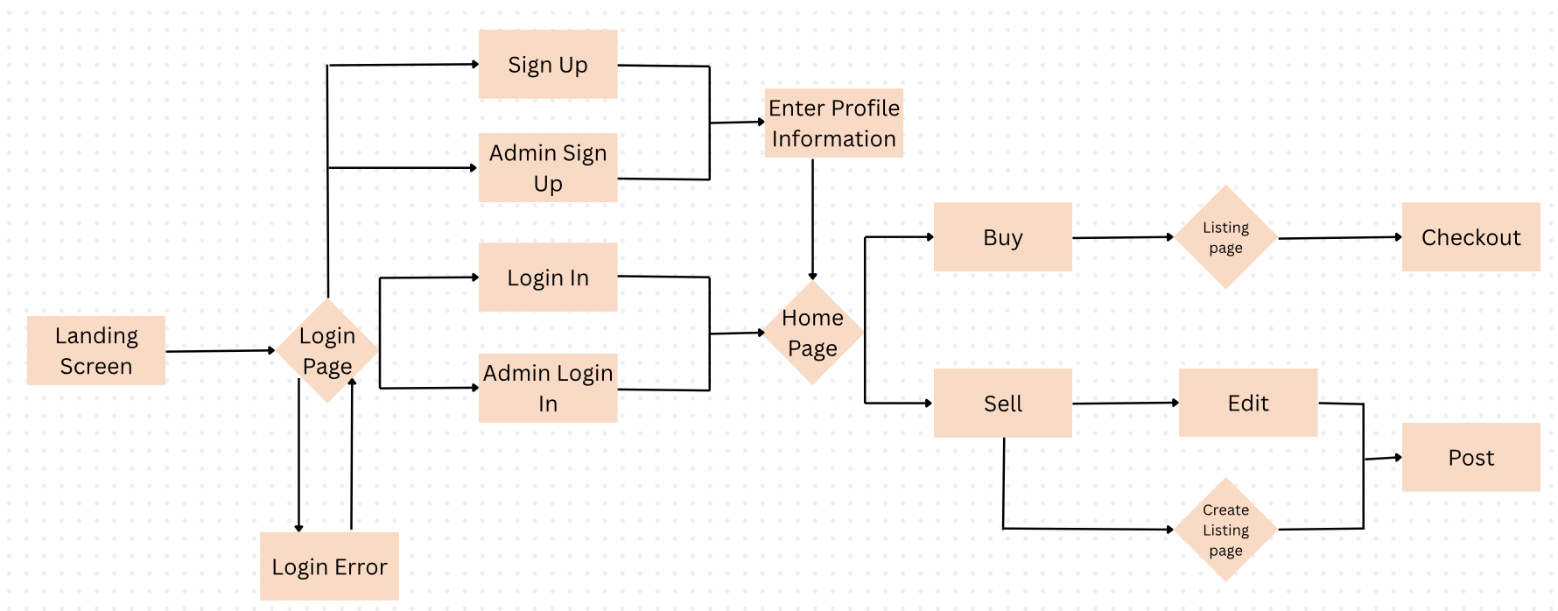

When entering the marketplace the user will be brought to the login page and have an option to either “sign up” or “login”. If the user is an admin, they will have a separate set of information to enter. If the user attempts to sign up, they will be brought to the profile screen and be prompted to enter their new user information. Once they finish their user will be created and saved while they are brought to the home page of the marketplace. If the user already has an account and chooses to login, they will be brought straight to the home page. If the user enters the wrong information, they will remain at the login screen and be prompted to enter the correct information carefully to avoid errors. Once the user is in the home page they have an option to search to buy or sell listings. If they choose to buy, they are brought to a general listings page and are free to select whatever they like. Once they select their item and are done searching they can head to the checkout page to place their order. If the user chose to sell a listing, they would first have the option to either edit a listing they have already posted or create a new one. After the user chooses their desired route they will post the listing and be brought back to the home page.

3.1.5 Data dictionary (Elali McNair)

- Users (Admin, Username, Password)
- Listings (Users, Title)
- Prices(Listings, Amount)
- The three lines above were written before most of the database existed. Section 3.1.6 has all eleven tables as they are actually built.
- users, storefronts, listings, listing_images, listing_sizes, cart_items, orders, order_items, purchases, wishlist, returns
- There is no separate Prices table. Price is a column on listings, cart_items and order_items.

3.1.6 Database schema(Chase Jones)
Sections above were written early in the project, when the plan was three tables. The database we actually are working with now has eleven.

The tables below are listed parents first, so a table always appears before anything that points at it.

Users
Column | Type | Nullability | Constraints and notes
id | INTEGER | NOT NULL | Auto-increment. Primary key
username | VARCHAR(50) | NOT NULL
password | TEXT | NOT NULL | Werkzeug hash, never the plaintext password
email | VARCHAR(100) | NOT NULL
role | VARCHAR(10) | nullable | Default 'user'. Either 'user' or 'admin'; this is what gates the admin pages
created_at | TIMESTAMP | nullable | Default CURRENT_TIMESTAMP.

Storefronts

Column | Type | Nullability | Constraints and notes
id | INTEGER | NOT NULL | Auto-increment. Primary key
owner_id | INTEGER | NOT NULL | UNIQUE, which is what limits a user to one storefront
brand_name | VARCHAR(80) | NOT NULL
bio | TEXT | nullable
logo_url | TEXT | nullable
banner_url | TEXT | nullable
contact_info | TEXT | nullable
preview_image_1 | TEXT | nullable
preview_image_2 | TEXT | nullable
preview_image_3 | TEXT | nullable
preview_image_4 | TEXT | nullable
categories | TEXT | nullable | Comma-separated; the service trims this down to three tags
is_active | BOOLEAN | nullable | Default true. Setting this false hides the storefront and pauses its listings
created_at | TIMESTAMP | nullable | Default CURRENT_TIMESTAMP.
updated_at | TIMESTAMP | nullable | Default CURRENT_TIMESTAMP.

Listings
Every listing belongs to a storefront rather than directly to a user, so ownership runs user to storefront to listing.

Column | Type | Nullability | Constraints and notes
id | INTEGER | NOT NULL | Auto-increment. Primary key
storefront_id | INTEGER | NOT NULL
title | VARCHAR(120) | NOT NULL
description | TEXT | nullable
price | NUMERIC(10,2) | NOT NULL
fulfillment_type | VARCHAR(20) | NOT NULL | CHECK: 'IN_STOCK' or 'PREORDER'
quantity_on_hand | INTEGER | nullable | CHECK >= 0; recalculated from listing_sizes
sizes_available | TEXT | nullable | Free text for display only; listing_sizes holds the real counts
status | VARCHAR(20) | nullable | Default 'ACTIVE'. CHECK: 'ACTIVE', 'INACTIVE', 'SOLD_OUT' or 'DELETED'
storefront_restore_status | VARCHAR(20) | nullable | Remembers the old status while the storefront is inactive
deleted_restore_status | VARCHAR(20) | nullable | Remembers the old status while the listing is soft-deleted
created_at | TIMESTAMP | nullable | Default CURRENT_TIMESTAMP.
updated_at | TIMESTAMP | nullable | Default CURRENT_TIMESTAMP.
is_made_to_order | BOOLEAN | nullable | Default false. If true, checkout skips the availability check for this listing

Listing_images
Photos for the listing itself. One can photo will be flagged as primary image for the listing card on users end.The image file itself will be in S3 the URL will be stored here.
Column | Type | Nullability | Constraints and notes
id | INTEGER | NOT NULL | Auto-increment. Primary key
listing_id | INTEGER | NOT NULL
image_url | TEXT | NOT NULL
is_primary | BOOLEAN | nullable | Default false. The image shown on the listing card
created_at | TIMESTAMP | nullable | Default CURRENT_TIMESTAMP.

Listing_sizes
How many of each size a listing has.
Column | Type | Nullability | Constraints and notes
id | INTEGER | NOT NULL | Auto-increment. Primary key
listing_id | INTEGER | NOT NULL
size | VARCHAR(20) | NOT NULL
quantity | INTEGER | NOT NULL | CHECK >= 0
created_at | TIMESTAMP | nullable | Default CURRENT_TIMESTAMP.

Cart_items
The shopping cart, kept on the server instead of in the browser. That is why a cart survives logging out: we read it back into the session the next time the user signs in.
Column | Type | Nullability | Constraints and notes
id | INTEGER | NOT NULL | Auto-increment. Primary key
user_id | INTEGER | NOT NULL
item_id | INTEGER | nullable | Points at a listing by value; there is no foreign key on this column
item_name | VARCHAR(255) | NOT NULL
price | NUMERIC(10,2) | NOT NULL | CHECK >= 0
quantity | INTEGER | NOT NULL | Default 1.
size | VARCHAR(50) | nullable
created_at | TIMESTAMP | nullable | Default CURRENT_TIMESTAMP.

Orders
One row per completed checkout, holding the confirmation number, the five buyer contact fields, and the order total. No payment information is stored anywhere, because the exchange happens in person.
Column | Type | Nullability | Constraints and notes
id | INTEGER | NOT NULL | Auto-increment. Primary key
user_id | INTEGER | NOT NULL
confirmation_number | VARCHAR(50) | NOT NULL | UNIQUE; format VAULT-YYMMDD-XXXXXX
buyer_first_name | VARCHAR(100) | NOT NULL
buyer_last_name | VARCHAR(100) | NOT NULL
buyer_email | VARCHAR(255) | NOT NULL
buyer_contact | VARCHAR(100) | NOT NULL
buyer_meeting_location | TEXT | NOT NULL | Free text, since the handoff is arranged in person
total_amount | NUMERIC(10,2) | NOT NULL
order_status | VARCHAR(20) | nullable | Default 'SUBMITTED'. Starts out as 'SUBMITTED'
created_at | TIMESTAMP | nullable | Default CURRENT_TIMESTAMP.

Order_items
The lines inside the order. We copy the price and the selected size into this table at the moment of purchase, so that if a seller later edits the listing the order still shows what the buyer actually paid.
Column | Type | Nullability | Constraints and notes
id | INTEGER | NOT NULL | Auto-increment. Primary key
order_id | INTEGER | NOT NULL
listing_id | INTEGER | nullable | No foreign key here, so an order survives its listing being deleted
item_name | VARCHAR(255) | NOT NULL
quantity | INTEGER | NOT NULL | CHECK > 0
price_at_purchase | NUMERIC(10,2) | NOT NULL | Copied at checkout; later price edits do not change it
selected_size | VARCHAR(50) | nullable

Purchases
Written by the purchase API.
Column | Type | Nullability | Constraints and notes
id | INTEGER | NOT NULL | Auto-increment. Primary key
user_id | INTEGER | NOT NULL
listing_id | INTEGER | NOT NULL
quantity | INTEGER | NOT NULL | CHECK > 0
purchase_price | NUMERIC(10,2) | NOT NULL | CHECK >= 0
purchase_date | TIMESTAMP | nullable | Default CURRENT_TIMESTAMP.

Wishlist
Listings a user has saved for later.
Column | Type | Nullability | Constraints and notes
id | INTEGER | NOT NULL | Auto-increment. Primary key
user_id | INTEGER | NOT NULL
listing_id | INTEGER | NOT NULL | UNIQUE together with user_id, so nothing is saved twice
added_date | TIMESTAMP | nullable | Default CURRENT_TIMESTAMP.

Returns
Return requests submitted by buyers.
Column | Type | Nullability | Constraints and notes
id | INTEGER | NOT NULL | Auto-increment. Primary key
user_id | INTEGER | NOT NULL
order_number | VARCHAR(120) | NOT NULL | Saved exactly as typed; nothing checks it against orders
reason | TEXT | NOT NULL
has_damage | BOOLEAN | NOT NULL
damage_image_url | TEXT | nullable
status | VARCHAR(20) | NOT NULL | Default 'pending'. CHECK: 'pending', 'reviewed' or 'resolved'
created_at | TIMESTAMP | nullable | Default CURRENT_TIMESTAMP.
updated_at | TIMESTAMP | nullable | Default CURRENT_TIMESTAMP.
is_deleted | BOOLEAN | nullable | Default false. Soft delete; hidden from the admin queue

Column | Type | Nullability | Constraints and notes
id | INTEGER | NOT NULL | Auto-increment. Primary key
sender_id | INTEGER | NOT NULL | CHECK sender_id <> receiver_id, so nobody can message themselves
receiver_id | INTEGER | NOT NULL
listing_id | INTEGER | nullable | Optional. ON DELETE SET NULL, so a conversation outlives its listing
body | TEXT | NOT NULL
is_read | BOOLEAN | nullable | Default false. Drives the unread indicator
created_at | TIMESTAMP | nullable | Default CURRENT_TIMESTAMP.
Column | Type | Nullability | Constraints and notes
id | INTEGER | NOT NULL | Auto-increment. Primary key
storefront_id | INTEGER | NOT NULL | UNIQUE together with reviewer_id: one review per user per storefront
reviewer_id | INTEGER | NOT NULL | Nothing stops this being the storefront’s own owner (see note below)
rating | INTEGER | NOT NULL | CHECK between 1 and 5
comment | TEXT | nullable
created_at | TIMESTAMP | nullable | Default CURRENT_TIMESTAMP.

3.1.7 Referential Integrity
The tables are connected by twelve foreign keys, all of them ON DELETE CASCADE, so deleting a user takes off their storefront, and through that storefront every listing beneath it together with its photos and size rows, plus that user’s cart, orders, order items, purchases, wishlist entries, and return requests. Before anyone develops an account deletion feature, it is important to understand that nothing is retained and nothing is left orphaned.

4.0 Functional Model and Description (David Jackson)

This section describes the functional breakdown of the Vault system, including processing logic, interfaces, data flow, performance considerations, and constraints. The system follows a client-server architecture deployed on AWS using Elastic Beanstalk for application hosting and Amazon RDS (PostgreSQL) for database services.

4.1 Description for Function n

The major system functions include:

User registration:

The User Registration function allows new Hampton University students to create an account within the Vault system. This function collects required user information, encrypts sensitive credentials, and stores the user record securely in the database.

The system ensures that:
- No duplicate accounts exist
- Passwords are securely hashed before storage

Successful registration creates an account and grants access to authentication services(login/logout). If validation fails, appropriate error messages are returned.

User authentication (login/logout):

The User Authentication function manages secure access to the marketplace. It verifies user credentials by comparing submitted login information with encrypted records stored in the database.

Once authenticated:
- Users gain access to the system
- A secure session is created

Create listing:

The Create Listing function allows authenticated users to post fashion items for sale within the marketplace. Users provide item details such as name, description, price, category, and upload an image.

The system:
- Validates all required fields
- Stores listing information in the database
- Makes the listing visible in the marketplace feed

Edit/delete listing:

The Edit Listing function allows users to modify the details of listings they have previously created. The system verifies listing ownership before permitting changes. The Delete Listing function allows the user to permanently delete the listing from the marketplace.

User can update/edit:
- Item description
- Price
- Category
- Availability status
(Chase Jones)
Once deleted:
- The listing status is set to DELETED and the record is retained, preserving the historical reference for any order that cites it
- The item no longer appears in search results or the marketplace feed

Browse & search listings:

The Browse Listings function allows users to view available fashion items posted by other students. The system retrieves active listings from the database and displays them in a structured and organized format. The Search and Filter function allows users to refine marketplace results using keywords and filtering criteria.

Listings can be sorted by:
- Most recent postings
- Price
- Category

Users will be able to search:
- Item name
- Price range
- Category
- Availability status

Admin management:

The Admin Management function allows authorized administrative users to moderate the platform.

Admins can:
- Remove inappropriate listings
- Suspend user accounts
- Monitor system activity

Purchase & checkout:

The Purchase or Checkout function allows a buyer to confirm interest in purchasing an item. When triggered, the system:
- Verifies item availability
- Sets the listing status to SOLD_OUT once its recomputed quantity across all sizes reaches zero
- Prevents overselling through pre-flight availability validation and per-size inventory decrement
- Records the order against the seller’s storefront for review on the storefront dashboard

(Chase Jones)
Note: All highlighted text in this document indicates content added or corrected in Revision 6.0 / Iteration 2, which brings the requirements into agreement with the delivered build.
See the Revision Log in Section 9.0.
Storefront management:
The Storefront Management function allows an authenticated user to establish and maintain a branded seller presence. The Vault operates a unified account model: users do not register as sellers. A user acquires seller capability by creating a storefront, after which that user may create and manage listings beneath it. Each user may own at most one storefront. Detailed requirements appear in Section 4.1.7.
Wishlist management:
The Wishlist Management function allows an authenticated user to save listings for later consideration and to retrieve, inspect, and remove those saved items. A wishlist is private to the account that owns it, and entries are stored as associations rather than copies so that a saved item always reflects the listing’s current price and availability. Detailed requirements appear in Section 4.1.8.
Transaction processing:
The Transaction Processing function carries a purchase from cart accumulation through order confirmation. It comprises a persistent shopping cart held against the user account, a checkout operation that validates availability and creates order records, and an order retrieval facility serving confirmation and history views. Detailed requirements appear in Section 4.1.9.
Return request processing:
The Return Request Processing function allows a buyer to raise a request against a completed order and allows administrators to review and resolve those requests. Detailed requirements appear in Section 4.1.10.

4.1.1 Processing narrative (PSPEC) for function n

A processing narrative for function n is presented.

User registration:

When a user selects “Register,” the system:
- Accepts input data (name, email, password)
- Validates email format and ensures it belongs to the Hampton University domain
- Checks for duplicate accounts in PostgreSQL (RDS)
- Encrypts the password using secure hashing
- Stores user information in the Users table
- Returns confirmation or error message

User authentication(login/logout):

- User submits email and password.
- The system retrieves the stored password hash from RDS.
- Compares the input password with the hashed value.
- If valid, generates a secure session token.
- Grants access to marketplace features.

Create listing:

- Authenticated user selects “Create Listing.”
- User inputs:
  - Item name
  - Description
  - Price
  - Category
  - Image upload
- System validates required fields
- Stores listing in Listings table in RDS
- Uploads image to AWS storage (S3). Displays listing in the marketplace feed

Edit/delete listing:

- User selects the listing they own
- System verifies ownership
- Allows modification or deletion
- Updates or removes listing from RDS

Browse & search listings

- User accesses homepage
- System retrieves active listings from RDS
- Displays listings sorted by most recent
- Search filters apply SQL query filters (price, category, keyword)

Admin management:

Admin users can:
- View all listings
- Remove inappropriate content
- Suspend user accounts

Purchase & checkout:

- User selects item
- Confirms purchase
- System verifies listing availability
- Marks item as sold in the database
- Notifies seller

4.1.2 Function n flow diagram

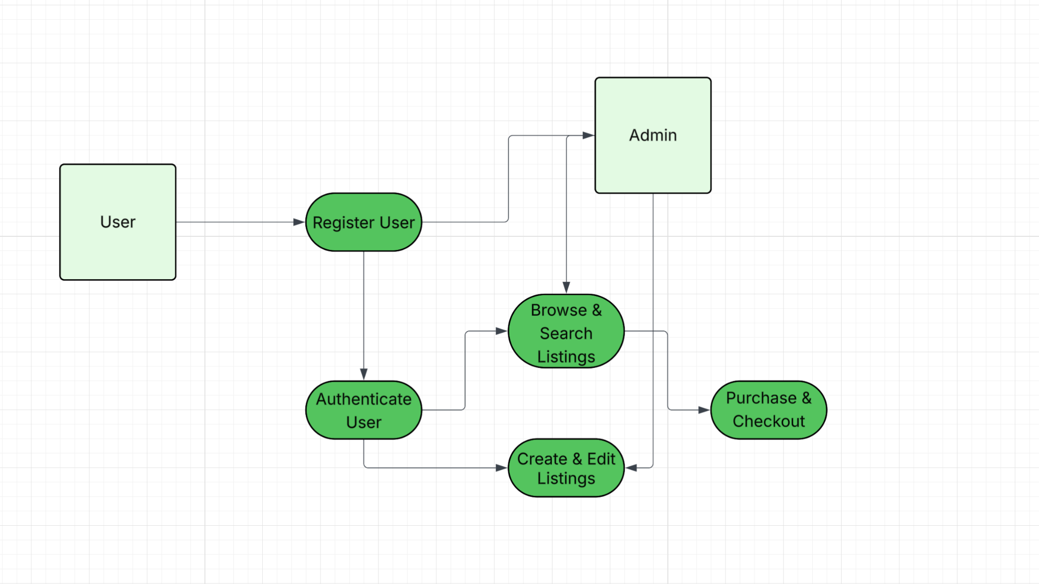

4.1.3 Function n interface description (Ryan Grimes)

A detailed description of the input and output interfaces for the function is presented.

- Input interface: JSON is a list of keys and values. During, the input interface expects three pieces of input: email, username, and password. If the data type doesn’t match the JSON rules, such as a phone number being inputted instead of an email, the interface rejects it at the window before it reaches the database.
- Output interface: If the login is successful, a 200 code response is sent back along with routing to the listing screen. But, if the login fails, a 401 error will be sent.
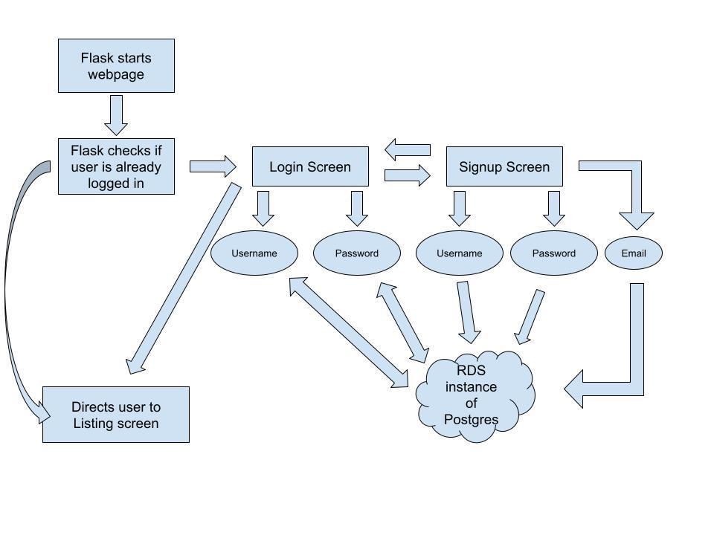

4.1.4 Function n transforms

A detailed description for each transform (subfunction) for function n is presented. Section 4.1.4 is repeated for each of k transforms.

4.1.4.1 Transform 1 description (processing narrative, PSPEC) (Ryan Grimes)

This transform manages how students join and enter the marketplace.

During registration, the system accepts a name, email, and password. During this process, the system ensures the email belongs to the Hampton University domain (@hamptonu.edu), the username/email isn’t a duplicate, and the password is hashed before storing it in the PostgreSQL database on AWS RDS.
When logging in, the system retrieves the stored hash and compares it to the input password. If they match, a secure session token is generated to grant access to the site’s features.

4.1.4.2 Transform 1 interface description (Ryan Grimes)

For the input interface, the system expects a JSON list containing the user’s email, username, and password. If the data types are incorrect, the interface rejects the input before it even reaches the database.
For the output interface, a “200” success code is returned during a successful login and routes the user to the listing screen. A failed login sends a “401” error code.

4.1.4.3 Transform 1 lower level flow diagrams

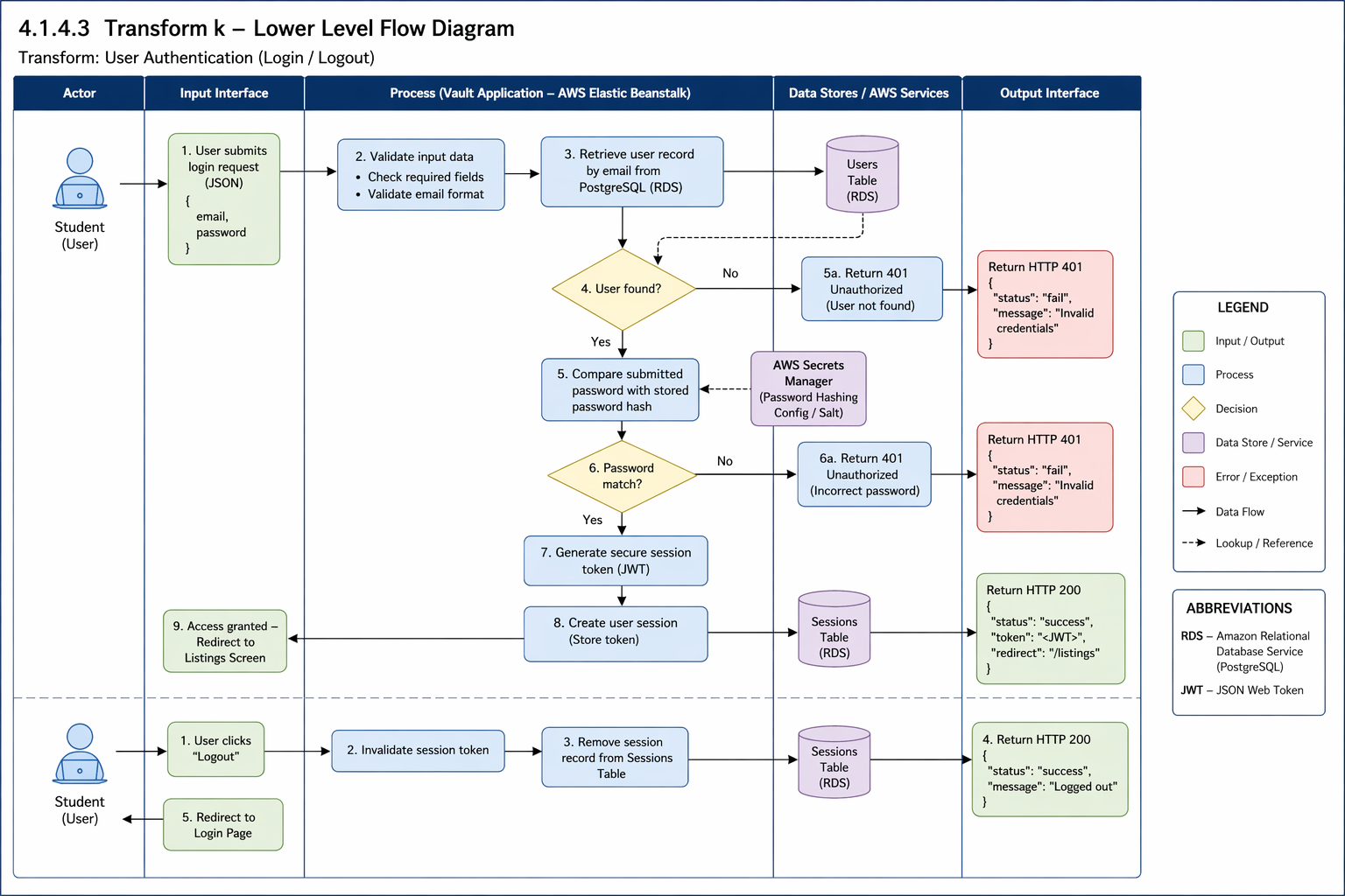

4.1.4.4 Transform 2 description (Ryan Grimes)

This transform handles how brand owners control their products.

During listing creation, authenticated users input an item’s name, description, price, and category. The system validates the fields, stores the details in the RDS database, and uploads the product image to Amazon S3 storage.
When it comes to edits and deletion, the system verifies that the user is the actual owner of the listing before allowing any modifications or deletions. If deleted, the record is removed or marked inactive so it doesn’t appear in the feed anymore.

4.1.4.5 Transform 2 interface description (Ryan Grimes)

For the input interface, item details (title, price, availability status) are provided during listing creation. For the output interface, a public catalog of active listings and updated user dashboards showing their managed storefront is displayed.

4.1.4.6 Transform 2 lower level flow diagrams (Ryan Grimes)

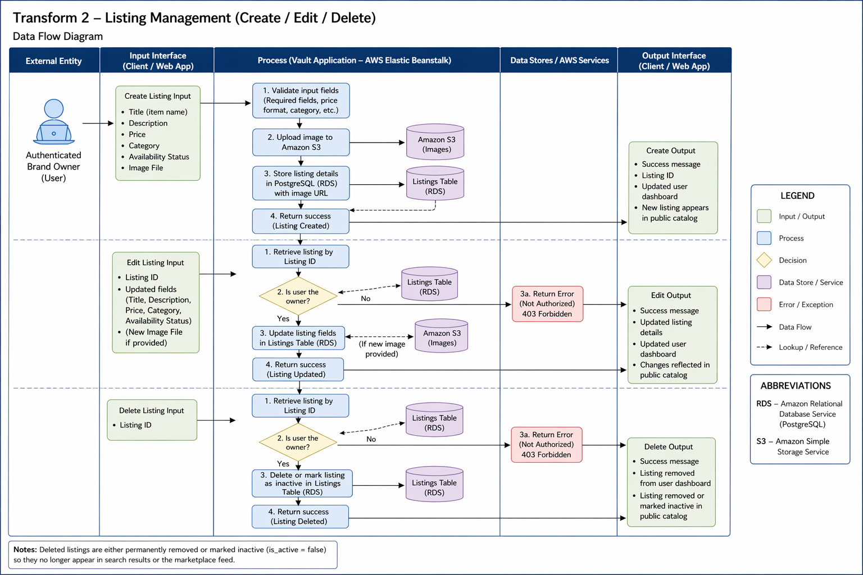

4.1.4.7 Transform 3 description (Ryan Grimes)

This transform handles the final transaction phase where a student buyer confirms their interest and purchases the item from the marketplace.

During purchase, the system queries the listings table to ensure the availability_status is still active to ensure concurrent purchases of a unique item. Once availability_status is verified, the backend executes a SQL UPDATE command to change the item’s status to sold. The system then records the transaction details and links the buyer’s user_id to the listing_id in a history table. Finally, the system clears the item from the user’s cart.

4.1.4.8 Transform 3 interface description (Ryan Grimes)

The inputs are the User_ID of the buyer and the Listing_ID of the specific item being purchased, and the outputs are the updated “Sold” status in the database, a confirmation message to the buyer, and a notification sent to the seller. In addition, the item is removed from other users’ feeds.

4.1.4.9 Transform 3 lower level flow diagrams (Ryan Grimes)

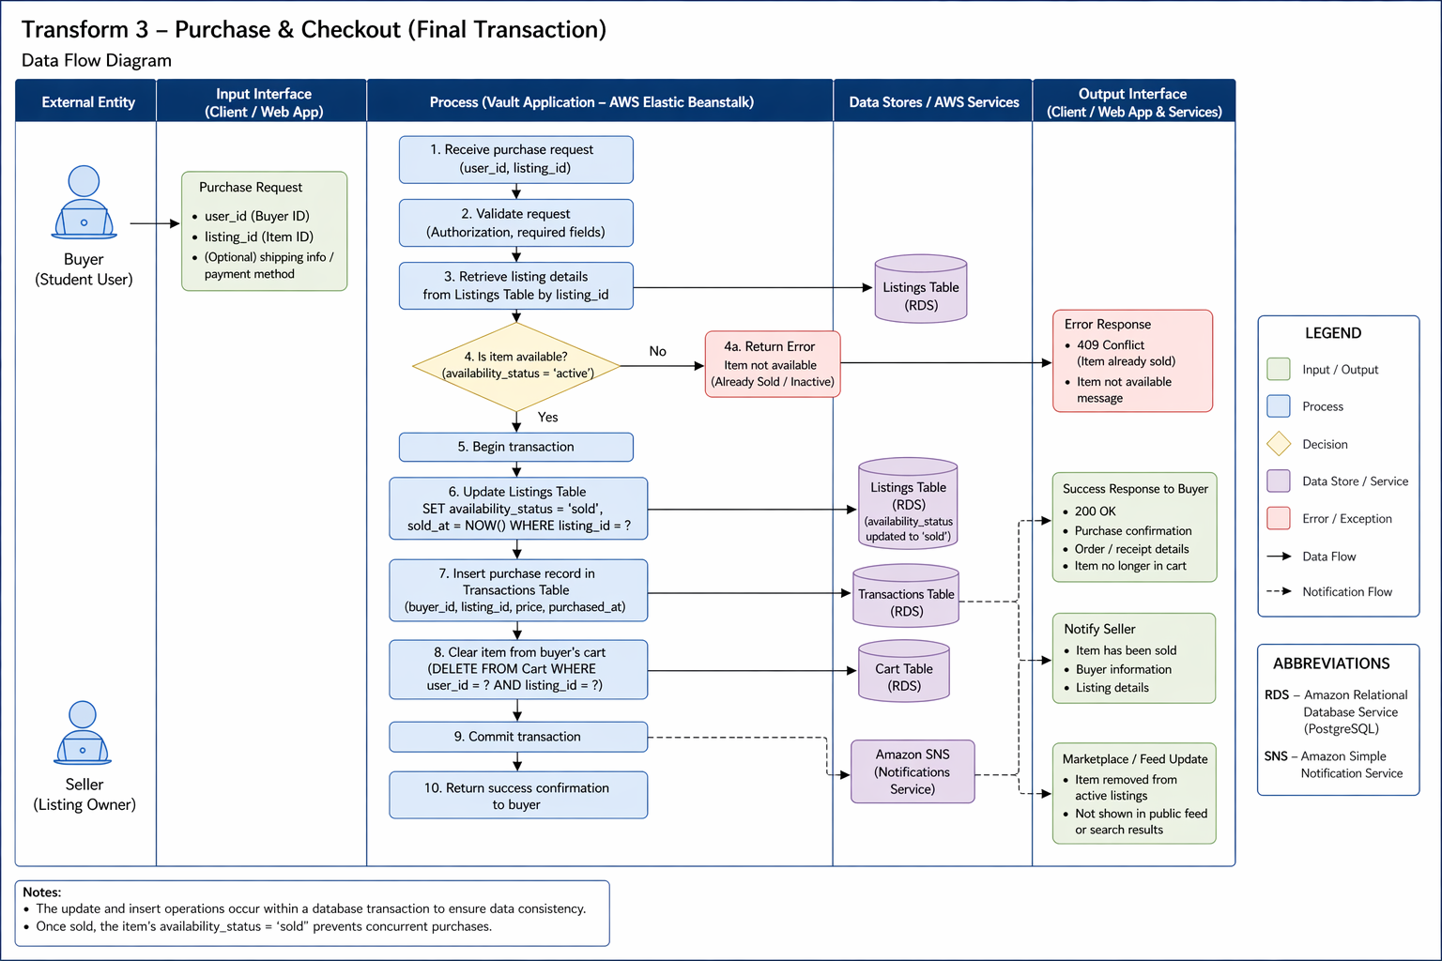

4.1.5 Performance Issues (Noah Higgs)

Special performance required for the subsystem is specified.

- Latency: Requests must travel from the user to the AWS RDS instance in us-east-2, and the goal is to stay under 200ms query response times.
- Concurrency: The system should be able to handle multiple simultaneous user inputs without locking database rows.

4.1.6 Design Constraints (Noah Higgs)

Any design constraints that will impact the subsystem are noted.

- Cloud security: The system is constrained by the AWS Security Group Inbound Rules. These only accept traffic from authorized IP addresses.
- Statelessness and session security: Sessions are stored in signed cookies instead of files to allow scalability in Flask. The cookies are signed with a secret key read from the SECRET_KEY environment variable. We did not hardcode the key in the source and it has no default value, so if it is missing, sessions cannot be signed (see 6.4).

Chase Jones

4.1.7 Storefront Management
The Storefront Management function allows an authenticated user to establish and maintain a branded seller presence within The Vault. A storefront carries brand identity information (brand name, biography, contact details), visual assets stored in Amazon S3 (logo, banner, and up to four preview images), and up to three category tags. Each storefront has an active state that governs its public visibility and the visibility of every listing it contains.
Creating a storefront:
- An authenticated user submits the storefront creation form.
- The system verifies that the user does not already own a storefront. If one exists, the request is rejected with "Storefront already created."
- The system validates that a brand name has been supplied and is not blank after trimming.
- The system normalizes submitted categories: values are trimmed, empty values discarded, and duplicates removed without regard to letter case. If more than three distinct categories remain, the request is rejected.
- Any uploaded images are transmitted to Amazon S3 and the returned public URLs are retained for storage.
- A storefront record is inserted with its active flag set to true and associated with the owner by user identifier.
- The user is redirected to the storefront dashboard and may now create listings.
Updating a storefront:
- The system retrieves the storefront and confirms the requester is either its owner or an administrator.
- Only fields on the permitted list are accepted: brand name, biography, logo URL, banner URL, contact information, the four preview image URLs, and categories. Any other submitted field is discarded.
- If a brand name is supplied it must remain non-empty after trimming; a blank value is rejected.
- Categories are re-normalized under the same rules applied at creation.
- The record is updated and the modification timestamp advanced.
Deactivating and reactivating a storefront:
- The system confirms the requester is the owner or an administrator.
- On deactivation the active flag is set to false and the system will also pause every listing beneath the storefront that is currently ACTIVE or SOLD_OUT. Each paused listing records its prior state so that it can be restored.
- A deactivated storefront remains reachable by its owner and by administrators but is withheld from public browsing.
- On reactivation the active flag is set to true and only those listings carrying a recorded restore state are returned to it. Listings deactivated individually by the owner, or deleted, are not disturbed.

Interface description
Category | Detail
Inputs | Brand name (required, up to 80 characters); biography; contact information; category selections (up to three); logo, banner, and up to four preview image files
Outputs | Storefront record; public storefront page; owner dashboard; error messages for duplicate, unauthorized, or invalid requests
Data stores | storefronts table (PostgreSQL); Amazon S3 for image objects
Endpoints | POST /api/storefronts, GET /api/storefronts, GET /api/storefronts/{id}, GET /api/storefronts/me, PUT /api/storefronts/{id}, PATCH /api/storefronts/{id}/deactivate, PATCH /api/storefronts/{id}/reactivate

Functional requirements
Req. ID | Requirement | Enforced by
SF-01 | The system shall permit each user account to own at most one storefront. | Service check and UNIQUE constraint on owner_id
SF-02 | The system shall require a non-empty brand name for storefront creation and shall reject a brand name that is blank after trimming. | Service validation
SF-03 | The system shall limit a storefront to three category tags and shall remove duplicate tags without regard to letter case. | Service normalization
SF-04 | The system shall store storefront images in Amazon S3 and retain only the resulting URLs in the database. | S3 utility module
SF-05 | The system shall permit only the storefront owner or an administrator to update, deactivate, or reactivate a storefront. | Service authorization guard
SF-06 | The system shall restrict update operations to an explicit list of permitted fields and shall discard any other submitted field. | Service field whitelist
SF-07 | The system shall treat an inactive storefront as hidden from public browsing while remaining accessible to its owner and to administrators. | Query filter
SF-08 | When a storefront is deactivated, the system shall pause every listing beneath it whose status is ACTIVE or SOLD_OUT, recording each listing’s prior status. | Storefront deactivation routine
SF-09 | When a storefront is reactivated, the system shall restore only those listings that carry a recorded storefront restore status, leaving individually deactivated and deleted listings unchanged. | Storefront reactivation routine
SF-10 | The system shall delete a user’s storefront when that user account is deleted. | Foreign key ON DELETE CASCADE
SF-11 | The system shall derive the requesting user’s identity and role from the server-side session when evaluating storefront permissions. | Session (see Section 4.1.12)

Error conditions
- Unauthenticated request — "Error! Unauthorized user."
- The user already owns a storefront — "Storefront already created."
- Brand name missing or blank — "brand_name is required" or "brand_name cannot be empty."
- More than three categories submitted — "You can select up to 3 storefront categories."
- Requester is neither owner nor administrator — "Unauthorized action."
- Storefront identifier not found — "Storefront not found."

4.1.8 Wishlist Management

Function description
The Wishlist Management function allows an authenticated user to save listings for later consideration and to retrieve, inspect, and remove those saved items. Entries are maintained as associations between a user and a listing rather than as copies of listing data, so a wishlist entry always reflects the listing’s current price, availability, and status. The system deliberately permits a user to save a listing that is inactive or sold out, on the reasoning that a shopper may wish to track an item until it returns to stock. Wishlist entries are removed automatically when the corresponding item is purchased.

Processing narrative
- An authenticated user selects the save action on a listing.
- The system confirms the listing exists. If it does not, the request is rejected with "Listing not found."
- The system attempts to insert a wishlist association for the user and listing.
- If the pair is already present, the uniqueness constraint prevents a duplicate and the system responds "Item already in wishlist" rather than raising an error.
- On retrieval, the system returns the user’s saved listings joined to current listing detail.
- On removal, the system deletes the association and confirms; if no association existed, it reports "Item not found in wishlist."
- During checkout, the system removes from the wishlist every listing contained in the completed order.

Interface description
Category | Detail
Inputs | Authenticated user identity; listing identifier
Outputs | Wishlist collection with current listing detail; membership status for a given listing; confirmation and error messages
Data stores | wishlist table (PostgreSQL)
Endpoints | POST /api/wishlist, GET /api/wishlist, DELETE /api/wishlist/{listing_id}, GET /api/wishlist/{listing_id}/check, GET /api/wishlist/items/{wishlist_id}

Functional requirements
Req. ID | Requirement | Enforced by
WL-01 | The system shall allow an authenticated user to save an existing listing to a wishlist held against that user’s account. | Wishlist service
WL-02 | The system shall prevent a listing from appearing more than once in a given user’s wishlist. | UNIQUE (user_id, listing_id)
WL-03 | When a user attempts to save a listing already present, the system shall report that condition without treating it as an error. | Wishlist service
WL-04 | The system shall reject an attempt to save a listing that does not exist. | Listing existence check
WL-05 | The system shall permit a user to save a listing whose status is inactive or sold out. | Deliberate omission of status filter
WL-06 | The system shall expose a user’s wishlist only to that user. | Identity scoping (see Section 4.1.12)
WL-07 | The system shall allow a user to remove a saved listing and shall report the outcome where no such entry existed. | Wishlist service
WL-08 | The system shall report whether a specified listing is present in the requesting user’s wishlist. | Wishlist service
WL-09 | On successful checkout, the system shall remove from the buyer’s wishlist every listing included in the order. | Checkout service
WL-10 | The system shall delete wishlist entries when either the owning user account or the referenced listing is deleted. | Foreign keys ON DELETE CASCADE

- Listing identifier does not resolve — "Listing not found"
- Listing already saved — "Item already in wishlist"
- Removal requested for an entry that does not exist — "Item not found in wishlist"
- Unauthenticated request — rejected before reaching the service layer

4.1.9 Transaction Processing
The Transaction Processing function carries a purchase from cart accumulation through order confirmation. It comprises three cooperating parts: a persistent shopping cart held in the database against the user account, a checkout operation that validates availability and creates order records, and an order retrieval facility that serves confirmation and history views.
The Vault performs no payment processing. Checkout captures the buyer’s contact details and a proposed meeting location, issues a confirmation number, and records the transaction; payment and handover occur in person between the parties. Completing checkout adjusts seller inventory and may transition affected listings to a sold-out state.
Cart maintenance:
- A user adds a listing to the cart, optionally specifying a size and quantity.
- The system records the item against the user’s account in the cart_items table, capturing item name, unit price, quantity, and size.
- Because the cart is stored server-side rather than in the browser, it survives logout and is restored on the user’s next authenticated session.
Checkout:
- The system confirms an authenticated session is present; an unauthenticated request is redirected to the login page.
- The system rejects an empty cart with "Cart is empty."
- Before any record is written, the system validates availability for every cart item in turn. A listing that cannot be found, that carries status SOLD_OUT, or whose quantity on hand is below the requested amount causes the entire checkout to fail with a message naming the item. Listings flagged made-to-order are exempt from this check.
- The system requires all five buyer detail fields — first name, last name, email address, contact method, and meeting location — and rejects the submission if any is blank.
- The system computes the order total as the sum of unit price multiplied by quantity across all cart items, rounded to two decimal places.
- The system generates a unique confirmation number of the form VAULT-YYMMDD-XXXXXX, where the final segment is six randomly chosen uppercase letters and digits.
- The system creates one order record and one order item record per cart line. Each order item captures the unit price at the moment of purchase and the selected size, so that later changes to the listing do not alter the historical record.
- For each purchased item having a size, the system decrements the corresponding per-size quantity and recomputes the listing’s total quantity on hand as the sum across all sizes.
- Where the recomputed total reaches zero the listing transitions to SOLD_OUT; where a previously sold-out listing is replenished above zero it returns to ACTIVE.
- The system clears the buyer’s cart and removes the purchased listings from the buyer’s wishlist.
- The system returns the confirmation number, order summary, and total for display on the confirmation page.
Order retrieval:
- A request for an order by confirmation number returns the order and its items only if the requesting user owns that order; otherwise the system denies access.
- A request for order history returns all orders belonging to the requesting user, most recent first.
Category | Detail
Inputs | Cart additions and removals (listing, size, quantity); buyer first name, last name, email, contact method, and meeting location
Outputs | Confirmation number; order summary with line items and total; order history; availability and validation error messages
Data stores | cart_items, orders, order_items, listing_sizes, listings (PostgreSQL)
Endpoints | POST /api/checkout/complete, GET /api/orders/by-confirmation/{confirmation_number}, GET /api/orders/my

Req. ID | Requirement | Enforced by
TX-01 | The system shall persist each user’s cart in the database so that cart contents survive logout and are restored on the next authenticated session. | cart_items table
TX-02 | The system shall require an authenticated session for access to the checkout and order confirmation pages. | Session guard in route handlers
TX-03 | The system shall reject a checkout submitted with an empty cart. | Checkout service
TX-04 | The system shall validate the availability of every cart item before creating any order record, and shall abort the entire checkout if any item is unavailable. | Pre-flight availability loop
TX-05 | The system shall treat a listing as unavailable when it cannot be found, when its status is SOLD_OUT, or when its quantity on hand is less than the quantity requested. | Availability check
TX-06 | The system shall exempt listings flagged made-to-order from availability validation. | Availability check
TX-07 | The system shall require buyer first name, last name, email address, contact method, and meeting location, rejecting the submission if any is blank. | Checkout service
TX-08 | The system shall compute the order total as the sum of unit price multiplied by quantity across all cart lines, rounded to two decimal places. | Checkout service
TX-09 | The system shall assign each order a unique confirmation number of the form VAULT-YYMMDD-XXXXXX. | Generator and UNIQUE constraint
TX-10 | The system shall record the unit price and selected size at the moment of purchase on each order item, so that subsequent listing changes do not alter the historical record. | order_items.price_at_purchase
TX-11 | The system shall decrement per-size inventory for each purchased item and recompute the listing’s total quantity on hand as the sum across all sizes. | Inventory update routine
TX-12 | The system shall set a listing’s status to SOLD_OUT when its recomputed quantity reaches zero, and shall return a sold-out listing to ACTIVE when its quantity rises above zero. | Inventory update routine
TX-13 | The system shall clear the buyer’s cart upon successful order creation. | Checkout service
TX-14 | The system shall remove purchased listings from the buyer’s wishlist upon successful order creation. | Checkout service
TX-15 | The system shall release an order to a requester only when that requester is the user who placed it. | Ownership check on retrieval
TX-16 | The system shall assign each new order an initial status of SUBMITTED. | orders.order_status default
TX-17 | The system shall not process payment; the transaction record shall support an in-person exchange model only. | Scope constraint

Error conditions
- Empty cart — "Cart is empty."
- Item sold out — "{item} is sold out."
- Insufficient stock — "{item} only has {n} in stock (you requested {m})."
- Listing no longer present — "Item (ID {id}) is no longer available."
- Missing buyer details — "All buyer details are required."
- Order requested by a user who does not own it — "Access denied."
- Confirmation number not found — "Order not found."

4.1.10 Return Request Processing

Function description
The Return Request Processing function allows a buyer to raise a request against a completed order and allows administrators to review and resolve those requests. A request captures the order it concerns by order number, a written reason, an explicit declaration of whether the item arrived damaged, and — where damage is reported — an optional photograph stored in Amazon S3. Requests progress through three states: pending on submission, reviewed once an administrator has examined the request, and resolved once the matter is settled. The Vault processes no payment, resolution is administrative: the system records the outcome and the parties settle any exchange of goods or money in person.

Processing narrative
- An authenticated buyer opens the return form and supplies the order number, a reason, and a damage declaration.
- The system validates that the requester is authenticated and that the order number, reason, and damage declaration are all present. A missing value in any of the three rejects the submission.
- The system interprets the damage declaration permissively, accepting the values true, yes, y, and 1 as affirmative and false, no, n, and 0 as negative; any other value is rejected.
- Where a damaged photograph is supplied, the system uploads it to Amazon S3 and retains the resulting URL.
- The system creates the return record with status pending and stamps the creation time.
- Administrators retrieve the outstanding request queue, which excludes any request previously soft-deleted.
- An administrator advances a request to be reviewed or resolved through the administrative endpoint, which requires an administrator session. Only the three permitted status values are accepted; any other value is refused by the database constraint.
- Where the identified request does not exist, the system reports "Return not found."

Interface description
Category | Detail
Inputs | Order number; reason for return; damage declaration; optional damage photograph
Outputs | Return record with assigned status; administrative request queue; validation and error messages
Data stores | returns table (PostgreSQL); Amazon S3 for damage photographs
Endpoints | POST /returns (submit); GET /admin/returns (administrative queue); PATCH /admin/returns/{return_id} (status update). GET /returns serves the returns page, not the request queue.

Functional requirements
Req. ID | Requirement | Enforced by
RT-01 | The system shall require an authenticated user to submit a return request. | Return service
RT-02 | The system shall require an order number, a reason, and a damage declaration on every return request. | Return service validation
RT-03 | The system shall accept the damage declaration in any of the forms true, yes, y, 1, false, no, n, or 0, and shall reject any other value. | Normalization routine
RT-04 | The system shall accept an optional damage photograph in PNG, JPG, JPEG, GIF, or WebP format only, shall store it in Amazon S3, and shall retain only the resulting URL. | Controller extension check and S3 utility module
RT-05 | The system shall assign every new return request the status pending. | Service default and column default
RT-06 | The system shall restrict return status to the values pending, reviewed, and resolved. | Database CHECK constraint (see Section 4.1.12)
RT-07 | The system shall reject an attempt to set a status outside the permitted set and shall return a client error rather than a server error. | Database CHECK constraint (see Section 4.1.12)
RT-08 | The system shall report an error where a status update names a request that does not exist. | Return service
RT-09 | The system shall support soft deletion of return requests and shall exclude soft-deleted requests from the administrative queue. | returns.is_deleted flag
RT-10 | The system shall record the creation time of every request and shall update the modification time whenever the status changes. | Timestamp columns
RT-11 | The system shall delete a user’s return requests when that user account is deleted. | Foreign key ON DELETE CASCADE
RT-12 | The system shall restrict the administrative return queue and the status update operation to an authenticated session holding the administrator role, returning 401 where no session is present and 403 where the session is not an administrator. | require_admin guard
RT-13 | The system shall verify that a submitted order number corresponds to an existing order placed by the requesting user. | Not yet implemented (see Section 4.1.12)

Error conditions
- Unauthenticated request — "Unauthorized."
- Order number missing — "order_number is required."
- Reason missing — "reason is required."
- Damage declaration missing or unrecognized — "has_damage is required."
- Status outside permitted set — "status must be pending, reviewed, or resolved."
- Request identifier not found — "Return not found."

Supporting data requirements
The four functions described above depend on seven database relations that supplement the data model given in Section 3.0.
Relation | Purpose and notable constraints
storefronts | One per user, enforced by a UNIQUE constraint on owner_id. Holds brand name, biography, contact information, logo and banner URLs, four preview image URLs, comma-delimited category tags, and an active flag. Cascades from users.
wishlist | Association between a user and a listing with an added date. UNIQUE (user_id, listing_id) prevents duplicates. Cascades from both users and listings.
cart_items | Persistent cart lines holding item identifier, name, unit price (at least zero), quantity, and size. Cascades from users.
orders | One row per completed checkout. Holds a UNIQUE confirmation number, the five buyer detail fields, the order total, and an order status defaulting to SUBMITTED. Cascades from users.
order_items | One row per order line. Records item name, quantity (greater than zero), unit price at purchase, and selected size. Cascades from orders.
listing_sizes | Per-size inventory for a listing. UNIQUE (listing_id, size); quantity constrained to at least zero. Cascades from listings.
returns | Return requests holding the order number, reason, damage flag, optional damage image URL, a status constrained to pending, reviewed, or resolved, and a soft-delete flag. Cascades from users.

4.2 Software Interface Description (Noah Higgs)

The software interface(s)to the outside world is(are) described.

4.2.1 External machine interfaces (Noah Higgs)

Interfaces to other machines (computers or devices) are described.

- Psycopg2 communicates to AWS RDS over port 5432. The connection is initialized in init_db.py and tested in db.py. The host, port, database name, user, and password are read from environment variables and are not stored in code.

4.2.2 External system interfaces (Ryan Grimes)

Interfaces to other systems, products or networks are described.

- AWS RDS: The Vault uses AWS RDS as a global database. The backend uses the psycopg2 adapter to open a secure communication channel over the TCP/IP network on port 5432 to the AWS PostgresSQL instance. This connection is protected by an AWS Security Group that only allows communications from explicitly approved IP addresses.
- Internet Browser: The server interfaces with the browser using JSON for data and HTML/CSS for visuals.

4.2.3 Human interface (Ryan Grimes)

An overview of any human interfaces to be designed for the software is presented.

- Web GUI: A webpage at https://127.0.0.1:5000 will contain the webpage frontend.
- Admin CLI: init_db.py allows for direct database schema management.

4.2.4 Environment configuration (Chase Jones)
The application reads its database, admin and cloud settings from environment variables. The table below lists the names the code actually calls taken from the source rather than from the .env.example.

Variable | Required | Read by | Purpose
DB_HOST | Yes | backend/db.py, backend/config/db.py | Hostname of the PostgreSQL server: the RDS endpoint when deployed, or 127.0.0.1 against a local instance.
DB_NAME | Yes | backend/db.py, backend/config/db.py | Database name.
DB_USER | Yes | backend/db.py, backend/config/db.py | Database user.
DB_PASSWORD | Yes | backend/db.py, backend/config/db.py | Database password.
DB_PORT | Yes | backend/db.py, backend/config/db.py | PostgreSQL port; 5432 in every environment so far.
DB_SSLMODE | Deployment only | backend/db.py only | Set to require for AWS RDS. Left unset for a local instance, which has no certificate to present.
DB_SSLROOTCERT | Optional | backend/db.py only | Path to a certificate authority bundle, where certificate verification is wanted.
SECRET_KEY | Yes | app.py | Signs the Flask session cookie.
ADMIN_USERNAME | Yes | auth_controller.py | Username accepted at the administrator login route.
ADMIN_PASSWORD | Yes | auth_controller.py | Password for that account.
AWS_ACCESS_KEY_ID | Optional | backend/utils/s3.py | IAM access key for S3. If this, the secret key or the bucket is missing, uploads fall back to local storage.
AWS_SECRET_ACCESS_KEY | Optional | backend/utils/s3.py | IAM secret key.
AWS_S3_BUCKET | Optional | backend/utils/s3.py | Bucket holding storefront, listing and damage images.
AWS_REGION | Optional | backend/utils/s3.py | Bucket region; falls back to us-east-2 when unset.

4.3 Control flow description (Ryan Grimes)

The control flow for the system is presented with reference to Section 5.0 of this document.

- Entry: Requests go to app.py.
- Routing: app.py delegates to a routing blueprint.
- Logic: The controllers validate the formatting of the requests and hand it to the services.
- Data: The services request data from the models, the models execute the SQL commands on the AWS RDS.
- Exit: Data flows back up the chain and is returned to the user as JSON.


VIEW
MODEL
CONTROLLER

5.0 Behavioral Model and Description (David Jackson)

(Section 5 will be addressed starting on iteration 2 and continuing through the remaining iterations.)

A description of the behavior of the software is presented.

5.1 Description for software behavior

This section describes the dynamic behavior of The Vault system, including the major system states and the events that trigger transitions between those states. The behavioral model illustrates how the system responds to user interactions, administrative actions, and internal validation processes.
The Vault operates as an event-driven, web-based system in which user inputs initiate system processing. The system transitions between defined operational states based on authentication status, user activity, and administrative privileges.

5.1.1 Events

Event | Description
Register Submitted | User provides information to register
Login Submitted | User tries logging in
Create listing clicked | User begins creating their listing
Submit listing | User submits their listing
Edit listing clicked | User edits their listing
Delete listing clicked | User removes their listing
Search performed | User searches for specific listings
Purchase confirmed | User confirms purchase
Admin remove | Admin removes a listing
Logout | User ends session and leaves the webpage

5.1.2 States

The system operates under the following primary states:
- Unauthenticated State
- Authenticated State
- Viewing Marketplace
- Creating Listing
- Editing Listing
- Checkout State
- Admin State

5.2 State Transition Diagrams

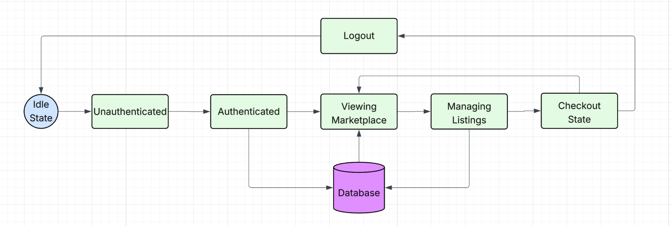

5.3 Control specification (CSPEC)

The system uses event-driven control logic:
- User input triggers events.
- Backend validates state.
- If valid, state transition occurs.
- If invalid, error state is returned.
Security control rules:
- Only authenticated users may create/edit/delete listings.
- Only admin users may remove content.
- Session timeout returns system to Unauthenticated state.

6.0 Restrictions, Limitations, and Constraints

This section outlines the critical restrictions, limitations, and constraints that impact the design, implementation, deployment, and operation of The Vault. These components stemmed from evaluating the technical environment, security requirements, availability of resources, and Hampton University. Understanding these limitations ensures realistic expectations and helps guide design decisions throughout development.

6.1 User and Access Restrictions (Noah Higgs)

The Vault is specifically geared towards university students. Even though students are allowed access to register, log in, and interact with the system they will not have admin access features to the marketplace. This restriction prevents any accidental data breaches for the users and provides an extra layer of security for the data being collected by the staff. Only emails ending in (hamptonu.edu) will be allowed to access The Vault to ensure that it is only Hampton University students accessing.
Administrator credentials are not stored in the source code. The admin login reads its username and password from the .env file (or the deployed environment configuration), so admin access can be changed or revoked without modifying code.

6.2 Functional Limitations

The Vault’s scope is limited to a basic campus marketplace for clothing items. Certain features commonly used in online marketplaces are excluded from this version of the system for this iteration/project. These limitations are: no integration with external e-commerce platforms or third party marketplaces, no advanced analytics, artificial intelligence, or recommendation systems.

These functional limitations ensure the project is manageable and meets course requirements and deadlines.

6.3 Technical and Platform Constraints (Noah Higgs)

The application contains no hardcoded credentials. The Flask session secret key, database settings, S3 settings, and admin login are all supplied through environment variables. They are loaded locally from a .env file with python-dotenv and set in the Elastic Beanstalk configuration when deployed. In production the application is served with Gunicorn.
AWS constraints the team is working around:
- Credit limit: each team member has $200 in AWS promotional credits, so deployments and testing are coordinated across accounts to avoid overspending.
- Free Tier limits: storage and service usage are limited, so resources are kept small and unused ones are shut down.
- Network access: RDS is reachable from the Elastic Beanstalk environment and explicitly approved IP addresses through Security Groups. A misconfigured rule can block deployment or connectivity, and a new developer IP must be added before local testing will connect.
- Shared infrastructure: The team shares one RDS instance and one Elastic Beanstalk environment, so database credentials are shared and rotated together.
- Environment configuration: variables must be set separately in the Elastic Beanstalk environment, because the local .env file is not deployed.

6.4 Security and Data Handling Constraints

Security requirements create more constraints and restrictions to the system design. The user passwords are hashed before storage, and no plaintext credentials are kept in source code or the repository. Access to sensitive data must follow basic cloud security practices that are efficient and safe such as proper authentication, authorization, and access control.

The system only collects necessary data for key functionality like usernames and passwords. The limit reduces risk exposure and is responsible for data handling. It also keeps it compliant with security standards of Hampton University’s student systems.
Secrets handling: The .env file is excluded from version control through .gitignore, and only .env.example is committed. No plaintext credentials appear in source files or team documentation. Each team member keeps their own local .env file, and the deployed values are set in the Elastic Beanstalk environment configuration.
Credential rotation: Any credential that has been committed to the repository or shared in documentation must be rotated. After rotation, the new values are entered only in the .env file and the Elastic Beanstalk environment configuration. Rotating the session secret key signs out all active sessions. AWS access keys are in scope only if real ones were ever committed.
No default secret key: The application does not include a default secret key and If SECRET_KEY is not set, the application still starts. Sessions cannot be signed, so login fails and a message is printed to the console. It also commits a default key to the repository, and anyone who has the key can forge a session cookie and appear logged in as another user. SECRET_KEY must be set in the .env file and in the Elastic Beanstalk environment.
Admin password storage: The admin password is currently stored as plain text in the .env file or the deployed environment configuration, and it is protected by keeping that file out of version control. A future improvement is to treat administrators like regular users, with hashed passwords stored in the database, so that no plaintext admin credential exists anywhere.

6.5 Resource and Schedule Constraints

The creation of The Vault is constrained to the course timeline, which requires all design, implementation, testing, and documentation to be completed within iteration deadlines. This limits the features that can be implemented.

6.6 Collaboration and Tooling Constraints

All documentation and collaboration is limited to google drive for documentation, GitHub for uploading code, and Jira for project timeline and plan. Communication is done by in person meetings, phone calls, and apple Imessage group chat. This requires consistent communication and collaboration and clarity of schedules and expectations.

6.7 Scalability Constraints

The current implementation of The Vault is constrained to a single campus deployment and limited features. Expansion to other campuses and services is outside the scope of this project and would require more resources, time, and security.

7.0 Validation Criteria (Noah Higgs)

Login Page
- Users are able to create an account
- Users are able to login to their already existing account
- The account login information will be stored into the database
- Once the login process is complete, the user will be brought to the listing page
Listings Page
- Users can view several different listing posted
- Users can create their own listing
- Users can edit their existing listing
- Users can select to buy a listing
- All user-created listing information will be stored into the database
- After the user selects to buy a listing, they will be brought to the checkout section
Checkout Page
- Users can confirm their order and submit their contact details and meeting location.

7.1 Classes of tests (David Jackson and Ryan Grimes)

- Unit Testing: This is when a tester tests small chunks of code, like a single function or method, to make sure it does what it’s supposed to. The goal is to confirm that the logic the developer wrote works the way they intended (GeeksforGeeks, 2025). This will be easily implemented by the Vault because programmers will test functionality before changes are committed to the shared repository.
- Integration Testing: This type of testing checks how different pieces of the software work together. It makes sure that data flows correctly between components and that nothing breaks when modules are combined (GeeksforGeeks, 2025). This will consistently be implemented individually and collaboratively by validating changes before commitment and validating changes on each individual’s desktop after commitment.
- System Testing: Once everything is integrated, system testing looks at the entire application as a whole. It checks if the full system meets the requirements and works the way it’s supposed to (GeeksforGeeks, 2025). This won’t be as heavily desired since a finished, working product isn’t expected by the customer.
- Black-Box Testing: In black-box testing, the tester doesn’t need to know how the system is built on the inside. They just provide inputs and check the outputs. This helps reveal how the system reacts to different user actions, whether expected or not, and can point out issues with usability, reliability, or performance. Common types include functional, non-functional, and regression testing (GeeksforGeeks, 2025;Imperva, n.d.). This may be difficult to implement because everyone is a programmer, so we’re expected to know how the system is built on the inside. To mitigate this issue, we can have individuals who did not code the tested functions test the functions.
- White-Box Testing: In white-box testing the tester has full access to the code, structure, and configuration. It checks the logic, data flow, and error handling to make sure everything inside the program runs the way it should (GeeksforGeeks, 2025; Imperva, 2025). This will be heavily and consistently used throughout coding. White-box testing should be done by every member of the team, and the software lead should do a very in-depth white-box testing.
- Security Testing: Ensures compliance with data protection policies and safeguards against vulnerabilities. Automated pytest checks verify that protected routes reject unauthenticated users The admin login uses environment-based credentials, and that no secrets are hardcoded. Testing also includes penetration testing and input validation checks.
- Functional Testing: Verifies that all specified functionalities operate as expected. Edge cases must also be tested.
- Usability Testing: Confirms that the system offers a clear and accessible interface.
- Scalability and Stress Testing: Verifies the system’s ability to handle large volumes of data and spikes of traffic without significant performance degradation.

7.2 Expected software response

- Scalability: Ability to process high volumes of listings and users.
- Security Compliance: No unauthorized access to restricted data or features, encrypted storage of sensitive data.
- Usability: Clear and accessible interface, ensuring seamless user interactions.
- Fault Tolerance: The system must be able to remain stable during unexpected failures, with automatic recovery and fallback mechanisms.

7.3 Performance bounds (Noah Higgs)
- Admin Security: Only authorized users should be able to access the admin page. Admin credentials come from the environment, and admin routes must reject any request without a valid admin session.

8.0 Code Contributions and Description

8.1 David Jackson Code Contributions
Iteration 3 code contributions include three backend files added and one modified in order to support administrative functionality in the Vault project. These updates allow authorized administrators to monitor activity on the platform and remove inappropriate users or listings. The purpose of these changes is to implement a structured admin control system using the existing backend architecture.
Files created/added to:
- admin_controller.py
- admin_service.py
- admin_model.py
- app.py

admin_controller.py
This file defines the API endpoints that allow administrators to interact with the system. It creates a Flask Blueprint called admin_bp, which groups all admin-related routes under the /admin URL prefix. The controller receives HTTP requests from the frontend and calls the appropriate service functions to process the request. These routes allow administrators to retrieve all users, delete users, retrieve all listings, delete listings, and view storefronts. The controller also ensures that only authorized administrators can perform these actions before forwarding requests to the service layer. Once the request is processed, the controller returns the results to the frontend in JSON format.

admin_service.py
The service layer contains the business logic that supports administrative actions. It acts as the middle layer between the controller and the model. The service validates input parameters, enforces any rules for administrative operations, and calls the model functions that interact with the database. For example, when an admin requests to delete a user or listing, the service verifies that the required ID was provided before passing the request to the model. This separation helps maintain clean architecture by keeping validation and system rules out of the database layer.

admin_model.py
This file manages all database-level operations related to administrative functionality. It connects to the PostgreSQL database using the shared database connection defined in db.py. The model executes SQL queries to retrieve or modify data in the database. The functions in this file allow administrators to retrieve all users, retrieve all listings, retrieve storefronts, and permanently delete users or listings. The model layer focuses strictly on database interaction and does not contain any business logic.

app.py
The app.py file was modified to register the new admin routes with the Flask application. Specifically, the file imports the admin_bp Blueprint from controllers.admin_controller and registers it using app.register_blueprint(admin_bp). This step is necessary because Flask applications must explicitly register Blueprints before their routes become accessible. Without this change, the admin endpoints such as /admin/users or /admin/listings would not be recognized by the application. Registering the Blueprint integrates the admin functionality into the existing backend API structure alongside the listing and storefront routes.

Iteration 4:
Iteration 4 code contributions include three frontend files added and two modified in order to support administrative functionality in the Vault project. These updates created the frontend for the previous admin backend files created in the last iteration. Allow authorized administrators to monitor platform activity and remove inappropriate users or listings. The purpose of these changes was to implement a user-friendly UI that users with admin access can use to effectively complete admin activities.

Files created/added to:
- admin_dashboard.html
- admin.css
- admin.js
- auth_controller.py
- admin_controller.py

admin_dashbaord.html
This file defines the structure and layout of the admin dashboard interface. It creates a simple webpage with three main sections: Users, Listings, and Storefronts. Each section includes a button that lets the administrator load data from the backend, and a table that displays it dynamically. The file links to the external CSS file for styling and the JavaScript file for functionality. Overall, this file serves as the main user interface that administrators interact with after logging in.

admin.css
This file controls the visual styling of the admin dashboard. It defines the overall look and feel of the page, including the light gray background, white section containers, table formatting, and button styles. It also includes specific styling for delete buttons, making them red. The purpose of this file is to improve the readability and organization of the dashboard without affecting its functionality.

admin.js
This file handles the dynamic functionality of the admin dashboard by interacting with the backend API. It contains functions that send HTTP requests to retrieve users, listings, and storefronts, as well as functions to delete users and listings. After receiving data from the backend, the JavaScript dynamically updates the HTML tables to display the information. This file makes the dashboard interactive and ensures administrators can perform actions without reloading the page.

Iteration 5:
Iteration 5 code contributions included 2 completely new files, admin_login.html and test_admin.py. It also included updates or modifications made to 8 other code files with the purpose of improve both functionality and appearance of the admin dashboard. The purpose of these new files and updates were to incorporate a login page for admin users of The Vault, as well as expand on our previous version of the admin dashboard that was lacking in depth.
Files created/added to:
- test_admin.py
- admin_login.html
- Auth_controller.py
- admin_model.py
- admin_dashboard.html
- login.html
- admin.css
- admin.js
- auth_controller.py
- admin_controller.py

test_admin.py
This file contains both unit tests and integration tests for the admin dashboard functionality. The unit tests verify that routes, authentication, and API responses behave correctly by simulating requests and using controlled test data. The integration tests connect to the real PostgreSQL database and confirm that operations such as deleting users, listings, and storefronts actually modify the database as expected.

admin_login.html
This file defines the structure and layout of the administrator login page. It provides a dedicated interface separate from the standard user login, allowing administrators to securely authenticate before accessing the admin dashboard. The page includes input fields for username and password, styled consistently with the existing application theme to maintain a unified user experience.

8.2 Elali McNair Code Contributions

Elali was responsible for creating the backend portion of the wishlist and purchase history features for The Vault marketplace product. Due to the frontend portion of the features not being ready to be implemented yet, the code will have to remain unused and inoperational for now.
Files Created/Added to:
- Init_db.py
- app.py
- wishlist_service.py
- purchase_service.py
- wishlist_model.py
- purchase_model.py
- wishlist_controller.py
- purhcase_controller.py
The service, model, and controller files were created not only for connectivity with the corresponding data tables but also serves as a setup placement for the frontend portion of the code. The wishlist and purchase history features will be active in nearly every part of the marketplace, either due to UI design or data recall with the listing data structures. Since both features will be created and regularly updated by the user they were added to the services folder and perform similar to the listing_service.py file. With the same reasoning and purpose, these features were added to the model and controller folders as well due to the constant potential editing or updates the user will make. The additions to the init_db.py were to serve as the initial data tables the user’s entered information will be saved as, while the app.py additions were made to check the features functionality during the creation of the application.

Iteration 4
Elali was responsible for creating the front end portion of the “Create Listing" feature, “Wishlist” feature, and “Purchase History” feature for The Vault marketplace product. Now that the frontend portion of code has been created and implemented the backend portion of code for all three of these features is operational along with the frontend portion.
Files Created/Added to:
- app.py
- listing_controller.py
- Storefront_controller.py
- create_listing.py
- create_storefront.css
- storefront_view.css
- create_listing.js
- storefront_view.js
- account.html
- create_listing.html
- storefront.html
- storefront_view.html
App.py, listing_controller.py, storefront_controller.py, create_storefront.css, storefront_view.css, storefront_view.js, account.html, storefront.html, and storefront_view.html were all edited to route properly to my backend portion of code and the files I created. Create_listing.py, create_lisitng.js, and create_listing.html were created this Iteration to complete the frontend portion of these features. The “storefront” files, along with account.html and app.py, were edited to properly implement the “Wishlist” feature. The “listing” files, along with account.html, app.py, and listing_controller.py were edited if not created to properly implement the “Create Listing” feature.

Iteration 5
Elali was responsible for creating the test files for the “Create Listing” and “Wishlist” features. Along with the test files, Elali also made functional edits to both of these features as well.
Files Created/Added to:
- Listing_controller.py
- Requirements.txt
- Storefront_view.css
- Create_listing.js
- Storefront_view.js
- Create_listing.html
- Test_create_listing_feature.py
- Test_wishlist_feature.py
Listing_controller.py, Requirements.txt, Storefront_view.css, Create_listing.js, Storefront_view.js, and Create_listing.html were all edited to change the wishlist icon to make it more appealing and to make sure the listings being created or edited were saved and properly updated regularly. The new files created were test_create_listing_feature.py and test_wishlist_feature.py. They were test files created to check if both features were working properly and performing their tasks.

8.3 Madison Boyd Code Contributions

Madison was responsible for the User Settings, implementing a modular design the manage user preferences and application configuration. She created the module using the MVC (model view controller) and service pattern to ensure separation and modularization of the application. She created a data model to define settings attribute, a controller to manage user driven requests, and a service layer to facilitate file I/O operations and persistence. Additionally, she implemented a testing file to validate data integrity, ensuring the application correctly handles both valid user inputs and invalid edge cases during file operations.

Files Created/Added to:

- usersettings.py the core service file responsible for reading, writing, and persisting user configuration data to the local file system, added usersettings.py file in models to define the structure and data attributes for the user settings object. Added a usersettings.py file in controller to manage the interface between the user/UI and the settings logic, routing requests to the correct services. I added a usersettings.py in the services folder which summarizes the logic and file handling procedures for the settings module.
- usersettingstest.py testing file that validates the settings logic, including input validation and file integrity checks

Iteration 4

Madison was responsible for designing and implementing the Account Screen for The Vault front-end, focusing on creating an intuitive and user-friendly interface for managing user activity. She developed the account.html file to structure and display key user information, including listings, wishlist, purchases, and sales history. The interface was designed using a tab-based navigation system, allowing users to seamlessly switch between different categories of their account data.
She ensured the layout clearly presents the user’s username at the top of the screen, showing personalization and user context. Additionally, she incorporated navigation functionality that allows users to easily return to the storefront or log out of their account.
Files Created/Added to:
- account.html – Core front-end file responsible for structuring the Account Screen UI, including tab-based navigation for user listings, wishlist, purchases, and sales history. Also includes display elements for the username and navigation options such as returning to the storefront and logging out.
Iteration 5:
Madison expanded her contributions by enhancing the testing and validation of the Settings functionality for The Vault, with a focus on ensuring reliability and integration with other account features. She updated the usersettingstest.py file to include additional unit and integration tests that verify both core settings behavior and its interaction with the broader application.
She implemented tests to confirm that account screen buttons displayed within the settings page correctly navigate users to their respective sections, ensuring consistency between the Settings interface and the Account Screen. This helped validate that the front-end navigation she previously developed functions properly across multiple components of the application.
In addition, she developed tests to verify that purchase history updates are accurately reflected within the user interface after transactions are completed. This ensures that user data remains synchronized between the settings, account screen, and backend systems.
Files Created/Added to:
- usersettingstest.py – Updated to include additional unit and integration tests for Settings functionality, including validation of account screen button navigation and purchase history updates.

8.4 Ryan Grimes Code Contributions

Ryan was responsible for the user registration and signup backend logic. He was able to create a file that connects the IDE (VS Code Studio) to the AWS RDS PostgresSQL instance, a file that initializes the user table with attributes (unique ID, username, email, password, role [admin or user]), a file that tests the IDE’s connection to the database, a file that tests if users’ credentials are being stored in the database, a file that tests the cart’s functionality, a file that registers users and checks Hampton University association, a file that verifies a user’s credentials during the login process by fetching the username from the database and uses an imported file that compares the password hashes, and a file that routes users between pages based on interactions and permissions. When it comes to user interface, Ryan designed the screens for the sign up and log in process in addition to the cart screen and backend.

Files Created/Added to:
- App.py: Executes the software.
- auth_utils.py: Hashes passwords and verifies hash comparisons.
- test_user.py: Tests if the database is storing user credentials.
- test_db.py: Test if the IDE is connected to the AWS RDS PostgresSQL instance.
- auth_services: Register user and validate login.
- auth_controller.py: Routes user based on permissions.
- db.py: Connects IDE to AWS RDS.
- init_db.py: Creates table schemas.
- Index.html: Front-end for welcome screen
- Signup.html: Front-end for sign up screen
- Login.html: Front-end for login screen
- Cart.html: Front-end for cart screen
- test_user_driver.py: Tests ability to store and retrieve credentials
- test_db_driver.py: Tests database connection
- test_cart_functionality_driver.py: Tests cart functions

8.5 Day Ekoi Code Contributions
Iteration 3 Code contributions include files added to the backend development of The Vault by implementing the core components responsible for storefront and listing management within the system.
Files Created/ added to:
- Listing_model.py
- Listing_controller.py
- Listing_service.py
- Storefront_model.py
- Storefront_service.py
- Storefront_controller.py
- db.py
- Init_db.py
- app.py
- mock_data.py
Focused on enabling users to create storefronts, publish listings for their products, and manage inventory while making sure everything works correctly with the database.
More specifically, the development of the storefront management functions (storefront_models.py, storefront.services.py, and storefront_controller.py). These files allow a registered user to create and maintain a storefront associated with their account. The storefront stores information such as the brand name, description, and any visuals such as logos or banners. Regarding the database structure, I designed it in a way that each storefront is tied to a specific user account through a foreign key relationship which ensures proper ownership and prevents unauthorized access.
The development of the listing management functionality (listing_model.py, listing_service.py, listing_controller.py) allows storefront owners (which are now considered brand owners) to create and manage listings within their storefront. Listings contain attributes such as title, description, price, and inventory information. It was designed for the system to support both inventory-based listings and pre-order listings, allowing brand owners to either manage existing stock or accept orders that are produced after purchase. Additional listing features implemented were listing image functionality and size based inventory tracking. The system allows multiple images to be associated with each listing and the system stores image URLs that reference files stored in S3. The system also now allows for clothing items in each listing to have different stock quantities depending on size, so each listing can track available quantities for individual sizes and it also auto updates to SOLD_OUT once quantity reaches 0. This makes the inventory system a lot more realistic.
Contributions to the database schema design, with creating several key tables including:
- Storefronts
- Listings
- Listing_images
- listing_sizes
Which were all implemented in the init_db.py file as well.
Lastly, there were additional files such as db.py, and mock_data.py added in order to successfully connect our new code structure to the database and test it.

8.5.1 Day Ekoi Coding Contributions - I4
Iteration 4 code contributions include files added to the frontend development of The Vault, implementing the core components responsible for the storefront browsing and creation experience.
Files Created/Added to:
- Storefront.html
- Storefront.css
- storefront.js
- Storefront_view.html
- Storefront_view.css
- Storefront_view.js
- Create_storefront.html
- Create_storefront.css
- Create_storefront.js
- Storefront_controller.py (updated)
storefront.html Serves as the main skeleton and entry point for the storefront homepage. Defines the page structure including the top navigation bar with bag and profile icon routing, a side navigation pane with Create Storefront and Create Listing buttons, a logo and search section, and the storefront card grid container where cards are injected dynamically by JavaScript. The pagination controls at the bottom of the page are also defined here.
storefront.css Handles all styling and layout for the storefront homepage. Styles the top navigation bar, menu button, side navigation pane, brand title, search bar, storefront cards, listing preview images, Add to Bag and Enter Storefront buttons, and pagination controls. Includes responsive design considerations to maintain consistent layout across different screen sizes.
storefront.js Dynamically generates storefront cards by fetching data from the backend API. Renders each card with the store logo, brand name, listing previews, and an Enter Storefront button that routes to the individual storefront view.
storefront_view.html Defines the page structure for the individual public-facing storefront page. Includes the banner, overlapping logo, store description section, and listing grid container.
storefront_view.css Controls the styling and layout of the storefront view page. Styles the banner, overlapping logo, back button, brand info, store description, and listing grid.
storefront_view.js Fetches and renders individual storefront data dynamically using the storefront ID from the URL. Populates the banner, logo, description, and listing grid with live data from the API.
create_storefront.html Defines the page structure for the storefront creation form. Includes input fields for brand name, description, logo, banner, contact info, categories, and preview images.
create_storefront.css Handles all styling for the create storefront form page. Styles the form fields, upload sections, category checkboxes, and action buttons.
create_storefront.js Captures form input on submission and sends it to the backend to create a new storefront. On success, the new storefront is reflected as a card on the homepage.
storefront_controller.py (updated) Updated to add Flask page routing for the storefront homepage, storefront view, and create storefront pages. Routes are registered under the storefront_pages_bp blueprint.

8.5.2 Day Ekoi Coding Contributions - I5

Iteration 5 code contributions include files added and updated to complete the storefront system, S3 image upload integration, listing lifecycle management, returns system, and database schema migrations for The Vault.
Files Created/Updated:
- utils/s3.py
- storefront_controller.py (updated)
- storefront_service.py (updated)
- storefront_model.py (updated)
- storefront.html (updated)
- storefront.css (updated)
- storefront.js (updated)
- storefront_view.html (updated)
- storefront_view.css (updated)
- storefront_view.js (updated)
- my_storefront.html
- my_storefront.css
- my_storefront.js
- create_storefront.html (updated)
- create_storefront.css (updated)
- create_storefront.js (updated)
- edit_storefront.html
- edit_storefront.js
- listing_controller.py (updated)
- return_controller.py
- return_service.py
- return_model.py
- returns.html
- returns.js
- init_db.py (updated
utils/s3.py
Created to handle all image upload functionality for the application using boto3. Provides the upload_image_to_s3() function which uploads image files to the configured S3 bucket and returns a public URL, used across storefront creation, listing creation, and return submissions.
storefront_controller.py
Updated to add the S3 image upload endpoint, page routing for the edit storefront page, edit listing page, and my storefront dashboard. Also added the storefront reactivation endpoint to restore a previously deactivated storefront and its associated listings.
storefront_service.py
Updated to add reactivate_storefront_service(), normalize_storefront_categories(), and support for the new storefront fields including contact info, preview images, and categories in both the create and update service functions.
storefront_model.py
Major refactor to support the expanded storefront schema, updating all model functions to include the new fields added to the storefronts table and fixing get_active_storefronts() to correctly filter by active status.
storefront.html / storefront.css / storefront.js
Updated to pull live storefront data from the database via the backend API, replacing the previous static implementation. Added real-time search functionality to filter storefronts based on user input.
storefront_view.html / storefront_view.css / storefront_view.js
Updated to dynamically fetch and render storefront data using the storefront ID from the URL, including banner, logo, store description, contact info, and listing grid. Added a lightbox image viewer for listing image previews.
my_storefront.html / my_storefront.css / my_storefront.js
New files created to implement the My Storefront dashboard page where brand owners can manage their storefront and listings. Includes buttons to edit, create listings, view the public storefront, and deactivate.
create_storefront.html / create_storefront.css / create_storefront.js
Updated to support the expanded storefront creation form including contact info, categories, and up to four preview images. The JavaScript was updated to handle S3 image uploads before form submission.
edit_storefront.html / edit_storefront.js
New files created to implement the edit storefront page, pre-populating all existing storefront fields on load and allowing the brand owner to update any field including uploading new images to S3.
listing_controller.py
Updated to integrate S3 image uploads into the listing creation flow supporting up to four images per listing. Added deactivate, reactivate, and restore endpoints for listing lifecycle management.
return_controller.py / return_service.py / return_model.py
Created to implement the full returns system backend, handling return form submissions including optional damage image uploads to S3, service-layer validation, and database record creation.
returns.html / returns.js
New files created to implement the returns page frontend where users can submit a return request with order number, reason, damage status, and an optional damage image upload.
init_db.py
Updated to add the orders, order_items, and cart_items table schemas and ALTER TABLE migration statements for new columns added to the storefronts and listings tables, executed on every application startup.

8.6 Kaila Roberts Code Contributions

For iteration 3, my code contributions consist of constructing and adding to the following files: listings.py, account_controller.py, and accountscreen.py.

listing.py
- This file is a part of our front-end development. Its purpose is to create a browser listing screen that will hold all listings created that are readily purchasable or available for pre-order. It allows users to view all listings in addition to our additional screen, which will be used to allow customers to view personal stores. Just like that, the screen, once a listing is chosen, will create a pop-up box and allow the user to view the listing's information. Creating this file, I used Python Tkinter for functionality. It also uses the requests library to communicate with the backend controller (listing_controller.py) and fetches the JSON data to build the marketplace grid.

Account_controller.py
- This file is a part of our back-end development. It supports the student dashboard or account screen, which will manage all user-specific data transactions. This file was made to process requests that involve student personal information and utilizes SQL queries that have parameters to fetch data based on the user_id for each user. In this document I was able to implement multi-table inquiry logic that will assist in verifying if the specific user has a storefront and any listings. Upon further testing, I will ensure the account management system will be able to be scaled independently as more features are added.

AccountScreen.py
- This file is a part of our front-end development. It serves as a centralized dashboard for managing account presence and more within the application. Using the Tkinter library, I created a modular layout that organizes user data into sections while using LabelFrame widgets. In this screen, users will be able to view five primary attributes: name, verified student email address, saved payment methods, purchase history, and (if applicable) personal listings. The interface is to be responsive and would update its view once navigated to, which ensures users are viewing their most recent/current account status.

Iteration 4 Contribution - Kaila Roberts
For iteration 4, my code contributions consist of constructing and adding to the following files: checkout.html, checkout.css, checkout.js, and app.py.
checkout.html This file is a primary component of our front-end web development. Its purpose is to provide a dedicated "Finalize Purchase" interface where users can complete their transactions after browsing the marketplace. I structured this page to include a dual-column layout: one section for collecting essential buyer data such as full name, campus email, and physical meeting location and a sidebar for the order summary. I implemented Flask's Jinja2 templating to include dynamic navigation, specifically adding a "Back to Cart" function that allows users to return to their bag without losing their session data.
checkout.css The checkout experience's visual architecture is managed by this file. I used CSS Flexbox and custom linear gradients to match the storefront's gold-on-black theme in order to preserve brand coherence with "The Vault" aesthetic. I used metallic borders and semi-transparent backgrounds to create particular "glass-morphism" effects for the form containers. To make the interface feel responsive and high-end for the user, I also created unique hover states and transitions for the "Complete Transaction" and "Back to Cart" buttons.
Checkout.js The client-side logic needed for a working marketplace is handled by this file. It acts as a link between the user interface and the browser's storage. In order to dynamically create the list of purchased items and determine the final order total, I wrote scripts to retrieve JSON data from localStorage. In order to manage form submission, which clears the user's cart upon a successful transaction and initiates a confirmation alert, I also implemented event listeners. This guarantees that the purchase process is interactive and gives the student buyer instant feedback.
app.py My contributions to this back-end file involved managing the routing and integration of the checkout module within the Flask framework. I defined the @app.route(‘/checkout’) function to render the checkout template and ensured all static assets were correctly linked. I worked on the integration logic to ensure that navigation between the Cart, Listing Screen, and Checkout remained seamless. By managing merge conflicts on the development branch, I successfully integrated my new web routes with the team's existing codebase, ensuring a stable environment for further testing.
Iteration 5 Contribution - Kaila Roberts

For this iteration, my code contributions consist of constructing, refining, and integrating multiple components related to the checkout system, including backend logic, controller functionality, testing, and post-transaction features. I contributed with the following files: checkout_models.py, checkout_service.py, checkout_controller.py, order_confirmation.html, and test_checkout.py.
checkout_models.py
This file serves as the data access layer for the checkout system. Its purpose is to handle direct communication with the database and retrieve all necessary information required during the checkout process. I structured this file to support retrieving user information, cart contents, and item pricing. This includes pulling stored user data for existing accounts so their information can be automatically populated during checkout, as well as retrieving all items currently in the cart.
checkout_service.py
This file contains the business logic that drives the checkout process. I corrected and implemented the functionality responsible for calculating the total price of items in the cart, ensuring accurate accumulation of item prices and quantities. Additionally, I developed logic to manage the checkout workflow, including processing cart data, validating user input, and preparing order details for completion. Lastly, I also implemented functionality that clears the user’s cart once a purchase is successfully completed.
checkout_controller.py
This file is responsible for handling the flow of data between the frontend and backend during the checkout process. I contributed to structuring controller logic that connects user actions, such as initiating checkout and completing a transaction, with the appropriate service functions. This includes routing users through the checkout process and ensuring that once a transaction is completed, they are redirected to the order confirmation page. This file plays a key role in maintaining a smooth and functional user experience.
order_confirmation.html
This file provides the user interface displayed after a successful transaction. Its purpose is to confirm that an order has been processed and to provide the user with clear feedback. I contributed to designing this page to display confirmation messaging and relevant order details, ensuring consistency with the overall checkout design. This page completes the transaction flow by giving users reassurance that their purchase was successful.
test_checkout.py
This file was created to support testing and validation of the checkout system. Its purpose is to ensure that all major checkout functionalities perform correctly. I designed and implemented test cases to verify total cost calculations, validate correct retrieval of user and cart data, and ensure that the checkout process executes without errors. This establishes a foundation for automated testing and improves overall system reliability.

9.0 Revision Log (Noah Higgs)

Revision | By | Date | Description
1.0 | The Vault | 1/13/26-1/22/2026 | Initial documentation edits, focused on familiarization with the project and the requirements we will be addressing to complete it.
2.0 | The Vault | 1/23/26-2/12/2026 | Corrected a few restrictions and filled in sections 4 & 5. Added section 1.3.1
3.0 | The Vault | 2/12/2026- 3/5/26 | Updated section 3 to include diagrams and relationship models and added a section 8 to include code contributions and description
4.0 | The Vault | 3/5/26-3/26/26 | Added code contributions for iteration 4
5.0 | The Vault | 4/23/2026 | Added Code contributions for iteration 5. Updated 4.1.4.1-4.1.4.9
6.0 | Chase Jones | 9/30/2026 | Added Sections 4.1.7-4.1.12 documenting storefront management, wishlist management, transaction processing, and return request processing, which were implemented but undocumented. Added the four functions to the Section 4.1 function list and corrected four statements in Section 4.1 that contradicted the delivered build. All added and corrected text is highlighted.
7.0 | The Vault | 10/1/2026 | Moved secrets to environment variables, removed hardcoded secret key and admin login, added credential rotation and AWS constraints. Updated 1.3, 1.3.1, 1.4, 4.1.5, 4.1.6, 4.2.1, 6.1, 6.3, 6.4, 7.0, 7.1, 7.3. Added section 8.7.

