Assignment 1 – Traveling Salesman

Hongbo Zhu UNI: hz2629

Evolutionary Computation & Design Automation

(MECS E4510)

Instructor: Prof. Hod Lipson

Date Submitted: 9/29/2019

Grace Hours Used: 0 h

Grace Hours Remaining: 96 h

1. Results summary table
2. Methods
   1. Representation Method

To represent the order of the path, i.e. the gene of an individual in whole population, an integer list which contains a thousand number from 0 to 999 without repeat is used. The numbers in this list represent each point the salesman needs to reach, and the order of the number in the list represents the sequence of the path. For instance, list [5, 1, 4, 2 ,3] means the salesman starts from point 5, passes through points 1, 4 and 2 in sequence, then stops in point3.

* 1. Variation Operators

In this assignment, two different variation operators are used. In the first operator, under a certain possibility, the mutation process variates the gene of an individual by randomly exchanging two integers in the gene list. Besides, two points crossover method, which means randomly swapping a part of gene between two random positions on genes of two individuals, is also applied in this operator. In the second operator, mutation only exchanges two adjacent points in gene. To implement crossover, this operator divides each gene in two part and combines them into two new genes, i.e. single point crossover.

* 1. Selection Process

Two Selection processes are implemented in the assignment. One is roulette wheel selection, the possibility of choosing one individual is proportional to individual’s fitness, which is the length of path. If is the fitness a gene, them the possibility of being selected is

where is the number of genes, and is the fitness of each individual. By using this method, a individual who has a better fitness will be selected more likely.

The second method to select is truncation selection. In this method, genes are ranked in order by their fitness from high to low (for this assignment, to find the shortest path, the order is low to high, vice versa, the order is ranked in high to low when the longest path is needed). After ranking, the best of genes are selected ( is an integer which can be 1,2,3...) so that higher-fitness genes are chosen to produce more individuals in latter processes.

* 1. Analysis

For both selection methods in this assignment, the possibility of being selected is proportional to the fitness, so higher-fitness individuals are more likely be selected. However, in roulette research, low-fitness genes are still able to be selected. Hence, this method has a higher randomness. It is more likely to find a better solution after the algorithm find a local solution. For truncation searching method, low-fitness genes are removed so that the average fitness of population is higher than the roulette search. When these genes crossover, the offspring has higher possible to meet a better fitness. However, since the low-fitness are removed, when an individual finds a solution in the area of global solution but the fitness is not out of performance, this gene is probably omitted by this method.

For two different crossover method, two points crossover has some advantages than single point crossover. In single point crossover, a crossover point is chosen randomly, then gene to the right of the point are swapped. This method separates the start and the end part of a gene list. It possibly changes the information of gene when the start and the end of the gene are related. However, in 1989 Sysweda [1] proposed that there is no obvious difference between these two methods.

In mutation methods, exchanging two point in gene randomly have a higher randomness than exchanging adjacent point. When the outcome of algorithm is around local optimum solution, higher randomness is able to mind a better solution in searching space.

Random

[1] G. Syswerda, Uniform Crossover in Genetic Algorithms, International Conference on Genetic Algorithms Morgan Kaufmann Publishers Inc. 1989.

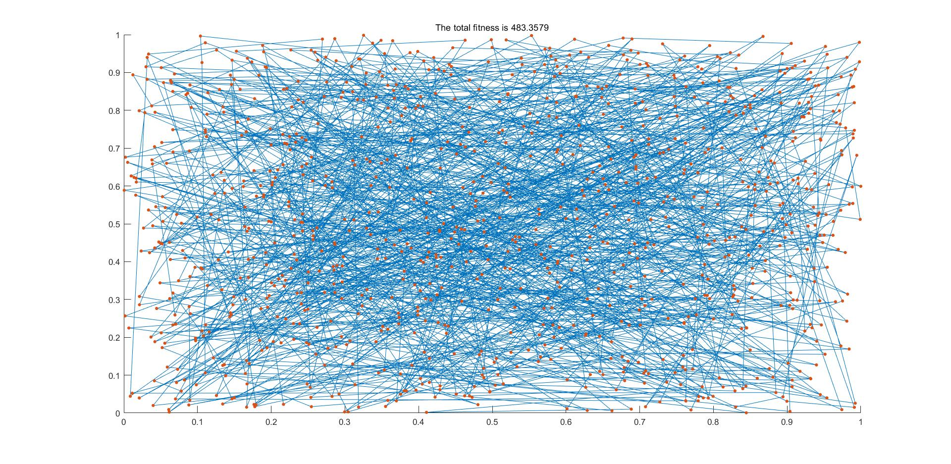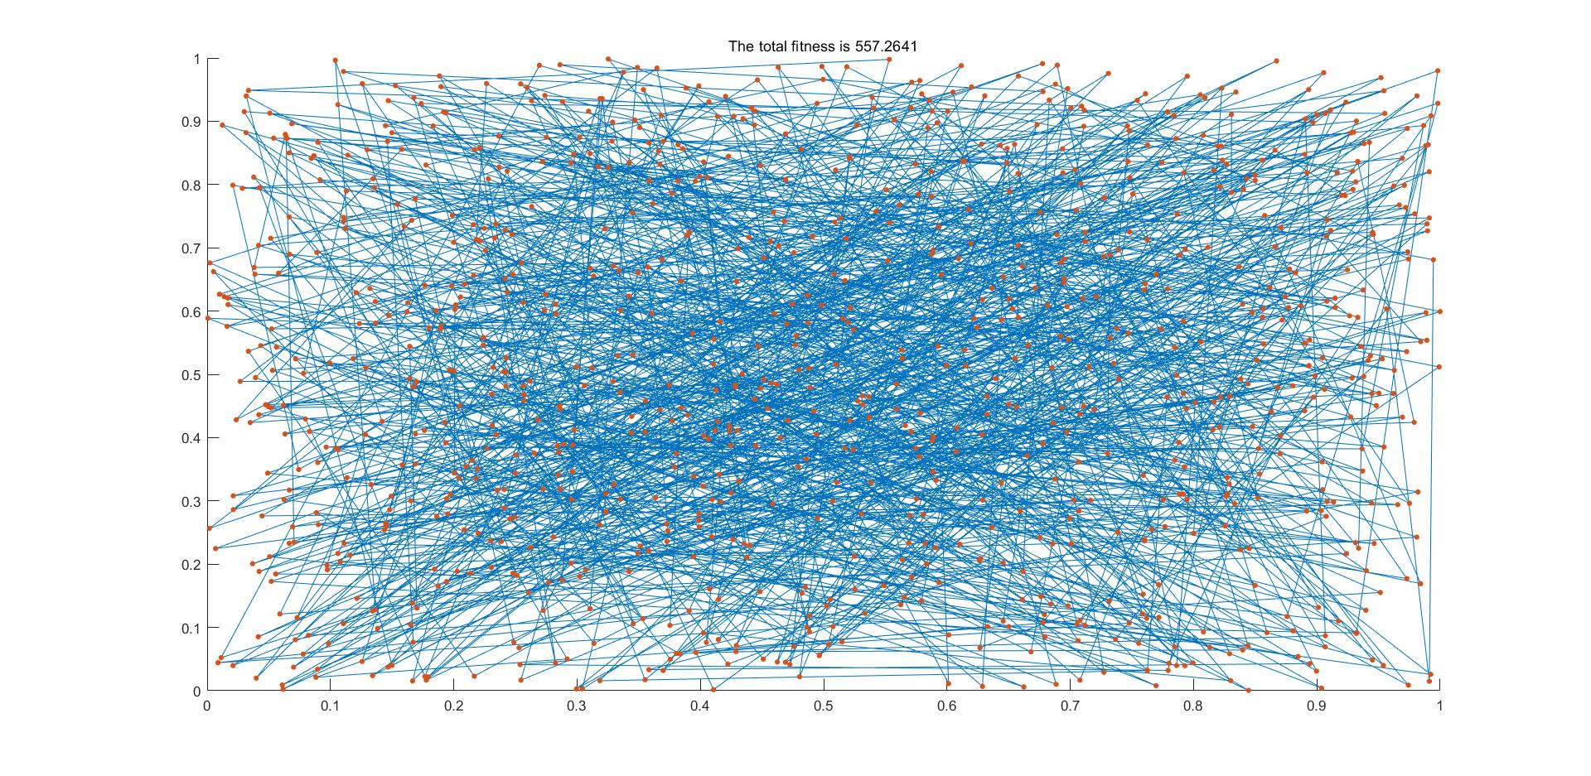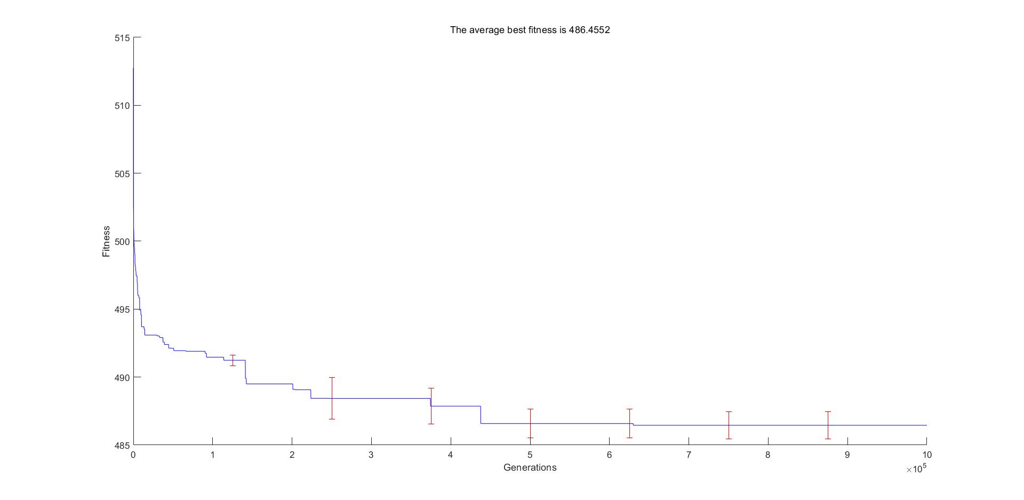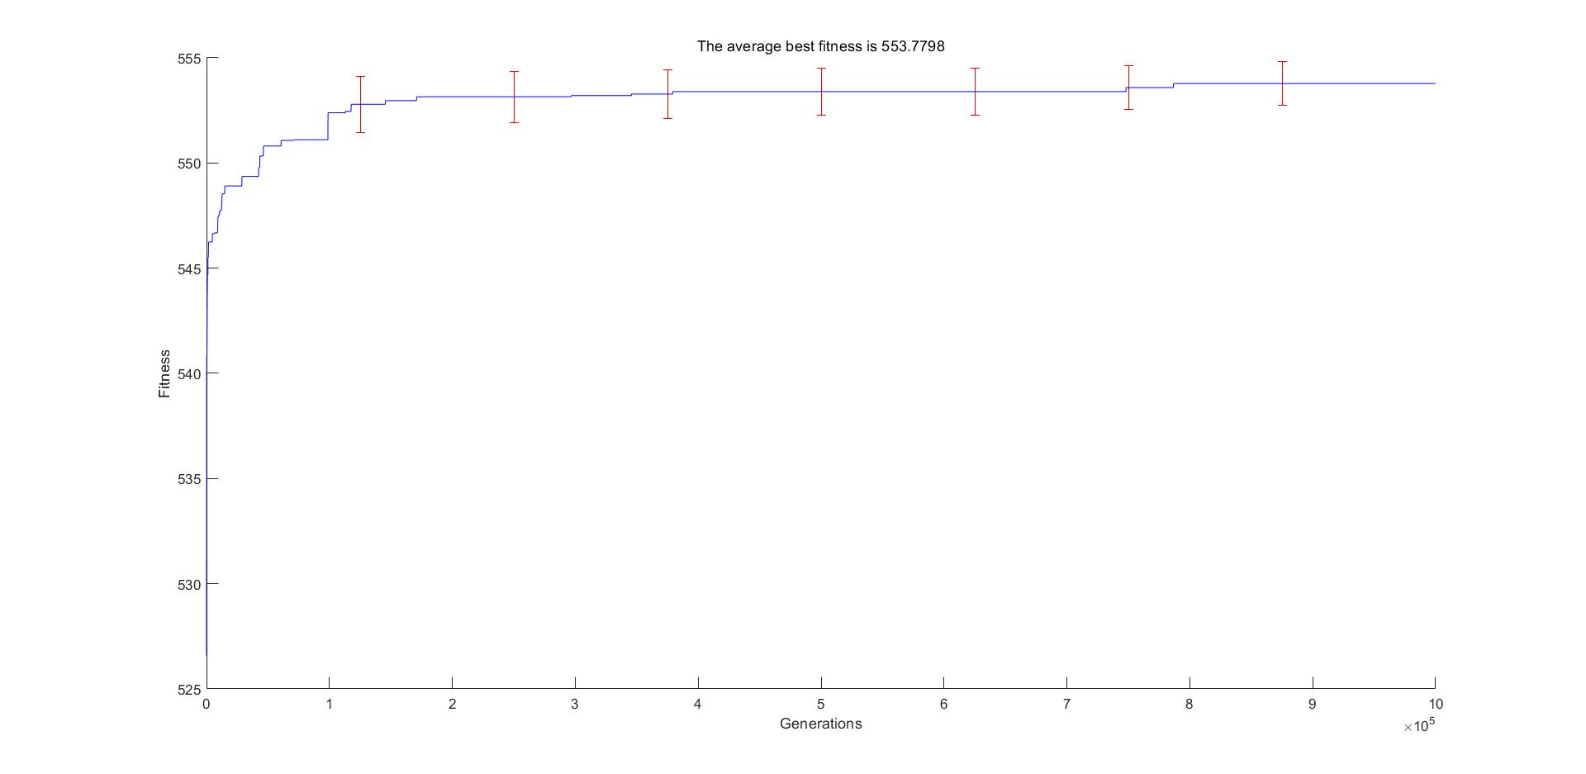

Climb

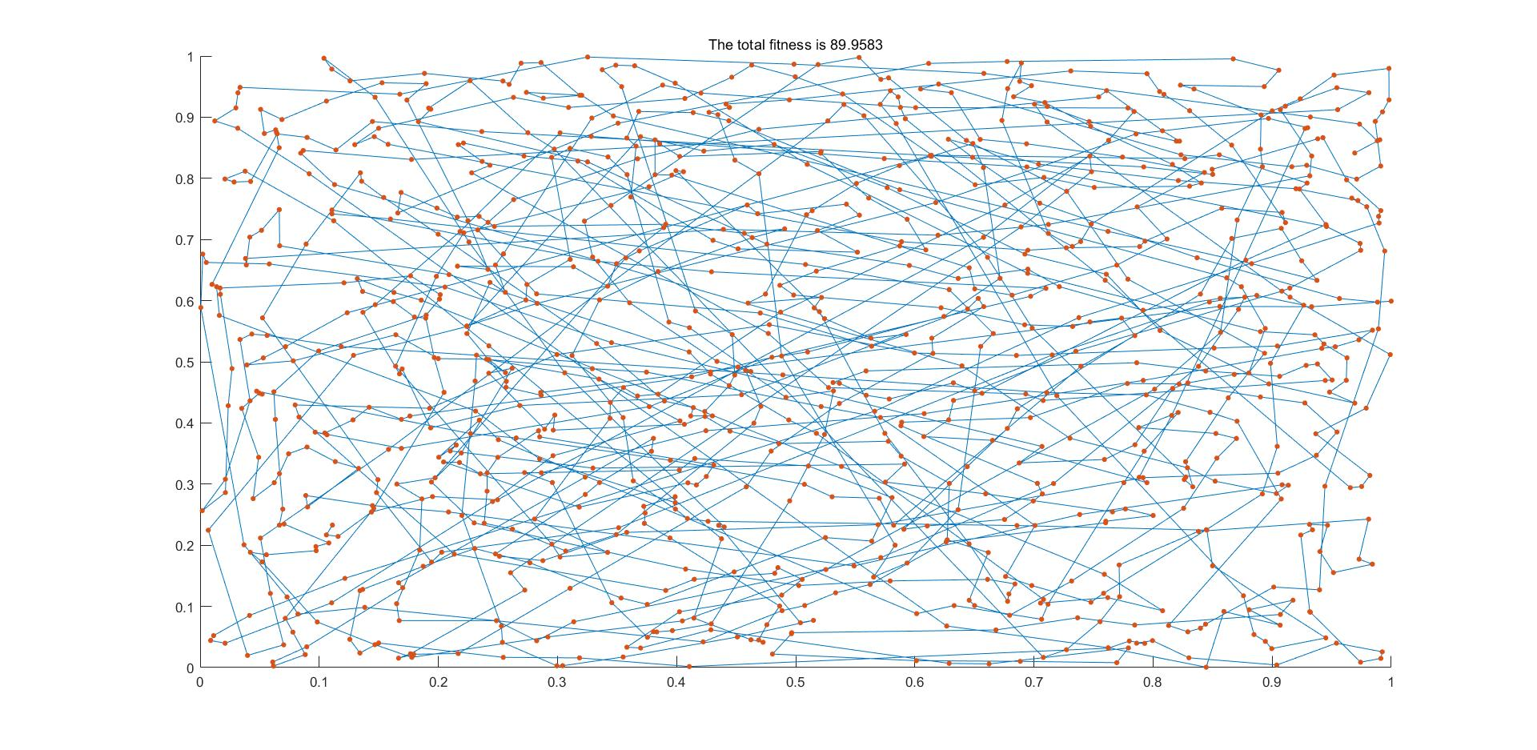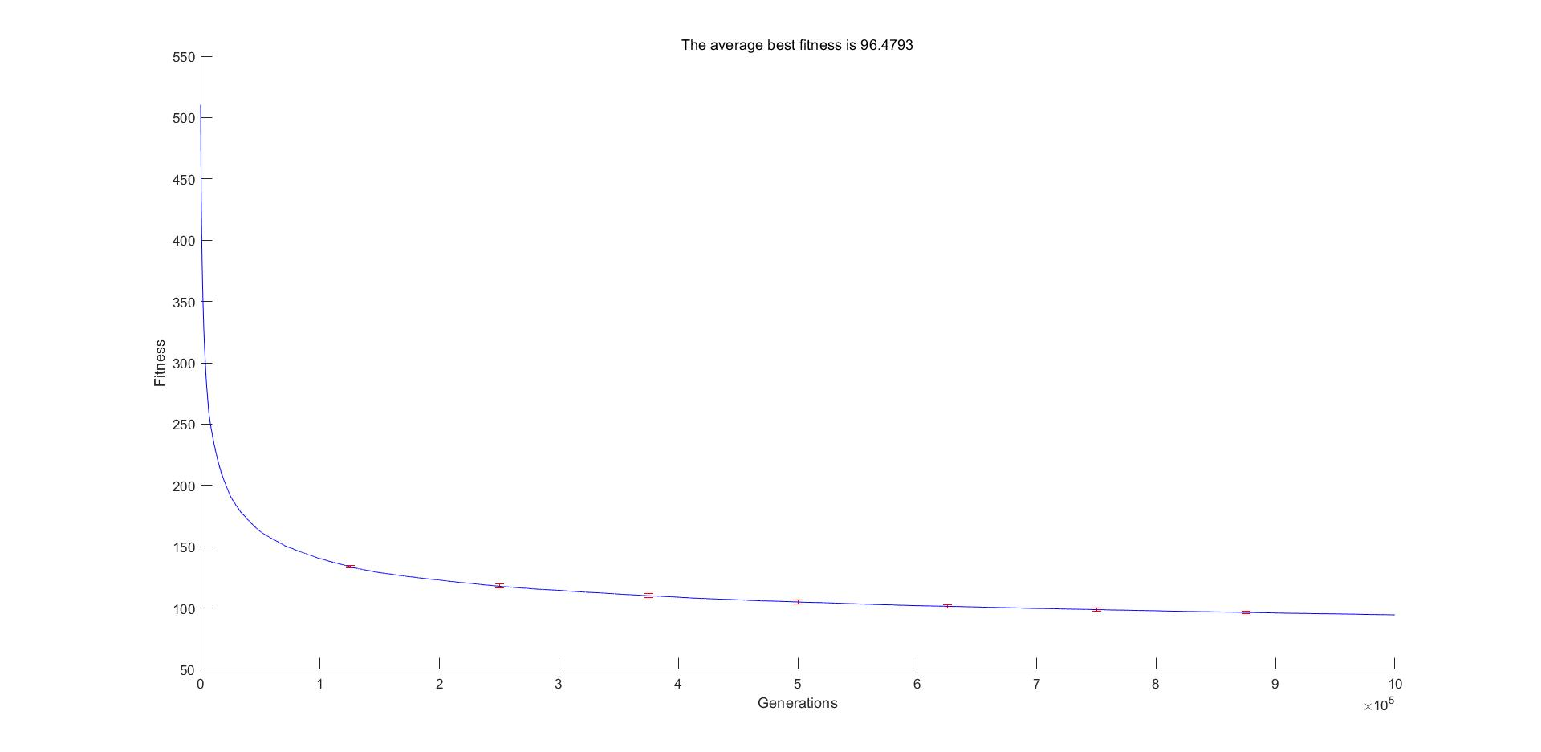

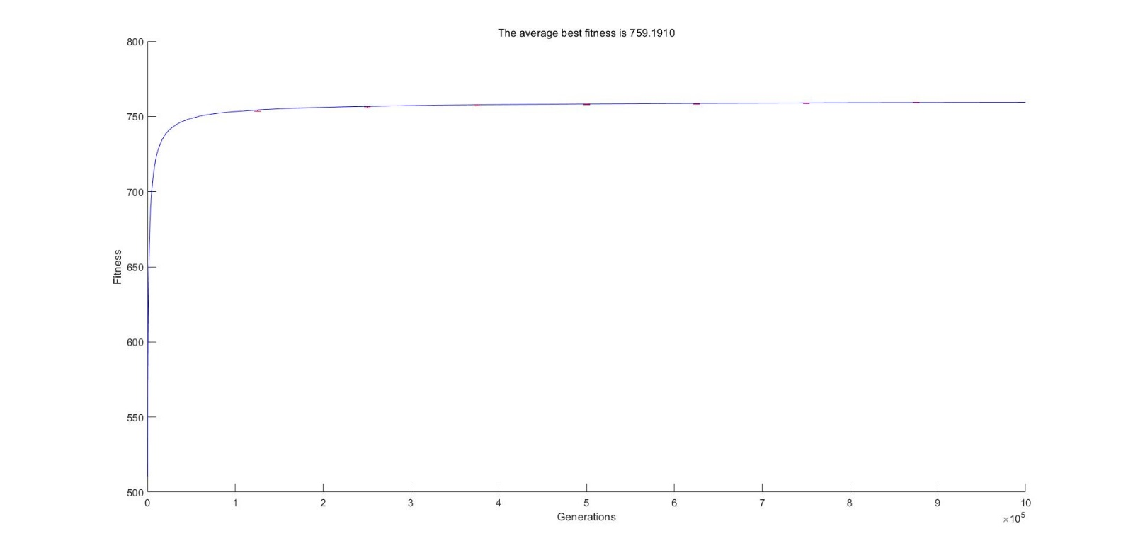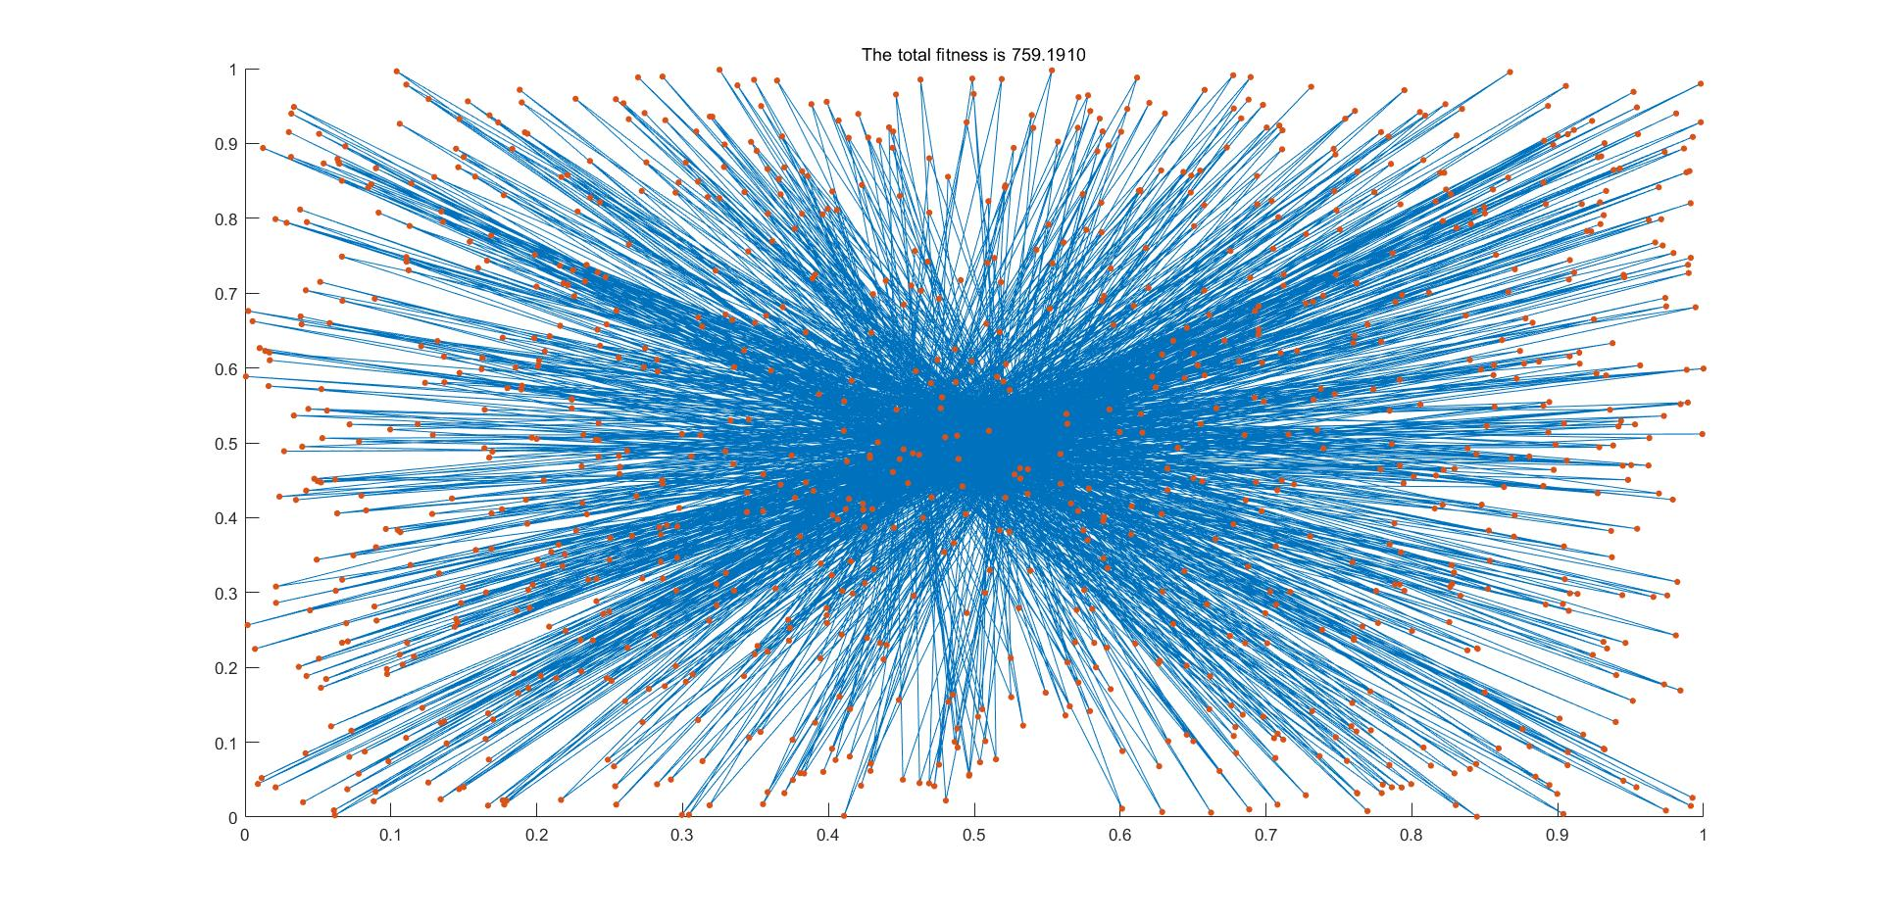

GA

Roulette Selection +

Truncation Selection

General

1. 5 Points: Cover page includes all information specified
2. 5 Points: General quality of the report (grammar, layout)
3. 5 Points: Random search curve submitted Sep 22
4. 5 Points: Summary result table showing all information requested
5. 5 Points: Dot plot for any one of the methods (not all required)
6. 5 Points: Convergence plot for any one of some methods (not all)
7. 5 Points: Code included (8pt courier single spacing)
8. 5 Points: Theoretical shortest path using Christofides' algorithm
9. 5 Points: Movie of optimizing path (one frame every time path improves)
10. 5 Points: learning curves clearly labeled, have error bars, labeled axes
11. 5 Points: Longshortestest path Overall performance (based on distance, evaluations)
12. 5 Points: Longest path Overall performance (based on distance, evaluations)

Methods

1. 5 Points description of representation used
2. 5 Points description of random search
3. 5 Points description of hill climber
4. 5 Points description of EA variation and selection methods used
5. 5 Points analysis of performance (what worked and what didn’t)
6. 5 Points two methods compared (bar chart)

Performance curves

1. 5 Points: Shortest path Learning curve of random search
2. 5 Points: Shortest path Learning curve of hill climber,
3. 5 Points: Shortest path Learning curve of EA and some variation of EA
4. 5 Points: Longest path Learning curve of random search
5. 5 Points: Longest path Learning curve of hill climber,
6. 5 Points: Longest path Learning curve of EA and some variation of EA