**实 验8：可编程计数器/定时器 8254 的使用**

小组成员:吕建瑶1811400,郑佶1811464,吴京1811440

**实 验内容**

1. 了解计数脉冲来时的计数规律.
2. 构建脉冲计数器,记录脉冲数.
3. 构建可编程定时信号发生器,并记录一个时间段内其发出脉冲的个数.

**程 序代码**

//1.c

#include <stdio.h> #include <stdlib.h> #include <conio.h> #include <bios.h> #include <ctype.h> #include <process.h> #include <time.h>

void main()

{

int clk1,clk2; int i;

int port_A=0x3000;

int port_B,port_C,port_CMD; unsigned int b,c,a,d=0; port_B=0x3004; port_C=0x3008; port_CMD=port_A+12; outp(port_CMD,0x31); outp(port_CMD,0x71); outp(port_CMD,0xB1); outp(port_A,0xE8); outp(port_A,0x03); for(a=0;a<13567;a++)

{

for(i=0;i<(14652);i++) for(d=0;d<a%23+5568;d++);

outp(port_CMD,0xC2); b=inp(port_A); c=inp(port_A); b=inp(port_A);

c+=b*256; printf("%d\n",c);

}

}

//2.c

#include <stdio.h> #include <stdlib.h>

#include <conio.h> #include <bios.h> #include <ctype.h> #include <process.h>

void main()

{

int clk1,clk2; int i;

int port_A = 0x3000;

int port_B,port_C,port_CMD; int b1,c1,a1,d1 = 0;

int b2,c2,a2 ,d2= 0; int b3,c3,a3 ,d3= 0; port_B = port_A+4; port_C = port_A+8; port_CMD = port_A+12;

outp(port_CMD,0x31); outp(port_A,0x00); outp(port_A,0x00); outp(port_CMD,0x71); outp(port_B,0x00); outp(port_B,0x00); outp(port_CMD,0xB1); outp(port_C,0x00); outp(port_C,0x00); clk1=clock(); do{clk2=clock();} while((clk2-clk1)<2); outp(port_CMD,0xDE); b1 = inp(port_A);

c1 = inp(port_A); a1= c1 +b1*256; b2 = inp(port_A); c2 = inp(port_A); a2= c2 +b2*256; b3 = inp(port_A); c3 = inp(port_A); a3= c3 +b3*256; clk1=clock();

do{clk2=clock();}while((clk2-clk1)<10); outp(port_CMD,0xDE);

b1 = inp(port_A); c1 = inp(port_A); d1= c1 +b1*256; b2 = inp(port_A); c2 = inp(port_A); d2 = c2 + b2*256; b3 = inp(port_A); c3 = inp(port_A); d3 = c3 +b3*256;

printf("counter1:%d\n",d1-a1); printf("counter2:%d\n",d2-a2); printf("counter3:%d\n",d3-a3);

}

//3.c

#include <stdio.h> #include <stdlib.h> #include <conio.h> #include <bios.h> #include <ctype.h> #include <process.h> #include <time.h> void main()

{

int clk1,clk2; int i;

int port_A = 0x3000;

int port_B,port_C,port_CMD; int b1,c1,a1,d1 = 0;

int b2,c2,a2 ,d2= 0; int b3,c3,a3 ,d3= 0; int x;

port_B = port_A+4; port_C = port_A+8; port_CMD = port_A+12;

outp(port_CMD,0x36); outp(port_A,0x40); outp(port_A,0x02);

outp(port_CMD,0x76); outp(port_B,0x80); outp(port_B,0x0C);

outp(port_CMD,0xB0); outp(port_C,0xFF); outp(port_C,0xFF); outp(port_CMD,0xc8); a1=inp(port_C); a2=inp(port_C); a3=inp(port_C); printf("%d %d\n",a2,a3);

clk1=clock(); do{clk2=clock();}while((clk2-clk1)<55); outp(port_CMD,0xc8);

d1=inp(port_C); d2=inp(port_C); d3=inp(port_C); printf("%d %d\n",d2,d3);

x=(d2-a2)+(d3-a3)*256;

printf("%d \n",x);

}

# 抽 象接线图

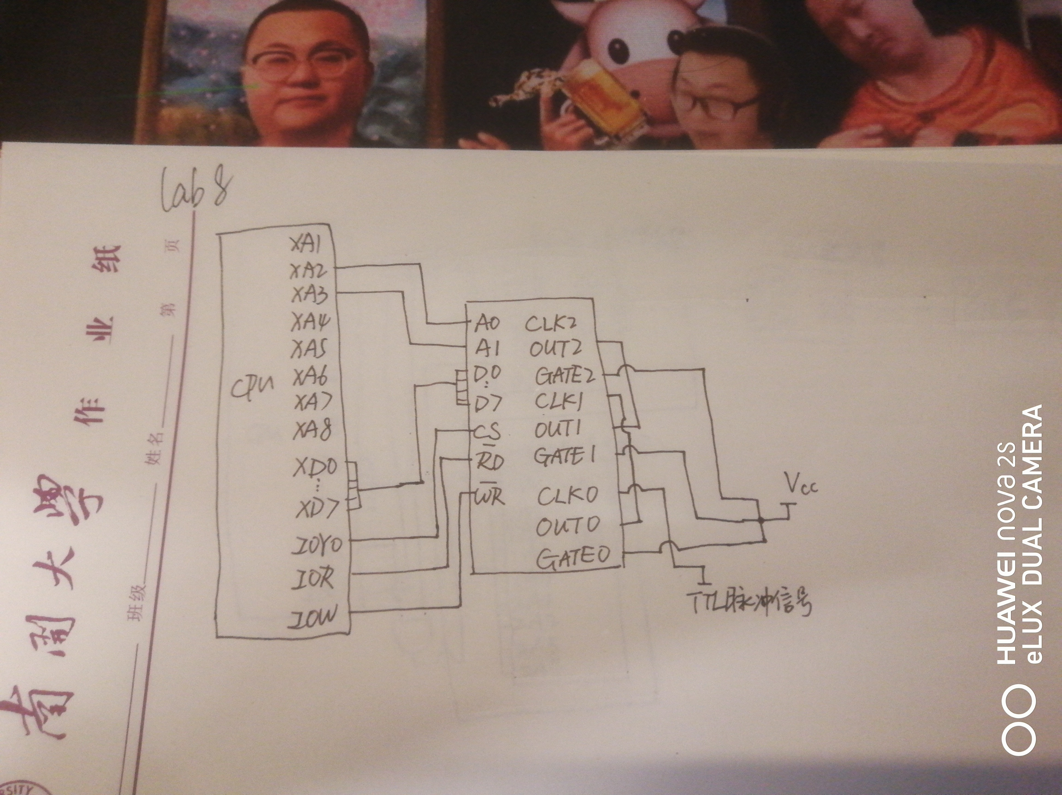

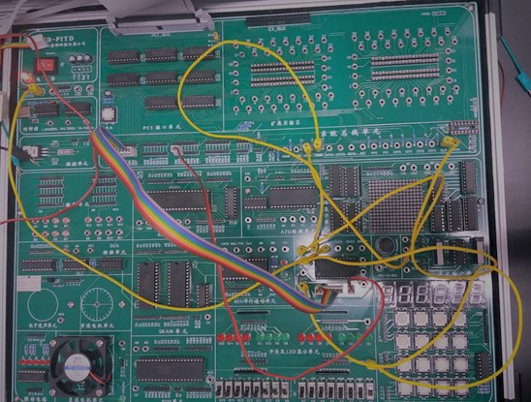**实 验连线图**

1:

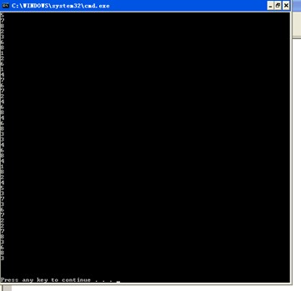

2:

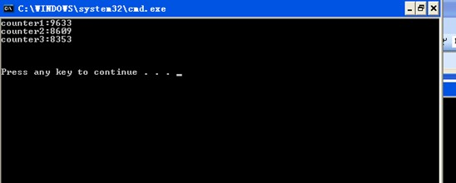

3:

