Higher Diploma in Software Engineering

ITP4511 Enterprise System Development
Assignment Report
(2024/2025)
Group: B4

Student | Contribution to the project (%)  (Total 100%) | Signature
Sair Pui Fung  (230066949) | 50% | 
Sair Pui Fung  (230066949) | - Senior Manager  - Warehouse (50%)
Yeung Lok Him (230022178) | 50% | 
Yeung Lok Him (230022178) | - Shop Staff  - Warehouse (50%)

We declare that this is a group project and that no part of this submission has been copied from any other student’s work or from any other source except where due acknowledgement is made explicitly in the text, nor has any part been written for us by another person.

Table of Contents
Table of Contents 2
1. Assumption and the user and system requirements 4
1.1. Assumption and the user requirements 4
1.2. System requirements 4
2. Site map 4
3. System structure on how MVC Model is applied 5
3.1. Model 5
JavaBeans: To represent data information which can help the user to reuse the object 5
Java DB: To handle data create read update delete records which help the user to linkage with the database 5
3.2. View 5
JSP Pages: User interface 5
Custom Tags: Reusable UI components 6
3.3. Controller 6
Servlets: Handle requests and responses 6
4. Database structure 7
4.1. Users 7
4.2. Locations 7
4.3. Fruits 7
4.4. Stock 7
4.5. Reservations 8
4.6. Borrowings 8
4.7. Deliveries 8
4.8. Consumption 9
5. Brief description of the major characteristics and design of your application 9
5.1. Role-Based Access Control 9
5.2. Inventory Management 9
5.3. Reservation System 9
5.4. Inter-Shop Borrowing 9
5.5. Reporting System 9
5.6. User-Friendly Interface 9
5.7. Security Implementation 10
6. Project Schedule 10
Week 1 (March 27 - April 2) 10
Week 2 (April 3 - April 9) 10
Week 3 (April 10 - April 16) 10
Week 4 (April 17 - April 23) 10
Week 5 (April 24 - April 28) 11
7. Conclusions 12
8. Skill checklist 13

Assumption and the user and system requirements

Assumption and the user requirements
- Web browsers should be accessible (e.g. Google Chrome)
- Users should have basic computer knowledge and internet access
- The system can be operated in real-time that gets data consistently through all locations
- Three user roles (Bakery Staff, Warehouse Staff, Senior Management [i.e. Admin]) own different permissions and access levels
- All shops within the same city can borrow fruit from one
- Inventory management is using the central warehouse through source countries to target shops

System requirements
- IDE version: Apache NetBeans IDE 16
- Java Platform: Zulu 8.0.442+6
- Server: Glassfish 5.1.0
- Java EE Version: Java EE 8 Web
- Browser: Chrome
- MySQL database is used for data storage
  - MySQL Connector: 8.0.27
- Maven version: 3.1

Site map
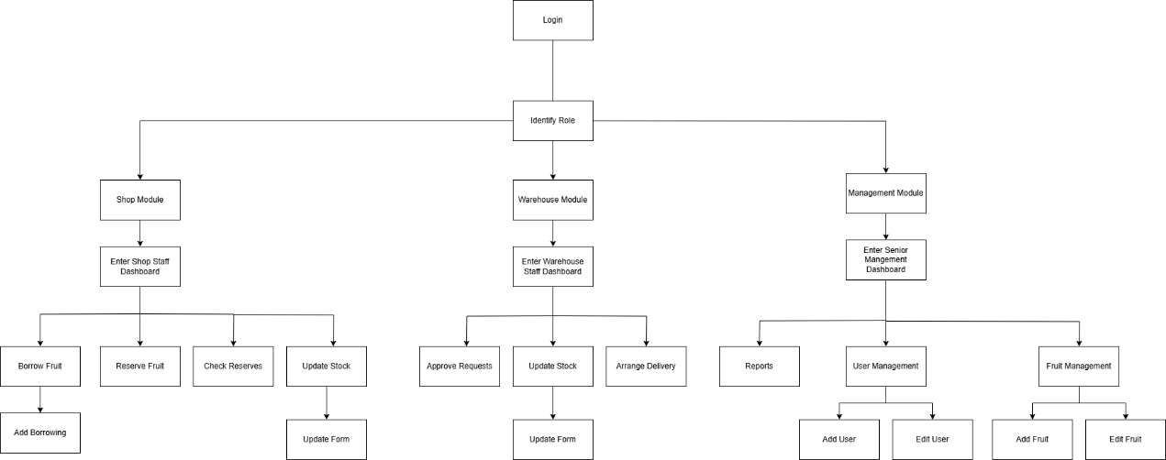

System structure on how MVC Model is applied

Model
It will process the request from the Controller to update data and will send back the result to the Controller. Moreover, the Model gives the data to the View through the Controller.

JavaBeans: To represent data information which can help the user to reuse the object
- UserBean.java: User information
- FruitBean.java: Fruit information
- LocationBean.java: Location information
- StockBean.java: Stock information
- ReservationBean.java: Reservation information
- BorrowingBean.java: Borrowing information

Java DB: To handle data create read update delete records which help the user to linkage with the database
- DBConnection.java: Database connection management
- UserDB.java: User-related database operations
- FruitDB.java: Fruit-related database operations
- LocationDB.java: Location-related database operations
- StockDB.java: Stock-related database operations
- ReservationDB.java: Reservation-related database operations
- BorrowingDB.java: Borrowing-related database operations

View

JSP Pages: User interface

Management Role:
- management/dashboard.jsp - Main overview page
- management/fruitManagement.jsp - Manage fruit inventory
- management/userManagement.jsp - User account management
- management/reports.jsp - View and generate reports
Forms:
- management/addFruit.jsp - Create new fruit entries
- management/editFruit.jsp - Modify existing fruit data
- management/addUser.jsp - Create new user accounts
- management/editUser.jsp - Modify user permissions and details

Shop Staff Role:
- shop/dashboard.jsp - Shop-specific overview
- shop/reserveFruit.jsp - Request fruit reserves
- shop/borrowFruit.jsp - Borrow from other shops
- shop/addBorrowing.jsp - Create borrowing requests
- shop/checkReserves.jsp - Monitor reservation status
- shop/updateStock.jsp - Update shop inventory
Warehouse Staff Role:
- warehouse/dashboard.jsp - Warehouse operations overview
- warehouse/approveRequests.jsp - Review pending requests
- warehouse/arrangeDelivery.jsp - Manage delivery logistics
- warehouse/updateStock.jsp - Update warehouse inventory levels
Approval pages:
- warehouse/confirmApproveReservation.jsp
- warehouse/confirmRejectReservation.jsp
- warehouse/confirmDeliverReservation.jsp

Custom Tags: Reusable UI components
StockLevelTag.java: Displays stock information
ReportTag.java: Generates reports
LocationSelectorTag.java: Location selection dropdown

Controller

Servlets: Handle requests and responses
LoginController.java: Manages authentication
UserController.java: User management
FruitController.java: Fruit management
StockController.java: Stock management
ReservationController.java: Reservation management
BorrowingController.java: Borrowing management
AuthenticationFilter.java: Security filter

Database structure

Users
Users
UserID | Primary Key
Username | Unique, the user account name
Password | The user password
Role | Role for different permission (shop_staff, warehouse_staff, senior_management)
Name | Title of the user
LocationID | Foreign Key, the location of the user
IsCentralStaff | Check that the user works at central warehouse

Locations
Locations
LocationID | Primary Key
Name | Location Name
City | City Name
Country | Country Name
Type | Shop Type (shop, warehouse, central_warehouse)
IsSource | Check that if the source location for fruits

Fruits
Fruits
FruitID | Primary Key
Name | Fruit Name
Description | Fruit Description
SourceCountry | Source Country of the fruits

Stock
Stock
StockID | Primary Key
LocationID | Foreign Key, location
FruitID | Foreign Key, fruits
Quantity | Current Stock Quantity
LastUpdated | Time of last update

Reservations
ReservationID | Primary Key
ShopLocationID | Foreign Key, shop locations
FruitID | Foreign Key, fruits
Quantity | Reserved Quantity
RequestDate | Date of Request for reservation
DeliveryDate | Scheduled delivery date
Status | Status of reservation (pending, approved, delivered, rejected)
UserID | Staff who created reservation request

Reservations

Borrowings
Borrowings
BorrowingID | Primary Key
SourceShopID | Foreign Key, source shop
DestinationShopID | Foreign Key destination shop
FruitID | Foreign Key, fruits
Quantity | Borrowed Quantity
RequestDate | Date of Request for borrowing
Status | Status of borrowing (pending, approved, delivered, rejected)
UserID | Staff who created borrowing request

Deliveries
Deliveries
DeliveryID | Primary Key
SourceLocationID | Foreign Key, source location
DestinationLocationID | Foreign Key, destination location
DeliveryDate | Scheduled delivery date
Status | Status of delivery (pending, in_transit, delivered)
RequestDate | Date of Request for delivery
Type | Type of delivery (reservation, borrowing)
RequestID | ID of relevant request

Consumption
Consumption
ConsumptionID | Primary Key
LocationID | Foreign Key, locations
FruitID | Foreign Key, fruits
Quantity | Consumed quantity
Date | Consumption date
Season | Season of cosumption

Brief description of the major characteristics and design of your application
The Acer International Bakery System is a comprehensive web application designed to improve material delivery efficiency between fruit source countries and bakery shops across international locations. The system implements the MVC architecture pattern to ensure clean separation of concerns and better maintainability.
Key Features:

Role-Based Access Control
Three user roles (shop staff, warehouse staff, senior management) with role-specific functionalities and interfaces.

Inventory Management
Real-time monitoring of fruit stock levels across all locations (source warehouses, central warehouses, bakery shops).

Reservation System
Allows bakery shops to reserve fruits from source countries with delivery date specification and approval workflow.

Inter-Shop Borrowing
Enables shops within the same city to borrow fruits from each other through a request and approval process.

Reporting System
Provides analytical reports on fruit consumption patterns by location, country, and season to support management decision-making.

User-Friendly Interface
Consistent styling with intuitive navigation and clear feedback messages for all operations.

Security Implementation
Session management, authentication, and authorization ensure that users can only access functions relevant to their roles.

The system uses Java EE technologies including JSP, Servlets, JSP Actions, Custom Tags, JavaBeans, and JDBC. Custom tags enhance UI component reusability, while JavaBeans efficiently encapsulate business logic. Prepared statements in JDBC queries prevent SQL injection attacks, ensuring data security.

Project Schedule

Week 1 (March 27 - April 2)
March 27-28: Project kickoff and requirements analysis
March 29-30: Database design
April 1-2: System architecture design

Week 2 (April 3 - April 9)
April 3-5: Frontend UI/UX design
April 6-9: Backend development (Part 1)
- Database implementation
- Set up development environment
- Develop core API endpoints
- Implement authentication system

Week 3 (April 10 - April 16)
April 10-13: Backend development (Part 2)
- Implement inventory management functions
- Develop reservation and borrowing systems
- Create delivery tracking functionality
- Implement reporting features
April 14-16: Frontend development (Part 1)
- Implement user interfaces
- Connect frontend to API endpoints
- Develop authentication views

Week 4 (April 17 - April 23)
April 17-19: Frontend development (Part 2)
- Implement dashboard visualizations
- Complete inventory management interfaces
- Develop reservation and borrowing screens
- Create delivery tracking views
April 20-21: Integration testing
- Test all system components together
- Identify and fix integration issues
April 22-23: User acceptance testing
- Conduct testing with stakeholders
- Collect feedback and implement critical changes

Week 5 (April 24 - April 28)
April 24-25: Final bug fixes and optimizations
- Address all reported issues
- Performance optimization
- Security review
April 26-27: System documentation
- Complete technical documentation

Conclusions
This project uses Java Web technology to implement a comprehensive fruit management system. The application effectively manages fruit inventory, store interactions, and delivery mechanisms through a well-structured database and clearly organized MVC components. The system demonstrates a practical implementation of database design and web application.

Skill checklist
Technology/Skill | Implementation in Project
JSP | Dynamic content generation, Form processing
Servlets | Request handling, Controller implementation
JSP Actions | JavaBean integration, Page inclusion
Custom Tags | Custom UI components (StockLevelTag, ReportTag)
JavaBeans | Data encapsulation, Business logic
JDBC | Database connection, CRUD operations
Session Management | User authentication, Session tracking
MVC Architecture | Separation of Model, View, and Controller
Security Implementation | Authentication, Authorization, Input validation
Error Handling | Exception handling

