Nama : Ighfar Nazar S

NIM : 19092001

Laporan Pertemuan 2

1. Latihan1
2. Source Code > controllers/Latihan1.php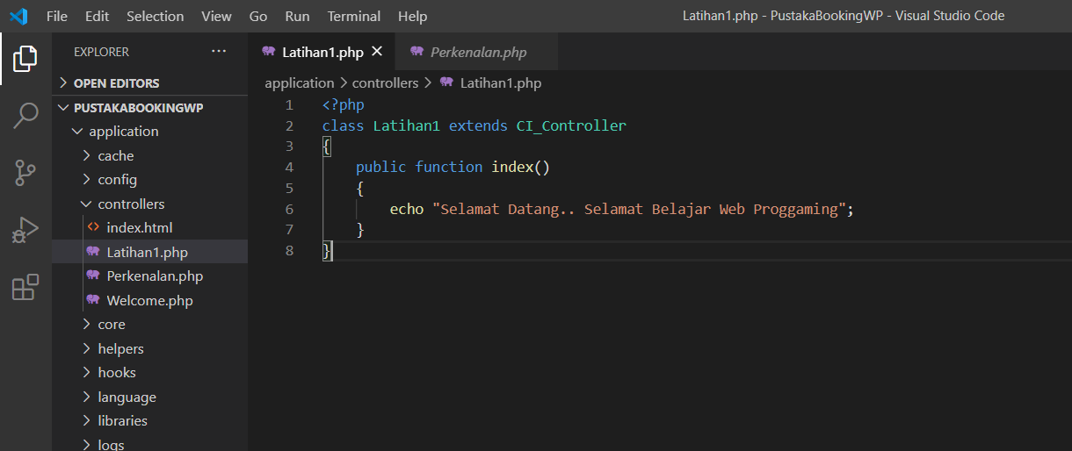
3. Hasil

(Akses : <http://localhost/PustakaBookingWP/index.php/latihan1>)

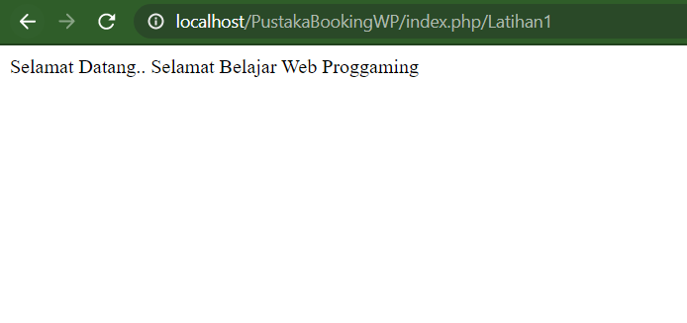

1. Controller dan Model
2. Source Code models/Model_latihan1.php

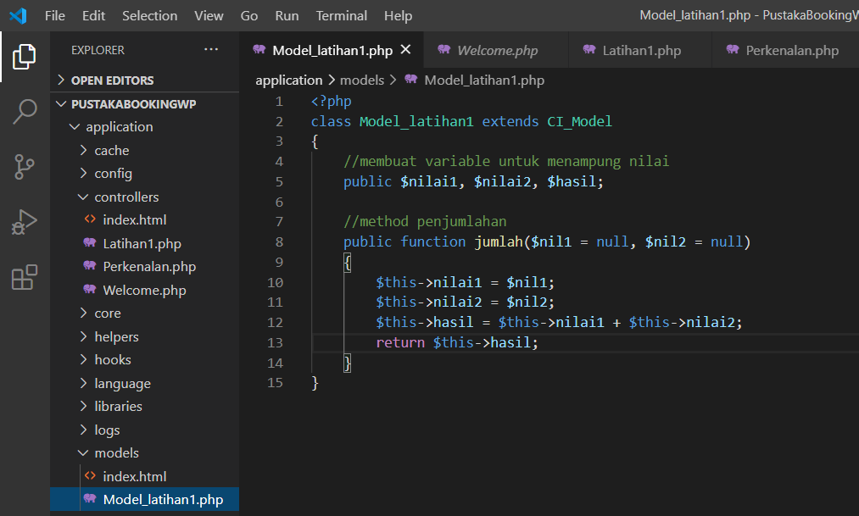

1. controllers/Latihan1.php

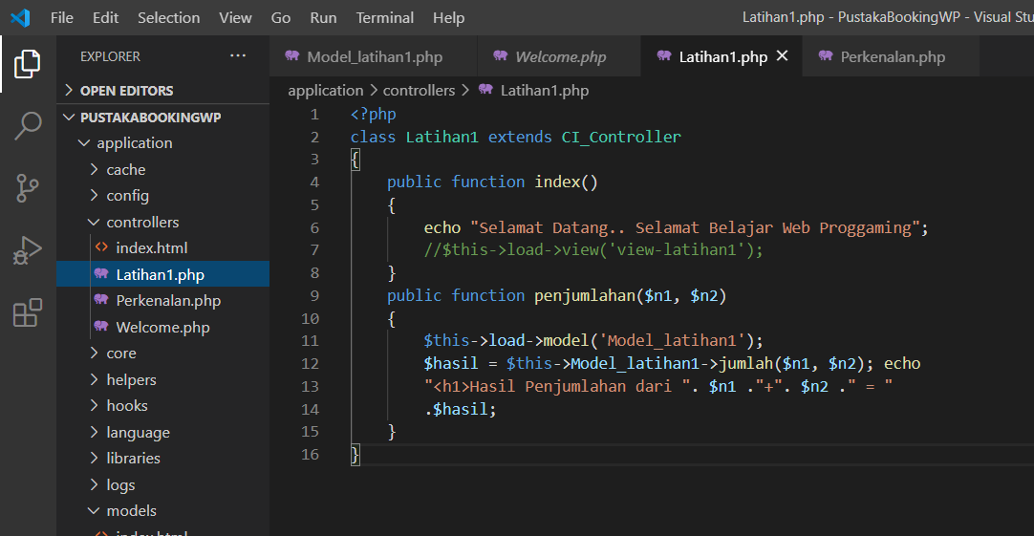

1. Hasil (Akses : <http://localhost/PustakaBookingWP/index.php/latihan1/penjumlahan/2/6>)

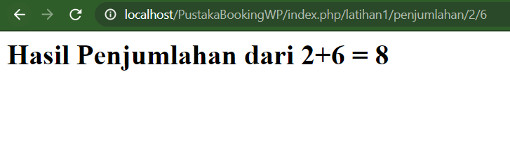

1. Controller View dan Model
2. Source Code controllers/views/view-latihan1.php

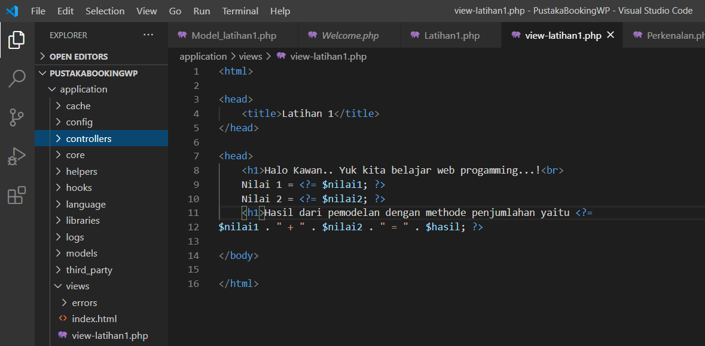controllers/Latihan1.php

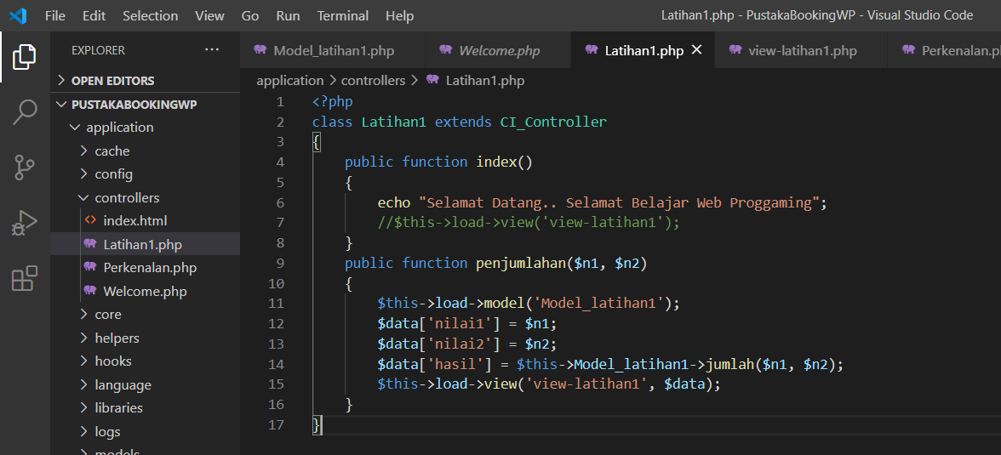

1. Hasil (Akses : <http://localhost/PustakaBookingWP/index.php/latihan1/penjumlahan/2/6>)

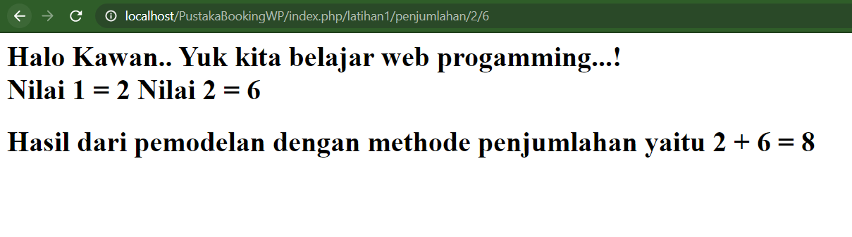

1. Mengganti Default Controller ke Latihan1
2. Source Code di config/routes.php

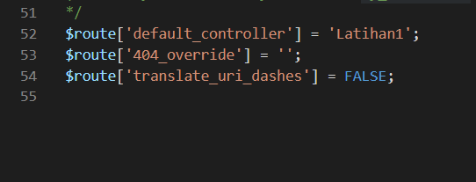

1. Hasil (Akses : http://localhost/PustakaBookingWP/index.php)

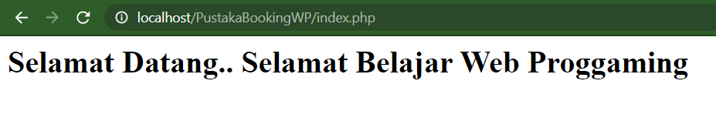

1. Membuat .htaccess

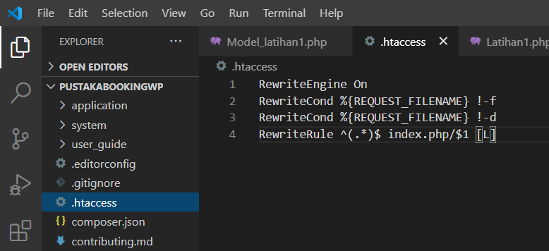

1. Hasil (Akses : <http://localhost/PustakaBookingWP/latihan1/penjumlahan/4/6>)

