Nama : Ighfar Nazar S

NIM : 19092001

Laporan Pertemuan 3

1. view-form-matakuliah
2. Source Code views/ view-form-matakuliah

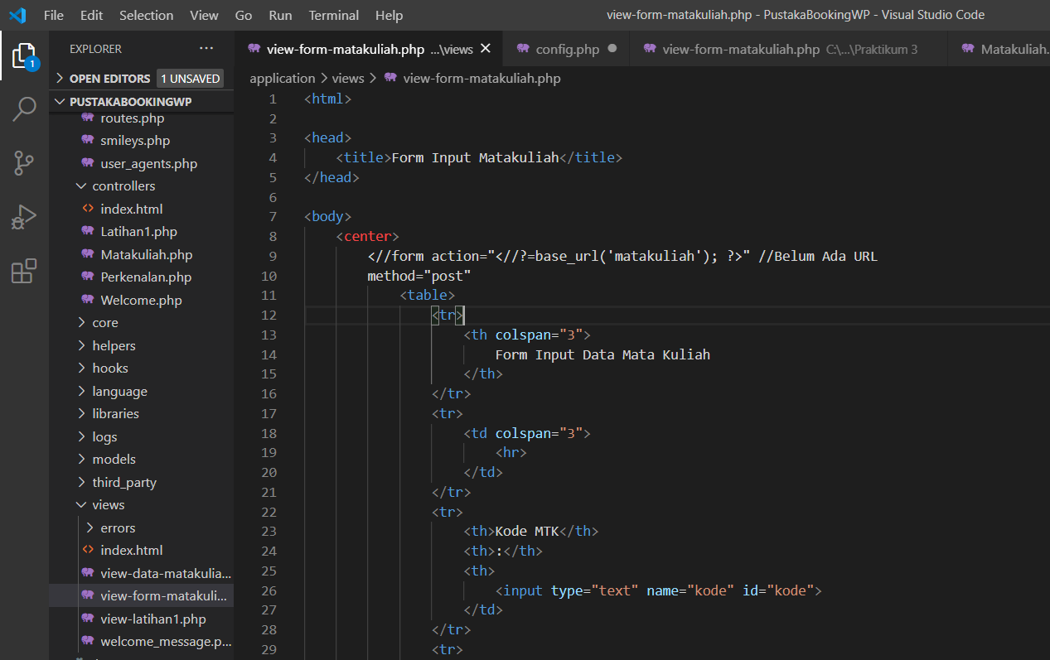

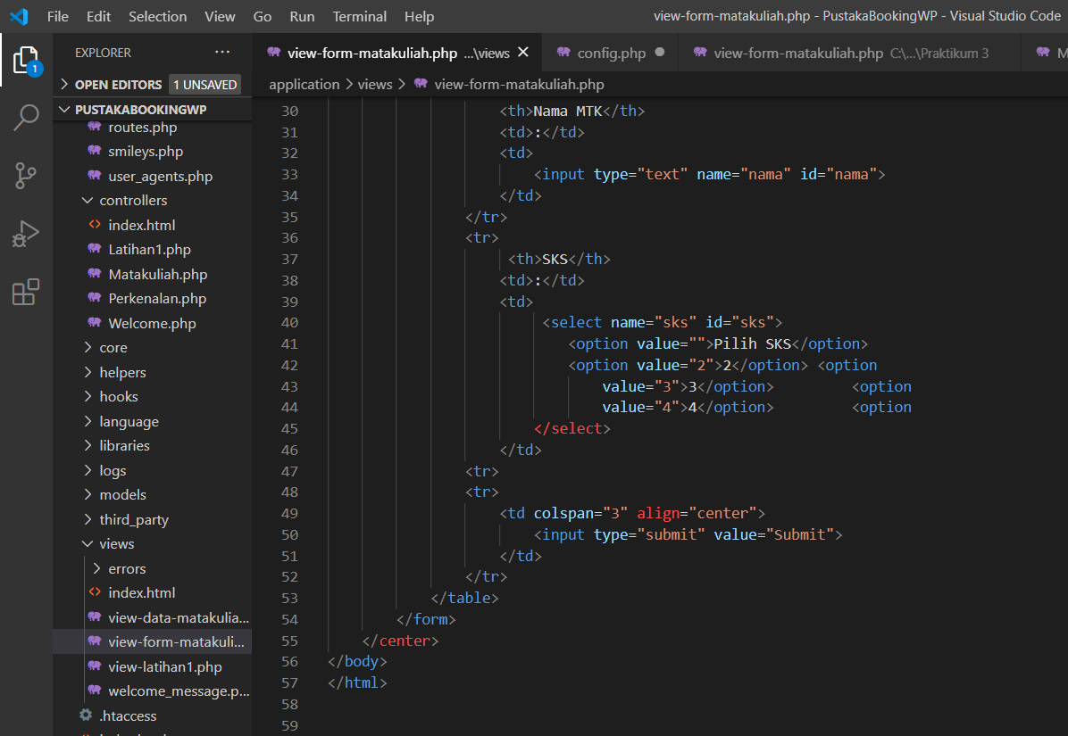

1. view-data-matakuliah
2. Code Source views/ view-data-matakuliah

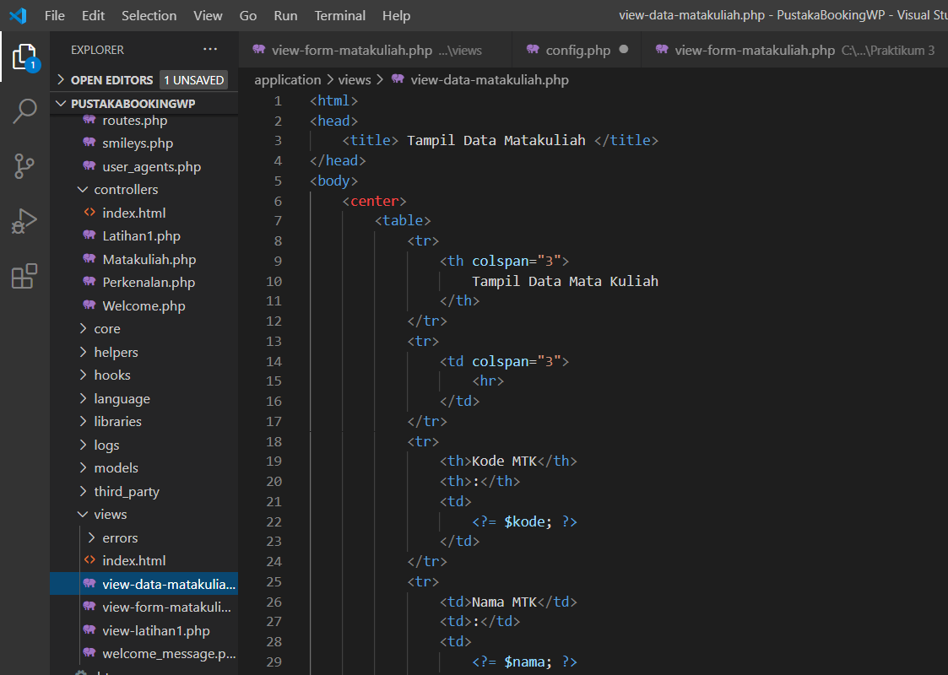

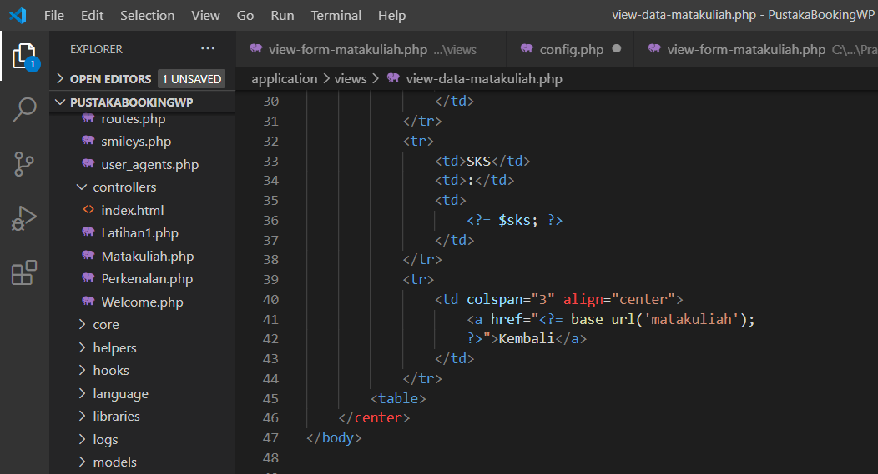

1. Hasil (Akses : <http://localhost/PustakaBookingWP/Matakuliah>)

