Nama : Ighfar Nazar S

NIM : 19092001

Laporan Pertemuan 4

1. Web.php
2. Source Code controllers/Web.php

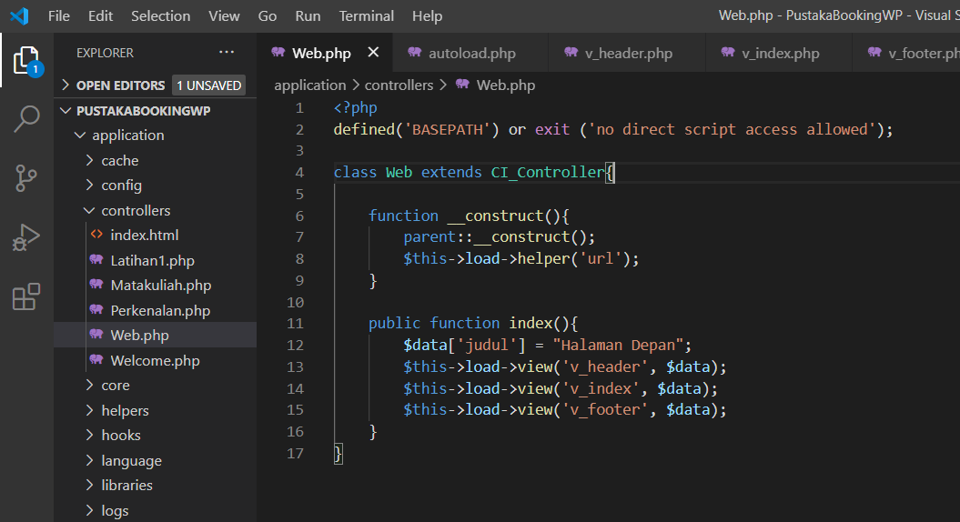

1. View source code (header, index, footer)
2. views/v_header.php

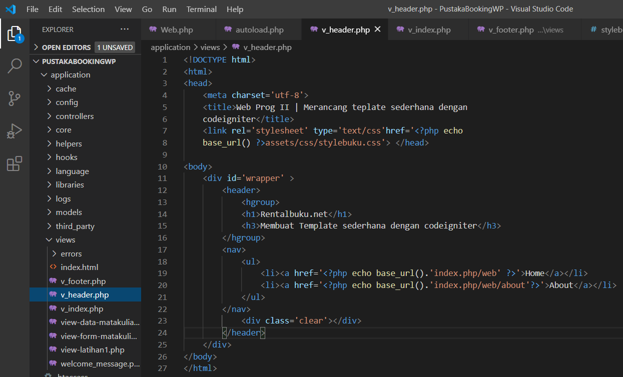

1. views/v_index.php

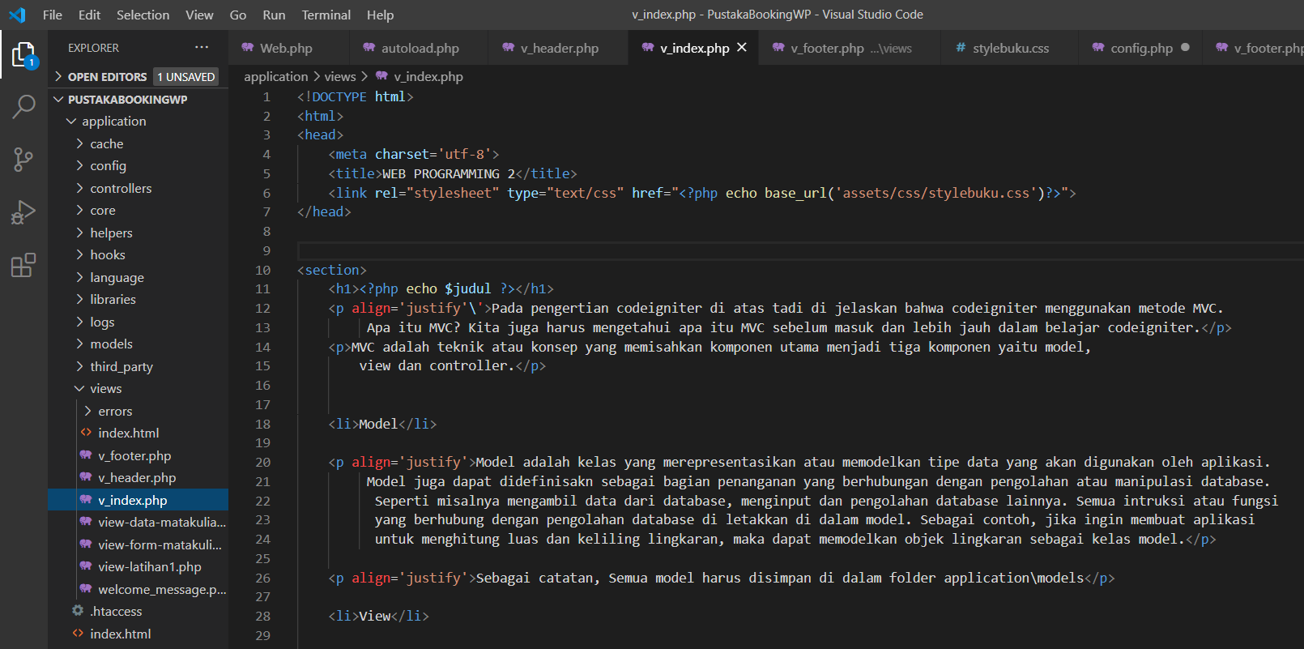

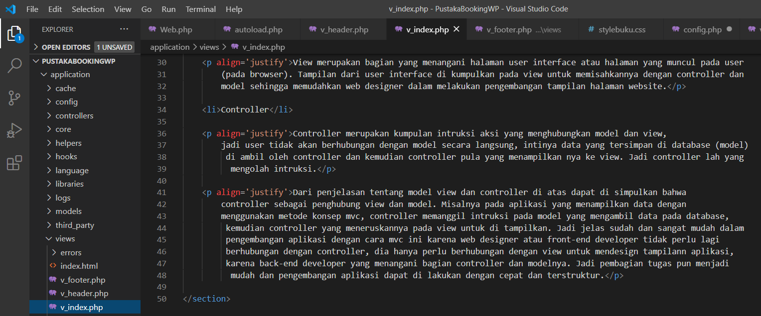

1. views/v_footer.php

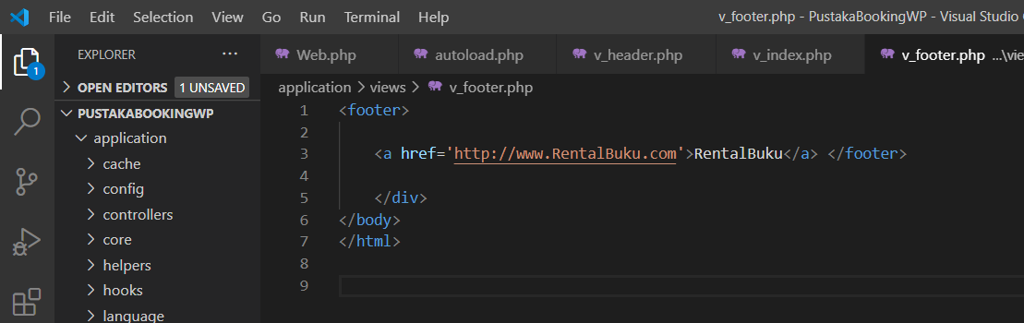

1. stylebuku.css
2. Source Code > assests/css/stylebuku.css

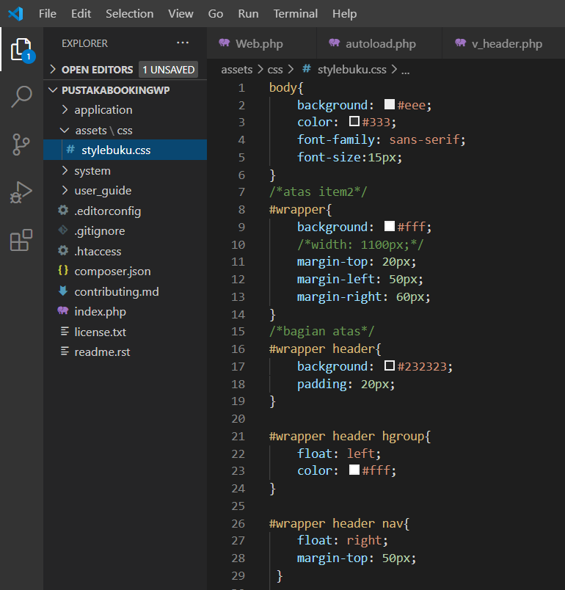

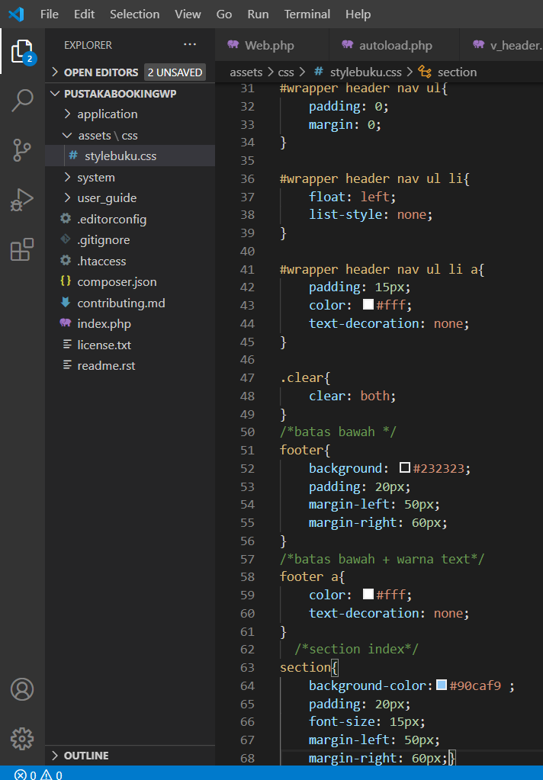

1. Hasil (Akses: <http://localhost/PustakaBookingWP/web>)

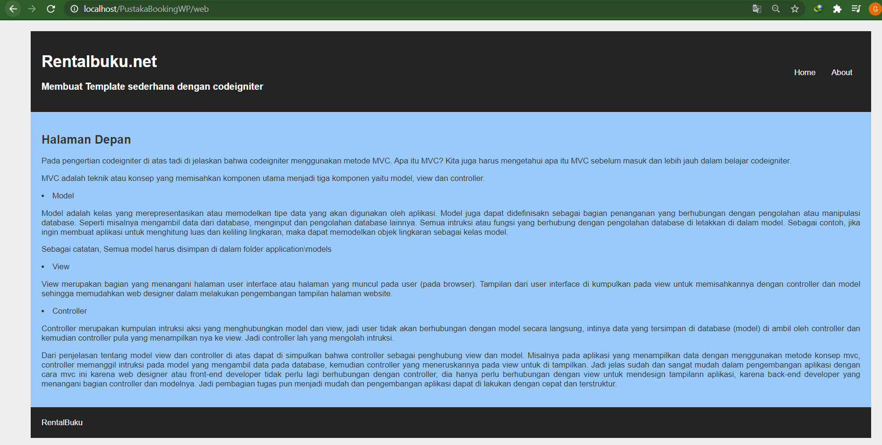

1. Mengedit config/config.php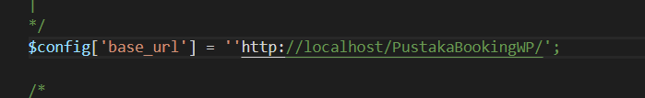
2. About
3. Source Code

* views/v_about

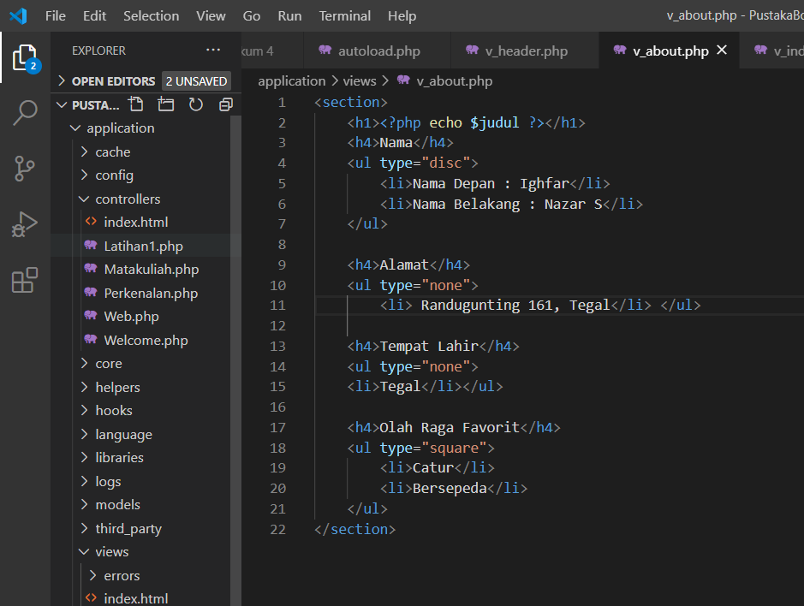

* penamban about() di Web.php

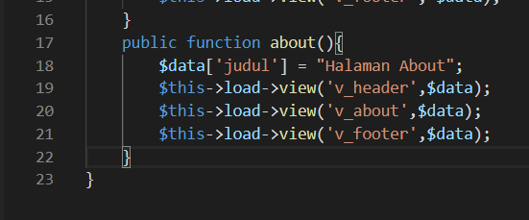

1. Hasil (Akses: <http://localhost/PustakaBookingWP/web/about>)

