Nama : Ighfar Nazar S

NIM : 19092001

Laporan Pertemuan 5

1. Autoload validation
2. Source Code config/autoload.php

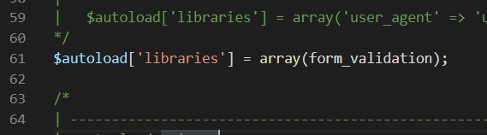

1. controllers/MatakuliahValidation.php

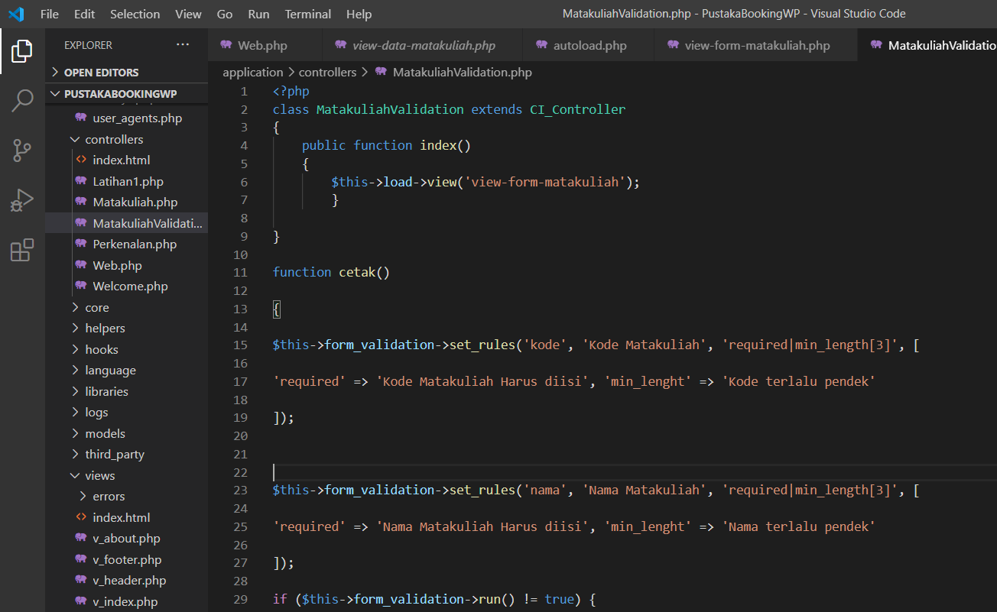

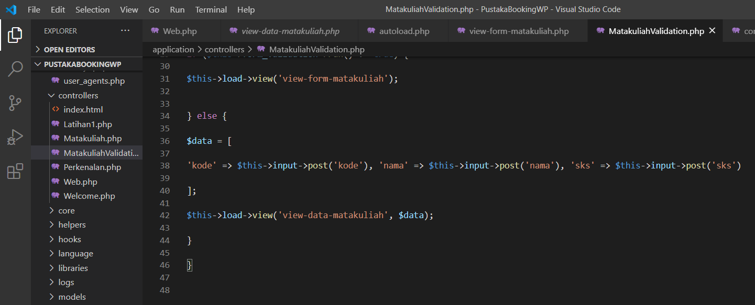

1. Hasil (<http://localhost/PustakaBookingWP/MatakuliahValidation>)

