SEG AI Project Command Centre
Executive Architecture, Evolution API Integration & Mermaid Workflow Specification
1. Executive Summary & Value Intent
Construction, engineering, and fabrication teams coordinate heavily inside WhatsApp groups. Critical decisions, scope variations, and site risks are frequently buried in message history, causing project delays and unbilled variations.
The SEG AI Project Command Centre operates on a Passive Observer Model. It allows all project participants to continue working in their normal WhatsApp groups without downloading new software. A dedicated AI instance joins designated groups as a silent participant, ingests messages, transcribes audio notes, inspects photos and drawings, and feeds a real-time executive dashboard.

2. How Evolution API Bypasses Meta Gateway Constraints

Feature | Meta Cloud API | Evolution API (Our Solution)
Group Listening | Restricts automated bot listening in multi-user groups. | Native Multi-Party Ingestion: Emulates standard WhatsApp Web WebSockets; joins normal groups as an ordinary participant.
Cost Structure | Charges per conversation window or message template. | Zero Per-Message Fees: Self-hosted Docker container on private VPS with fixed hosting costs.
Onboarding | Requires complex Meta app verification and templates. | Instant QR Pairing: Linked in minutes via standard WhatsApp Web QR code on a dedicated SIM.
Anti-Ban Safety | High risk if used for outbound automation. | Zero-Outbound Rule: 100% read-only listener. Never types or sends messages, eliminating spam detection.

3. End-to-End System Workflow
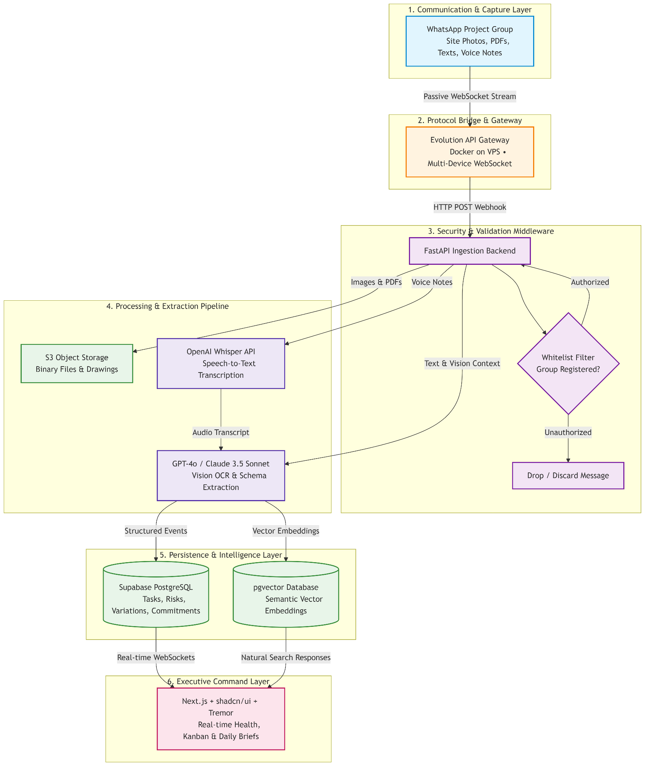

EVOLUTION API WORKFLOW
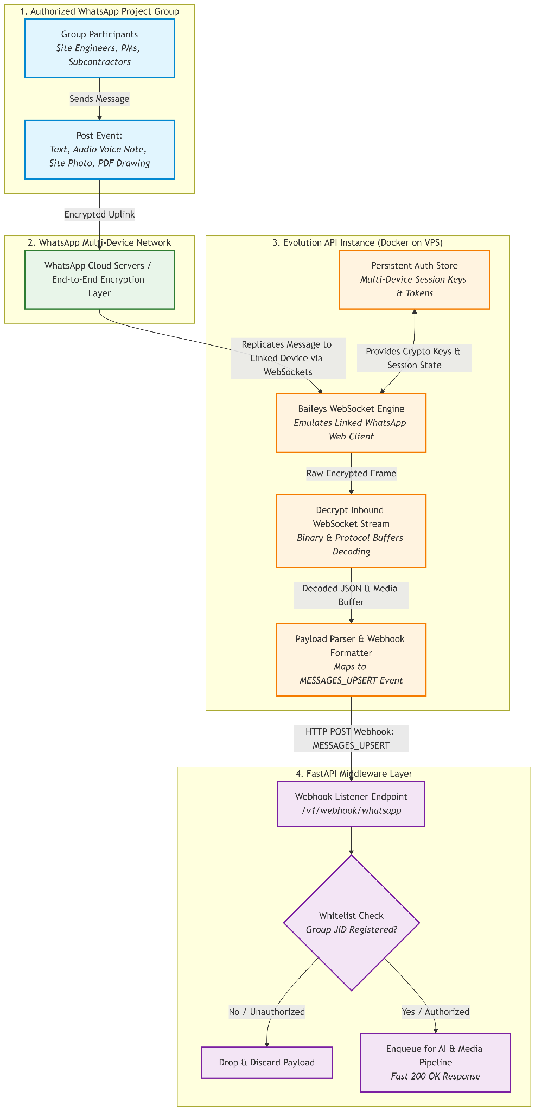

4. Recommended Technology Stack

Layer | Technology | Operational Role
Gateway | Evolution API (Docker/VPS) | WebSocket client emulating WhatsApp Web multi-device session.
Middleware | FastAPI (Python) | Asynchronous router handling validation, S3 uploads, and AI orchestration.
Voice AI | OpenAI Whisper API | Transcribes noisy site voice notes into clean text transcripts.
Extraction AI | GPT-4o / Claude 3.5 Sonnet | Vision OCR and structured JSON extraction for Tasks, Variations, and Risks.
Persistence | Supabase (PostgreSQL + S3) | Database with pgvector for natural language search and S3 media storage.
Dashboard | Next.js + shadcn/ui + Tremor | Real-time KPIs, Kanban task tracking, and variation approval queues.

5. 3-Step Setup & Onboarding Guide
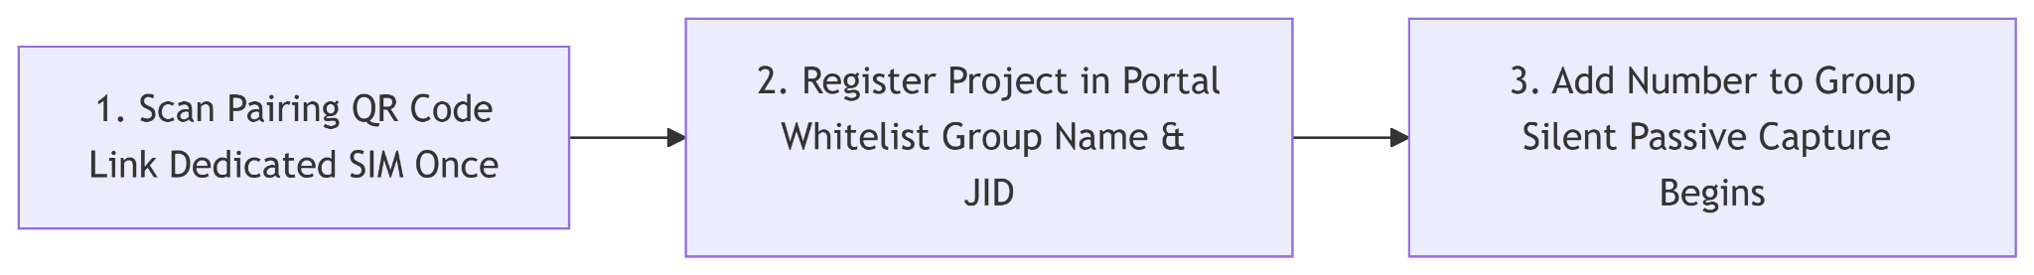
- 1. One-Time Gateway Pairing: Scan a WhatsApp Web QR code using a dedicated company SIM on the Evolution API instance. Credentials persist across reboots.
- 2. Project Whitelist Registration: Project manager enters Project ID (e.g. SEG-2026-047) and registers authorized WhatsApp Group Names.
- 3. Add to WhatsApp Group: Group admin adds the AI phone number to the chat. The bot silently verifies the group and begins passive capture.

6. Real-Time Dashboard Updates & Media Processing

Chat Input | AI Vision & Extraction Action | Live Dashboard Output
Text Instructions | Parses owner, target deadline, and task dependencies. | Kanban Card: Real-time task assigned to owner.
Scope Alterations | Identifies dimension changes, extra doors, or night shifts. | Variation Queue: Unbilled variation flagged for pricing.
Site & Defect Photos | Vision model assesses civil readiness, glass cracks, and snags. | Risk & Snag Ticket: Replacement workflow created.
Drawings & PDFs | OCR reads revision codes and approval status stamps. | Approval Log: Calculates outstanding review days.
Delivery Slips & POs | Extracts quantities and dates from physical receipts. | Supplier Tracker: Automatically marks promise Completed.

