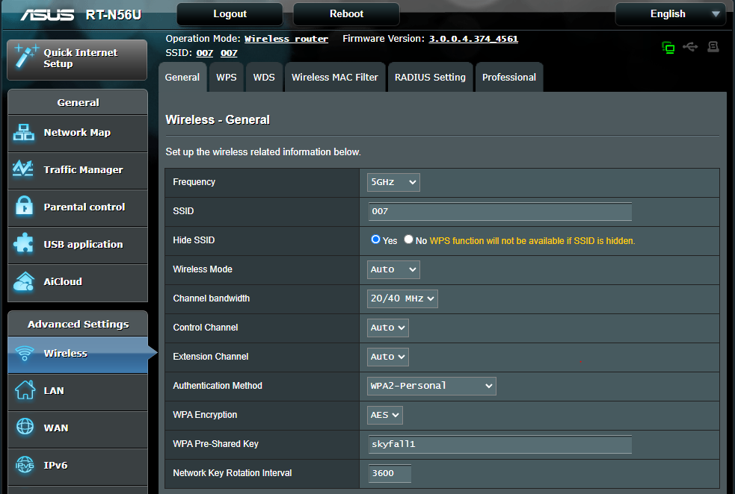

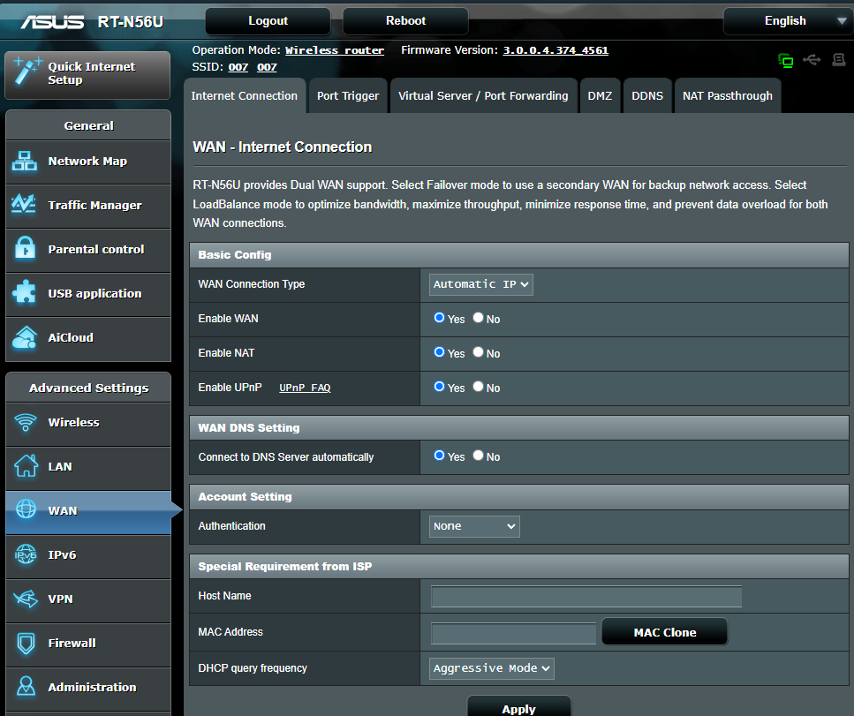

Hi [@gigerstyle](https://forum.amebaiot.com/u/gigerstyle)

Due to differences in national regulations on active scanning in the 5GHz band, the board is configured with passive scanning on all 5GHz channels as a default.

This setting is configured using the eFuse, and detailed information on active and passive channel configurations can be seen in [AN0400 Application Note 21](https://github.com/ambiot/ambd_sdk/blob/master/doc/AN0400%20Ameba-D%20Application%20Note.pdf) chapter 13.5.4 Wi-Fi Channel Plan.

From chapter 18.2.4.3, int wifi_set_channel_plan(uint8_t channel_plan) found in wifi_conf.c can be used to change the eFuse channel plan, with the available channel plans found in wifi_constants.h

<https://forum.amebaiot.com/t/rtl8720dn-connection-to-ap-with-hidden-ssid/1033/5>

[**gigerstyle**](https://forum.amebaiot.com/u/gigerstyle)

[Feb '22](https://forum.amebaiot.com/t/rtl8720dn-connection-to-ap-with-hidden-ssid/1033/8)

Hi [@wyy](https://forum.amebaiot.com/u/wyy)

Thanks for getting back to me and pointing me to the Application Note. That did the trick. After setting the correct channel plan I can now connect to 5GHz with hidden ssid. Very good.

Thanks,

Marc