**ZacPacMan (ZP) overview**

* **Electrical board:**

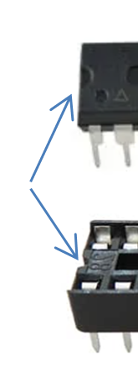

* + Computer chips. One ATMEGA chip and one ESP8266:
    - ATMEGA holds the majority of the program. When changes to the program on ATMEGA are made, I will send you a chip to swap out. It is important to align the chip with the notch on one end to match the notch in the receptacle.

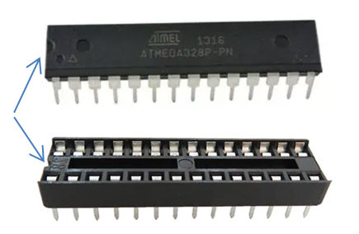

* + - ESP8266 is the chip that connects to WIFI or  
      if unable to connect to a WIFI network, will create its own WIFI network named **ZacPacMan** with a password of **Arcade1980** (the year PacMan wasreleased). When changes to the program on ESP8266 are made, I will send you a chip to swap out. It is important to align the ESP8266 chip as follows…

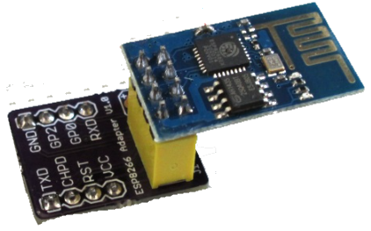

* + Switches: There are three switches on the electrical board. One control the main power. Another controls power to the ESP8266. One more controls power to the ATMEGA. You probably never need to adjust those.
  + Resetable fuses:
    - There is a 3amp resetable fuse on the main electrical board near the power jack. That fuse will likely not be tripped as we are pulling only about 1.4 amps when all 6 objects are lit up. But in the event it does trip, you should just unplug and replug in the power supply to reset. It is possible too that the resetable fuse will act as a voltage regulator and not trip the power out. We (Nick and I) are not too sure as a forced overload did allow current but only the right amount.
    - Each object also has a smaller, ½ amp resetable fuse. Those fuses also will likely not be tripped as we are pulling only about 0.23 amps with any given object. But in the event it does trip, you should just unplug and replug in the power supply to reset. Again, we (Nick and I) are not too sure as a forced overload did allow current but only the right amount. Those ½ amp fuses are internal to each object alone with 4 large resistors that dissipate the small amount of heat flowing through the 10 ohm resistance with each set of fairy lights (the LED lights in the object). FYI…There are 20 LEDs in each object.
* Sensors: One is motion detection and one is a light sensor.
  + On the day this shelf was given to you, neither of those are programmed yet but they have been tested. Those sensors will be utilized in future program version changes.
  + The motion sensor on top can be moved to another location or can be turned (loosen screw, turn, tighten screw).
  + The light sensor is mounted on the back wall and its purpose is to measure overall room light. It too can can be moved or turned.
* ATMEGA pins: Not all of the pins on the ATMEGA chip are utilized, so if in the future, you wanted to add a sensor (sound, temperature/humidity, another motion or light sensor), that can be accomodated.
* Objects (PacMan, Cherry, Ghosts):
  + Each object can be removed from the shelf and individually lighted with the modified usb cable provided. If you want more USB cables like that, let me know.
  + You can’t power the entire shelf from a USB port. Only one (perhaps two) could be powered from one USB port.
  + Each object has a fairy light with 20 LEDs.
  + Each object has four large, 1Watt, 10 ohm resistors (two paralell pairs in series) to provide 10 ohms of resistance with the 20 LEDs. The 10 ohms provides very bright LEDs. Higher ohms would dim them and maybe provide longer life. There is not a lot of burn in /testing time with these so let me know the moment something fails.
  + Each object also has a ½ amp resetable fuse as stated earlier.
  + The far left (Pinky) and far right (Inky) objects are on ATMEGA pins 3 and 11 which have some interference with sound. So, if sound is being played when fading in or fading out those objects, the blinking is rather irradic. There are work arounds, but Nick and I thought the fact that those two objects have that quality adds to shelf’s character, so we left that as is.
  + I can make more objects if you like. A different fruit (Peach?) or another ghost (green?). Just let me know.
  + I can also make a very simple, small, 3D printed PACMAN stand so PACMAN stands up properly when pulled from the shelf.
* **Android App / Games**:
  + I have two games in mind I would like to program for ZP.
  + I also want to learn how to build a phone app interface so that is coming too.
  + I have a breadboard that I can simulate all ZP functions and do the programming at home. You will only need to swap out chips now and then and/or download the latest app.
  + I think I should add a protective box around the electrical board once we have some burn in time with this shelf.

Last… Nick has been a tremendous help with the electrical board design and understanding the electrical flow. His help was tremendous in ensuring a safe system.