1. If you chose to use a tool or language other than the recommended, briefly explain why.

Ans: N/A->chose Selenium/WebDriver

1. How did you go about locating the elements for your tests?

Ans: I located the elements by xpath which included partial xpaths and bulk extraction of objects and created custom partial xpaths.

1. If your test was running successfully on a regular basis, then suddenly began to fail, how would you find and correct the problem?

Ans: I would do some manual testing first to see if any objects and/or elements have changed. If they have changed, I would change my code/script according. If nothing has changed, I would look to see if they are related to timing or other related issues

1. What is one additional validation step that you would add to the test, if any?

Ans: For this particular test, I would add validation to the total number of items in the cart and the total amount for the purchase(Due to encountering some issues, I was not able to implement these validations)

1. Did you spot any bugs within the application while creating the test? If so, report it here just as you would report it to the engineer responsible for fixing it.

Ans: I spotted a bug and report it as below:

**Description:** Categories Selection List panel is shown missing on Selenium/WebDriver if searching an item using Search feature

**Precondition:** User is writing Selenium java code on Eclipse IDE(Luna)

**Browsers:** Chrome (Version 56.0.2924.87 (64-bit)), FireFox v46. IE10

**OS:** Win10

**Steps to reproduce:**

1. User successfully login Shipt.com using the following credentials: [qatest@shipt.com/Sh1pt123](http://qatest@shipt.com/Sh1pt123)!
2. Use Search feature and search an item by clicking on the magnified glass icon-Pls see below screenshots
3. Normal User View(Correct):

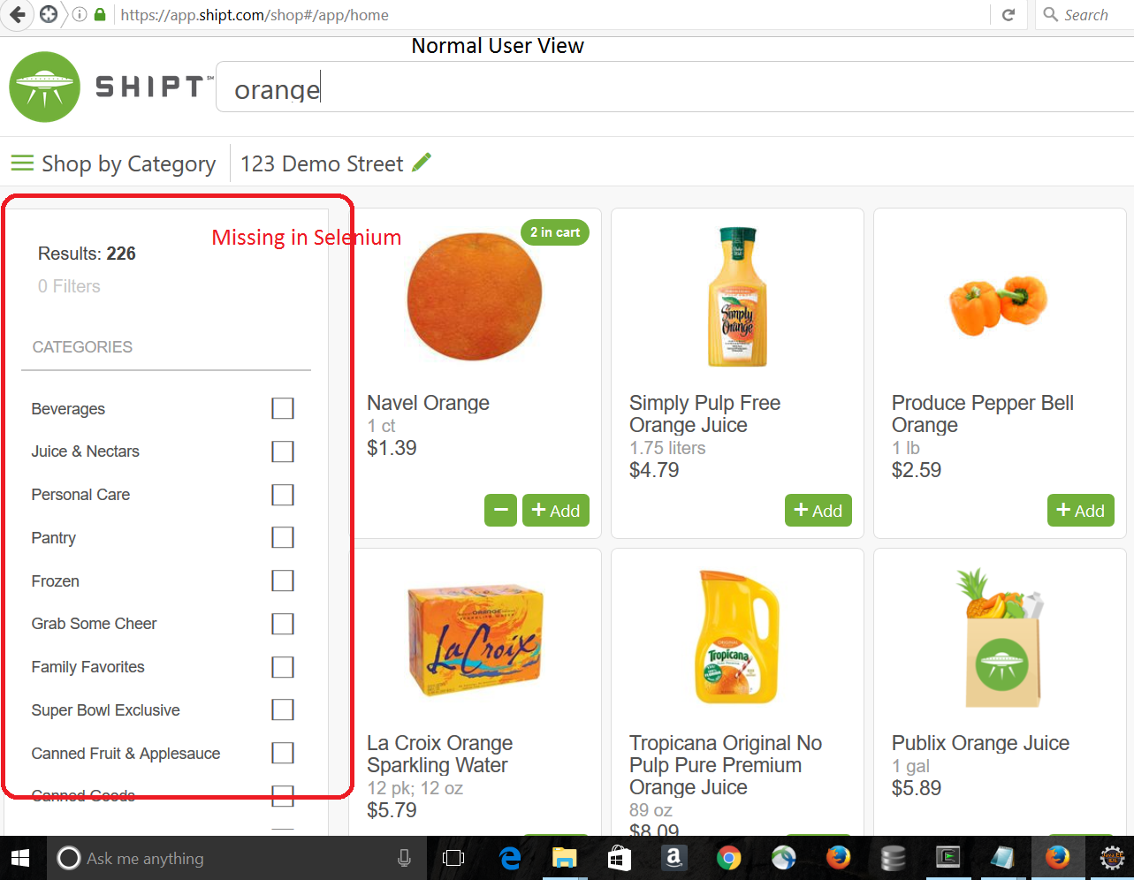

Selenium View(Incorrect- Missing Categories Selection List Panel):

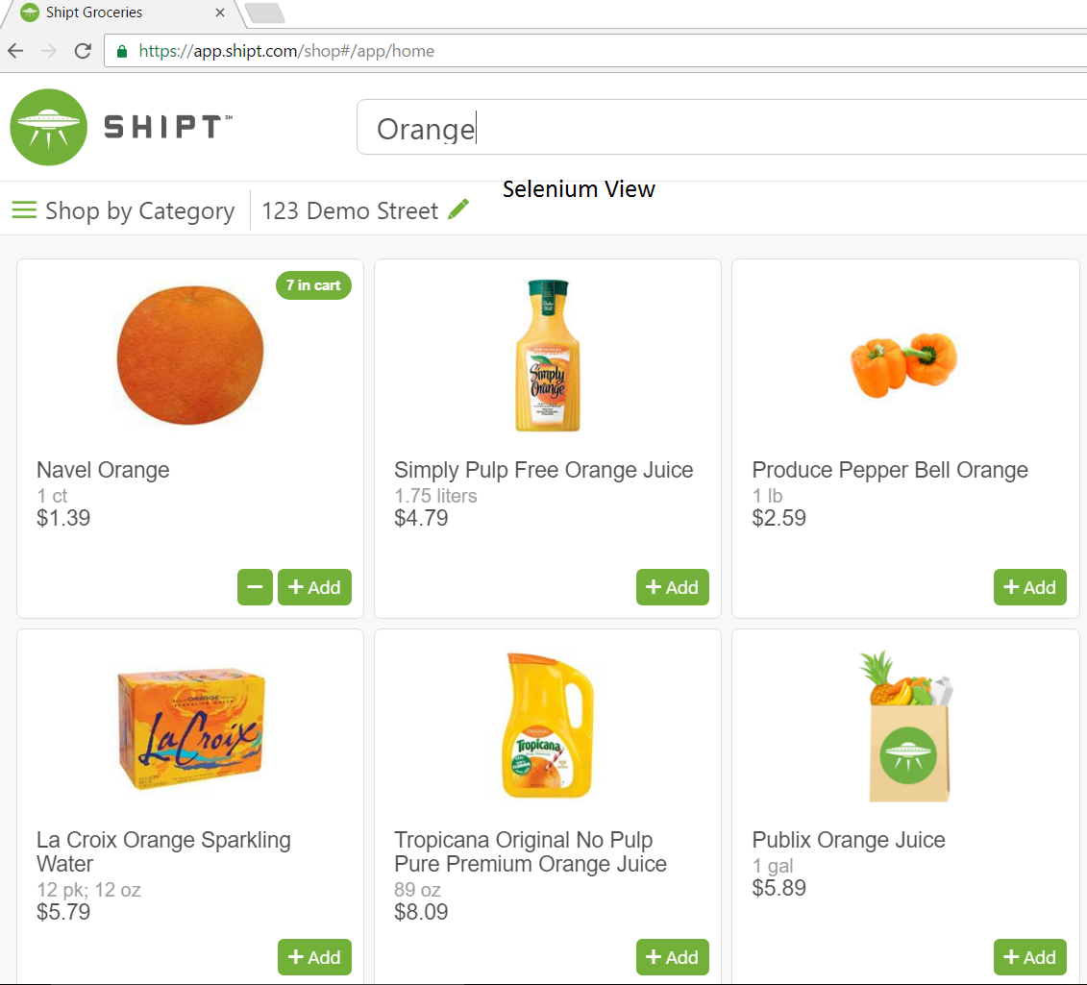

**Actual result:**

Categories Selection List panel on the left hand page is missing if searching an item when user is creating Selenium code/script in Selenium view

**Expected result:**

Selection list panel should NOT be missing if searching an item on Selenium/WebDriver.