

Invoice Management System

260CT – Software engineering

LAB ASSIGNMENT

Charles Barry | 7750656

Table of Contents

Task 1 2

Invoice Management Class Diagram 2

Report 2

Task 2 3

Graphical User Interface Design Prototype 3

Pre-feedback 3

Post-feedback 4

Unit Testing 5

Functional Prototype 6

# Task 1

## Invoice Management Class Diagram

## Report

# Task 2

## Graphical User Interface Design Prototype

I decided to use JavaFX to create my GUI. This was achieved by creating multiple containers and populating them with different objects, as well as modifying the FXML code for small adjustments like ID declarations and defining controllers.

### Pre-feedback

Search Bar

Intended to allow the user to filter the invoices in the table

Invoice Table

To display the properties of each invoice clearly to the user, allowing the user to select individual invoices to edit

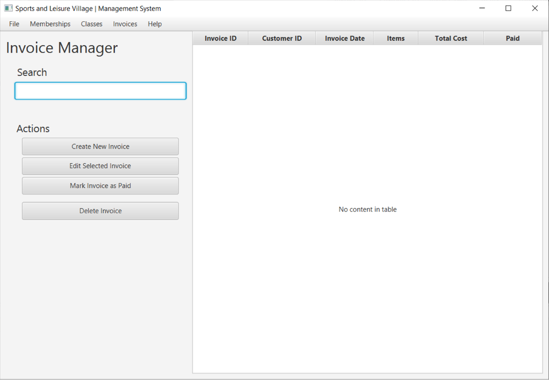

TODO

TODO

Feedback Given

### Post-feedback

Choice Box

This has been implemented so that the user can specify what field they would like to search by

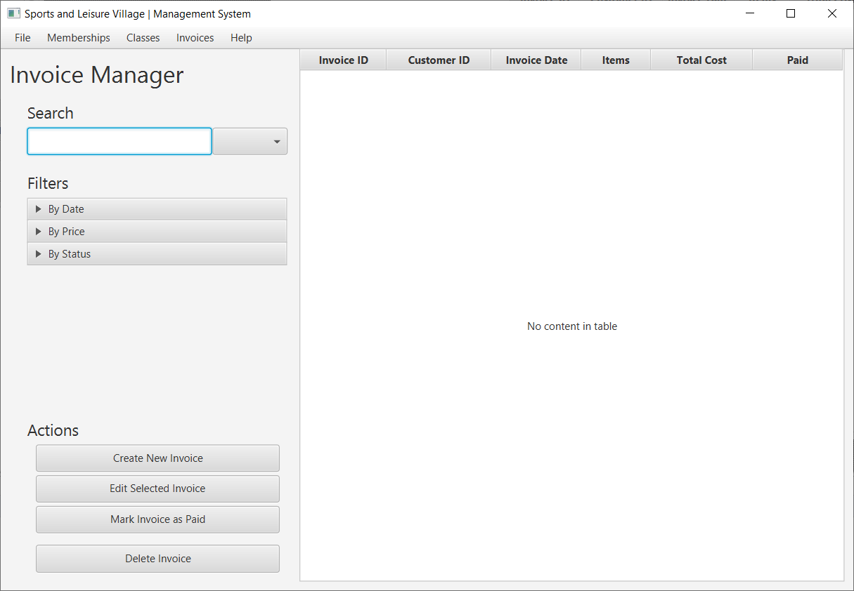

TODO

TODO

TODO

TODO

## Unit Testing

## Functional Prototype

