**Task 1**

Our primary stakeholders are hobby cyclists - people who train and cycle as more than just a means for transport. Specifically, our stakeholders are those within Cambridge as we have the ability to include them in our data gathering process as well as then having a more targeted primary stakeholder whom we can show more interest in.

We have chosen our primary stakeholders to be these so-called ‘hobby cyclists’, i.e. cyclists who choose to regularly train with some given schedule as opposed to those who cycle merely to commute for work or study. This is because they can’t necessarily reschedule their cycling time due to punctuality requirements associated with their place of work or study. The purpose is to see how currently available weather applications impact their lives and training regimes and how a proprietary application targeted specifically for them could bring about improvements to their livelihoods.

In our current location, there is no shortage of active cyclists available which corresponds to lots of potential data points as well as lots of potential beneficiaries. Having questioned a sample of our primary stakeholders, it appears likely that cycling would be more appealing if the weather is subjectively ‘better’ throughout the duration of their cycling activity. We believe that most cyclists would prefer relatively warmer and dryer weather. However, it is entirely possible that some cyclists will prefer to cycle in the rain instead, as is observable in our data, because it could be seen as more refreshing, or perhaps because it is the weather they have grown used to given the geographical location.

It is clear in our quantitative data that the primary stakeholder spans a large age demographic, with the cycling appealing to young and old alike, and therefore it would be important to consider all of these age groups when collecting data and designing the solution. Additionally, people could have different preferences based on the region in which they live, as this will affect your cycling in terms of journey and common weather. One other major factor could be the design of their bikes such as whether or not it has mudguards whose need is determined by the conditions of the terrain which is dependant on the weather, or wheels appropriate for off-road cycling. We also have justifiable reason to believe that certain types of weather are safer than others. For example, wet and icy weather conditions could potentially greatly increase the chances of an accident and thus cyclists may prefer to avoid it in concern of their safety.

Along with having discovered the contextual data regarding cyclists’ routines, we found out through meeting the primary stakeholders that with current weather applications, it is difficult to plan a route that corresponds with ideal weather and then not need to use their phone during a journey. This leads to a level of disorganization which some have found to be stressful in their lives, gives us enough cause for a proprietary interactive weather application, suitable across the desired demographic, whose general requirement is to give our primary stakeholders the organization they need to go about planning training routines around the weather with much more ease to promote a safe and stress free journey.

The primary stakeholders are the cyclists who choose to use our proprietary weather app. They may consist of people of many age groups and they will be directly interacting with the application in the form of being able to build up their training schedule around weather predictions and perhaps even immediate history, as knowing it snowed recently can indicate icy terrain, and this can help them maximize their training, safety and organization which leads to managing and minimizing stress. This still allows the basic demands to be met - they are able to view the weather and weather predictions/history in and around their location. Instead of being disappointed by having their training schedule coincide with undesirable weather, they can view the future weather predictions and build up their schedule, choosing ideal routes, giving them peace of mind and a stress free present.

The secondary stakeholders are those who add to the weather database behind our chosen API which provides the data which is shown in our application. While they do not directly interact with our application unless they happen to be a cyclist who fits under the primary stakeholders, they do still provide input in the form of weather data which is displayed in our app. The output from our application, the weather readings, is targeted towards the primary stakeholders.

Tertiary stakeholders may consist of the people our cyclists could potentially meet on their journeys, such as car drivers and other road users. Our application has indirect impact on them through the cyclists as they do not then have to be weary of disorganised cyclists on the road who could lose control due to cycling in undesired weather conditions and nasty terrain or display signs of frustration which results from the undesired conditions. Given the additional levels of organisation this would provide, different cycling routes could be taken that also minimizes interruptions to other road users and promotes safer road environments.

Our facilitating stakeholders include cycling organisations who may encourage their members to use the application to promote safe cycling and an organized fitness plan, which is beneficial to the members in terms of health and safety, and also aids in the development of our application in terms of continuation, further developments and releases, and its increase in popularity. There is also us, the developers, who build, implement and develop the weather application and as the legal owners, have the responsibility of maintaining it.

We have decided that questionnaires and focus group interviews with a use case would be the best methods to gather data. Questionnaires allow us to gather statistics such as preferred weather for training and interest in our product which would allow for a quantitative analysis that aids in refining our functional and non-functional requirements. As an example, questions will allow us to get a measure for the age demographics and quantitative opinion regarding the impact weather has on their cycling schedules. These figures can be compounded into graphical representations which will allow us to draw quantitative conclusions and finally refine some requirements. The points in the requirements developments process that are met using this are aims, sources of satisfaction, knowledge and skills and attitude to work. There is more support for quantitative measures as there is a limit to the open endedness offered which is covered in the focus group. In terms of aims and measure of success we can compare the figures for prefered to actual weather that coincides with training regimes. Sources of satisfaction is partially covered in the open answer question but satisfaction can be measured by numerical ratings. Knowledge and skills is calculated as a measure in terms of cyclists’ feelings regarding current services. Work attitude is also determined open endedly but is gone through in more detail in the focus group which is used to determine the usefulness of our applications, and how it can appeal to a majority of our primary stakeholders.

Focus groups allow us to do group interviews to gather insight from our primary stakeholders in the form of qualitative measures which can be analysed to gather their opinions. In terms of developing requirements, we are covering the open ended answers mentioned above as well as responsibilities held, work-group attributes, the nature of their work and their conditions. By work here we are referring to their main activity which is cycling. We can find out about their issues with current available services in detail and the possible impact our weather app would have on theses cyclists. This allows us to analyse their current situation and see how they would have it compare to a theoretical situation involving our product, which is the use case we would provide. Here we can measure the general satisfaction and use it to refine the requirements of our application so that the overall consensus is positive and meets the needs such as adhering to cycling safety, which is an example of responsibility in action.

Other methods such as one-on-one interviews were discarded as they can be combined within our focus groups to save time which is a limited resource, but still gather the essential data that interviews are useful for. Focus groups, in our case, have the advantage of allowing us to see our primary stakeholders interact with each other and viewing the impact this has on groups of people rather than individuals, as our product is targeted at a group. Card sorting and web analytics were also discarded due to time implications and because the quantity of unique data that these methods can contribute to our overall data gathered already is low since the questionnaires and focus groups provide most of the essential data which helps in defining and refining requirements.

**Question 5**

* Quantitative results from questionnaire with figures
* Qualitative results from questionnaire/focus group
* Analyse results

**Question 6**

What we found about:

* Aims
* Sources of Satisfaction
* Knowledge and Skills
* Attitudes to Work
* Work-Group Attributes
* Nature of Activities
* Responsibility
* Working Conditions

Overviews of Requirements (Functional and Non-Functional)

**Questionnaire**

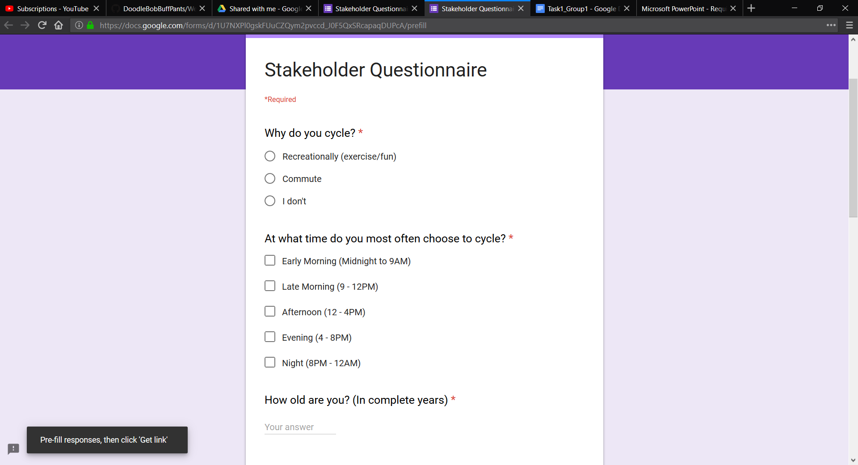

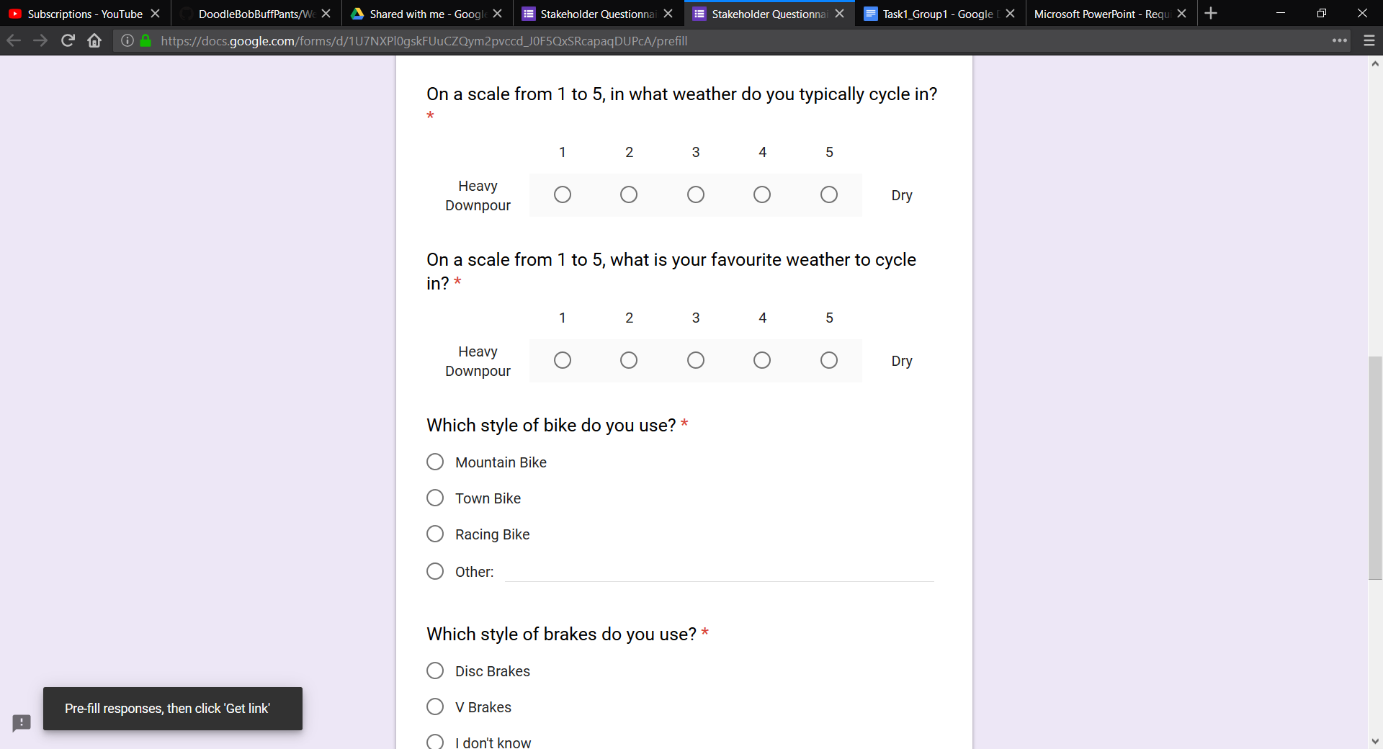

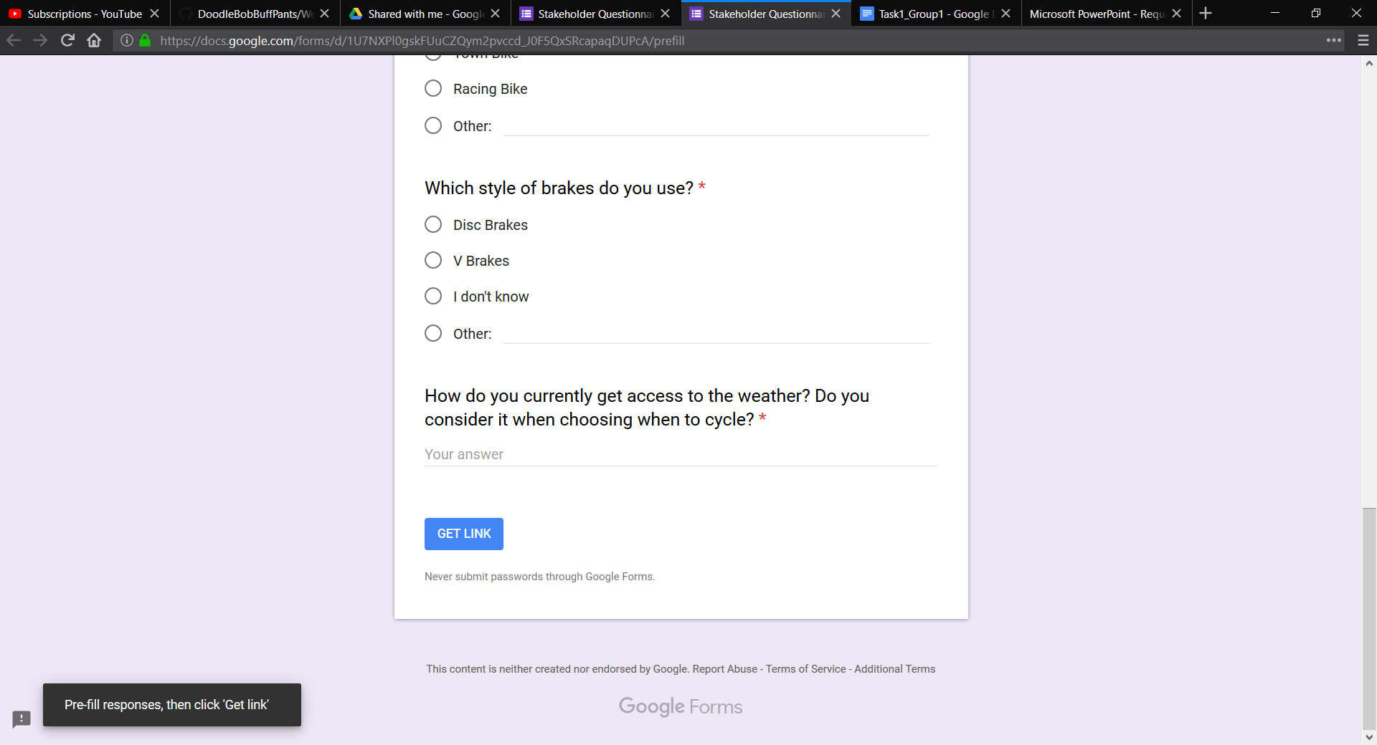

**Focus Group**

The purpose is to get answers that sheds some light on our stakeholders in their contextual environment with a series of questions followed by answers which are recorded separately and anonymously. Below is an outline of the questions certainly asked, although conversation can veer off-topic and all significant occurrences are discussed in data analysis, but the important information is contained within answers to the following -

Questions:

* What type of bike do you have?
* Would you choose to cycle in different weather if you had a different type of bike?
* Does your bike have a mudguard installed?
* How does it affect your weather-related cycling decisions?
* Do you often check the weather before you go cycling?
* How does it influence your decision?
* How could your weather checking experience be improved?
* How does this make you feel in terms of stress and organisation?
* On long rides do you check the weather to decide when to turn back?