CDC OPEN PROJECT 25-26

Satellite Imagery–Based Property Valuation

A Multimodal Machine Learning Study

Project Completed By: Sumit Sharma

Branch: Engineering Physics

Enrollment No.: 23123042

Overview: Approach and Modeling Strategy

1.1 Motivation
Property valuation is influenced not only by intrinsic attributes such as size, quality, and layout, but also by extrinsic neighborhood characteristics including greenery, infrastructure, road density, and proximity to water bodies. While traditional machine learning models rely heavily on structured tabular data, such neighborhood-level attributes are difficult to encode numerically.
This project investigates whether satellite imagery, when combined with structured housing data, can enhance property price prediction by providing visual environmental context.

1.2 High-Level Strategy
The overall strategy followed a progressive, evidence-driven pipeline:
- Build a strong tabular-only baseline using classical ML models.
- Perform Exploratory Data Analysis (EDA) to understand both numerical and spatial patterns.
- Programmatically acquire satellite imagery using geographic coordinates.
- Extract visual representations using a pretrained CNN (ResNet-18).
- Experiment with multiple multimodal fusion architectures.
- Compare unimodal vs multimodal performance using RMSE and R².
- Apply Grad-CAM to interpret visual features.
- Select the final model based on empirical performance, not complexity.
This approach prioritizes robustness, interpretability, and honest evaluation.

Exploratory Data Analysis (EDA)
EDA was conducted to understand the distributional, spatial, and visual characteristics of the data.

2.1 Price Distribution Analysis
- Property prices exhibit a right-skewed distribution, with a small number of luxury properties.
- Median prices lie substantially below the maximum, indicating high variance.
- This skewness motivates the use of tree-based models and optional log-transformation during experimentation.
Key takeaway:
Price prediction is inherently noisy; absolute accuracy must be interpreted relative to scale.
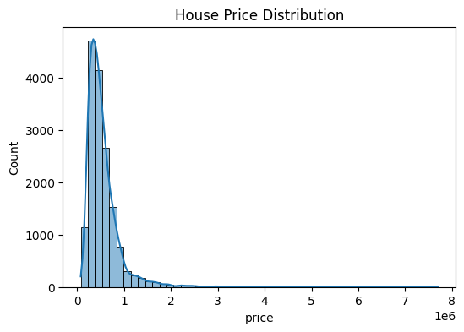

2.2 Feature Relationships (Tabular EDA)
Key observations from correlation and scatter analyses:
- sqft_living and grade show strong positive correlation with price.
- bathrooms and view contribute significantly to valuation.
- waterfront properties consistently command a premium.
- Latitude and longitude reveal geographical clustering of high-value regions.
These findings justify:
- The use of ensemble methods (Random Forest)
- The inclusion of location-derived visual context
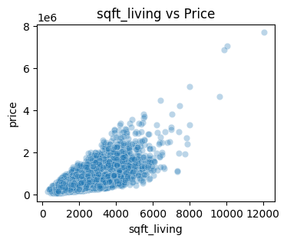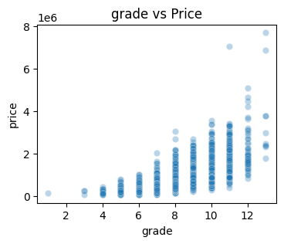
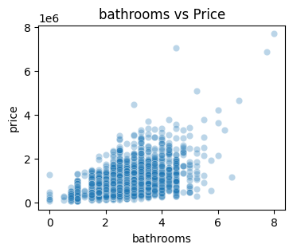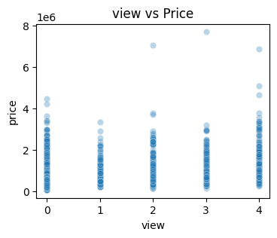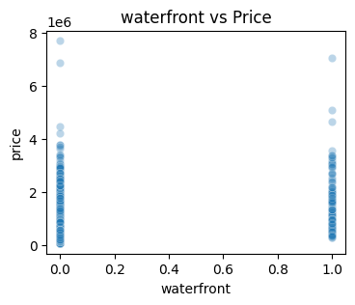

2.3 Geospatial & Visual EDA (Satellite Images)
Sample satellite images were visualized directly during EDA to qualitatively assess neighborhood context.
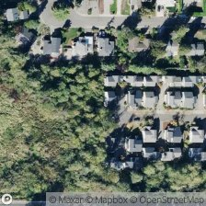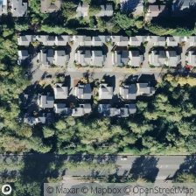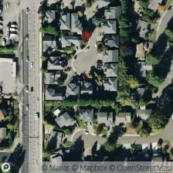
Sample Satellite Images downloaded using Mapbox API
From visual inspection:
- High-value properties are often located near:
  - Water bodies
  - Dense greenery
  - Well-connected road networks
- Lower-value regions tend to show:
  - High concrete density
  - Sparse vegetation
  - Industrial or highly congested layouts
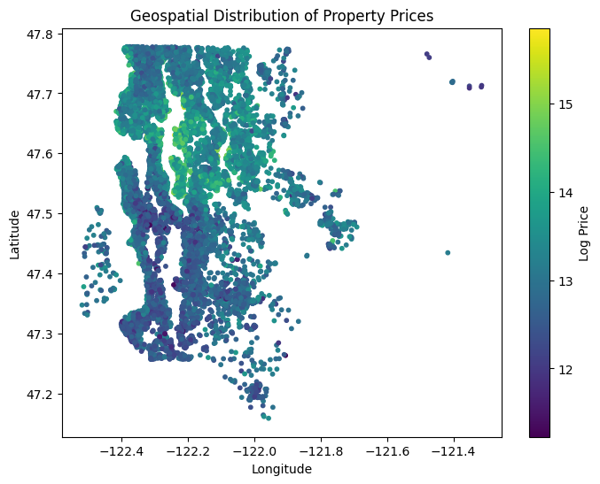
EDA Insight:
Satellite imagery captures macro-level neighborhood signals that are not explicitly present in tabular data.

Financial and Visual Insights
This section connects visual cues to economic interpretation.

3.1 Green Cover vs Concrete Density
- Areas with visible tree cover and parks generally correspond to higher property values.
- Vegetation acts as a proxy for:
  - Environmental quality
  - Affluence
  - Lower population density
Conversely:
- Highly concrete-dense areas often reflect urban congestion or industrial zones, associated with lower average prices.

3.2 Waterfront Proximity
Satellite images clearly distinguish waterfront properties.
- Visual proximity to lakes or rivers strongly correlates with premium pricing.
- This aligns with tabular feature waterfront, validating that satellite imagery encodes meaningful economic signals.
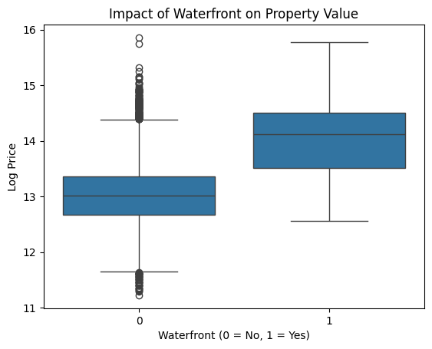

3.3 Road and Infrastructure Patterns
- Well-structured road networks indicate planned neighborhoods and accessibility.
- Gradual road layouts often outperform chaotic dense grids in valuation.
Conclusion:
Visual features extracted from satellite images have clear economic intuition, even if they do not always improve numerical model performance.
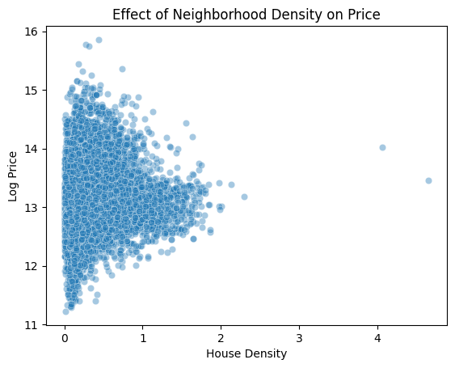

Architecture Diagram
The following diagram summarizes the multimodal pipeline explored in this project.
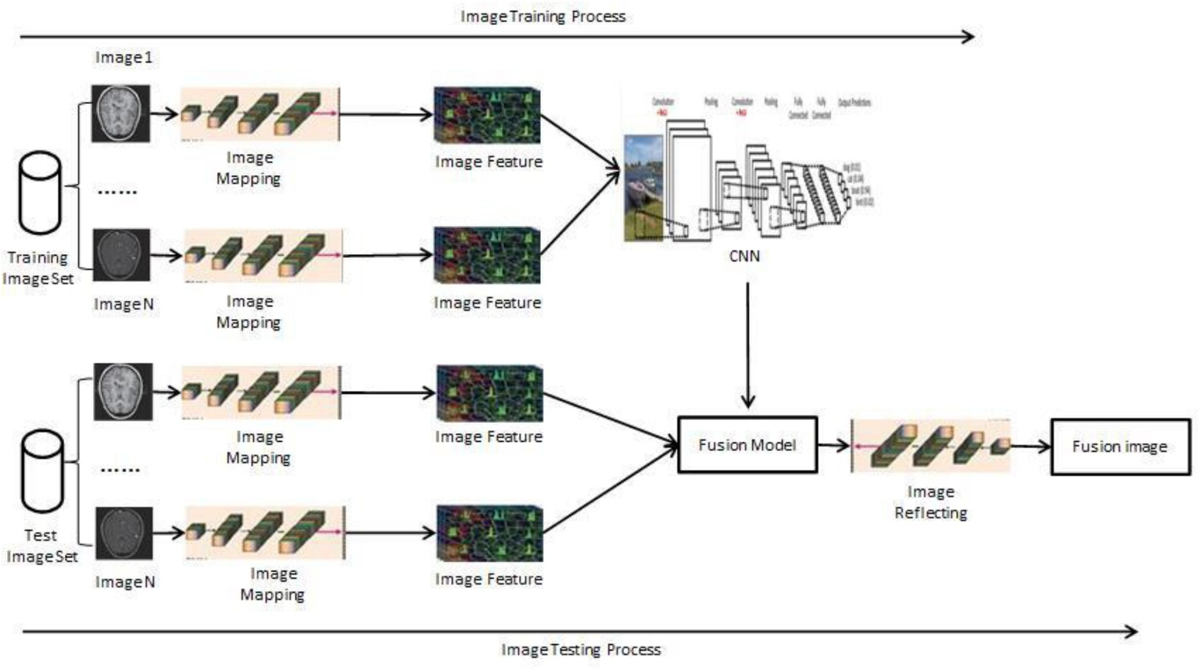
Architecture Description (Textual)
- Tabular Branch
  - Structured housing attributes
  - Direct input to regression model
- Image Branch
  - Satellite image
  - Pretrained ResNet-18
  - 512-dimensional visual embedding
- Fusion Layer
  - Concatenation of tabular and image features
  - Optional dimensionality reduction (PCA)
- Prediction Head
  - Regression model (Random Forest / Ridge / MLP)

Modeling and Results

5.1 Tabular-Only Models
Multiple models were tested on structured data alone.
Best-performing model: Random Forest Regressor
Metric | Value
RMSE | ~129,000
R² | ~0.87
This establishes a strong baseline.

5.2 Multimodal Models (Tabular + Satellite Images)
Several fusion strategies were evaluated.
Model | RMSE | R²
RF + CNN embeddings | ~160,000 | ~0.78
MLP + CNN embeddings | ~195,000 | ~0.66
PCA + Ridge (CNN + Tabular) | ~170,000 | ~0.74

5.3 Interpretation of Results
Key observations:
- Multimodal models did not outperform the tabular baseline.
- High-dimensional CNN embeddings introduced noise.
- ImageNet-pretrained CNNs are not task-aligned for real estate valuation.
- Limited dataset size (~4k images) constrained multimodal learning.
Critical Insight:
Multimodal learning is not inherently superior; its success depends on alignment between representation, task, and data scale.

Explainability with Grad-CAM
Grad-CAM was applied to the CNN to understand what visual regions influenced feature extraction.
Observations:
- Strong activation on:
  - Water bodies
  - Green spaces
  - Major road structures
- Minimal attention on homogeneous regions
This confirms that:
- The CNN captures meaningful environmental context
- Lack of performance gain is due to fusion limitations, not irrelevant visual features
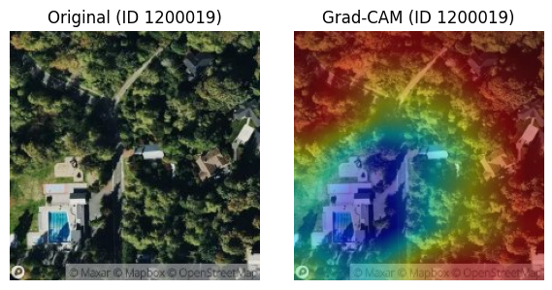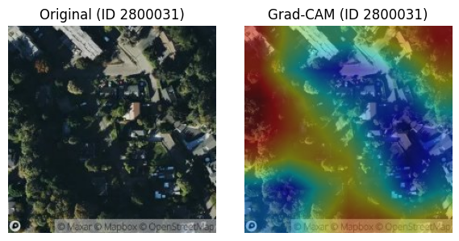
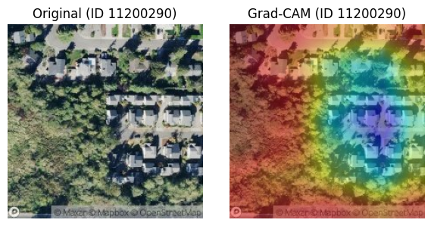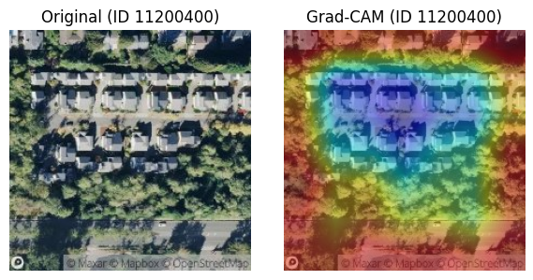
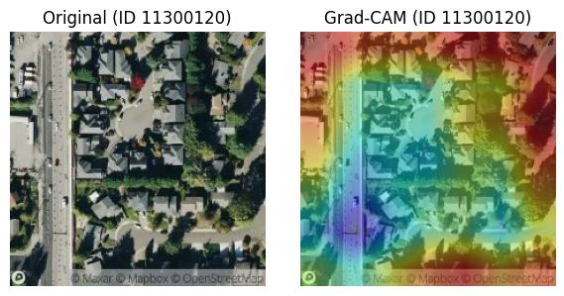

Final Model Selection
Despite extensive multimodal experimentation, the tabular-only Random Forest was selected for final predictions because:
- It achieved the lowest RMSE
- It was the most stable across validation
- It was easier to interpret and deploy
The final prediction file was generated using this model.

Conclusion
- This project demonstrates a complete, end-to-end multimodal ML pipeline, from data acquisition to explainability. While satellite imagery provided valuable qualitative insights into neighborhood context, naive fusion with pretrained CNN embeddings did not yield quantitative improvements over a strong tabular baseline.
- The key takeaway reflects a real-world ML principle:
- Model effectiveness is determined by empirical evidence, not architectural complexity.

Future Work
- Fine-tuning CNNs on real estate–specific imagery
- Learning region-level embeddings instead of full-image features
- Graph-based modeling of spatial neighborhoods
- Temporal modeling of housing price trends

