GRC Risk Treatment Implementation
Jonathan W. Doolan
doolanjw0@gmail.com
linkedin.com/in/jonathanwdoolangrc
October 2025

Executive Summary
This portfolio documents the implementation of four critical security controls addressing high-priority organizational risks. Each control was identified through formal risk assessment, implemented following industry frameworks (NIST CSF, CIS Controls, ISO 27002), tested for effectiveness, and documented with comprehensive evidence for audit readiness.

Risk Treatment Summary
Risk ID | Control Implemented | Inherent Risk | Residual Risk | Risk Reduction
R-001 | Multi-Factor Authentication | 12 (High) | 6 (Medium) | 50%
R-002 | SIEM Logging & Monitoring | 15 (High) | 8 (Medium) | 47%
R-004 | Endpoint Detection + Encryption | 12 (High) | 4 (Low) | 67%
R-012 | Local Privileged Access Mgmt | 12 (High) | 4 (Low) | 67%

Risk Register
Risk ID | Risk Description | Inherent Risk | Treatment | Residual Risk | Status
R-002 | Because of incomplete central logging and alerting exploited by attackers to hide lateral movement, incidents may be detected too late, increasing impact. | 15 | Mitigate | 8 | Implemented
R-001 | Because of weak MFA enrollment exploited by phishing attackers, account takeover may lead to unauthorized access and data exfiltration. | 12 | Mitigate | 6 | Implemented
R-004 | Because of inadequate endpoint protection and lack of disk encryption exploited by malware or physical theft, there is a risk of data exposure and operational disruption. | 12 | Mitigate | 4 | Implemented
R-012 | Because of daily user accounts with administrative privileges exploited by malware or compromised credentials, there is a risk of privilege escalation and lateral movement during security incidents. | 12 | Mitigate | 4 | Implemented
R-006 | Because of ad-hoc scanning and inconsistent patch SLAs exploited by known vulnerabilities, there is a risk of system compromise and audit findings. | 12 | Mitigate | 6 | Planned
R-003 | Because of inadequate vendor due diligence (no SOC 2/ISO evidence review) exploited by a compromised provider, there is a risk of data exposure or service interruption. | 10 | Mitigate | 6 | Planned
R-005 | Because of incomplete backup coverage and untested recovery procedures exploited by ransomware or system failure, there is a risk of permanent data loss and extended downtime. | 10 | Mitigate | 5 | Planned

Risk Rating Scale: Inherent Risk = Likelihood (1-5) × Impact (1-5) | Critical: 20-25 | High: 12-19 | Medium: 6-11 | Low: 1-5

Treatment 1: Multi-Factor Authentication (MFA)

Risk Addressed
R-001: Because of weak MFA enrollment exploited by phishing attackers, account takeover may lead to unauthorized access and data exfiltration.
Risk Level: High (12) | Impact: Unauthorized access to systems and data

Risk Treatment Strategy
Strategy: Risk Mitigation/Reduction

Control Implementation
Platform: ZITADEL Cloud (Identity Provider)
Implementation Date: September 13, 2025
Owner: Jonathan Doolan

Baseline: MFA enforcement disabled - users authenticated with password only
Changes: Enabled organization-wide MFA policy with TOTP (Time-based One-Time Password), a standard method where a unique, temporary code is generated by an authenticator app and required for login
Testing: Created test user, verified mandatory MFA enrollment on first login, confirmed OTP requirement for subsequent authentication

Security Impact
- Reduces account takeover risk from compromised passwords
- Aligns with NIST 800-63B authentication guidelines
- Satisfies SOC 2 CC6.1 (Logical Access Controls)

Business Value
Reducing the risk of account takeover from High (12) to Medium (6) moves the organization toward meeting legal and regulatory requirements for strong customer data protection, lowering the potential for costly data breach litigation and regulatory fines. This control demonstrates due diligence in protecting sensitive information and maintaining customer trust.

Framework Alignment
NIST CSF | CIS Controls | ISO 27002 | SOC 2
PR.AC-7 | Control 6.3 | 5.17 | CC6.1

Residual Risk: 6 (Medium) - 50% reduction from inherent risk of 12

Treatment 2: Security Information and Event Management (SIEM)

Risk Addressed
R-002: Because of incomplete central logging and alerting exploited by attackers to hide lateral movement, incidents may be detected too late, increasing impact.
Risk Level: High (15) | Impact: Delayed incident detection, limited forensic capability

Risk Treatment Strategy
Strategy: Risk Mitigation/Reduction

Control Implementation
Platform: Grafana Cloud Logs (HTTP endpoint)
Implementation Date: September 12, 2025
Owner: Jonathan Doolan

Baseline: No SIEM (Security Information and Event Management) or centralized logging infrastructure
Changes: Configured Grafana Cloud Logs HTTP endpoint with authenticated ingestion, established secure token storage
Testing: Sent test log via PowerShell with JSON payload, received HTTP 204 success response, verified log searchability in Grafana Explore interface

Security Impact
- Enables centralized log collection for security monitoring
- Provides foundation for detection rules and alerting
- Supports incident response and forensic investigations

Business Value
Reducing incident detection delay from High (15) to Medium (8) significantly decreases potential breach costs by enabling faster response. Industry data shows that reducing mean time to detect (MTTD) from weeks to hours can reduce breach costs by 30-50%. This control also satisfies audit requirements for security monitoring under SOC 2 and demonstrates operational readiness for cyber insurance underwriting.

Framework Alignment
NIST CSF | CIS Controls | ISO 27002 | SOC 2
DE.CM-1, DE.CM-7 | Control 8.2, 8.6 | 8.15, 8.16 | CC7.2, CC7.3

Residual Risk: 8 (Medium) - 47% reduction from inherent risk of 15

Treatment 3: Endpoint Detection & Full Disk Encryption

Risk Addressed
R-004: Because of inadequate endpoint protection and lack of disk encryption exploited by malware or physical theft, there is a risk of data exposure and operational disruption.
Risk Level: High (12) | Impact: Malware infection, data breach, unauthorized access

Risk Treatment Strategy
Strategy: Risk Mitigation/Reduction

Control Implementation
Platform: Windows Defender + BitLocker
Implementation Date: September 17, 2025
Owner: Jonathan Doolan

Baseline: Windows Defender active with basic protection, BitLocker (full disk encryption) not enabled
Endpoint Detection: Verified and enabled real-time monitoring, behavior monitoring, IOAV (IE and Office AV - protection against downloads and email attachments), and tamper protection
Full Disk Encryption: Enabled BitLocker with TPM (Trusted Platform Module) protection, recovery key secured in password manager
Testing: Created EICAR test file (industry-standard malware test), verified detection and automatic quarantine by Windows Defender

Security Impact
- Real-time malware detection and prevention
- Data-at-rest protection via encryption
- Protection against physical device theft

Business Value
Reducing endpoint compromise risk from High (12) to Low (4) protects against the most common attack vector in modern breaches. Full disk encryption specifically addresses regulatory requirements for data protection (HIPAA, GDPR, state breach notification laws) and eliminates breach notification obligations in case of lost or stolen devices. This 67% risk reduction translates to measurable reduction in potential breach costs and regulatory penalties.

Framework Alignment
NIST CSF | CIS Controls | ISO 27002 | SOC 2
PR.DS-1, DE.CM-4 | Control 10.1, 10.5 | 8.3, 8.24 | CC6.6, CC6.7

Residual Risk: 4 (Low) - 67% reduction from inherent risk of 12

Treatment 4: Local Privileged Access Management (PAM)

Risk Addressed
R-012: Because of daily user accounts with administrative privileges exploited by malware or compromised credentials, there is a risk of privilege escalation and lateral movement during security incidents.
Risk Level: High (12) | Impact: Privilege escalation, lateral movement in security incidents

Risk Treatment Strategy
Strategy: Risk Mitigation/Reduction

Control Implementation
Platform: Windows Local User Management (Local PAM for Endpoints)
Implementation Date: September 17, 2025
Owner: Jonathan Doolan

Note: This implementation focuses on Local Privileged Access Management for endpoints. Full-scale enterprise PAM typically includes centralized password vaulting and session recording; this project demonstrates the foundational principle of least privilege at the endpoint level.

Baseline: Daily-use account with Administrator privileges, no emergency access account
Changes: Created emergency breakglass account with admin rights, removed daily account from Administrators group
Testing: Verified administrator group membership changes via PowerShell (Get-LocalGroupMember cmdlet), tested standard user functionality

Security Impact
- Implements principle of least privilege
- Reduces attack surface for privilege escalation
- Maintains emergency access capability via dedicated breakglass account

Business Value
Reducing privileged access misuse from High (12) to Low (4) directly addresses one of the most exploited security gaps in ransomware and insider threat scenarios. Operating with least privilege limits the blast radius of compromised credentials and satisfies compliance requirements for access controls. This control demonstrates mature security practices and reduces liability in breach scenarios by showing appropriate preventive measures were in place.

Framework Alignment
NIST CSF | CIS Controls | ISO 27002 | SOC 2
PR.AC-4 | Control 5.4, 6 | 5.15, 8.2 | CC6.2

Residual Risk: 4 (Low) - 67% reduction from inherent risk of 12

Appendix: Evidence Documentation

R-001: Multi-Factor Authentication Evidence
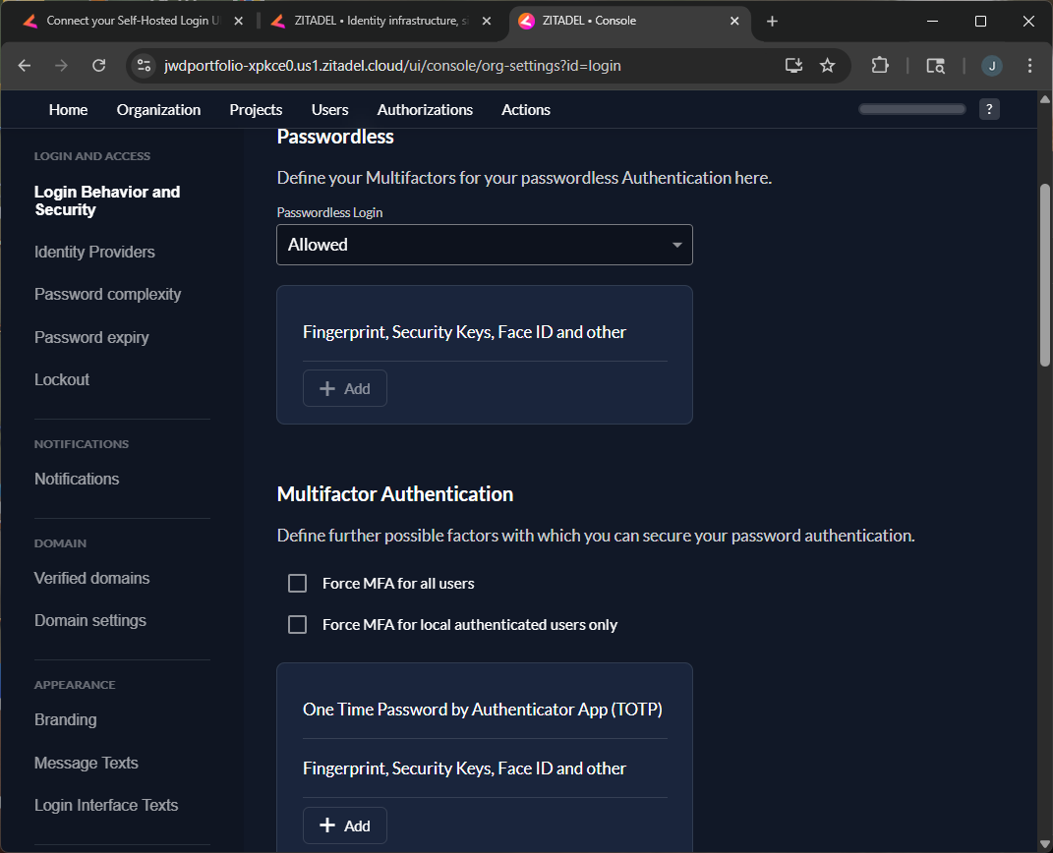
Figure 1: MFA Policy - Baseline (Disabled)

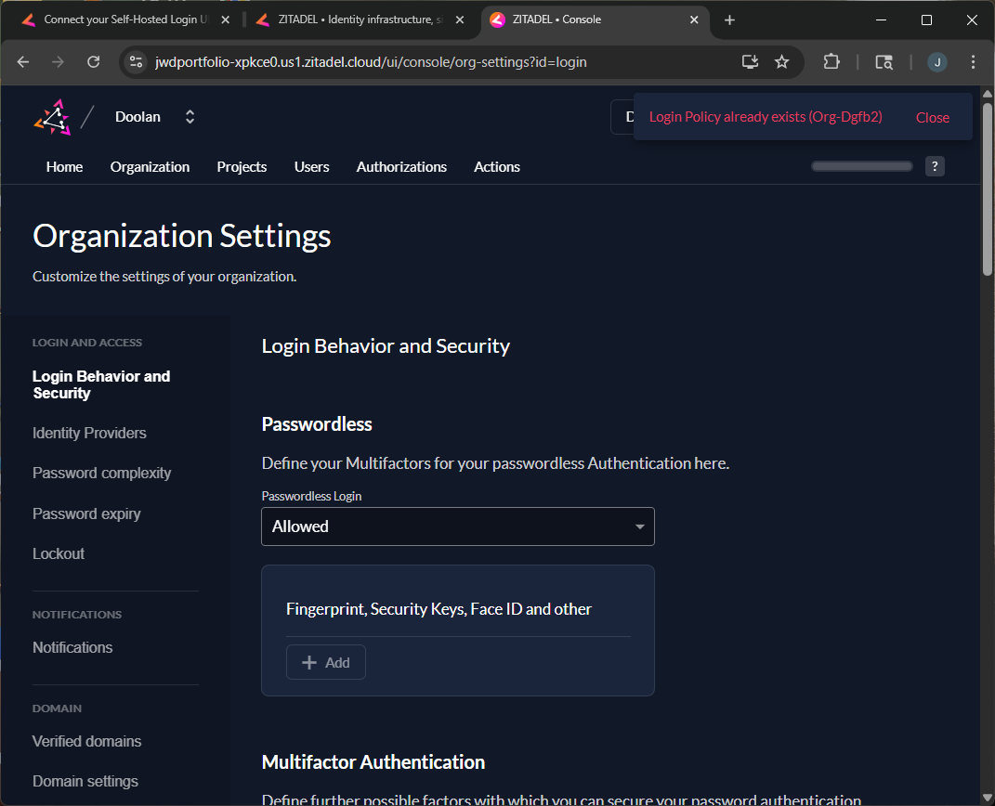
Figure 2: MFA Policy - Enabled

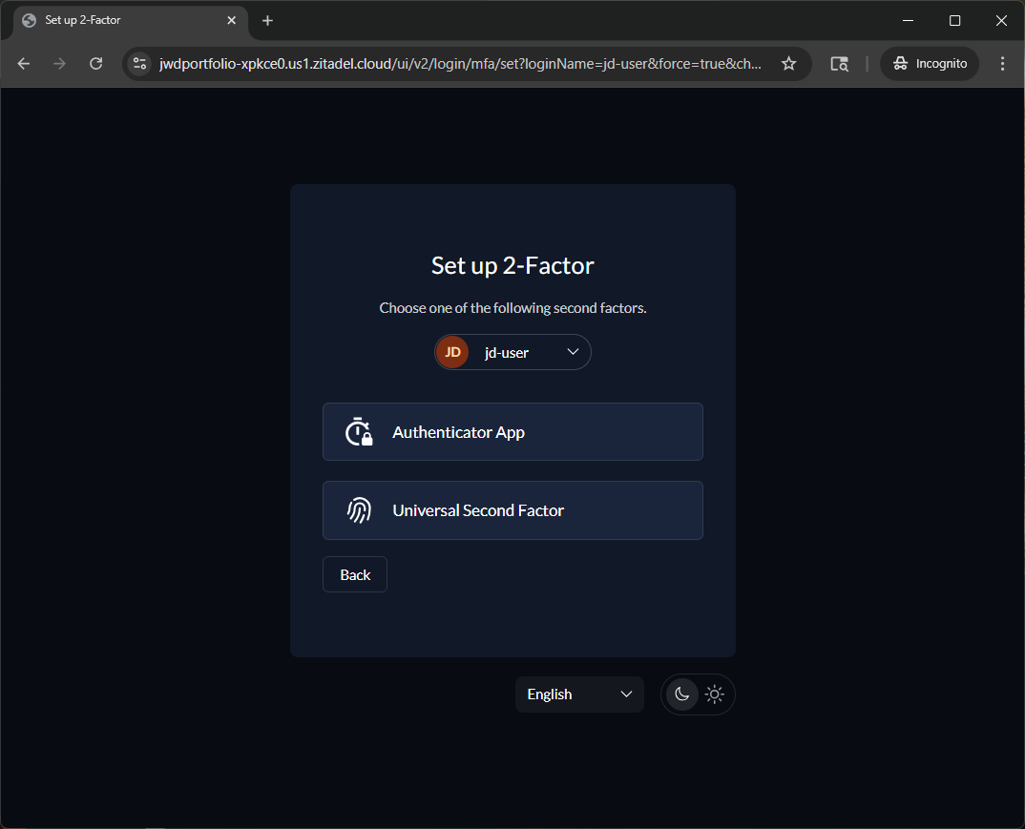
Figure 3: User MFA Enrollment

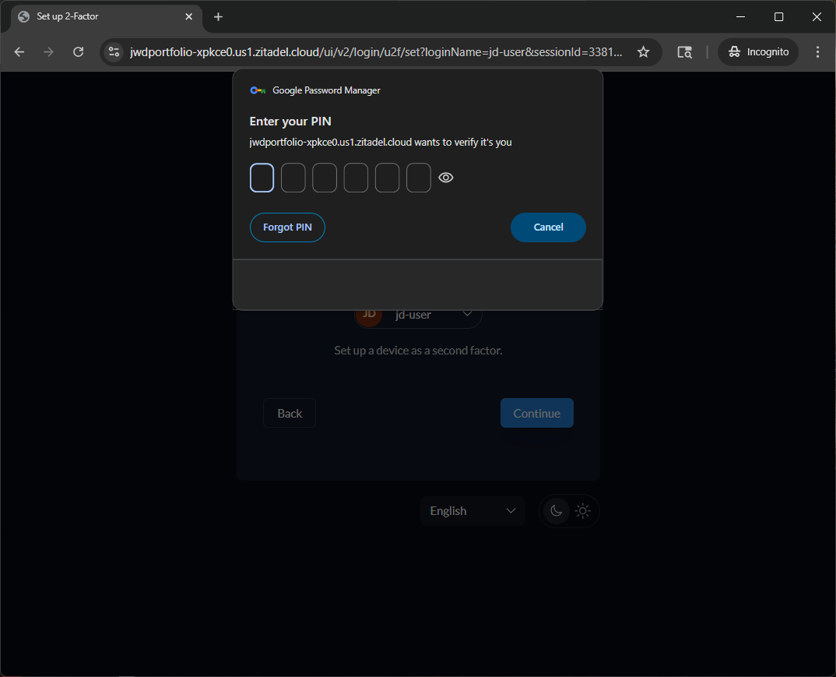
Figure 4: OTP Challenge on Login

R-002: SIEM Implementation Evidence
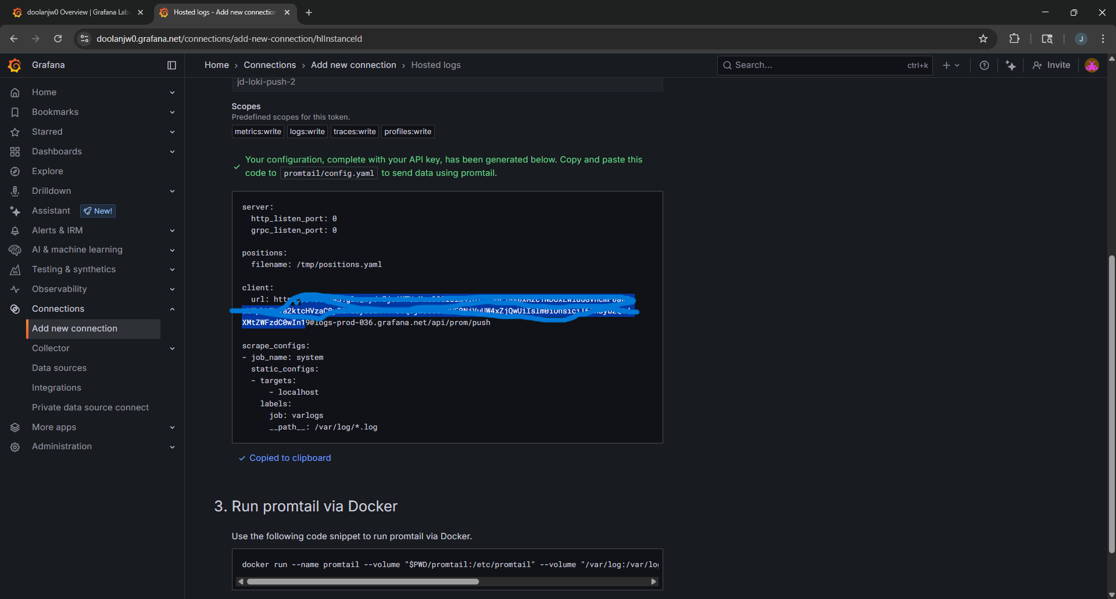
Figure 5: Grafana Cloud Endpoint Configuration


Figure 6: SIEM Connection Settings

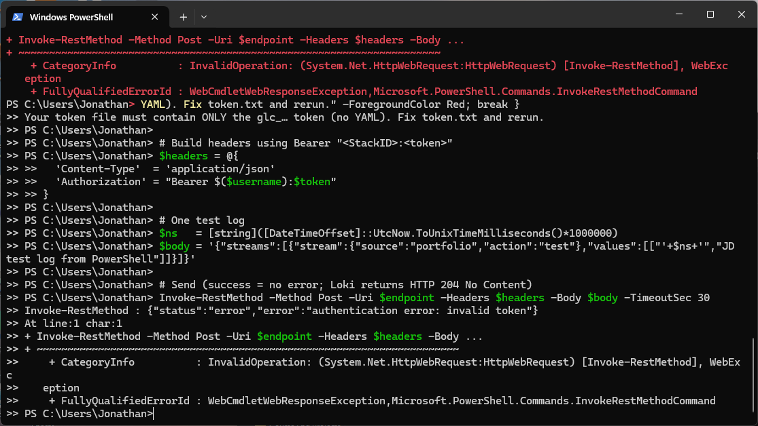
Figure 7: Test Log Successfully Ingested

R-004: Endpoint Detection & Encryption Evidence
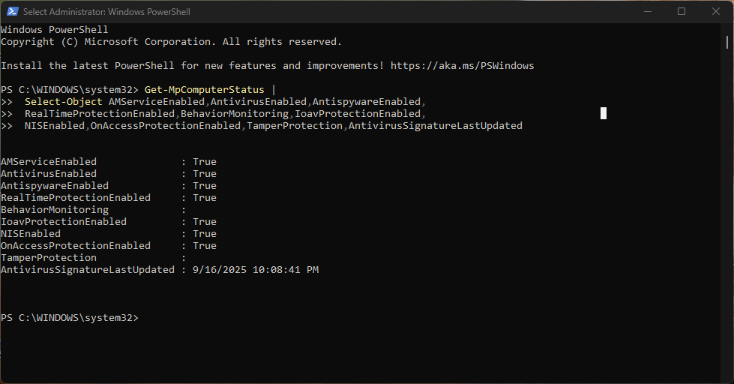
Figure 8: Windows Defender Baseline

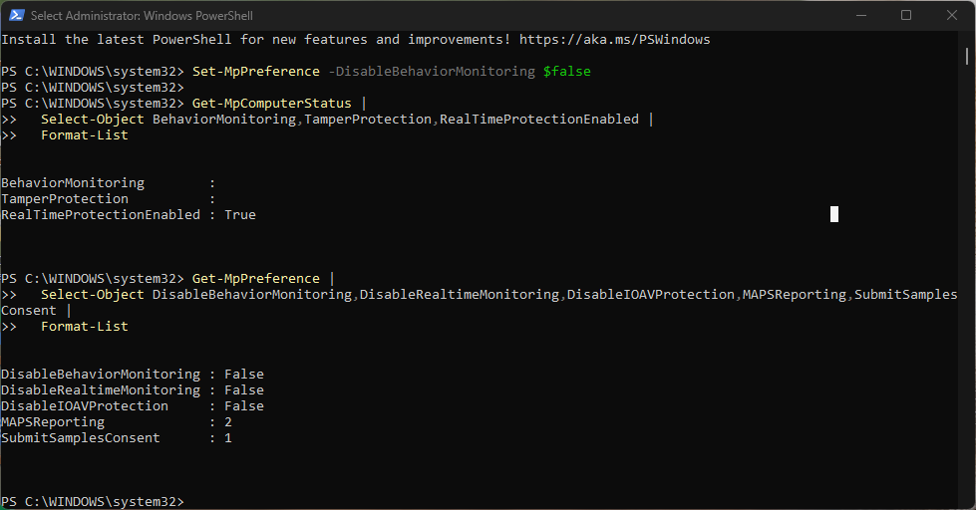
Figure 9: Defender Policy Configuration

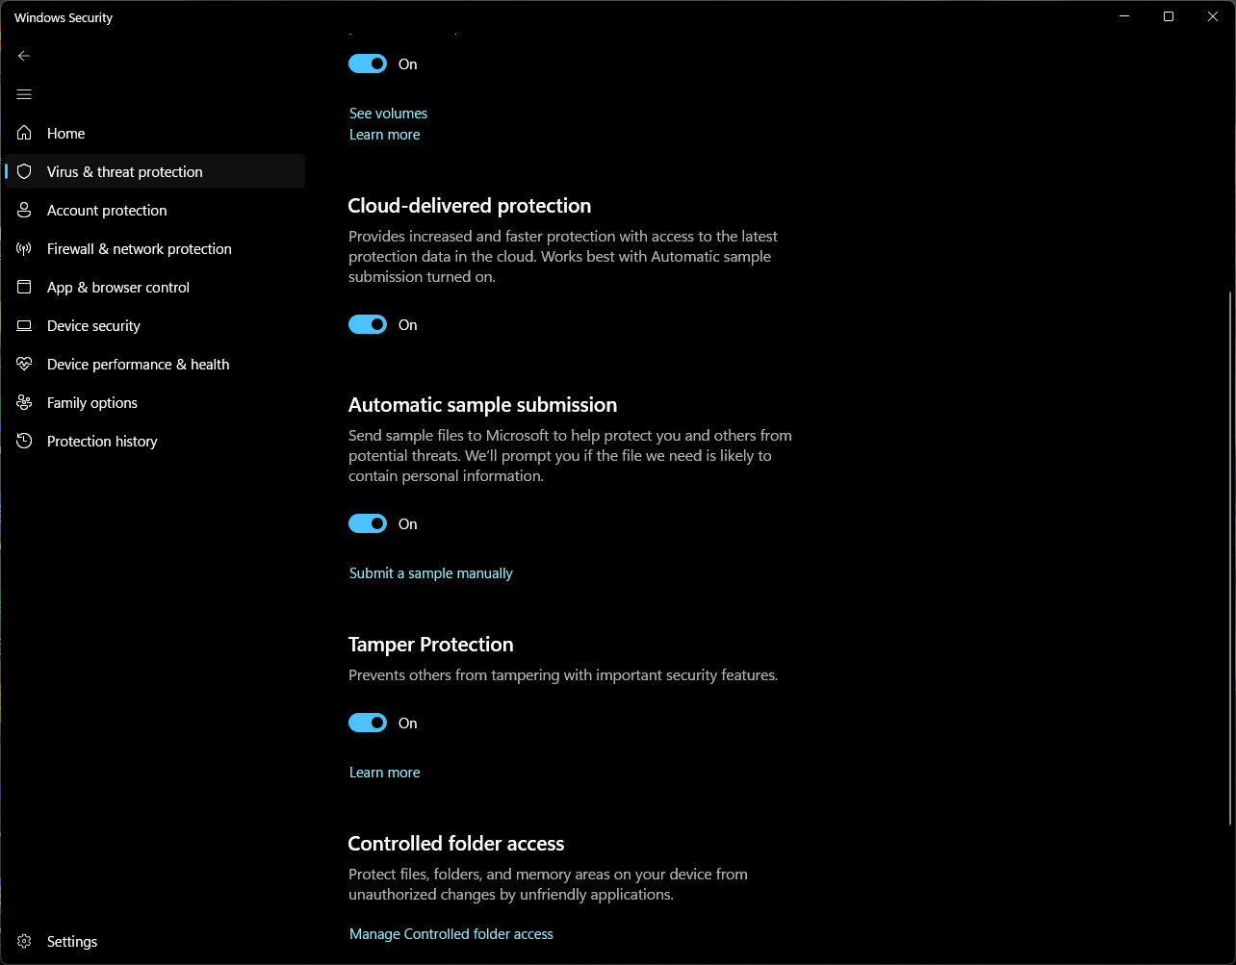
Figure 10: Tamper Protection Enabled

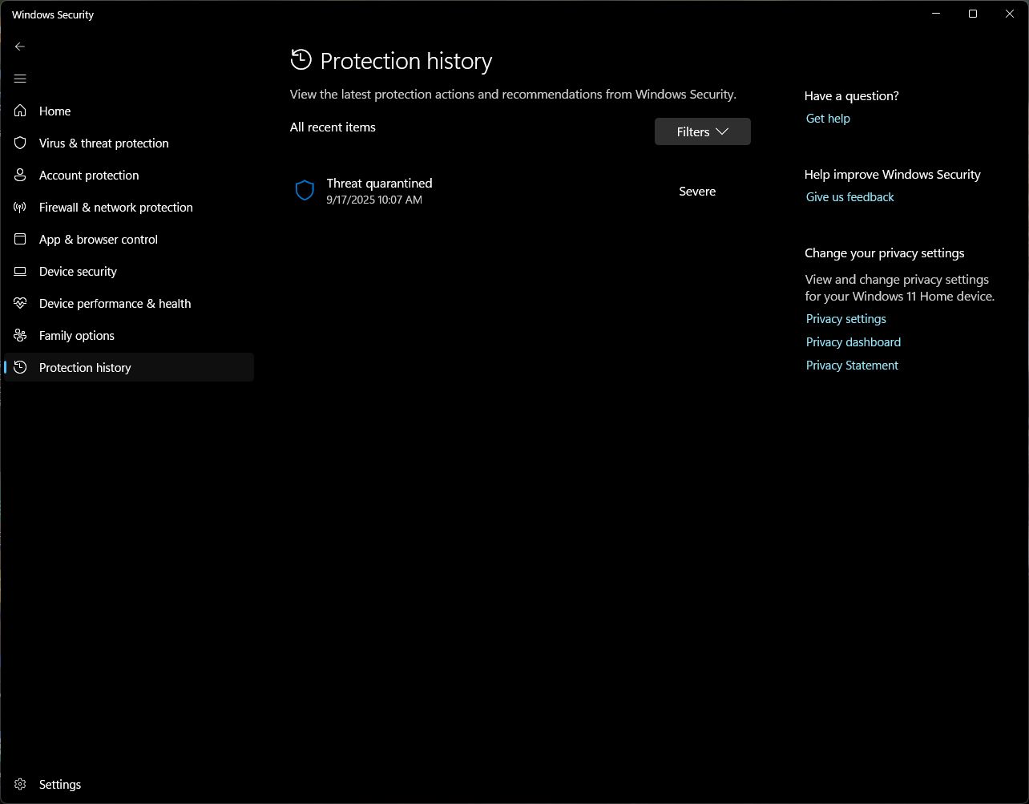
Figure 11: EICAR Test File Detected

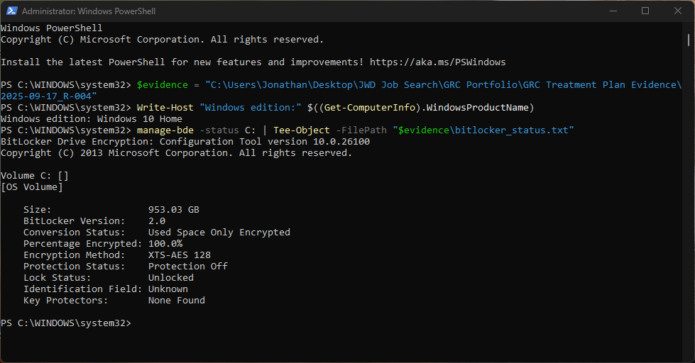
Figure 12: BitLocker Status Verification

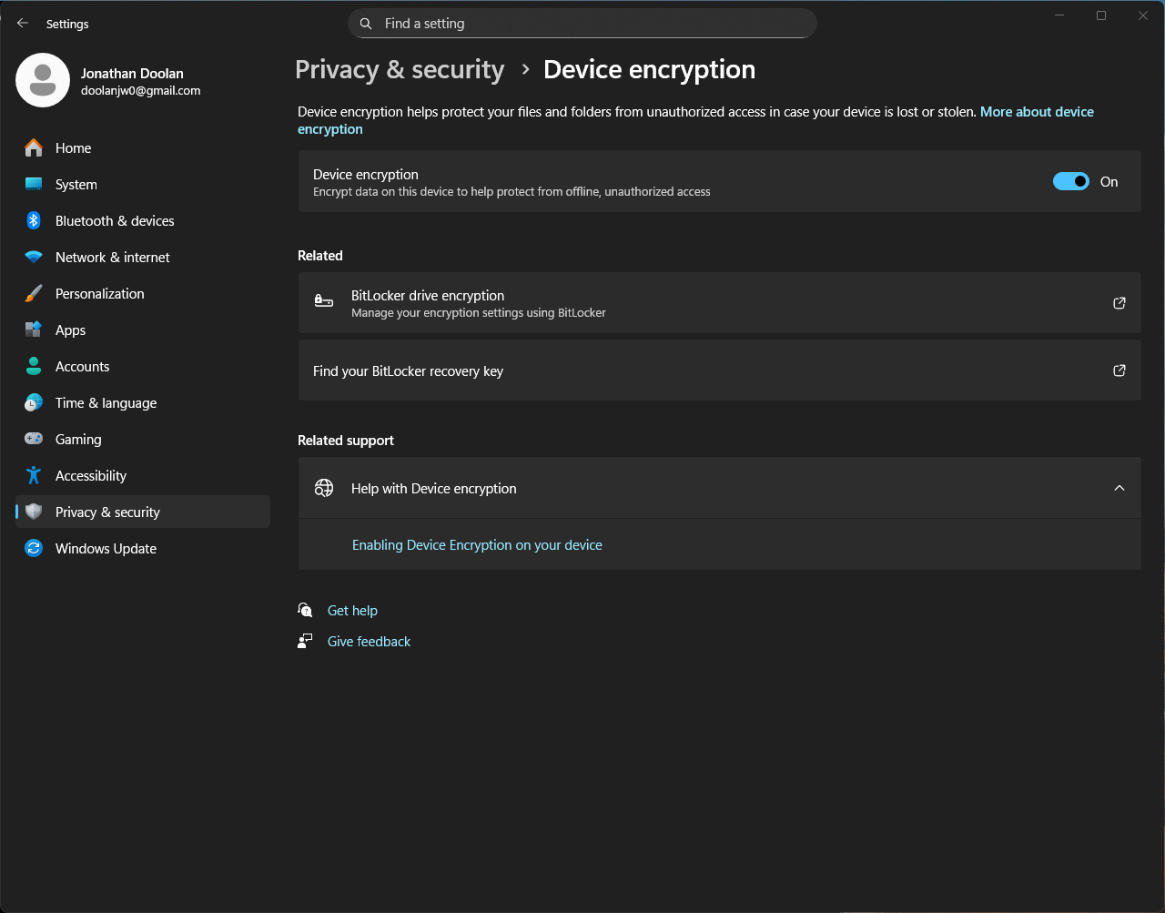
Figure 13: Full Disk Encryption Enabled

BitLocker Configuration Details

R-012: Local Privileged Access Management Evidence
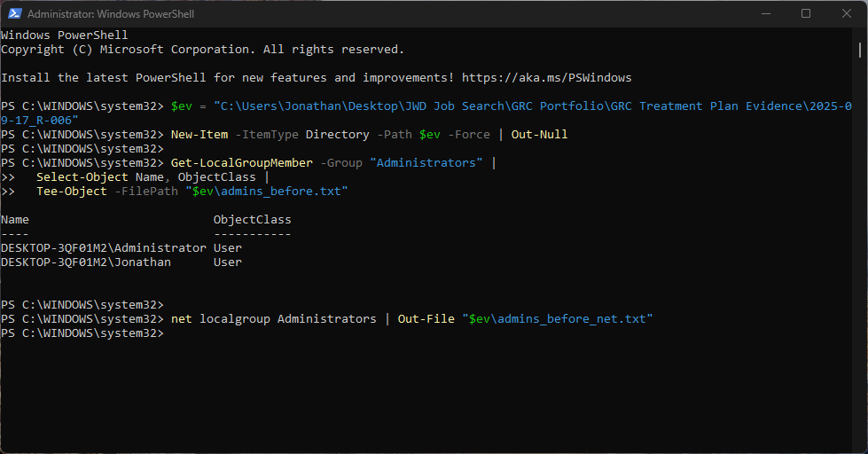
Figure 14: User Account Configuration

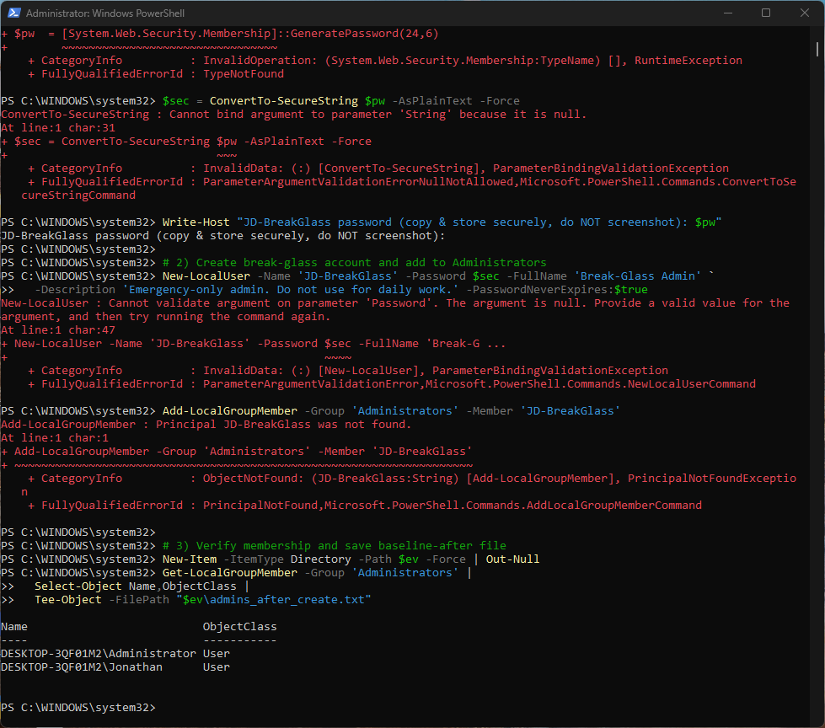
Figure 15: Access Policy Settings

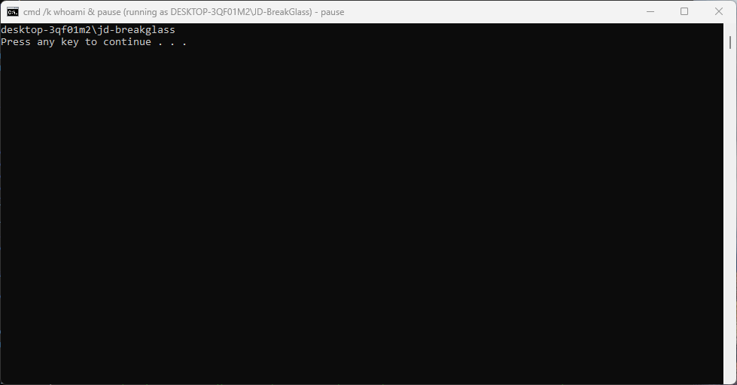
Figure 16: Standard User Testing

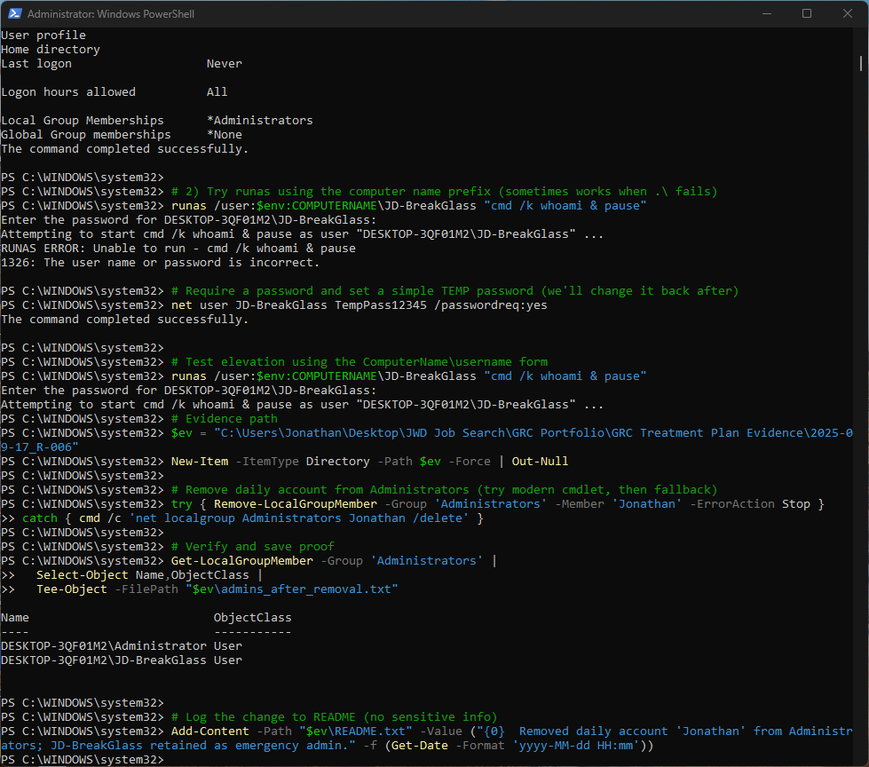
Figure 17: Final Configuration

