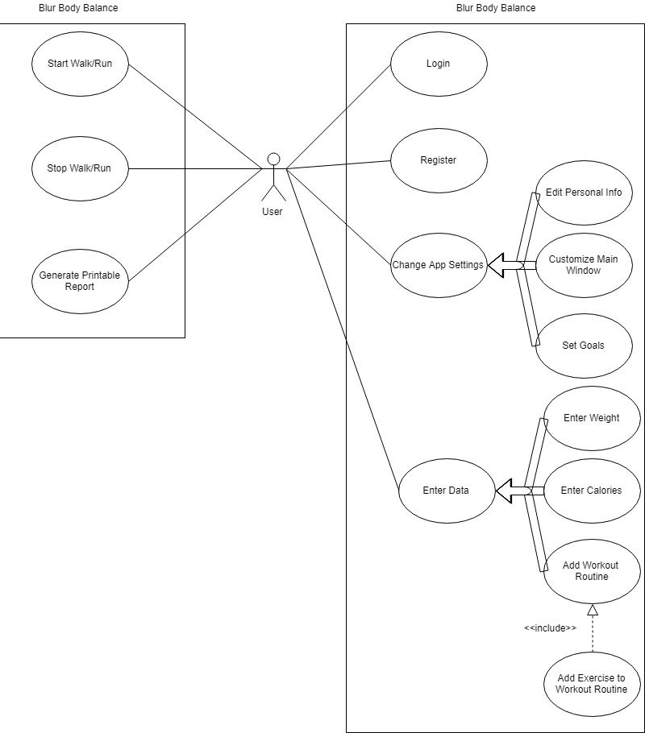

**Use case:** Login

**Steps**:

**Actor Actions** **System Responses**

1) Choose username field

2) Type in username

3) Choose password field

4) Type in password

5) Click “Login” button

6) check if user is registered

7) if wrong, display “username or password is incorrect”

8) if right, display main window of app

**Use case**: Register

**Steps**:

**Actor Actions** **System Responses**

1) click register button

2) display register screen

3) Enter information

4) enable “Register” button when all fields are filled

5) Click “Register” Button

**Use Case**: Change App Settings

**Related Use Cases**:

Generalization of:

Set Goals

Enter Personal Info

Customize Main Window

**Steps**:

**Actor Actions** **System Responses**

1) Navigate to “app settings”

2) select which setting to change

3) display setting change page

4) Invoke Set Goals/Enter Personal Info

/Customize Main Window

5) select save

6) save info

7) Update UI if applicable

**Use Case**: Edit Personal Info

**Related Use Cases**:

Specialization of:

Change App Settings

**Steps**:

**Actor Actions** **System Responses**

1) navigate to app settings

2) select “change personal info”

3) display personal info fields

4) enter new personal info

5) select “save”

6) save settings

7) return to app settings page

**Use Case**: Customize Main Window

**Related Use Cases**:

Specialization of:

Change App Settings

**Steps**:

**Actor Actions** **System Responses**

1) navigate to “app settings”

2) select “customize main window”

3) display main window settings

4) select desired info to be displayed

5) select “save”

6) save settings

7) update main window

**Use case**: Set Goals

**Related use cases**:

**Steps**:

**Actor Actions** **System Responses**

1) navigate to app settings

2) select “edit goals”

3) open goal edit page

4) edit goals in the provided fields

5) select “save”

6) save goals

7) return to app settings

**Use case**: Enter Data

**Related Use Cases**:

Generalization of:

Enter Weight

Enter Calories

Enter Workout

**Steps**:

**Actor Actions** **System Responses**

1) navigate to relevant tab

2) select option to enter data

3) display field for the user

4) enter data

5) select enter

6) save data

7) update UI

**Use case**: Enter Weight

**Related Use Cases**:

Specialization of:

Enter Data

**Steps**:

**Actor Actions** **System Responses**

1) navigate to “weight” tab

2) select “enter weight” button

3) display new weight entry screen

4) enter new weight

5) save weight

6) return to weight page

7) update UI

**Use case**: Enter Calories

**Related Use Cases**:

Specialization of:

Enter Data

**Steps**:

**Actor Actions** **System Responses**

1) navigate to “calories” tab

2) select “enter calories” button

3) display new calorie entry screen

4) enter new calorie entry

5) save calorie entry

6) return to calorie page

7) update UI

**Use case**: Add Workout Routine

**Related Use Cases**:

Specialization of:

Enter Data

Include:

Add Exercise to Workout Routine

**Steps**:

**Actor Actions** **System Responses**

1) navigate to “workout” tab

2) select “create new workout” button

3) display new workout entry screen

4) Add Exercise To Workout Routine

Invoked

5) save workout

6) return to workout page

7) update UI

**Use case**: Add Exercise to Workout Routine

**Related Use Cases**:

Included in:

Add Workout Routine

**Actor Actions**  **System Responses**

1) select “add exercise”

2) display exercise fields

3) enter exercise information

4) select add

5) add exercise to workout routine

6) return to previous screen

7) Update UI

**Use Case**: Start Walk/Run

**Steps**:

**Actor Actions** **System Responses**

1) navigate to “exercise” tab

2) select “Start walk/run”

3) display the walk/run page

4) keep updating UI with new data

**Use Case**: Stop Walk/Run

**Steps**:

**Actor Actions** **System Responses**

1) select “stop walk/run”

2) record data

3) return to “exercise” tab

4) Update UI

**Use Case**: Generate Printable Report

**Steps**:

**Actor Actions** **System Responses**

1) select “generate printable report”

2) display all relevant information