Diagrams

Walk/Run: User starts walk and run. Walk/Run starts the recorder. The recorder records users movements until user says stop. When app stopped by user, the recorder saves data then returns progress report to user of walk/run

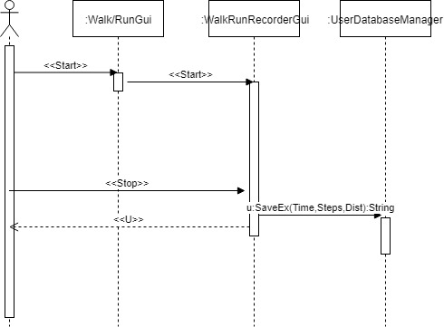

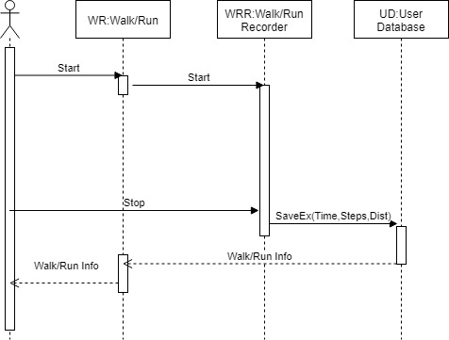

Login: User enters login information. Login info is passed to the user database. The user database authenticates the credentials. If the credentials are authorised the login interface gives user access to app. If the credentials were denied an error message will appear.

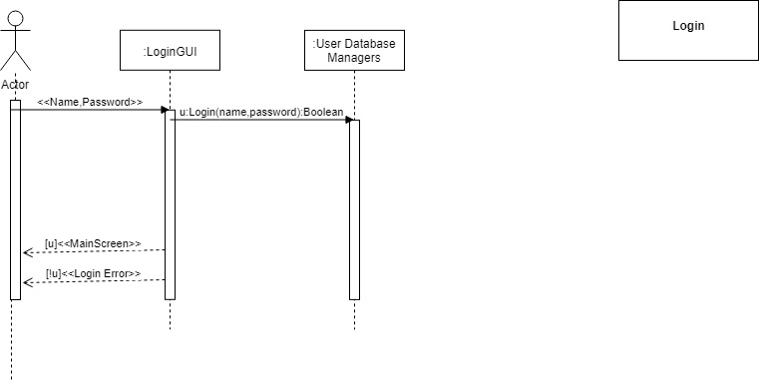

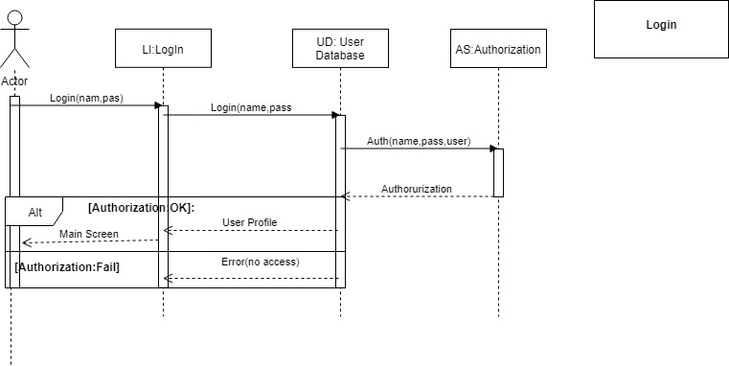

Register: User enters registration information. The Register tells the user database to make profile based on the passed info. After profile is created the message propagates back to user informing them that they are registered to use the application.

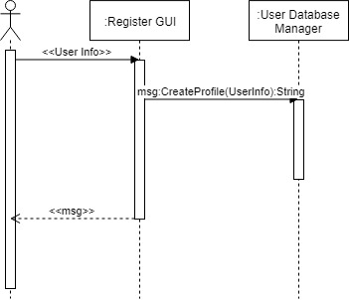

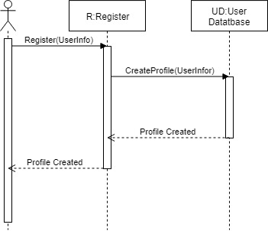

Enter Data: User selects tab to enter data. On tab user enters the information to the Enter Data. Enter Data has the User Database save the info. User receive response after data is saved.

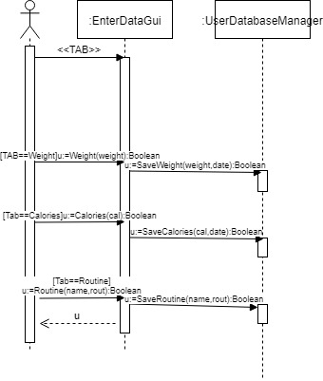

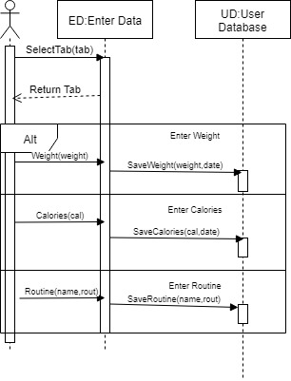

App Settings: User enters which setting they would like to change. App Settings returns the window for the setting. The User enters the changed setting info. The App settings has the User Database save the setting. The App Settings returns the main setting screen back to the user.

