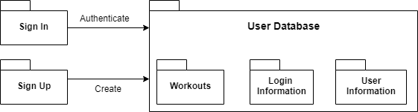

The user will be able to sign up to create an account which will be stored in the user database. When the user already has an account they will be able to sign in to access the data associated with their profile from the user database. The user database will contain information for each user. The user’s information will be separated into a log of workouts including runs, login information, as well as general user information such as weight, age, etc.

A Box and Line Diagram is used to show the process of sign in/sign up as well as what information is stored in the database for each user in an abstract way.