**Unit Testing:**

As the app is developed we want to look at the functions we create in further detail and make sure they work at the current state of the app these are the current tests that have been done and more will be added in the future. These tests are done using the flutter_test package

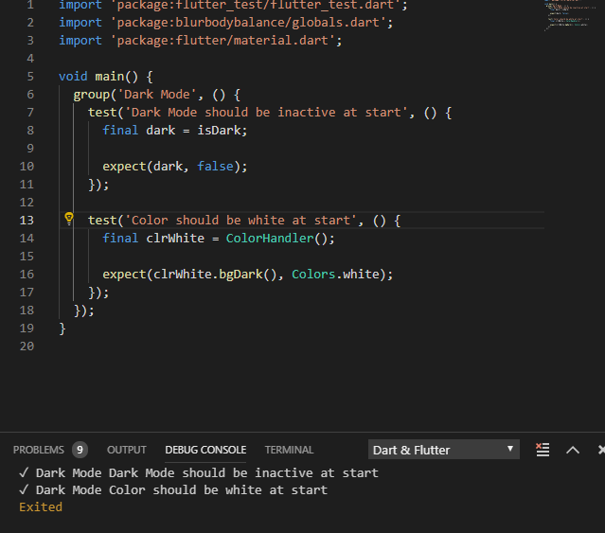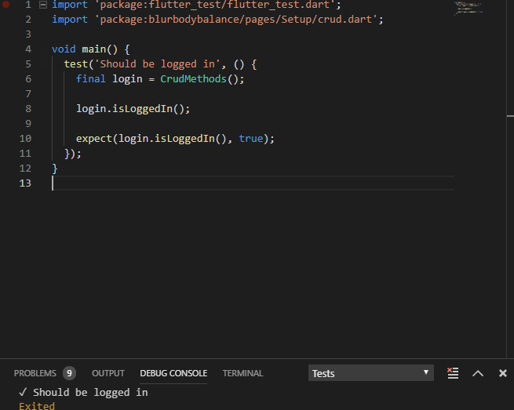

Once further implemented/fixed tests that we would like to get done are testing the database to see if it received data, check if user entered correct information for user information and check if the password is of the correct length among other features that will be implemented.

**Use Case Testing:**

Will be finished in the next deliverable

**Acceptance Testing:**

Will be finished in the next deliverable