MODEL VIEW CONTROLLER

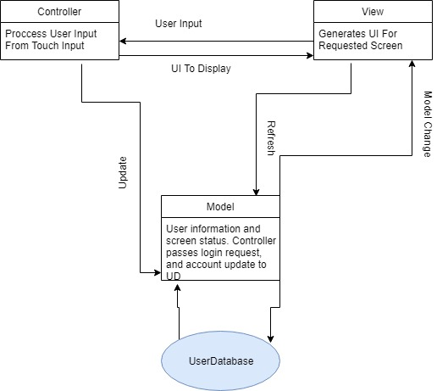

The model view controller is the best option for our app. The app keeps state information in several classes such as settings, steps, and walk within the model. The model sends the ui the configuration information. The view is where the UI is and where the user interacts. When the user interacts with the system these interactions are passed to the controller. The controller processes the requests and asks that the model updates its information based off the request. This is the best architecture for our system to do best reflect how information flows within the system as described earlier.