**Unit Testing:**

The tests are done using the flutter_test package

isLoggedIn(): bool

|  |  |  |  |
| --- | --- | --- | --- |
| Step | Test Steps | Test Data | Expected Results |
| 1 | Create a null user | User = FirebaseAuth.instance().signInWithEmailPassword(email: “test”, password: “test”) | false |
| 2 | Call isLoggedIn to see if user exists |  |  |

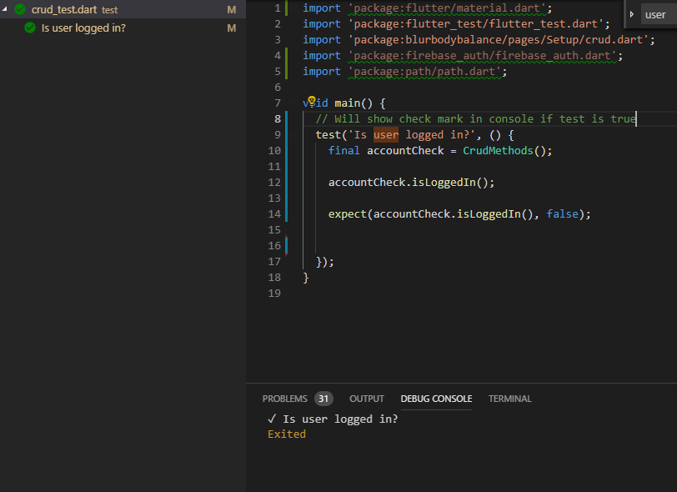

isDark(): bool

|  |  |  |  |
| --- | --- | --- | --- |
| Step | Test Steps | Test Data | Expected Results |
| 1 | Create local variable which will hold state of UI color | final dark = isDark | false |

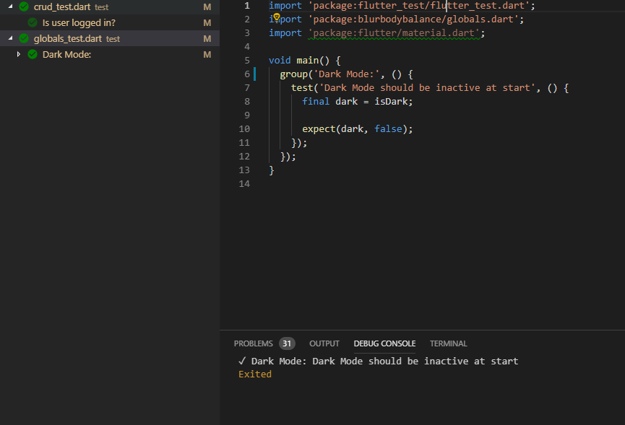

(): bool

|  |  |  |  |
| --- | --- | --- | --- |
| Step | Test Steps | Test Data | Expected Results |
| 1 | Create local variable which will hold state of dist unit | final dist = isDark | false |

**Use Case Testing:**

Title: Check Password (Signup)

Actors: User

Requirements:

Main Scenario:

1. User enters password
2. System detects if user entered password
3. System detects if user password was confirmed
4. System moves to next page

Alternatives:

2a) System does not detect user entered password

2a1) System remains on current signup page

2b) System finds an error in the password

2b1) Display error if password doesn’t exceed 7 characters

2b2) Display error if password doesn’t contain a number

3a) System does not detect if user confirmed password

3a1) System remains on current signup page

3a2) Displays error if passwords don’t match

4a) System doesn’t move to next page

4a1) System stays on current page

Title: Login

Actors: User

Requirements:

Main Scenario:

1. User enters email
2. User enters password
3. System detects if user entered password
4. System detects if user entered email
5. User taps sign in
6. System detects if user tapped sign in
7. System moves to home screen

Alternatives:

3a) System does not detect user entered password

3a1) System remains on current signup page

3b) System finds an error in the password

3b1) Displays error saying password doesn’t exist for the account or the account doesn’t exist

4a) System does not detect user entered email

4a1) System remains on current page

4b) System finds an error in the email

4b1) Displays error saying email doesn’t exist for the account or the account doesn’t exist

6a) System doesn’t detect if user tapped button

6a1) System stays on current page

7a) System doesn’t move to next page

7a1) System stays on current page

Title: Signup

Actors: User

Requirements:

Main Scenario:

1. User enters password
2. System detects if user entered password
3. System detects if user password was confirmed
4. System moves to next page

Alternatives:

2a) System does not detect user entered password

2a1) System remains on current signup page

2b) System finds an error in the password

2b1) Display error if password doesn’t exceed 7 characters

2b2) Display error if password doesn’t contain a number

3a) System does not detect if user confirmed password

3a1) System remains on current signup page

3a2) Displays error if passwords don’t match

4a) System doesn’t move to next page

4a1) System stays on current page

**Acceptance Testing:**

For our acceptance testing we wanted to make sure that our pedometer met the standards for what we wanted out of our app. We tested the pedometer for over the course of a week and it worked with 99% accuracy so the group of people we would provide this app for would get what they would be expecting for this. Another thing we wanted to check if the graph was going up to meet with user goals and the graph did in fact move up with the step count so in this case the user would be getting what they expected.