# Diagram of connecting a computer to a TV VGA - SCART (RGB)

Connecting TVs with SCART (RGB) connectors, as well as WTC-201 color monitors (and others) to a computer is a question of interest to many PC owners, but usually it does not go beyond interest.

The image on a VGA-monitor is formed by a high line scan, which is 2 times higher than that used on a TV. There is not just more lines but also more frames, hence, the quality is correspondingly better.

This is the main obstacle in the "friendship" between the PC and the TV! Connection is made using the following:

* Driver for video card
* Pairing devices (dedicated adapter)
* Driver + not complicated adapter

I have tested the third most widespread (aka the cheapest) method - a simple adapter and a program that "generates" a suitable signal for the TV. It is widely described on more than one Internet page and can be easily reproduced: this requires 4 resistors, a KR155LP5 (or analogs) power supply (+ 5v). However, cheap parts and free drivers do not provide acceptable quality. Static pictures look disgusting. Much better dynamics: games, screensavers, etc.

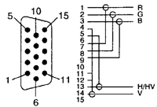

**VGA pinout**

To obtain a normal (television) sync pulse, it is necessary to mix the vertical and horizontal sync pulses using a logic element on the K155LP5.

**Converters**

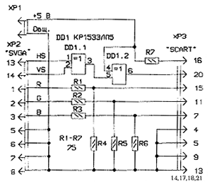  
*Converter on KR1533LP5, power supply of the microcircuit pin 14 + 5V, pin 7 -5V.*

Converter circuit from "Radio 98.1". In scart: 16 - control signal (covers RGB), 20 - sync pulse, 15 - red, 11 - green, 7 - blue; 4,5,9,13,14,17,18,21 - common wire.

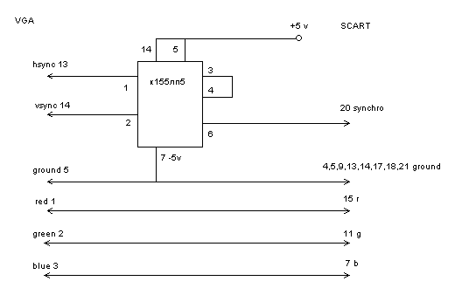  
*Converter K155LP5*

Another circuit for K155LP5 (in SCART, you need to apply + 5V to connector 16).

### Drivers:

* [**TV1.RAR**](https://nice-artip-ru.translate.goog/files/tv1.rar?_x_tr_sl=auto&_x_tr_tl=en&_x_tr_hl=sv)
* [**PCV.RAR**](https://nice-artip-ru.translate.goog/files/pcv.rar?_x_tr_sl=auto&_x_tr_tl=en&_x_tr_hl=sv)

The driver allows the video card to generate a video signal that is suitable for the TV. I liked (although both drivers work) - TV1. Support for 256 colors, maximum resolution 800x600. In principle, in Windows you can still work with 256 colors (in general, it is not much different from Hi-Color).

These drivers are not suitable for Windows 2000 and above.