**Jumpers and solder jumpers**

The CPU280 contains a total of 10 settable jumpers, used to adjust various system configuration parameters. In addition, there are 12 solder jumpers, which allow connecting a few signals to fixed potentials. Both types are listed here.

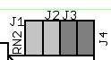**J1,J2 these two jumpers determine the clock scaling (ratio of external clock).The   
 possible combinations are:**

J1 connected J2 connected Ratio 2:1

J1 open J2 connected Ratio 1:1(default)

J1 connected J2 open Ratio 4:1

J1 open J2 open Illegal

**J3,J4 These two jumpers determine the number of wait states for EPROM access as follows:**

J3 connected J4 connected 0 Wait-states

J3 open J4 connected 1 Wait-state

J3 connected J4 open 2 Wait-states

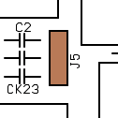J3 open J4 open 3 Wait-states

**J5 Selects the EPROM type:**

J5 towards the CPU: 27C256 (preconnected!)

J5 towards the RAM: 27C512

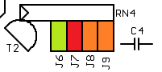**J6 Precompensation of the FDC on the innermost tracks:**

J6 connected: 187 ns

J6 open: 125 ns (default)

**J7-J9 User configuration jumpers, read in by the GPI**

**default = all open**

J7 connect: For 1. initialisation or system reset – restores the Default-Setup  
 parameter and the starts the config menu

**J8,J9 not defined**

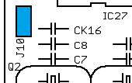**J10 Internal reset of the RTC (use only when power off)**

LJ1 Connects ECB signals /MRQ with VCC

LJ2 Connects ECB signals /BUSAK with VCC

LJ3-5 Connects CPU-Pin CTIO0-2 with GND

LJ6-8 Connects CPU-Pin CTIN0-2 with GND (preconn.)

LJ9-10 Connects CPU-Pin /DMASTB0-1 with GND

LJ11-12 Connects CPU-Pin /RDY1-2 with GND (preconn.)

