create table Branch(branchname varchar(30),branchcity varchar(30),assets real,primary key(branchname));

clear screen

select * from tab;

create table BankAccount(accno integer,branchname varchar(30),balance real,primary key(accno),foreign key(branchname) references Branch(branchname));

create table BankCustomer(customername varchar(30),customerstreet varchar(30),customercity varchar(30),primary key(customername));

create table Depositer(customername varchar(30),accno integer, primary key(customername,accno),foreign key(customername) references BankCustomer(customername),foreign key(accno) references BankAccount(accno));

desc Loan

create table Loan(loannumber int,branchname varchar(30),amount real,primary key(loannumber),foreign key(branchname) references branch(branchname));

insert into Branch values('SBI_Chamarajapet','Banglore','50000');

insert into Branch values('SBI_ResidencyRoad','Banglore','10000');

insert into Branch values('SBI_ShivajiRoad','Bombay','20000');

insert into Branch values('SBI_Parliament','Delhi','10000');

insert into Branch values('SBI_Jantarmantar','Delhi','20000');

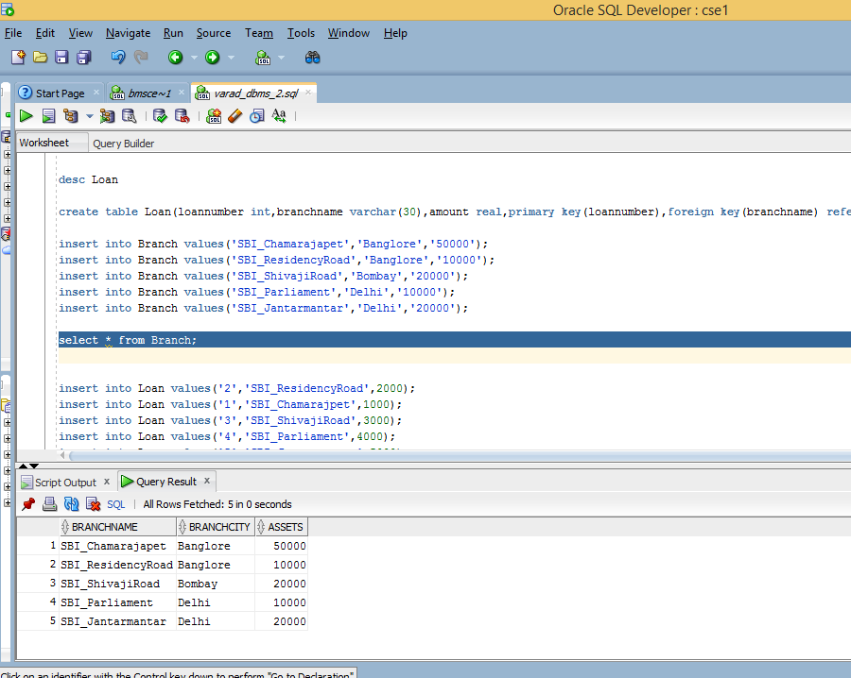

select * from Loan;

insert into Loan values('2','SBI_ResidencyRoad',2000);

insert into Loan values('1','SBI_Chamarajpet',1000);

insert into Loan values('3','SBI_ShivajiRoad',3000);

insert into Loan values('4','SBI_Parliament',4000);

insert into Loan values('5','SBI_Jantarmantar',5000);

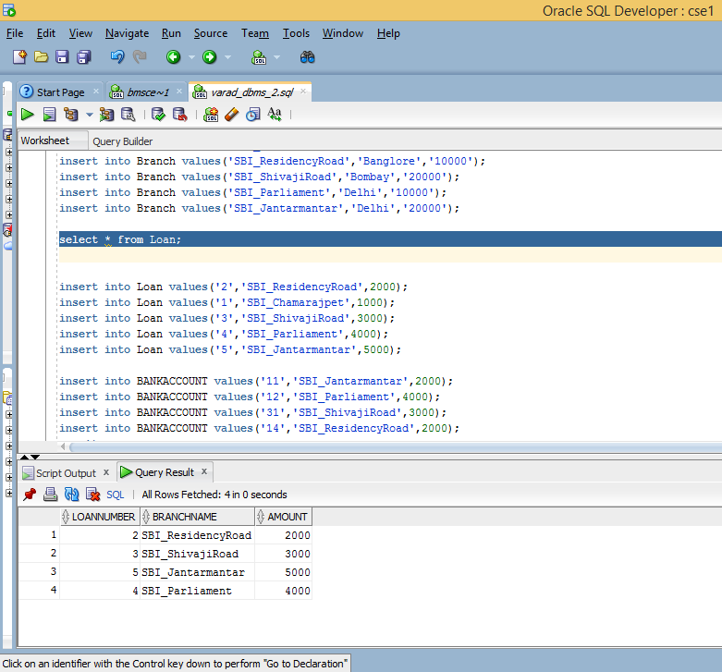

insert into BANKACCOUNT values('11','SBI_Jantarmantar',2000);

insert into BANKACCOUNT values('12','SBI_Parliament',4000);

insert into BANKACCOUNT values('31','SBI_ShivajiRoad',3000);

insert into BANKACCOUNT values('14','SBI_ResidencyRoad',2000);

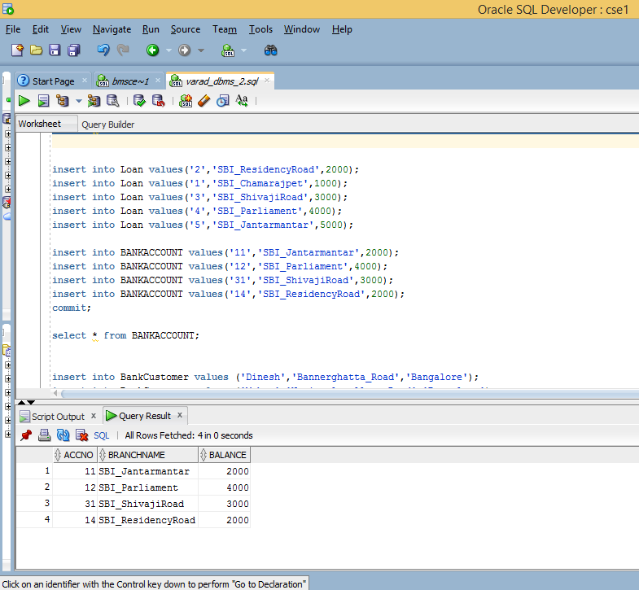

commit;

select * from BANKACCOUNT;

insert into BankCustomer values ('Dinesh','Bannerghatta_Road','Bangalore');

insert into BankCustomer values ('Mohan','National_college_Road','Bangalore');

insert into BankCustomer values ('Nikhil','Akbar_Road','Delhi');

insert into BankCustomer values ('Ravi','Prithviraj_Road','Delhi')

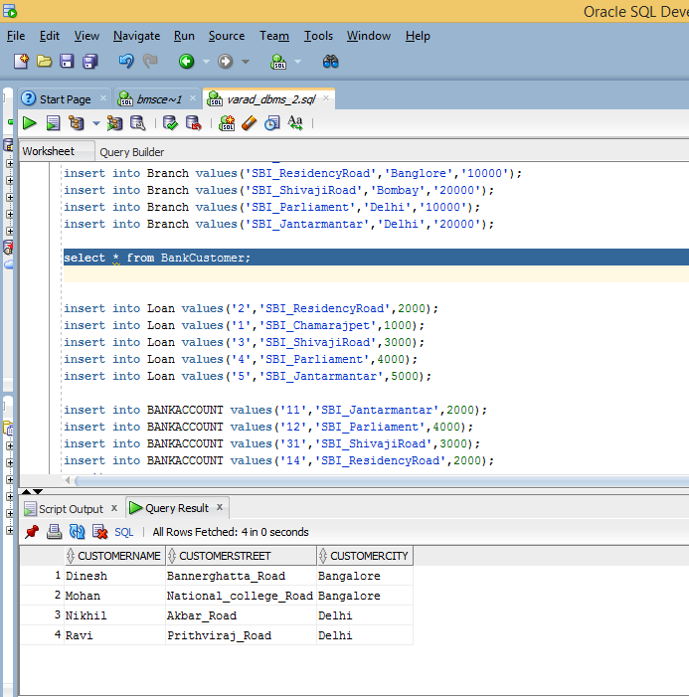

insert into Depositer values ('Ravi',5);

insert into Depositer values ('Avinash',8);

insert into Depositer values ('Nikhil',9);

insert into Depositer values ('Dinesh',10);

insert into Depositer values ('Nikhil',11);

