

**Envelope Follower**

**Auto Q**

User Guide

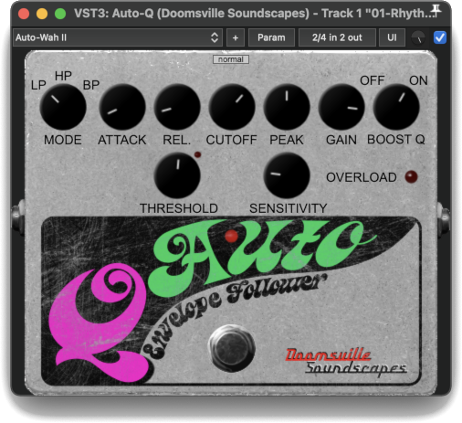

The Doomsville Soundscapes “Auto‑Q” Envelope Follower, also known as an “Auto‑Wah”, uses an envelope detector to modulate the cutoff frequency of a filter acting on an input signal.

Controls:

SCALE GUI – The small drop-down list at the top centre of the effect’s panel allows you to select the plugin’s display size. Options are tiny, small, medium, normal, large & giant.

KICK SWITCH – Turns the Auto‑Q on or off (bypass mode).

MODE – Select between 3 different types of filter: Low Pass, High Pass and Band Pass.

ATTACK – Specifies the duration of the attack stage of the envelope detector. Ranges from 1 to 250 milliseconds.

REL. – Specifies the duration of the release stage of the envelope detector. Ranges from 1 to 2000 milliseconds

CUTOFF – Specifies the cutoff frequency of the filter. Ranges from 20 to 10,000 Hz.

PEAK – Specifies the intensity of the peak, or “Q” at the cutoff frequency. Ranges from 0.707 $(\frac{\sqrt{2}}{2})$ to 20.

GAIN – Specifies the output gain of the filter. Ranges from -20 to 12 dB.

BOOST Q – Turns gain compensation on or off. When on, frequencies higher and lower than the cutoff frequency will be attenuated, accentuating the peak, or ‘Q’.

THRESHOLD – The threshold for the amplitude, output by the envelope detector, at which the Auto‑Q will commence to modulate the filter cutoff frequency. Ranges from -20 to 0 dB.

* All Doomsville Soundscapes effects which contain a Threshold control also have a small LED to the top right of the THRESHOLD knob. This LED will light up when the threshold is exceeded, giving a visual cue to help you dial in the right value for the sound you wish to create.

SENSITIVTY – The factor by which the detected amplitude envelope above the threshold will modulate the filter cutoff frequency. Ranges from 0.25 to 5.

Meters:

OVERLOAD – This LED will light up when the output signal of the Auto‑Q exceeds unity gain (0 dB).

* Should you wish to raise any issues you encountered while using this plugin, or review issues raised by other users, including those which have already been fixed, please visit:  
  <https://github.com/DoomyDwyer/ASPiKProjects/issues>.