

HOWLER

CIRCUIT MODELED OVERDRIVE

User Guide

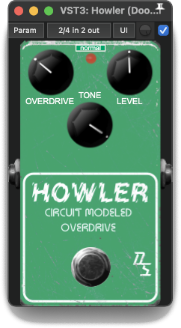

The Doomsville Soundscapes “Howler” Circuit Modeled Overdrive is an overdrive effect created using the technique of *Circuit Modeling* to model the behaviour of the analog circuit (Tone Control & Clipping Stage) of a famous overdrive pedal from the late 1970s.

Controls:

SCALE GUI – The small drop-down list at the top centre of the effect’s panel allows you to select the plugin’s display size. Options are tiny, small, medium, normal, large & giant.

KICK SWITCH – Turns the Howler on or off (bypass mode).

OVERDRIVE – Increases the amount of distortion and sustain as this knob is rotated clockwise.

TONE – Controls the tone. Mid and high tones are emphasised more as this knob is rotated clockwise.

LEVEL – Controls the level of the output signal. Experiment with this to attain an output level when switched on similar to when the effect is in bypass mode.

* Should you wish to raise any issues you encountered while using this plugin, or review issues raised by other users, including those which have already been fixed, please visit:  
  <https://github.com/DoomyDwyer/ASPiKProjects/issues>.