



D u c k I n g d e l a y

User Guide

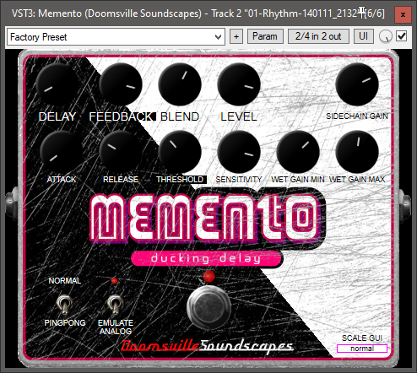

The Doomsville Soundscapes “Memento” Ducking Delay is a delay effect which can operate in stereo “Ping-Pong” mode, as well as emulate an analog delay effect using a low pass filter on the feedback path. The ducking delay also contains a side chain processor, to attenuate (duck) the wet (delayed) signal when the dry signal’s level reaches or exceeds a given threshold. This helps avoid a muddy mix of the wet & dry signals at times where the dry signal has a high amplitude.

Controls:

SCALE GUI – The small drop-down list at the bottom right of the effect’s panel allows you to select the plugin’s display size. Options are tiny, small, medium, normal, large & giant.

KICK SWITCH – Turns the Memento on or off (bypass mode).

DELAY – Controls the delay time. Ranges from 0 to 2 seconds.

FEEDBACK – Controls the amount of wet signal fed back into the delay’s stereo circular buffers. Ranges from 0% to 90%.

BLEND – Wet/Dry Mix. When fully counter-clockwise, only the dry signal will be output. When fully clockwise, only the wet signal will be output. At 12 o’clock, the wet & dry signals are equal in the mix.

LEVEL – Controls the level of the output signal. Ranges from -60 to 12 dB.

Side Chain Processing:

SIDECHAIN GAIN – Controls the gain to the side chain prior to processing. Ranges from -60 to 12 dB.

ATTACK – Specifies the duration of the attack stage of the envelope detector in the side chain. Ranges from 1 to 250 milliseconds.

RELEASE – Specifies the duration of the release stage of the envelope detector in the side chain. Ranges from 1 to 2000 milliseconds

THRESHOLD – The threshold for the amplitude of the dry signal, at which the Memento will commence to attenuate (duck) the wet (delayed) signal. Ranges from -20 to 0 dB.

SENSITIVTY – The factor by which the side chain’s output level will be amplified, when the dry signal is below the level set by THRESHOLD. Ranges from 0.25 to 5.

WET GAIN MIN – When the dry signal is at or exceeds the level set by THRESHOLD, the side chain’s output level is set to this value (ducked). The side chain’s output level will in any case never be less than this value. Ranges from -60 to 12 dB.

WET GAIN MAX – When the dry signal is below the level set by THRESHOLD, the side chain’s output level will never exceed this value. Ranges from -60 to 12 dB.

Options:

NORMAL/PINGPONG – Switches between “Normal” mode, similar to a mono delay, and “Ping-Pong” mode, where the delay artefacts alternate between the left & right channels.

EMULATE ANALOG – When on, a first order low pass filter with a fixed cutoff frequency of 1000 Hz and an output gain of 0.707 $(\frac{\sqrt{2}}{2})$ dB will attenuate the higher frequencies in the feedback path, leading to a faster decay of the delay artefacts. This emulates the loss of high frequencies inherent in the use of a *compander* around the Bucket Brigade Delay ICs present in many analog delay effects.