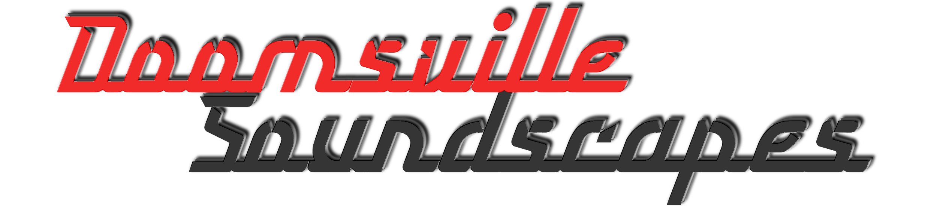



Stereo Phase Shifter

User Guide

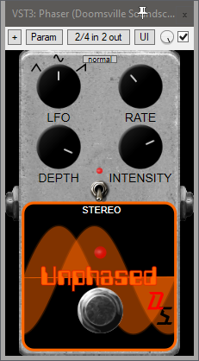

The Doomsville Soundscapes “Unphased” Stereo Phase Shifter is a phaser effect which can modulate the phase of a signal using one of three LFO waveforms. This phaser can also create a stereo effect, where the phaser will sweep between the left & right channels.

Controls:

SCALE GUI – The small drop-down list at the top centre of the effect’s panel allows you to select the plugin’s display size. Options are tiny, small, medium, normal, large & giant.

KICK SWITCH – Turns the Phaser on or off (bypass mode).

LFO – Select between 3 different LFO (Low Frequency Oscillator) waveforms to modulate the phase of the input signal: Triangle, Sine & Sawtooth.

RATE – Controls the LFO frequency. As this knob is rotated clockwise, the phasing effect quickens. Ranges from 0.02 to 20 Hz.

DEPTH – Controls the percentage of the LFO’s value, which is used to modulate the cutoff frequency of the 6 first order all pass stages in the phaser. Ranges from 0% to 100%.

INTENSITY – Controls the percentage of the feedback from the 6 first order all pass stages in the phaser. Ranges from 0% to 100%. Values between 75% and 95% will sound best.

Options:

STEREO – Turns the stereo effect on or off. When on, the phaser will sweep between the left & right channels.