



Digital Delay

User Guide

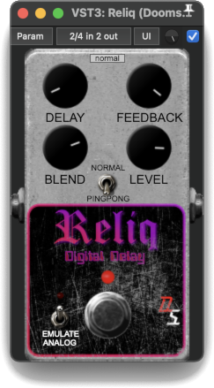

The Doomsville Soundscapes “Reliq” Digital Delay is a delay effect which can operate in stereo “Ping-Pong” mode. There’s also the option to emulate an analog delay effect using a low pass filter on the feedback path.

Controls:

SCALE GUI – The small drop-down list at the top centre of the effect’s panel allows you to select the plugin’s display size. Options are tiny, small, medium, normal, large & giant.

KICK SWITCH – Turns the Reliq on or off (bypass mode).

DELAY – Controls the delay time. Ranges from 0 to 2 seconds.

FEEDBACK – Controls the amount of wet signal fed back into the delay’s stereo circular buffers. Ranges from 0% to 90%.

BLEND – Wet/Dry Mix. When fully counter-clockwise, only the dry signal will be output. When fully clockwise, only the wet signal will be output. At 12 o’clock, the wet & dry signals are equal in the mix.

LEVEL – Controls the level of the output signal. Ranges from -60 to 12 dB.

Options:

NORMAL/PINGPONG – Switches between “Normal” stereo mode, where each channel’s delay artefacts are output on its own channel, and “Ping-Pong” mode, where the delay artefacts alternate between the left & right channels.

EMULATE ANALOG – When on, a first order low pass filter with a fixed cutoff frequency of 1000 Hz and an output gain of 0.707 $(\frac{\sqrt{2}}{2})$ dB will attenuate the higher frequencies in the feedback path, leading to a faster decay of the delay artefacts. This emulates the loss of high frequencies inherent in the use of a *compander* around the Bucket Brigade Delay ICs present in many analog delay effects.

* Should you wish to raise any issues you encountered while using this plugin, or review issues raised by other users, including those which have already been fixed, please visit:  
  <https://github.com/DoomyDwyer/ASPiKProjects/issues>.