杭州电子科技大学 计算机学院
航班预订系统
《数据库课程设计》设计报告
专 业 软件工程
班 级 周一上午3-5节
小组成员 薛可欣（17141321会计学）
戴东晖（18151224）
张琦智（19052230）
毛锐（19052024）

完成时间 2021/1/9

目 录
1系统介绍 4
1.1问题描述 4
1.2系统简介 4
2系统模块划分 5
2.1系统结构图 5
2.2各模块功能概述 5
3系统需求分析 5
3.1系统综合需求 5
3.2数据流图 6
3.3数据字典 8
4概念结构设计 13
5逻辑结构设计 16
5.1逻辑结构设计 16
5.2模式优化 16
6物理设计 18
7系统SQL实现 19
7.1表的创建 19
7.2视图的创建 29
7.3存储过程或触发器的创建 34
8 WEB连接部署实现机票预订的实现 46
9课程总结 51
10参考文献 52
11致谢 53

1系统介绍

1.1问题描述
随着网络的遍及，人们需求享受网络带来的方便、快捷和资讯的传播，并利用电脑进行网上活动。随着当前人们出行的需求越来越多，订购机票的需求也日益增多。为了解决人们一键订购机票，查询航班信息，购买附加服务如飞机保险，托运行李的需求，我们拟开发机票预订系统网站，方便人们在网站上订购机票。

1.2系统简介
本系统是机票预订系统，主要用户有旅客和管理员两种。旅客可以在系统上完成查询航班信息，机票预订，机票退订，购买行李额，购买保险，享受平台折扣，查询未出行订单和历史订单等功能。管理员可以在添加或删除航班，添加或更改航班座位价格，保险种类和价格，删除用户等操作。

2系统模块划分

2.1系统结构图
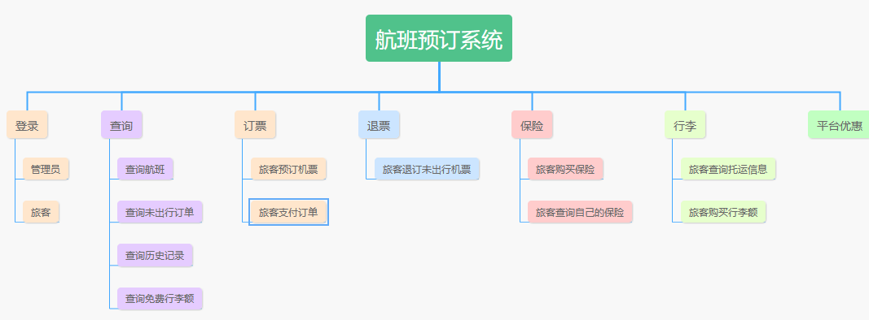

2.2各模块功能概述

登录：旅客、管理员
订票：预定机票，凭订单支付机票费用，生产支付凭证
退订：退订未出行机票
查询：查询航班，未出行订单，历史记录，免费行李额，保险信息
保险：旅客可以购买保险和查询自己已经购买的保险
行李：旅客可以购买超重行李额，查询自己的托运信息
平台优惠：旅客可以获取平台优惠
后台：管理员可以在添加或删除航班，增删改航班座位价格，增删改保险种类和价格，删除用户

3系统需求分析

3.1系统综合需求
旅客
- 旅客登录退出；
- 输入基本信息；
- 查询航班；
- 查询未出行订单；
- 查询历史出行订单；
- 查询保险信息；
- 查询平台优惠；
- 查询自己已购买的保险；
- 查询免费行李额；
- 进行机票预订；
- 在预订时选择需要的保险以及可选的优惠;
- 凭登机牌托运行李；
- 退订机票；
- 旅客购买超重行李额；
- 根据起飞地点时间机型查询航班；

航班管理员：
- 航班管理员登录退出；
- 添加或删除航班；
- 增删改每个航班的坐位信息；
- 根据航班号，对机票价格的同一进行涨价或降价
- 添加修改删除保险信息
- 查询每个航班的预定情况
- 最高权限。

3.2数据流图

【第0级】
用户登录时分为旅客和管理员两种，每个人有不同的权限。旅客拥有旅客权限，管理员拥有最高权限。
管理员（航空公司）主要工作是修改航班信息和选座信息
旅客可以查询选座信息和航班信息
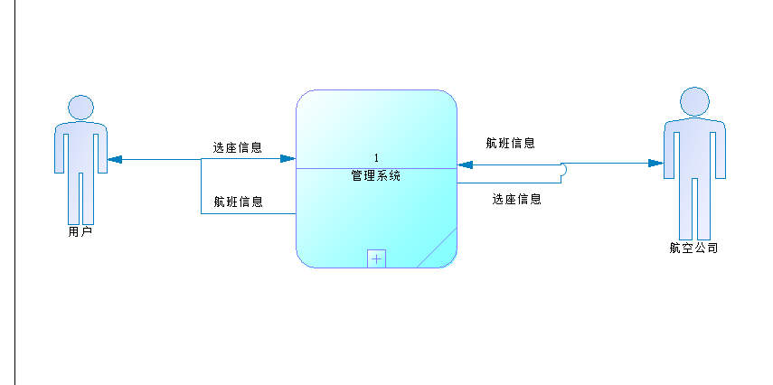
【第1级】
判断用户是否已经注册，判断输入 账号密码是否和账号及密码中的数据一致，一致则登录成功
旅客可以查询座位信息
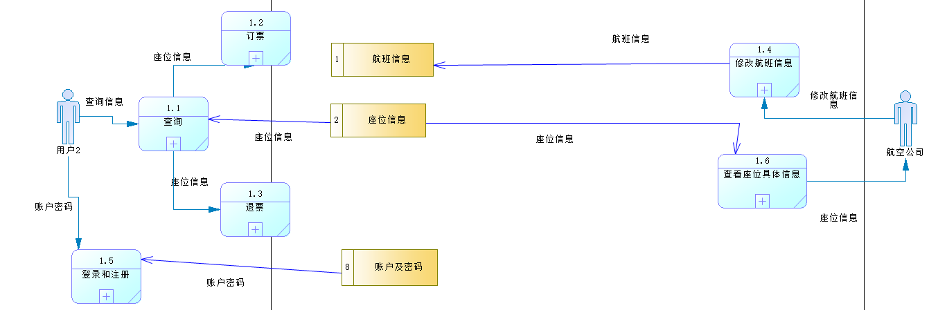
【第2级】

旅客经查询功能后，进行订票。
旅客可以选择查看免费行李额并购买超额行李重量
旅客可以查看保险并购买不同种类的保险
旅客在支付订单后（包括行李费用，保险费用，座位费用）
系统更新座位信息
系统为旅客生成付款凭证
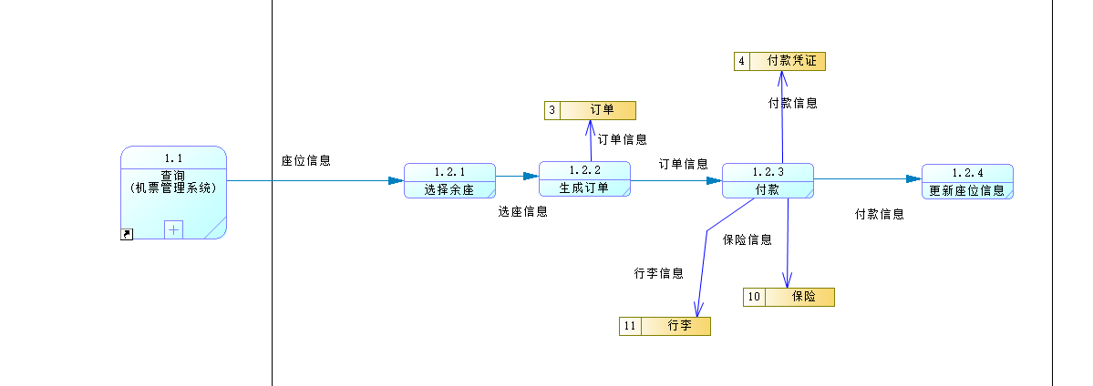

--用户经查询功能后，查询到未出行订单，进行退票。系统更新座位信息
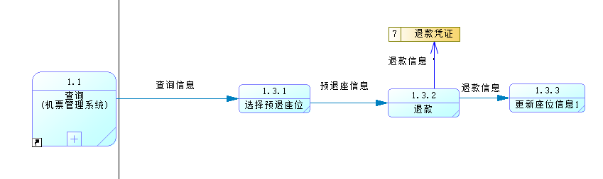
---用户基本登录功能，包含注册和登录

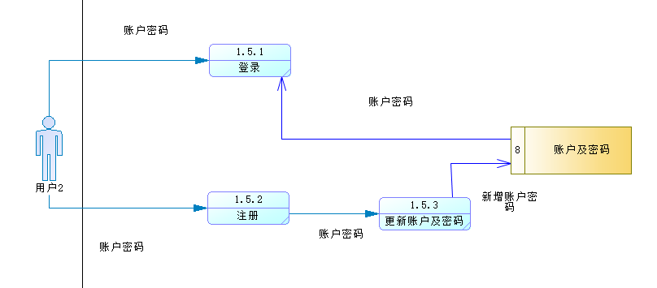

---航空公司修改航班信息（起飞时间，往返地，价格等）
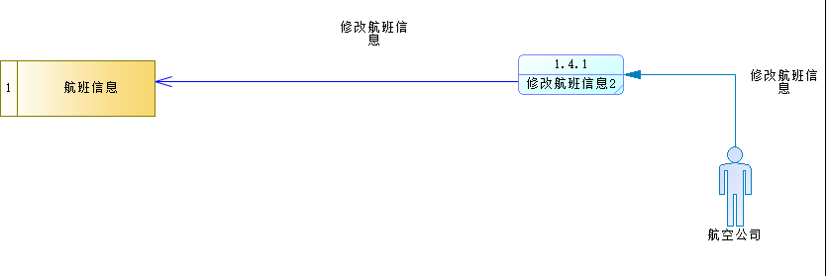

---航空公司总览座位信息，系统计算满座率
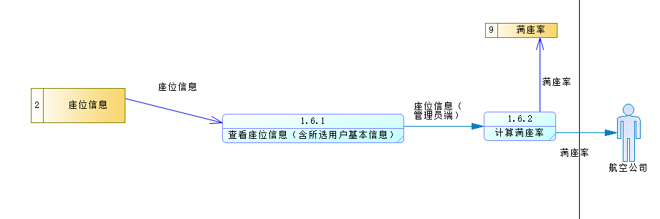

3.3数据字典

数据元素定义表
编号 | 数据元素名 | 别名 | 数据类型 | 数据长度 | 备注
E001 | 旅客姓名 |  | Characters | 20
E002 | 证件类型 |  | Variable characters | 15 | 身份证/护照/外国人永久居留身份证/港澳台居民居住证
E003 | 证件号码 |  | Variable characters | 20 | 身份证号/护照号/外国人永久居留身份证号/港澳台居民居住证号
E004 | 旅客性别 |  | Characters | 1
E005 | 出生日期 |  | Date
E006 | 旅客手机号 |  | Variable characters | 20
E007 | 旅客邮箱 |  | Variable characters | 20
E008 | 管理员姓名 |  | Characters | 20
E009 | 管理员编号 |  | Characters | 10
E010 | 航班号 |  | Variable characters | 20
E011 | 航班预订起飞时间 | 起飞时间 | Date & Time
E012 | 航班预订降落时间 | 降落时间 | Date & Time
E013 | 航空公司 |  | Variable characters | 20
E014 | 航班起飞地点 |  | Variable characters | 20
E015 | 航班降落地点 |  | Variable characters | 20
E016 | 机场名 |  | Characters | 20
E017 | 航站楼 |  | Characters | 20
E018 | 机型 |  | Characters | 20
E019 | 舱位名 |  | Variable characters | 5 | 头等舱/经济舱/商务舱
E020 | 座位数 |  | Integer
E021 | 航班座位号 |  | Characters | 5
E022 | 座位价格 |  | Float
E023 | 登机编号 |  | Variable characters | 20
E024 | 免费行李额 |  | Float
E025 | 用户名 |  | Variable characters | 20
E026 | 用户编号 |  | Variable characters | 20
E027 | 用户身份 |  | Variable characters | 20 | 普通旅客为旅客身份，管理员为管理员身份
E028 | 旅客登录密码 |  | Variable characters | 20
E029 | 折扣起始时间 |  | Datatime
E030 | 保险终止日期 |  | Datatime
E031 | 订单编号 |  | Variable characters | 20
E032 | 支付方式 |  | Variable characters |  | 中国银行/交通银行/农业银行/支付宝/微信
E033 | 座位号 |  | Characters | 5
E034 | 退票手续费 |  | Float
E035 | 实际退票金额 | 退票金额 | Float |  | 实际机票价格-退票手续费
E036 | 座位是否空闲 |  | Integer
E037 | 退款订单编号 |  | Variable characters | 20
E038 | 托运号 |  | Variable characters | 20
E039 | 超重重量 |  | Float |  | 行李重量-免费行李额
E040 | 行李超重费用 |  | Float
E041 | 管理员密码 |  | F |  | 超重重量*行李重量单价
E042 | 行李件数 |  | Integer
E043 | 行李重量 |  | Float
E044 | 保险价格 |  | Float
E045 | 保险类型 |  | Variable characters | 20
E046 | 保险起始日期 |  | Datetime
E047 | 具体的保障内容 |  | long Variable characters | 1024
E048 | 保险金额 |  | Float
E049 | 保险订单号 |  | Variable characters | 20
E050 | 受益人证件号码 |  | Variable characters | 20
E051 | 折扣终止时间 |  | Datetime
E052 | 折扣金额 |  | short Float
E053 | 折扣ID |  | Float
E054 | 投保人证件号码 |  | Variable characters
E055 | 管理员账户 |  | Variable characters
E056 | 订单总价 |  | Float

名字：旅客(Traveller）
别名：旅客信息;t
描述：预订机票所需的旅客基本信息
定义：旅客 = 旅客姓名（E001）+证件类型（E002）+证件号码（E003）+旅客性别（E004）+出生日期（E005）+旅客手机号（E006）+旅客邮箱（E007）+旅客登录密码（E028）
位置：P1.5.1-D8

名字：管理员(Adiministrator)
别名：管理员信息;a
描述：各个航空公司管理员基本信息
定义：管理员 = 管理员姓名（E008）+管理员编号（E009）+管理员密码+管理员账户
位置：P1.5.1-D8

名字：航班信息(Flight-information)
别名：fi
描述：旅客可以查询到的机票信息
定义：航班信息 = 航班号（E010）+航班预订起飞时间（E011）+航班预订降落时间（E012）+航空公司（E013）+航班起飞地点（E014）+航班降落地点（E015）+机场名（E016）+航站楼（E017）+机型（E018）
位置：D1

名字：座位信息(Flight-seat)
别名：fs
描述：每个飞机上所有座位分布
定义：座位信息=座位号（E021）+座位价格（E022）+航班号（）+座位是否空闲
位置：P1.1-D2

名字：订单(myorder)
别名：o
描述：旅客选中航班和座位产生订单
定义：订单=订单编号（E031）+折扣ID（）+保险编号（）+证件号码（E001）+托运号+订单总价
位置：P1.2.2-D3

名字：付款凭证(Payment-voucher)
别名：Pay;p
描述：每张订单付款后产生付款凭证，可用于查看相关信息和退票
定义：付款凭证=付款订单编号（E031）+支付方式（E032）+订单编号（E031）
位置：P1.2.3-D4

名字：退款凭证(Refund-vouher)
别名：Refund;r
描述：每张订单退款后产生退凭证，可用于查看相关信息
定义：退款凭证=退款订单编号（E037）+订单编号（E031）
位置：P1.3.2-D7

名字：行李（luggage）
别名：l
描述：旅客托运的行李
定义：行李 =免费行李额（E024）+托运号（E038）+超重重量（E039）+行李超重费用（E040）+行李件数（E042）+行李重量（E043）+证件号码

名字：保险（Insurance）
别名：i
描述：旅客可以选择购买保险
定义：保险 =保险价格（E044）+保险类型（E045）+保险起始日期（E046）+具体的保障内容（E047）+最大保险额（E048）+保险订单号（E049）+受益人证件号码（E050）+投保人证件号码（E054）+保险终止日期（E030）

名字：平台折扣（Discount）
别名：d
描述：平台给旅客购买机票的优惠
定义：平台折扣=折扣终止时间（E051）+折扣金额（E052）+折扣ID（E053）+折扣起始时间(E029)+证件号码

4概念结构设计
E-R图
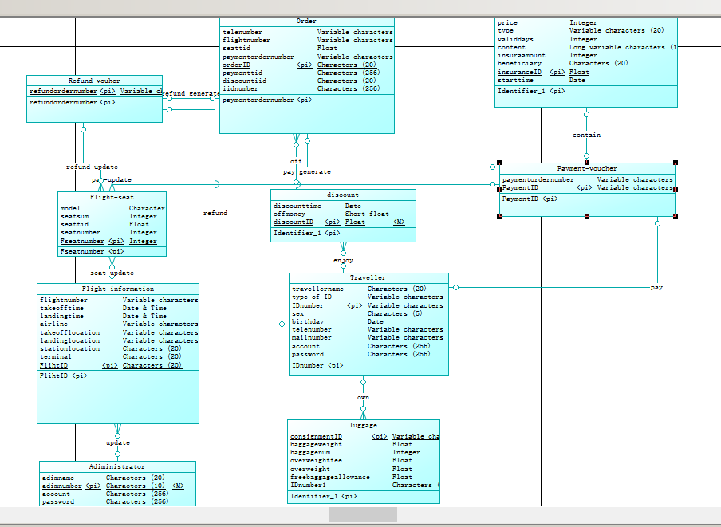
图一 ER全局图
由于图一有部分截图不全以及字体过小我们截了局部图方便查看
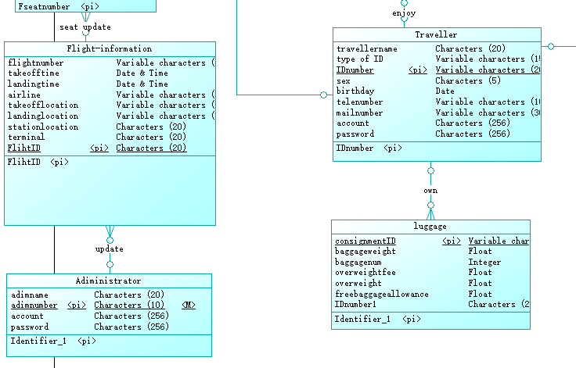

图二 局部图1
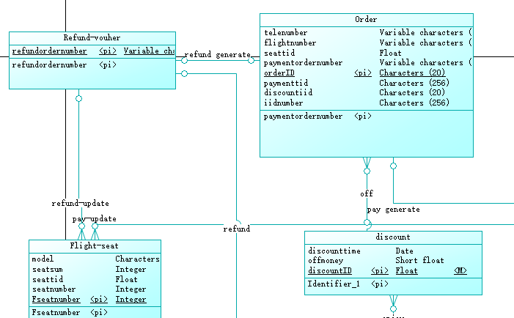
图三 局部图2

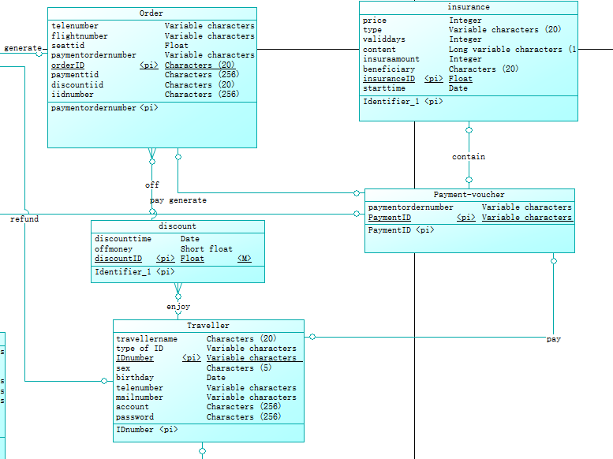

图四 局部图3

5逻辑结构设计

5.1逻辑结构设计
航班预订系统课程设计共有十个实体，分别为
myOrder(orderID,PaymentID,FlihtID,discountID,insuranceID,money luggageID,seatID,IDnumber)

Payment-voucher (PaymentID,orderID )

discount (discountID ,discounttime, offmoney ,IDnumber endtime )

insurance(insuranceID,price, type, validdays, content insuraamount , beneficiary , PaymentID ,endtime)

Flight-seat(seatID,seatcost,FlihtID, free)

Refund-vouher(refundordernumber,orderID)

Flightinformation(FlihtID,flightnumber,takeofftime,landingtime,airline,takeofflocation,landinglocation,stationlocation,terminal,,adimnumber）

Traveller(IDnumber,travellername,typeofID,PaymentID,refundordernumber,sex,birthday,telenumber,mailnumber,account,password）

luggage(consignmentID,IDnumber,baggageweight,baggagenum,overweightfee,overweight,freebaggageallowance）

adiministractor(adimnumber,adimname,account,password)

5.2模式优化
符合1NF的关系中的每个属性都不可再分；
2NF在1NF的基础之上,消除了非主属性对于码的部分函数依赖；
3NF在2NF的基础之上,消除了非主属性对于码的传递函数依赖。

adiministractor的主码是adimnumber,adimname,account,password完全依赖于主码且不存在传递依赖

luggage的主码是consignmentID,baggageweight,baggagenum,overweightfee,overweight,freebaggageallowance完全依赖于主码且不存在传递依赖,外码为IDnumber

Traveller的主码是IDnumber,travellername,typeofID,PaymentID,refundordernumber,sex,birthday,telenumber,mailnumber,account,password完全依赖于主码且不存在传递依赖

Flightinformation的主码是FlihtID。flightnumber,takeofftime,landingtime,airline,takeofflocation,landinglocation,stationlocation,terminal,,adimnumberd完全依赖于主码且不存在传递依赖

Refund-vouher的主码是refundordernumber ,外码为orderID。

Flight-seat的主码是seatID。seatcost, free完全依赖于主码且不存在传递依赖。外码是FlihtID

insurance的主码是insuranceID 。price type validdays content insuraamount beneficiary endtime完全依赖于主码且不存在传递依赖。 PaymentID是外码。

discount 的主码是discountID。discounttime offmoney endtime完全依赖于主码且不存在传递依赖。 IDnumber 是外码。

Payment-voucher 的主码是PaymentID 。orderID是外码。

myOrder的主码是orderID。money完全依赖于主码且不存在传递依赖。外码是PaymentID FlihtID discountID insuranceID luggageID seatID IDnumber

6物理设计
索引
索引1:起飞时间、航班号;
create index ix_flight on dbo.[Flight-information](takeofftime,Flightid)
起飞地点、降落地点、航班号
create index ix_flight2 on dbo.[Flight-information](takeofflocation,landinglocation,Flightid)
索引2:账户、密码组合索引
create index ix_account on dbo.[Traveller](account,password)
用户挑选航班时通常需要根据时间来筛选航班信息,建立起飞时间的索引可以快速找到航班号,从而查询到对应的航班信息;
用户挑选航班时也需要根据起飞地点和降落地点挑选航班,建立相应索引,可以快速找到对应的航班信息；
同时以上两者的信息在航班实体中通常不需要频繁地更改,所以建立索引通常不会引起性能降低。
用户登录时,经常需要查询用户的账号、密码是否存在和对应,建立账号、密码索引可以快速地找到相应的信息。

7系统SQL实现

7.1表的创建
USE [master]
GO
/****** Object: Database [fly] Script Date: 2021/1/3 16:49:24 ******/
CREATE DATABASE [fly]
CONTAINMENT = NONE
ON PRIMARY
( NAME = N'fly', FILENAME = N'E:\sqlshili\MSSQL12.SQLEXPRESS\MSSQL\DATA\fly.mdf' , SIZE = 5120KB , MAXSIZE = UNLIMITED, FILEGROWTH = 1024KB )
LOG ON
( NAME = N'fly_log', FILENAME = N'E:\sqlshili\MSSQL12.SQLEXPRESS\MSSQL\DATA\fly_log.ldf' , SIZE = 2048KB , MAXSIZE = 2048GB , FILEGROWTH = 10%)
GO
ALTER DATABASE [fly] SET COMPATIBILITY_LEVEL = 120
GO
IF (1 = FULLTEXTSERVICEPROPERTY('IsFullTextInstalled'))
begin
EXEC [fly].[dbo].[sp_fulltext_database] @action = 'enable'
end
GO
ALTER DATABASE [fly] SET ANSI_NULL_DEFAULT OFF
GO
ALTER DATABASE [fly] SET ANSI_NULLS OFF
GO
ALTER DATABASE [fly] SET ANSI_PADDING OFF
GO
ALTER DATABASE [fly] SET ANSI_WARNINGS OFF
GO
ALTER DATABASE [fly] SET ARITHABORT OFF
GO
ALTER DATABASE [fly] SET AUTO_CLOSE OFF
GO
ALTER DATABASE [fly] SET AUTO_SHRINK OFF
GO
ALTER DATABASE [fly] SET AUTO_UPDATE_STATISTICS ON
GO
ALTER DATABASE [fly] SET CURSOR_CLOSE_ON_COMMIT OFF
GO
ALTER DATABASE [fly] SET CURSOR_DEFAULT GLOBAL
GO
ALTER DATABASE [fly] SET CONCAT_NULL_YIELDS_NULL OFF
GO
ALTER DATABASE [fly] SET NUMERIC_ROUNDABORT OFF
GO
ALTER DATABASE [fly] SET QUOTED_IDENTIFIER OFF
GO
ALTER DATABASE [fly] SET RECURSIVE_TRIGGERS OFF
GO
ALTER DATABASE [fly] SET DISABLE_BROKER
GO
ALTER DATABASE [fly] SET AUTO_UPDATE_STATISTICS_ASYNC OFF
GO
ALTER DATABASE [fly] SET DATE_CORRELATION_OPTIMIZATION OFF
GO
ALTER DATABASE [fly] SET TRUSTWORTHY OFF
GO
ALTER DATABASE [fly] SET ALLOW_SNAPSHOT_ISOLATION OFF
GO
ALTER DATABASE [fly] SET PARAMETERIZATION SIMPLE
GO
ALTER DATABASE [fly] SET READ_COMMITTED_SNAPSHOT OFF
GO
ALTER DATABASE [fly] SET HONOR_BROKER_PRIORITY OFF
GO
ALTER DATABASE [fly] SET RECOVERY SIMPLE
GO
ALTER DATABASE [fly] SET MULTI_USER
GO
ALTER DATABASE [fly] SET PAGE_VERIFY CHECKSUM
GO
ALTER DATABASE [fly] SET DB_CHAINING OFF
GO
ALTER DATABASE [fly] SET FILESTREAM( NON_TRANSACTED_ACCESS = OFF )
GO
ALTER DATABASE [fly] SET TARGET_RECOVERY_TIME = 0 SECONDS
GO
ALTER DATABASE [fly] SET DELAYED_DURABILITY = DISABLED
GO
USE [fly]
GO
/****** Object: Table [dbo].[Adiministrator] Script Date: 2021/1/3 16:49:24 ******/
SET ANSI_NULLS ON
GO
SET QUOTED_IDENTIFIER ON
GO
SET ANSI_PADDING ON
GO
CREATE TABLE [dbo].[Adiministrator](
[adimname] [char](20) NULL,
[adimnumber] [char](10) NOT NULL,
[account] [varchar](10) NULL,
[password] [varchar](10) NULL,
CONSTRAINT [PK_ADIMINISTRATOR] PRIMARY KEY NONCLUSTERED
(
[adimnumber] ASC
)WITH (PAD_INDEX = OFF, STATISTICS_NORECOMPUTE = OFF, IGNORE_DUP_KEY = OFF, ALLOW_ROW_LOCKS = ON, ALLOW_PAGE_LOCKS = ON) ON [PRIMARY]
) ON [PRIMARY]

GO
SET ANSI_PADDING OFF
GO
/****** Object: Table [dbo].[discount] Script Date: 2021/1/3 16:49:24 ******/
SET ANSI_NULLS ON
GO
SET QUOTED_IDENTIFIER ON
GO
SET ANSI_PADDING ON
GO
CREATE TABLE [dbo].[discount](
[discounttime] [datetime] NULL,
[offmoney] [real] NULL,
[discountID] [float] NOT NULL,
[IDnumber] [varchar](20) NULL,
[endtime] [datetime] NULL,
CONSTRAINT [PK_DISCOUNT] PRIMARY KEY NONCLUSTERED
(
[discountID] ASC
)WITH (PAD_INDEX = OFF, STATISTICS_NORECOMPUTE = OFF, IGNORE_DUP_KEY = OFF, ALLOW_ROW_LOCKS = ON, ALLOW_PAGE_LOCKS = ON) ON [PRIMARY]
) ON [PRIMARY]

GO
SET ANSI_PADDING OFF
GO
/****** Object: Table [dbo].[Flight-information] Script Date: 2021/1/3 16:49:24 ******/
SET ANSI_NULLS ON
GO
SET QUOTED_IDENTIFIER ON
GO
SET ANSI_PADDING ON
GO
CREATE TABLE [dbo].[Flight-information](
[takeofftime] [datetime] NULL,
[landingtime] [datetime] NULL,
[airline] [varchar](20) NULL,
[takeofflocation] [varchar](20) NULL,
[landinglocation] [varchar](20) NULL,
[stationlocation] [char](20) NULL,
[terminal] [char](20) NULL,
[model] [char](20) NULL,
[FlihtID] [char](20) NOT NULL,
[adimnumber] [char](10) NULL,
CONSTRAINT [PK_FLIGHT-INFORMATION] PRIMARY KEY NONCLUSTERED
(
[FlihtID] ASC
)WITH (PAD_INDEX = OFF, STATISTICS_NORECOMPUTE = OFF, IGNORE_DUP_KEY = OFF, ALLOW_ROW_LOCKS = ON, ALLOW_PAGE_LOCKS = ON) ON [PRIMARY]
) ON [PRIMARY]

GO
SET ANSI_PADDING OFF
GO
/****** Object: Table [dbo].[Flight-seat] Script Date: 2021/1/3 16:49:24 ******/
SET ANSI_NULLS ON
GO
SET QUOTED_IDENTIFIER ON
GO
SET ANSI_PADDING ON
GO
CREATE TABLE [dbo].[Flight-seat](
[free] [int] NULL,
[seatcost] [float] NULL,
[SeatID] [int] NOT NULL,
[FlihtID] [char](20) NULL,
CONSTRAINT [PK_FLIGHT-SEAT] PRIMARY KEY NONCLUSTERED
(
[SeatID] ASC
)WITH (PAD_INDEX = OFF, STATISTICS_NORECOMPUTE = OFF, IGNORE_DUP_KEY = OFF, ALLOW_ROW_LOCKS = ON, ALLOW_PAGE_LOCKS = ON) ON [PRIMARY]
) ON [PRIMARY]

GO
SET ANSI_PADDING OFF
GO
/****** Object: Table [dbo].[insurance] Script Date: 2021/1/3 16:49:24 ******/
SET ANSI_NULLS ON
GO
SET QUOTED_IDENTIFIER ON
GO
SET ANSI_PADDING ON
GO
CREATE TABLE [dbo].[insurance](
[price] [int] NULL,
[type] [varchar](20) NULL,
[content] [varchar](1024) NULL,
[insuraamount] [int] NULL,
[beneficiary] [char](20) NULL,
[insuranceID] [float] NOT NULL,
[PaymentID] [varchar](20) NULL,
[startday] [datetime] NULL,
[endtime] [datetime] NULL,
CONSTRAINT [PK_INSURANCE] PRIMARY KEY NONCLUSTERED
(
[insuranceID] ASC
)WITH (PAD_INDEX = OFF, STATISTICS_NORECOMPUTE = OFF, IGNORE_DUP_KEY = OFF, ALLOW_ROW_LOCKS = ON, ALLOW_PAGE_LOCKS = ON) ON [PRIMARY]
) ON [PRIMARY]

GO
SET ANSI_PADDING OFF
GO
/****** Object: Table [dbo].[luggage] Script Date: 2021/1/3 16:49:24 ******/
SET ANSI_NULLS ON
GO
SET QUOTED_IDENTIFIER ON
GO
SET ANSI_PADDING ON
GO
CREATE TABLE [dbo].[luggage](
[consignmentID] [varchar](20) NOT NULL,
[IDnumber] [varchar](20) NULL,
[baggageweight] [float] NULL,
[baggagenum] [int] NULL,
[overweightfee] [float] NULL,
[overweight] [float] NULL,
[freebaggageallowance] [float] NULL,
CONSTRAINT [PK_LUGGAGE] PRIMARY KEY NONCLUSTERED
(
[consignmentID] ASC
)WITH (PAD_INDEX = OFF, STATISTICS_NORECOMPUTE = OFF, IGNORE_DUP_KEY = OFF, ALLOW_ROW_LOCKS = ON, ALLOW_PAGE_LOCKS = ON) ON [PRIMARY]
) ON [PRIMARY]

GO
SET ANSI_PADDING OFF
GO
/****** Object: Table [dbo].[myOrder] Script Date: 2021/1/3 16:49:24 ******/
SET ANSI_NULLS ON
GO
SET QUOTED_IDENTIFIER ON
GO
SET ANSI_PADDING ON
GO
CREATE TABLE [dbo].[myOrder](
[orderID] [char](20) NOT NULL,
[PaymentID] [varchar](20) NULL,
[discountID] [float] NULL,
[filghtID] [varchar](20) NULL,
[seatID] [float] NULL,
[luaggageID] [varchar](20) NULL,
[money] [float] NULL,
[IDnumber] [varchar](20) NULL,
CONSTRAINT [PK_ORDER] PRIMARY KEY NONCLUSTERED
(
[orderID] ASC
)WITH (PAD_INDEX = OFF, STATISTICS_NORECOMPUTE = OFF, IGNORE_DUP_KEY = OFF, ALLOW_ROW_LOCKS = ON, ALLOW_PAGE_LOCKS = ON) ON [PRIMARY]
) ON [PRIMARY]

GO
SET ANSI_PADDING OFF
GO
/****** Object: Table [dbo].[Payment-voucher] Script Date: 2021/1/3 16:49:24 ******/
SET ANSI_NULLS ON
GO
SET QUOTED_IDENTIFIER ON
GO
SET ANSI_PADDING ON
GO
CREATE TABLE [dbo].[Payment-voucher](
[PaymentID] [varchar](20) NOT NULL,
[orderID] [char](20) NULL,
CONSTRAINT [PK_PAYMENT-VOUCHER] PRIMARY KEY NONCLUSTERED
(
[PaymentID] ASC
)WITH (PAD_INDEX = OFF, STATISTICS_NORECOMPUTE = OFF, IGNORE_DUP_KEY = OFF, ALLOW_ROW_LOCKS = ON, ALLOW_PAGE_LOCKS = ON) ON [PRIMARY]
) ON [PRIMARY]

GO
SET ANSI_PADDING OFF
GO
/****** Object: Table [dbo].[Refund-vouher] Script Date: 2021/1/3 16:49:24 ******/
SET ANSI_NULLS ON
GO
SET QUOTED_IDENTIFIER ON
GO
SET ANSI_PADDING ON
GO
CREATE TABLE [dbo].[Refund-vouher](
[refundordernumber] [varchar](20) NOT NULL,
[orderID] [char](20) NULL,
CONSTRAINT [PK_REFUND-VOUHER] PRIMARY KEY NONCLUSTERED
(
[refundordernumber] ASC
)WITH (PAD_INDEX = OFF, STATISTICS_NORECOMPUTE = OFF, IGNORE_DUP_KEY = OFF, ALLOW_ROW_LOCKS = ON, ALLOW_PAGE_LOCKS = ON) ON [PRIMARY]
) ON [PRIMARY]

GO
SET ANSI_PADDING OFF
GO
/****** Object: Table [dbo].[Traveller] Script Date: 2021/1/3 16:49:24 ******/
SET ANSI_NULLS ON
GO
SET QUOTED_IDENTIFIER ON
GO
SET ANSI_PADDING ON
GO
CREATE TABLE [dbo].[Traveller](
[travellername] [char](20) NULL,
[type of ID] [varchar](15) NULL,
[IDnumber] [varchar](20) NOT NULL,
[PaymentID] [varchar](20) NULL,
[refundordernumber] [varchar](20) NULL,
[sex] [char](5) NULL,
[birthday] [datetime] NULL,
[telenumber] [varchar](10) NULL,
[mailnumber] [varchar](30) NULL,
CONSTRAINT [PK_TRAVELLER] PRIMARY KEY NONCLUSTERED
(
[IDnumber] ASC
)WITH (PAD_INDEX = OFF, STATISTICS_NORECOMPUTE = OFF, IGNORE_DUP_KEY = OFF, ALLOW_ROW_LOCKS = ON, ALLOW_PAGE_LOCKS = ON) ON [PRIMARY]
) ON [PRIMARY]

GO
SET ANSI_PADDING OFF
GO
/****** Object: View [dbo].[Final_price] Script Date: 2021/1/3 16:49:24 ******/
SET ANSI_NULLS ON
GO
SET QUOTED_IDENTIFIER ON
GO
create view [dbo].[Final_price](travellername,seatcost,luggageprice,insuranceprice,offprice,finalprice)
as select t.travellername,fs.seatcost,l.overweightfee,i.price,d.offmoney,fs.seatcost+l.overweightfee+i.price-d.offmoney
from luggage l,insurance i,discount d,[Flight-seat] fs,Traveller t
where l.overweightfee in
(
select l.overweightfee
from luggage
where luggage.overweight>0
)
and d.discounttime<GETDATE()
and fs.seatcost>0
and l.overweight >0
and i.type<>null
;

GO
SET ANSI_PADDING ON

GO
/****** Object: Index [enjoy_FK] Script Date: 2021/1/3 16:49:24 ******/
CREATE NONCLUSTERED INDEX [enjoy_FK] ON [dbo].[discount]
(
[IDnumber] ASC
)WITH (PAD_INDEX = OFF, STATISTICS_NORECOMPUTE = OFF, SORT_IN_TEMPDB = OFF, DROP_EXISTING = OFF, ONLINE = OFF, ALLOW_ROW_LOCKS = ON, ALLOW_PAGE_LOCKS = ON) ON [PRIMARY]
GO
SET ANSI_PADDING ON

GO
/****** Object: Index [seat update_FK] Script Date: 2021/1/3 16:49:24 ******/
CREATE NONCLUSTERED INDEX [seat update_FK] ON [dbo].[Flight-seat]
(
[FlihtID] ASC
)WITH (PAD_INDEX = OFF, STATISTICS_NORECOMPUTE = OFF, SORT_IN_TEMPDB = OFF, DROP_EXISTING = OFF, ONLINE = OFF, ALLOW_ROW_LOCKS = ON, ALLOW_PAGE_LOCKS = ON) ON [PRIMARY]
GO
SET ANSI_PADDING ON

GO
/****** Object: Index [contain_FK] Script Date: 2021/1/3 16:49:24 ******/
CREATE NONCLUSTERED INDEX [contain_FK] ON [dbo].[insurance]
(
[PaymentID] ASC
)WITH (PAD_INDEX = OFF, STATISTICS_NORECOMPUTE = OFF, SORT_IN_TEMPDB = OFF, DROP_EXISTING = OFF, ONLINE = OFF, ALLOW_ROW_LOCKS = ON, ALLOW_PAGE_LOCKS = ON) ON [PRIMARY]
GO
SET ANSI_PADDING ON

GO
/****** Object: Index [own_FK] Script Date: 2021/1/3 16:49:24 ******/
CREATE NONCLUSTERED INDEX [own_FK] ON [dbo].[luggage]
(
[IDnumber] ASC
)WITH (PAD_INDEX = OFF, STATISTICS_NORECOMPUTE = OFF, SORT_IN_TEMPDB = OFF, DROP_EXISTING = OFF, ONLINE = OFF, ALLOW_ROW_LOCKS = ON, ALLOW_PAGE_LOCKS = ON) ON [PRIMARY]
GO
/****** Object: Index [off_FK] Script Date: 2021/1/3 16:49:24 ******/
CREATE NONCLUSTERED INDEX [off_FK] ON [dbo].[myOrder]
(
[discountID] ASC
)WITH (PAD_INDEX = OFF, STATISTICS_NORECOMPUTE = OFF, SORT_IN_TEMPDB = OFF, DROP_EXISTING = OFF, ONLINE = OFF, ALLOW_ROW_LOCKS = ON, ALLOW_PAGE_LOCKS = ON) ON [PRIMARY]
GO
SET ANSI_PADDING ON

GO
/****** Object: Index [pay generate_FK] Script Date: 2021/1/3 16:49:24 ******/
CREATE NONCLUSTERED INDEX [pay generate_FK] ON [dbo].[myOrder]
(
[PaymentID] ASC
)WITH (PAD_INDEX = OFF, STATISTICS_NORECOMPUTE = OFF, SORT_IN_TEMPDB = OFF, DROP_EXISTING = OFF, ONLINE = OFF, ALLOW_ROW_LOCKS = ON, ALLOW_PAGE_LOCKS = ON) ON [PRIMARY]
GO
SET ANSI_PADDING ON

GO
/****** Object: Index [pay generate_FK] Script Date: 2021/1/3 16:49:24 ******/
CREATE NONCLUSTERED INDEX [pay generate_FK] ON [dbo].[Payment-voucher]
(
[orderID] ASC
)WITH (PAD_INDEX = OFF, STATISTICS_NORECOMPUTE = OFF, SORT_IN_TEMPDB = OFF, DROP_EXISTING = OFF, ONLINE = OFF, ALLOW_ROW_LOCKS = ON, ALLOW_PAGE_LOCKS = ON) ON [PRIMARY]
GO
SET ANSI_PADDING ON

GO
/****** Object: Index [refund generate_FK] Script Date: 2021/1/3 16:49:24 ******/
CREATE NONCLUSTERED INDEX [refund generate_FK] ON [dbo].[Refund-vouher]
(
[orderID] ASC
)WITH (PAD_INDEX = OFF, STATISTICS_NORECOMPUTE = OFF, SORT_IN_TEMPDB = OFF, DROP_EXISTING = OFF, ONLINE = OFF, ALLOW_ROW_LOCKS = ON, ALLOW_PAGE_LOCKS = ON) ON [PRIMARY]
GO
SET ANSI_PADDING ON

GO
/****** Object: Index [pay_FK] Script Date: 2021/1/3 16:49:24 ******/
CREATE NONCLUSTERED INDEX [pay_FK] ON [dbo].[Traveller]
(
[PaymentID] ASC
)WITH (PAD_INDEX = OFF, STATISTICS_NORECOMPUTE = OFF, SORT_IN_TEMPDB = OFF, DROP_EXISTING = OFF, ONLINE = OFF, ALLOW_ROW_LOCKS = ON, ALLOW_PAGE_LOCKS = ON) ON [PRIMARY]
GO
SET ANSI_PADDING ON

GO
/****** Object: Index [refund_FK] Script Date: 2021/1/3 16:49:24 ******/
CREATE NONCLUSTERED INDEX [refund_FK] ON [dbo].[Traveller]
(
[refundordernumber] ASC
)WITH (PAD_INDEX = OFF, STATISTICS_NORECOMPUTE = OFF, SORT_IN_TEMPDB = OFF, DROP_EXISTING = OFF, ONLINE = OFF, ALLOW_ROW_LOCKS = ON, ALLOW_PAGE_LOCKS = ON) ON [PRIMARY]
GO
EXEC sys.sp_addextendedproperty @name=N'MS_Description', @value=N'管理员' , @level0type=N'SCHEMA',@level0name=N'dbo', @level1type=N'TABLE',@level1name=N'Adiministrator'
GO
EXEC sys.sp_addextendedproperty @name=N'MS_Description', @value=N'航班信息' , @level0type=N'SCHEMA',@level0name=N'dbo', @level1type=N'TABLE',@level1name=N'Flight-information'
GO
EXEC sys.sp_addextendedproperty @name=N'MS_Description', @value=N'航班座位信息' , @level0type=N'SCHEMA',@level0name=N'dbo', @level1type=N'TABLE',@level1name=N'Flight-seat'
GO
EXEC sys.sp_addextendedproperty @name=N'MS_Description', @value=N'用户产生订单' , @level0type=N'SCHEMA',@level0name=N'dbo', @level1type=N'TABLE',@level1name=N'myOrder'
GO
EXEC sys.sp_addextendedproperty @name=N'MS_Description', @value=N'付款凭证' , @level0type=N'SCHEMA',@level0name=N'dbo', @level1type=N'TABLE',@level1name=N'Payment-voucher'
GO
EXEC sys.sp_addextendedproperty @name=N'MS_Description', @value=N'退款凭证' , @level0type=N'SCHEMA',@level0name=N'dbo', @level1type=N'TABLE',@level1name=N'Refund-vouher'
GO
EXEC sys.sp_addextendedproperty @name=N'MS_Description', @value=N'旅客' , @level0type=N'SCHEMA',@level0name=N'dbo', @level1type=N'TABLE',@level1name=N'Traveller'
GO
USE [master]
GO
ALTER DATABASE [fly] SET READ_WRITE
GO

7.2视图的创建
(1)旅客查询航班时,可能需要查询起飞时间在2021-1-1号之后的,起飞地点为杭州 并且机型为中型机的航班。(戴东晖）

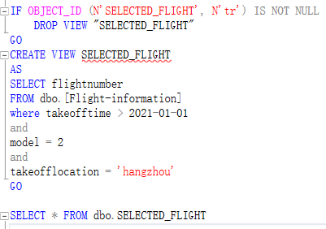
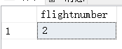

(2)用户可能需要查询价格小于200的保险(戴东晖）
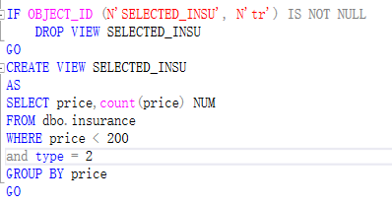
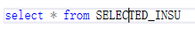
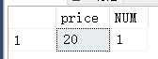
(3)创建实付金额视图（薛可欣）
因为在预订航班时,除了机票外,旅客还要考虑行李价格和保险以及平台折扣,公式为：实付金额=座位价格+行李价格+保险价格-折扣
if object_id(N' Final_price')is not null
drop view Final_price
go
create view Final_price(travellername,seatcost,offmoney,luggageprice,insuranceprice,finalprice)
as
select t.travellername,fs.seatcost,d.offmoney,l.overweightfee,i.price,fs.seatcost-d.offmoney+l.overweightfee+i.price as final
from discount d,Traveller t,[Flight-seat] fs,myOrder o,luggage l,insurance i
where d.offmoney in
(select d.offmoney
from Traveller t,discount d,myOrder o
where t.IDnumber= o.IDnumber and o.IDnumber=d.IDnumber)
and t.IDnumber=d.IDnumber
and o.seatID=fs.SeatID
and t.IDnumber= o.IDnumber
and l.IDnumber=t.IDnumber
and i.PaymentID=t.IDnumber
with check option;
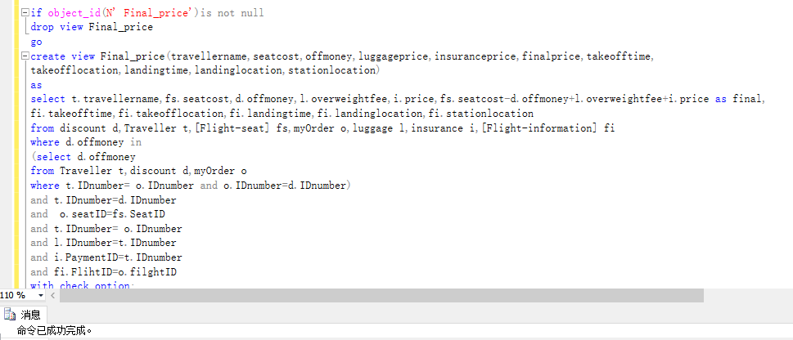

（4）未出行订单（薛可欣）
保存了用户未来要完成的订单。用户可以在平台上查询自己还没有完成的订单,了解未来乘机的相关信息
if object_id(N' Futureorders')is not null
drop view Futureorders
go
create view Futureorders(travellername,IDnumber,orderID,FlihtID,takeofftime,takeofflocation,landingtime,landinglocation,
stationlocation,finalprice,freebaggageallowance)
as
select t.travellername,t.IDnumber, o.orderID,fi.FlihtID,fi.takeofftime,fi.takeofflocation,fi.landingtime,
fi.landinglocation,fi.stationlocation,fp.finalprice,l.freebaggageallowance
from Traveller t,myOrder o,luggage l,[Flight-information] fi,Final_price fp
where t.IDnumber=o.IDnumber
and o.luaggageID=l.consignmentID
and o.filghtID=fi.FlihtID
and t.travellername=fp.travellername
and fi.landingtime>GETDATE()
with check option;
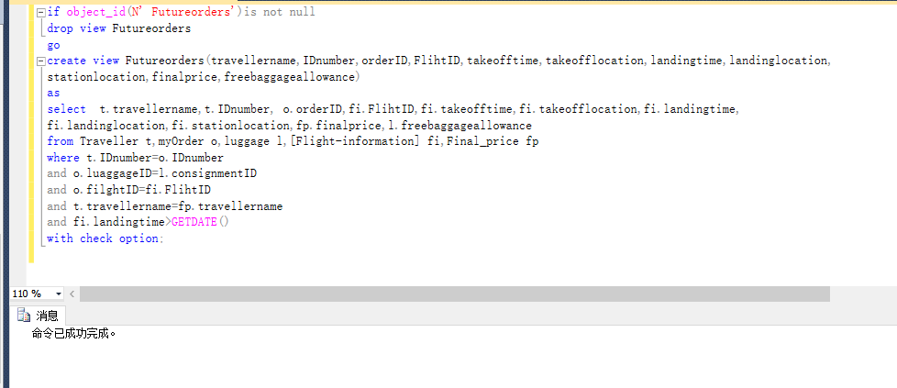
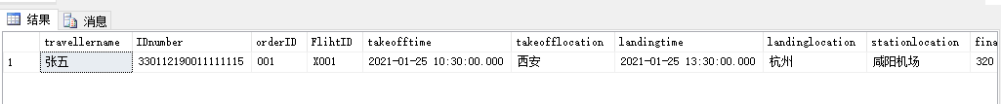
（5）历史订单（薛可欣）
保存了用户历史出行的消息
if object_id(N' Historyorders')is not null
drop view Historyorders
go
create view Historyorders(travellername,IDnumber,orderID,FlihtID,takeofftime,takeofflocation,landingtime,landinglocation,
stationlocation,finalprice,freebaggageallowance)
as
select t.travellername,t.IDnumber, o.orderID,fi.FlihtID,fi.takeofftime,fi.takeofflocation,fi.landingtime,
fi.landinglocation,fi.stationlocation,fp.finalprice,l.freebaggageallowance
from Traveller t,myOrder o,luggage l,[Flight-information] fi,Final_price fp
where t.IDnumber=o.IDnumber
and o.luaggageID=l.consignmentID
and o.filghtID=fi.FlihtID
and t.travellername=fp.travellername
and fi.landingtime<GETDATE()
with check option;
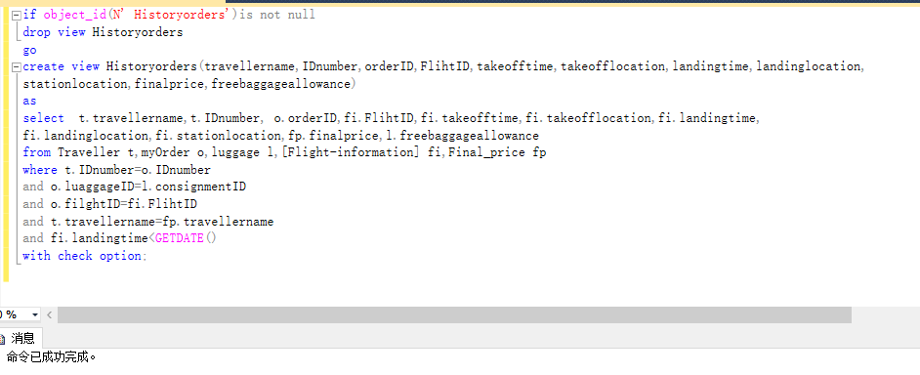
(6)管理员对航班进行查询、修改的管理员操作视图
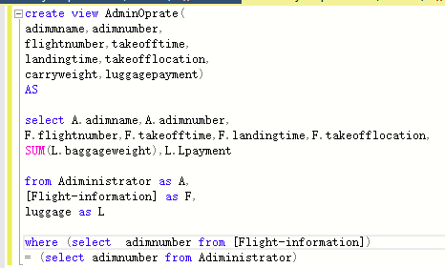

（7）查询航班座位信息（薛可欣）
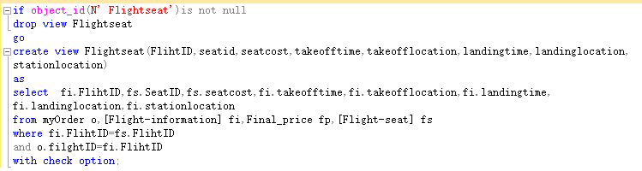

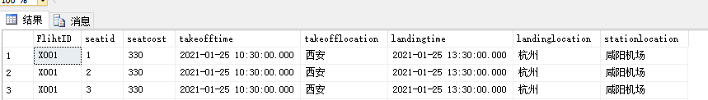
（8）查询座位id以及已选此座的个人信息（毛锐）
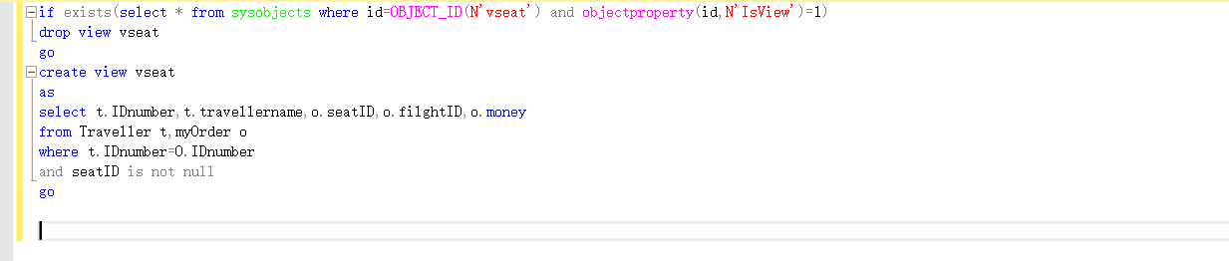

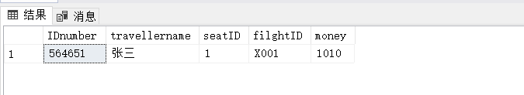

7.3存储过程或触发器的创建
存储过程
1.旅客在上飞机前可能需要托运行李,这时候可能需要插入行李的记录。（戴东辉）
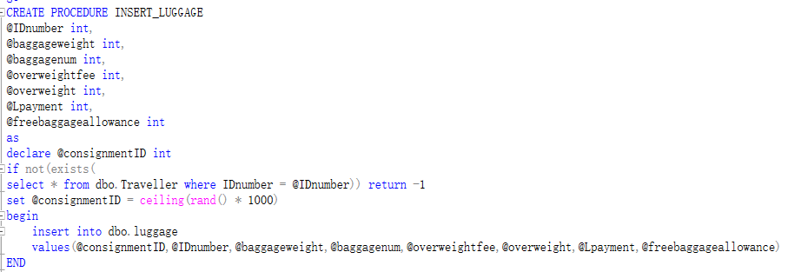
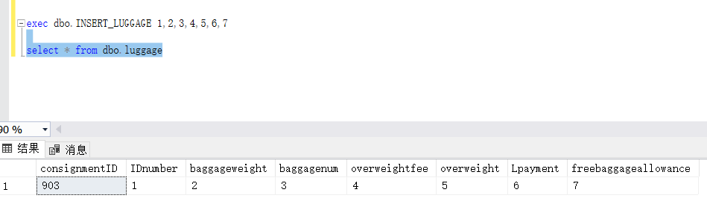

2.机票的价格经常变动,所以有时候需要涨价,使用游标在存储过程中修改机票价格,比如将 A001航班的座位价格提高20%（薛可欣）
if (exists(select * from sys.objects where name='updateseatcost'))
drop proc updateseatcost
go
create procedure updateseatcost
as
declare empcost cursor for
select fi.seatcost,fi.FlihtID
from [Flight-seat] fi
declare @increment decimal(5,1)
declare @thefid char(20)
open empcost
fetch next from empcost into @increment,@thefid
while(@@FETCH_STATUS=0)
begin
if @thefid='X001'
set @increment=0.1
else if @thefid='A001'
set @increment=0.2
update [Flight-seat]
set seatcost=seatcost*(1+@increment)
where FlihtID=@thefid
fetch next from empcost into @increment,@thefid
end
close empcost
deallocate empcost
go

exec updateseatcost
原先的价格：
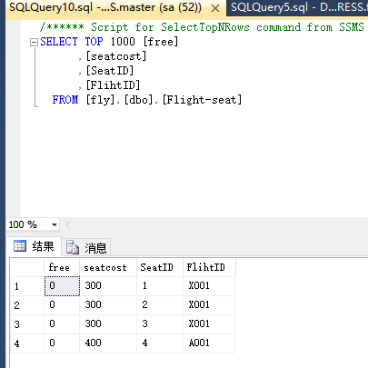
涨价之后的价格：
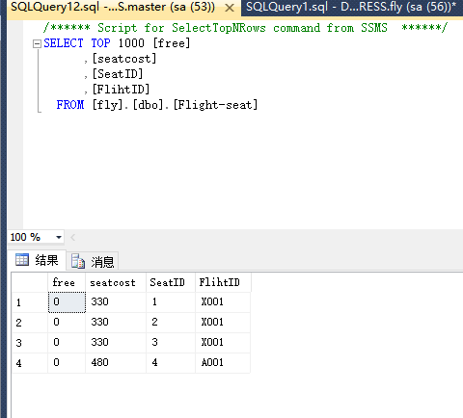

3.机票有时候也需要将降价,比如将A001的机票打九折（薛可欣）
if (exists(select * from sys.objects where name='updateseatcostdown'))
drop proc updateseatcostdown
go
create procedure updateseatcostdown
as
declare empcost cursor for
select fi.seatcost,fi.FlihtID
from [Flight-seat] fi
declare @increment float
declare @thefid char(20)
open empcost
fetch next from empcost into @increment,@thefid
while(@@FETCH_STATUS=0)
begin
if @thefid='A001'
set @increment=0.9
update [Flight-seat]
set seatcost=seatcost*@increment
where FlihtID=@thefid
fetch next from empcost into @increment,@thefid
end
close empcost
deallocate empcost
go

exec updateseatcostdown
原先的价格：

降价之后的价格：
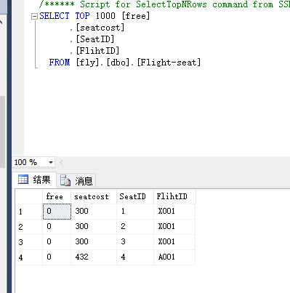

4.判断旅客是否存在,若存在,查询一个旅客参加了几个保险,还在有效期内的有几份（薛可欣）
if (exists(select * from sys.objects where name='trajoininsurance'))
drop proc trajoininsurance
go
create procedure trajoininsurance
@tra_id varchar(20)
as
declare
@tra_exist varchar(20),
@count varchar(20),
@count2 varchar(20)
select @tra_exist=count(*)
from Traveller t
where t.IDnumber=@tra_id
if @tra_exist=0
print @tra_id+ '不存在'
else
begin
select @count=count(*)
from Traveller t,insurance i
where @tra_id=i.PaymentID and t.IDnumber=@tra_id
if @count=0
begin
print @tra_id+'参加保险份数为'+@count
return 0
end
else
begin
select @count2=count(*)
from Traveller t,insurance i
where @tra_id=i.PaymentID and t.IDnumber=@tra_id and i.endtime>GETDATE()
print @tra_id+'参加保险份数为'+@count+' 其中还在有效期内的份数为 '+@count2
return @count
end
end

exec trajoininsurance @tra_id=330112190011111111
exec trajoininsurance @tra_id=330112190011111115

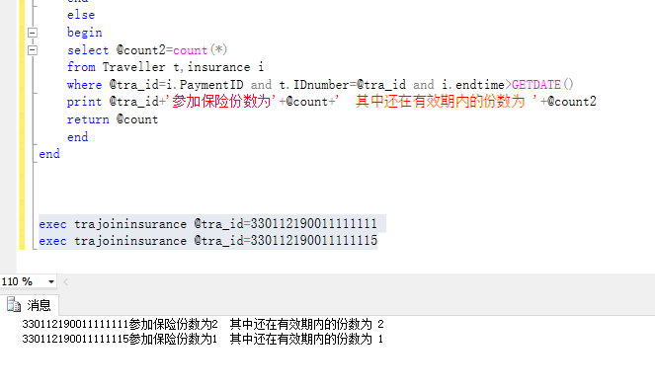
5.插入新的保险类型时,可以使用该存储过程。（戴东晖）
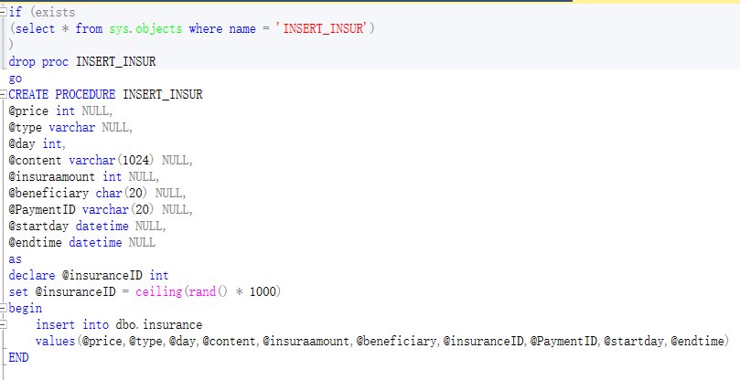
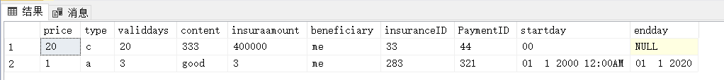

6.实现查询所有旅客信息（毛锐）

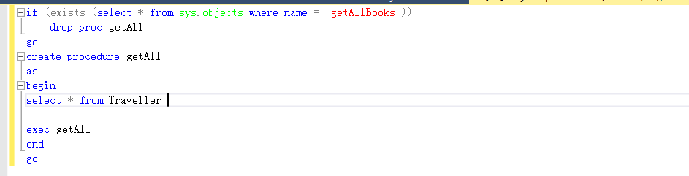
7.插入航班信息（戴东晖）
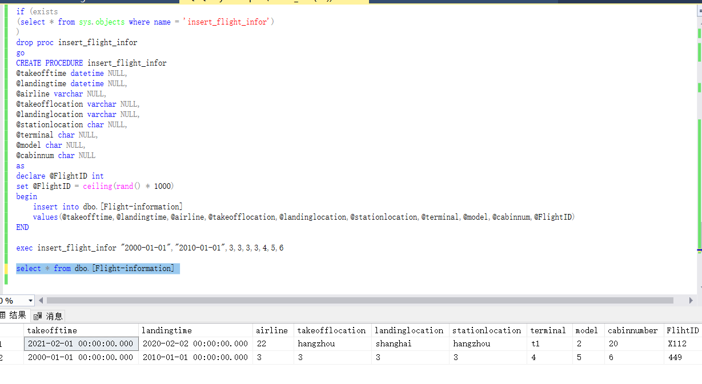
8.更新航班信息（戴东晖）
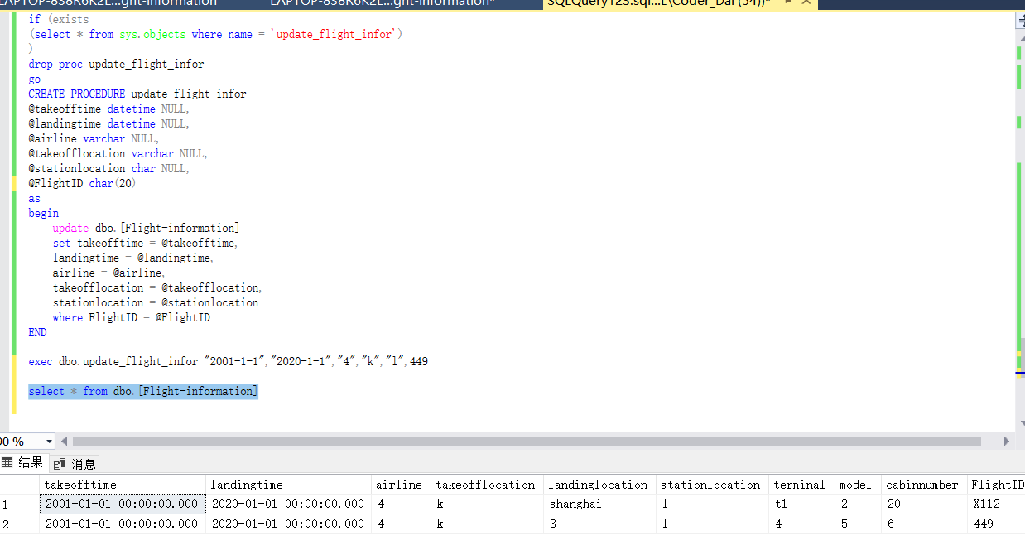

触发器
1.当更新某个用户的优惠券金额时,那么它的支付订单的金额也要改变。（戴东晖）
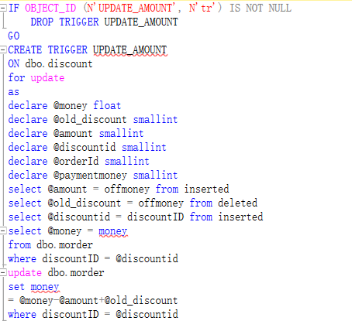

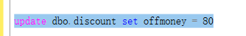
原来的(折扣金额为0)
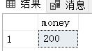
执行过后的
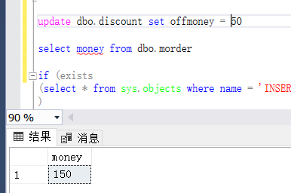

2.修改保险类型自动修改保险价格（毛锐）
create trigger tri_orderupdate
on insurance
for update
as
if update(type)
if (select type from inserted)='安全保险'
update insurance
set price=30
where insuranceID=(select insuranceID from inserted)
else if update(type)
if (select type from inserted)='延误保险'
update insurance
set price=20
where insuranceID=(select insuranceID from inserted)
else if update(type)
if (select type from inserted)='退票保险'
update insurance
set price=10
where insuranceID=(select insuranceID from inserted)

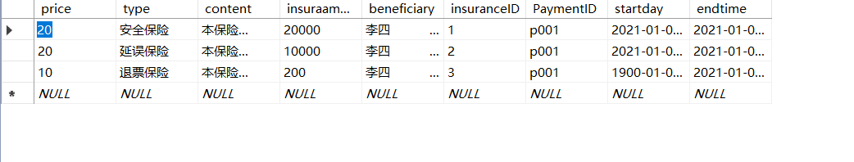
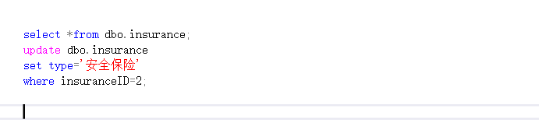
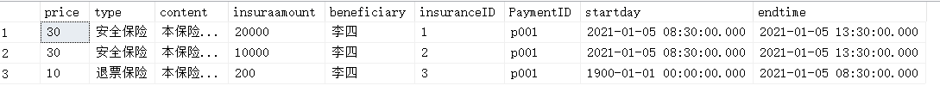
3.当删除优惠时,订单里的金额也需要更新。（戴东晖）
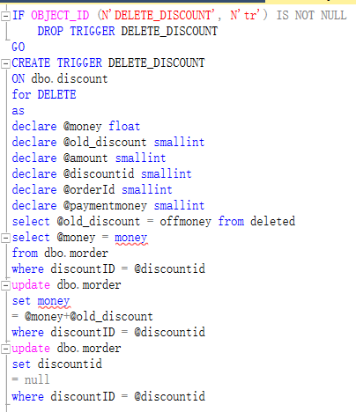
前:
后:

4.当用户购买超重行李额时,行李中的超重重量和订单中的金额也会随之改变（薛可欣）
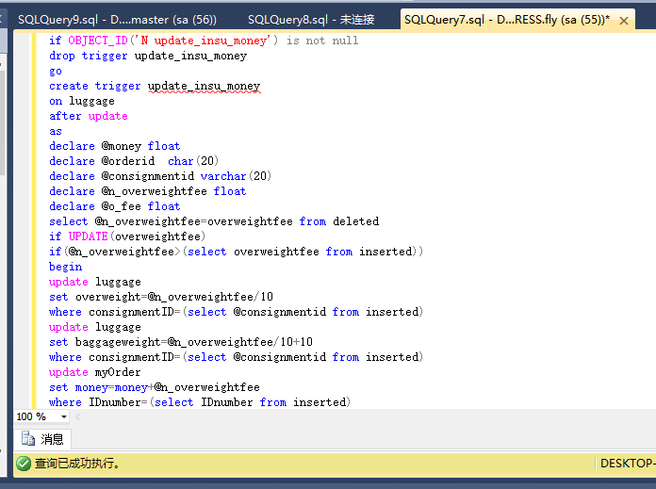
购买前
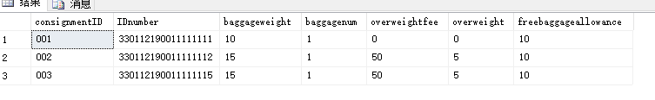
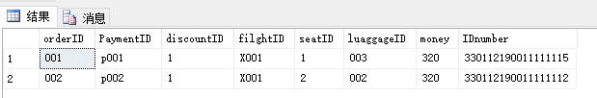
购买后
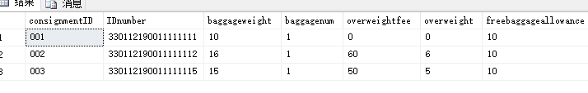
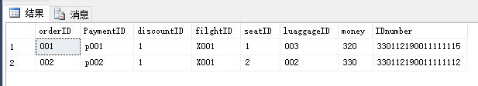
5.如果用户想注销账号,检测是否还有未完成订单,如果有则不能注销（薛可欣）
if OBJECT_ID('N deletetra') is not null
drop trigger deletetra
go
create trigger deletetra
on traveller
after delete
as
begin
if exists (
select *
from Futureorders
inner join deleted on Futureorders.IDnumber=deleted.IDnumber)
begin
print '有出行计划未完成,不能删除'
rollback transaction
end
end
go
delete Traveller where IDnumber='330112190011111113'
delete Traveller where IDnumber='330112190011111115'
注销前
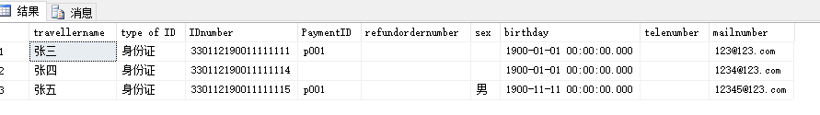

注销后
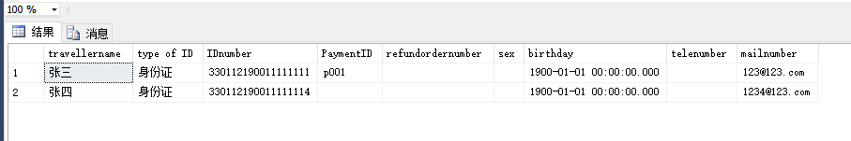
7.管理员修改相关信息后更新最后修改的管理员号（张琦智）
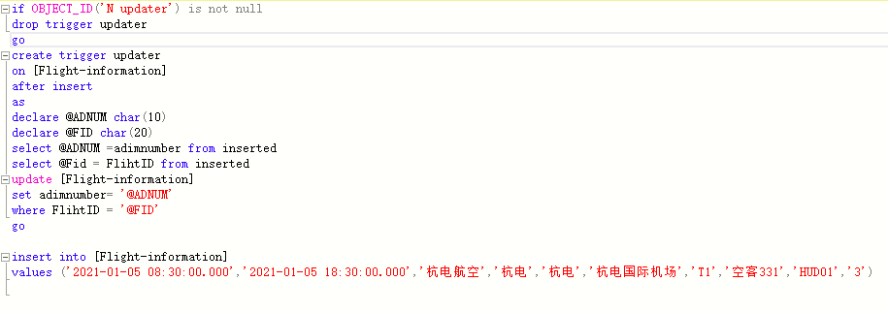
效果
8.管理员账号注销,账号密码置空,保留管理员编号（张琦智）
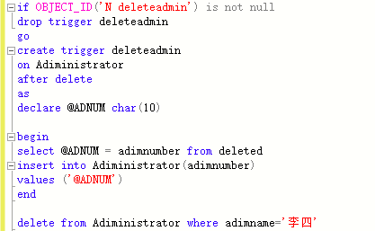
修改前
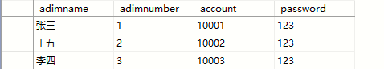
修改后
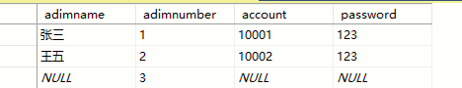

8.WEB连接部署实现机票预订的实现
运行效果截图：
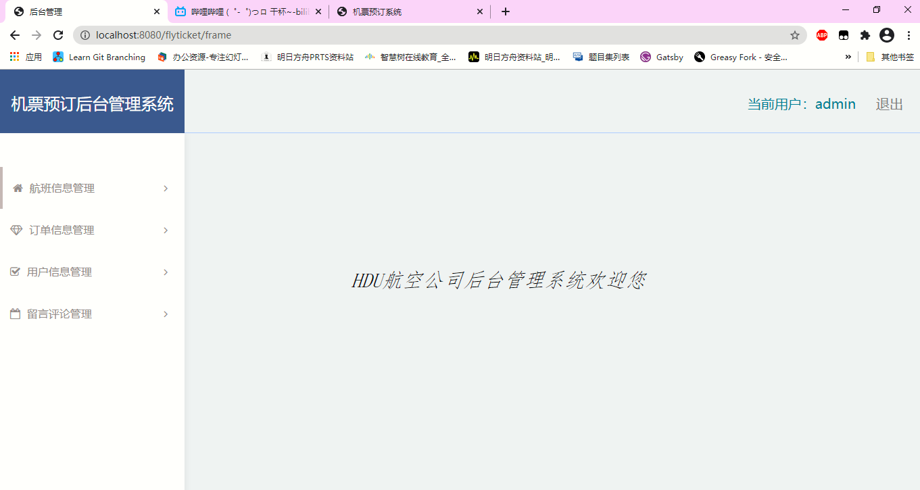
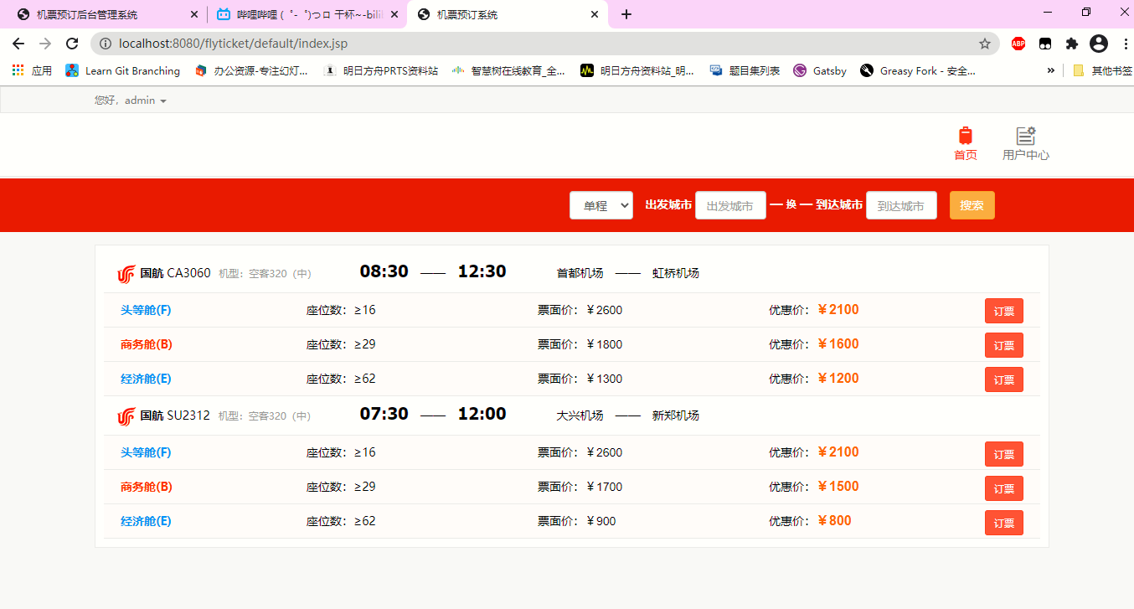
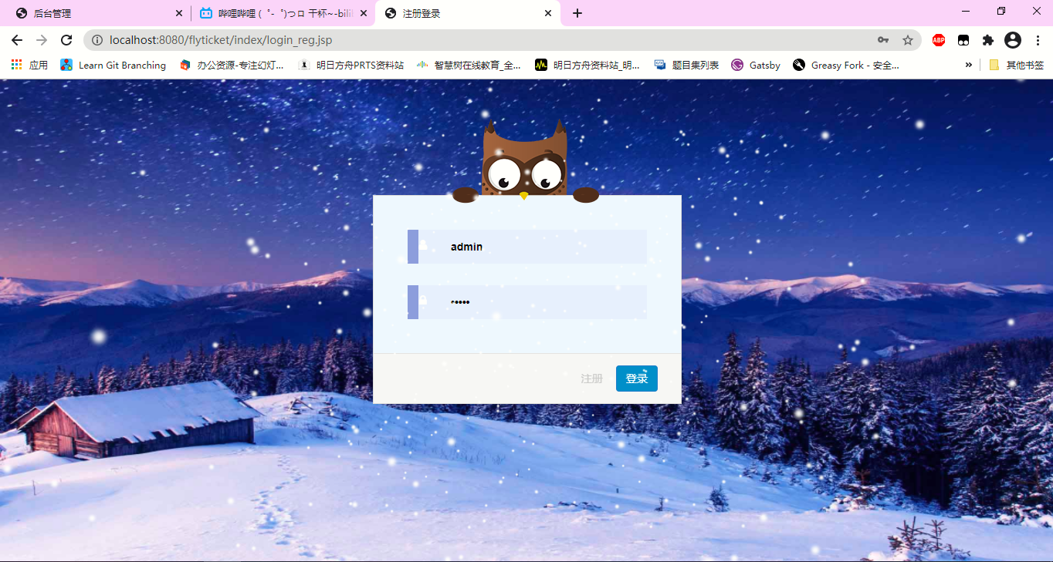
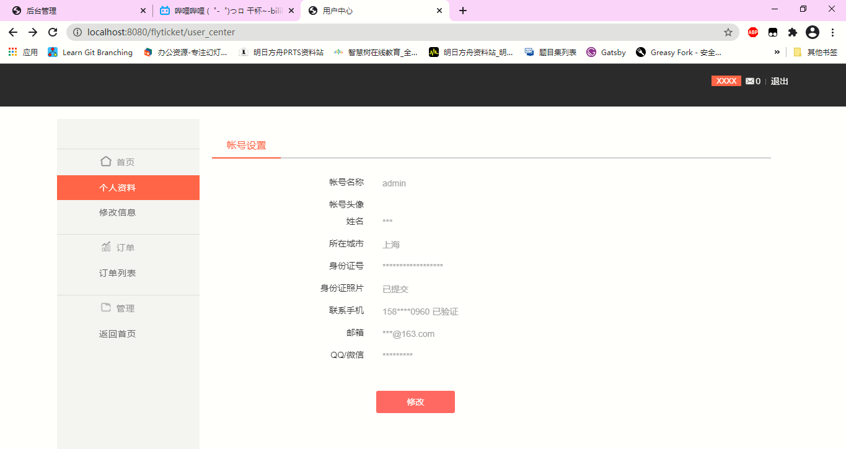
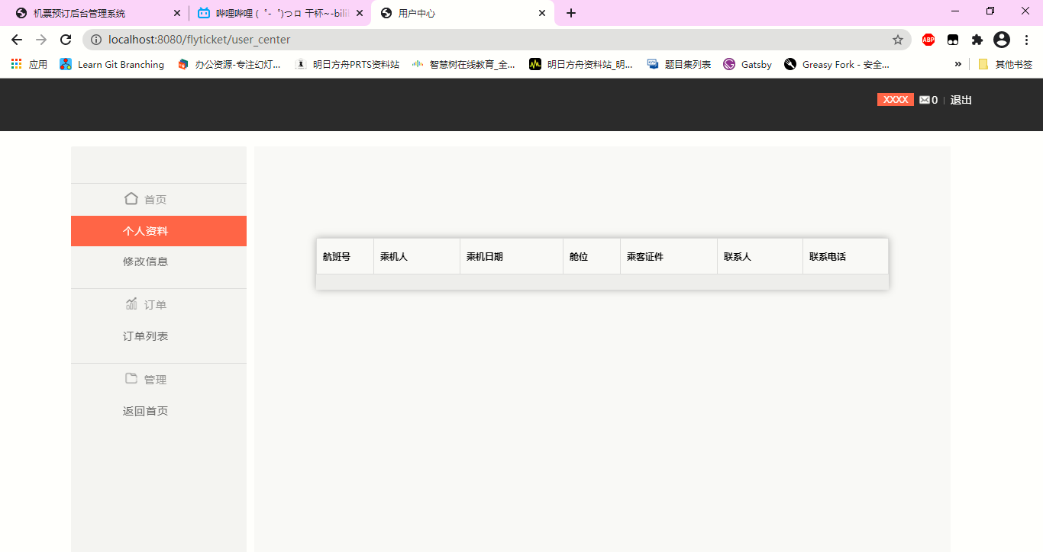
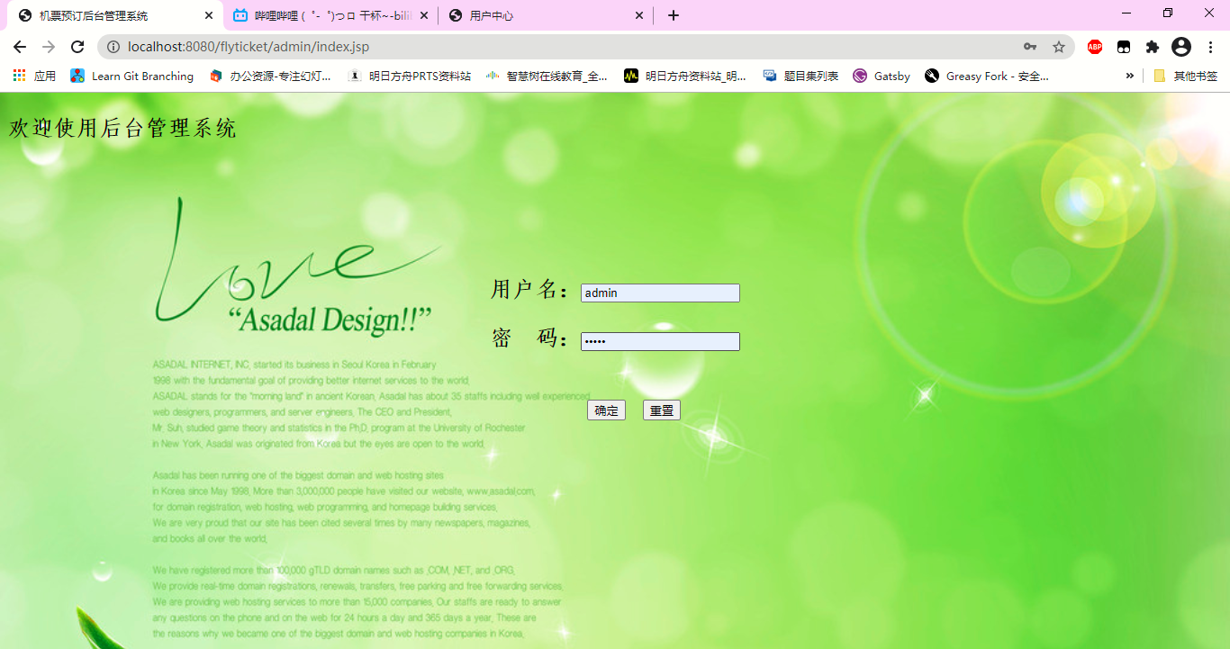
部署示意图：
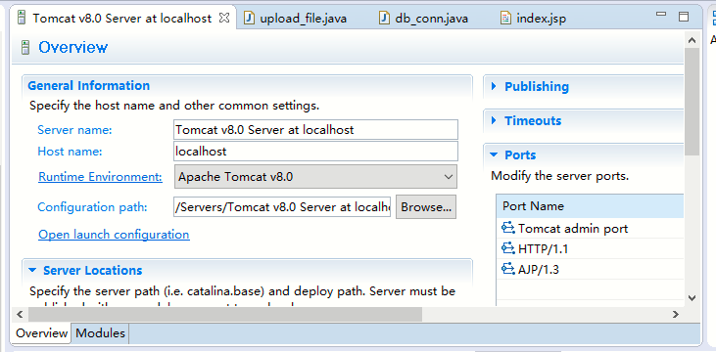
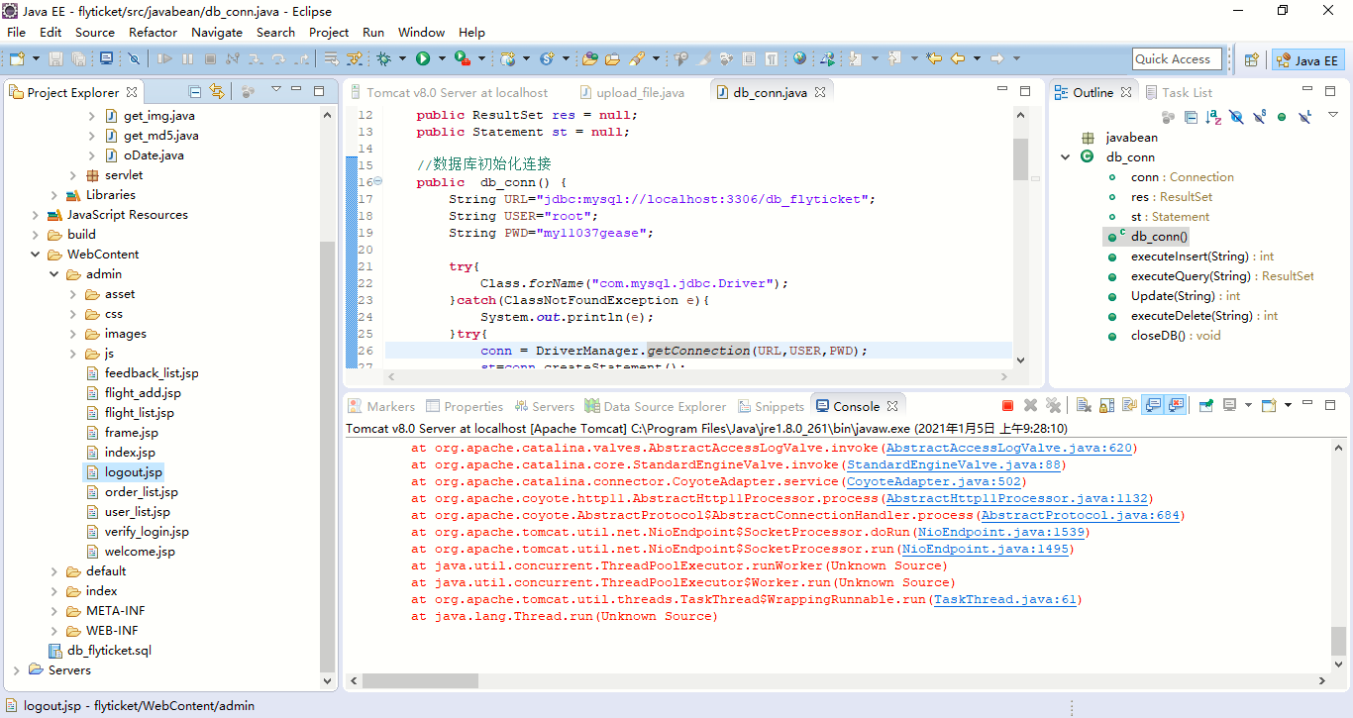
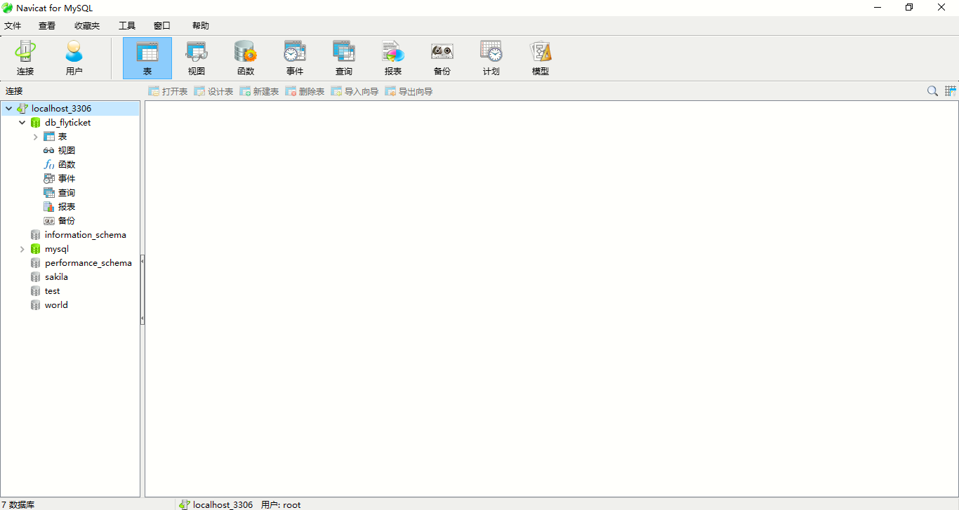
数据库视图（半示例）：
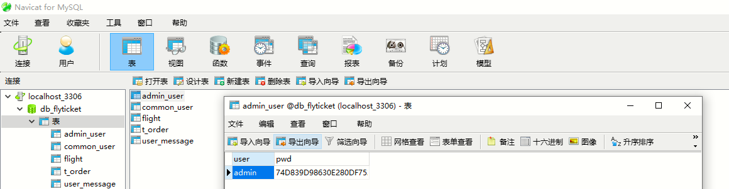

9课程总结
很快一学期就要过去了,这个学期的数据库课程设计也结束了。在做实验的时候我有很多的感悟。
首先,整个实验分为分析需求、画数据流图、画E-R(实体-联系)图、设计逻辑、物理模型等几个步骤，在做完这几个步骤后实验才算真正完成。
我们选的题目时航班订票系统,在需求分析过程中，我们通过上网查资料，试用了很多订票APP，去图书馆查阅相关资料，结合我们的生活经验，并且根据携程等旅游网站的订票设计,根据可行性研究的结果和用户的需要，分析现有情况及问题。在一个月的时间里，不断地对程序及各模块进行修改、编译、调试、运行，其间遇到很多问题，经过组内讨论，最终把它解决了。
通过本次课程设计，对SQL语言，数据库的创建、修改、删除方法有了一定的了解，通过导入表和删除表、更改表，学会了数据库的基本操作。很多事情不是想象中的那么简单的，它涉及到的各种实体、属性、数据流程、数据处理等等。很多时候感觉后面的设计根本无法继续，感觉像是被前面做的各种图限制了。所以返工的几次，浪费了很多时间和精力。
在画数据流图的时候,我在思考为什么要做这个流图。后来我发现,做数据流图是为了画E-R图服务的,只有搞清楚实体之间的交互关系,才能搞清楚E-R图是怎么画的,而只有把E-R图画出来,才能在建立关系模式的时候确认外键(外键代表着实体之间的联系),以及后续的触发器(触发器也可以表示实体之间的联系)的设置。在做关系模型转换的时候碰到有些实体即可以认为是实体又可以作为属性，为了避免冗余，尽量按照属性处理了。
通过这次课程设计发现这其中需要的很多知识我们没有接触过，去图书馆查资料的时候发现我们前边所学到的仅仅是皮毛，还有很多需要我们掌握的东西我们根本不知道。同时也发现有很多已经学过的东西我们没有理解到位，不能灵活运用于实际,不能很好的用来解决问题。通过这次实践课，我们掌握了理论课上没有讲述的存储过程，触发器等知识点。明白只有实践才能真正掌握知识。不断的大量的实践，通过不断的自学，不断地发现问题，思考问题，进而解决问题。

10参考文献
书籍类格式: 作者 书名[M] 出版社 出版时间
[1] 张红娟, 傅婷婷编著. 《数据库原理》[M], 西安电子科技大学出版社, 2016
[2] 西尔伯沙茨著.《数据库系统概念》[M], 机械工业出版社, 2000
网页参考格式：题目 完整的URL地址
[3] 详解第一范式、第二范式、第三范式、BCNF范式.
https://blog.csdn.net/wenco1/article/details/88077279
[4] ER图设计的原则、方法与步骤.
https://www.cnblogs.com/vvlj/p/12750674.html
[5] powerdesigner 画ER图.
https://www.cnblogs.com/yingsong/p/5072375.html

11致谢
感谢傅婷婷老师对我们小组悉心的指导。在完成数据库课程设计的过程中，从课程设计的选题，到论需求分析，逻辑结构设计，物理结构设计，老师都提出了很多指导。最开始我们小组需求分析文档写的不好，老师也在验收的时候提出了批评和意见。之后我们小组更改了需求分析，然后一步步完成了实验。没有傅婷婷老师的悉心指导，我们小组无法完成航班预订系统的课程设计，在此表示感谢。

