逻辑、物理结构设计及系统实现

课题名称：航班预订系统课程设计

课题组员：戴东晖、薛可欣、张琦智、毛锐

完成时间： 2020/11/20

5逻辑结构设计

5.1逻辑结构设计
myOrder(orderID,PaymentID,FlihtID,discountID,insuranceID,money luggageID,seatID,IDnumber)

Payment-voucher (PaymentID,orderID )

discount (discountID ,discounttime, offmoney ,IDnumber endtime )

insurance(insuranceID,price, type, validdays, content insuraamount , beneficiary , PaymentID ,endtime)

Flight-seat(seatID,seatcost,FlihtID, free)

Refund-vouher(refundordernumber,orderID)

Flightinformation(FlihtID,flightnumber,takeofftime,landingtime,airline,takeofflocation,landinglocation,stationlocation,terminal,,adimnumber）

Traveller(IDnumber,travellername,typeofID,PaymentID,refundordernumber,sex,birthday,telenumber,mailnumber,account,password）

luggage(consignmentID,IDnumber,baggageweight,baggagenum,overweightfee,overweight,freebaggageallowance）

adiministractor(adimnumber,adimname,account,password)

5.2模式优化
符合1NF的关系中的每个属性都不可再分；
2NF在1NF的基础之上,消除了非主属性对于码的部分函数依赖；
3NF在2NF的基础之上,消除了非主属性对于码的传递函数依赖。

adiministractor的主码是adimnumber,adimname,account,password完全依赖于主码且不存在传递依赖

luggage的主码是consignmentID,baggageweight,baggagenum,overweightfee,overweight,freebaggageallowance完全依赖于主码且不存在传递依赖,外码为IDnumber

Traveller的主码是IDnumber,travellername,typeofID,PaymentID,refundordernumber,sex,birthday,telenumber,mailnumber,account,password完全依赖于主码且不存在传递依赖

Flightinformation的主码是FlihtID。flightnumber,takeofftime,landingtime,airline,takeofflocation,landinglocation,stationlocation,terminal,,adimnumberd完全依赖于主码且不存在传递依赖

Refund-vouher的主码是refundordernumber ,外码为orderID。

Flight-seat的主码是seatID。seatcost, free完全依赖于主码且不存在传递依赖。外码是FlihtID

insurance的主码是insuranceID 。price type validdays content insuraamount beneficiary endtime完全依赖于主码且不存在传递依赖。 PaymentID是外码。

discount 的主码是discountID。discounttime offmoney endtime完全依赖于主码且不存在传递依赖。 IDnumber 是外码。

Payment-voucher 的主码是PaymentID 。orderID是外码。

myOrder的主码是orderID。money完全依赖于主码且不存在传递依赖。外码是PaymentID FlihtID discountID insuranceID luggageID seatID IDnumber
6物理设计
索引1:起飞时间、航班号;
create index ix_flight on dbo.[Flight-information](takeofftime,Flightid)
起飞地点、降落地点、航班号
create index ix_flight2 on dbo.[Flight-information](takeofflocation,landinglocation,Flightid)
索引2:账户、密码组合索引
create index ix_account on dbo.[Traveller](account,password)
用户挑选航班时通常需要根据时间来筛选航班信息,建立起飞时间的索引可以快速找到航班号,从而查询到对应的航班信息;
用户挑选航班时也需要根据起飞地点和降落地点挑选航班,建立相应索引,可以快速找到对应的航班信息；
同时以上两者的信息在航班实体中通常不需要频繁地更改,所以建立索引通常不会引起性能降低。
用户登录时,经常需要查询用户的账号、密码是否存在和对应,建立账号、密码索引可以快速地找到相应的信息。

7系统SQL实现

7.1表的创建
USE [master]
GO
/****** Object: Database [fly] Script Date: 2021/1/3 16:49:24 ******/
CREATE DATABASE [fly]
CONTAINMENT = NONE
ON PRIMARY
( NAME = N'fly', FILENAME = N'E:\sqlshili\MSSQL12.SQLEXPRESS\MSSQL\DATA\fly.mdf' , SIZE = 5120KB , MAXSIZE = UNLIMITED, FILEGROWTH = 1024KB )
LOG ON
( NAME = N'fly_log', FILENAME = N'E:\sqlshili\MSSQL12.SQLEXPRESS\MSSQL\DATA\fly_log.ldf' , SIZE = 2048KB , MAXSIZE = 2048GB , FILEGROWTH = 10%)
GO
ALTER DATABASE [fly] SET COMPATIBILITY_LEVEL = 120
GO
IF (1 = FULLTEXTSERVICEPROPERTY('IsFullTextInstalled'))
begin
EXEC [fly].[dbo].[sp_fulltext_database] @action = 'enable'
end
GO
ALTER DATABASE [fly] SET ANSI_NULL_DEFAULT OFF
GO
ALTER DATABASE [fly] SET ANSI_NULLS OFF
GO
ALTER DATABASE [fly] SET ANSI_PADDING OFF
GO
ALTER DATABASE [fly] SET ANSI_WARNINGS OFF
GO
ALTER DATABASE [fly] SET ARITHABORT OFF
GO
ALTER DATABASE [fly] SET AUTO_CLOSE OFF
GO
ALTER DATABASE [fly] SET AUTO_SHRINK OFF
GO
ALTER DATABASE [fly] SET AUTO_UPDATE_STATISTICS ON
GO
ALTER DATABASE [fly] SET CURSOR_CLOSE_ON_COMMIT OFF
GO
ALTER DATABASE [fly] SET CURSOR_DEFAULT GLOBAL
GO
ALTER DATABASE [fly] SET CONCAT_NULL_YIELDS_NULL OFF
GO
ALTER DATABASE [fly] SET NUMERIC_ROUNDABORT OFF
GO
ALTER DATABASE [fly] SET QUOTED_IDENTIFIER OFF
GO
ALTER DATABASE [fly] SET RECURSIVE_TRIGGERS OFF
GO
ALTER DATABASE [fly] SET DISABLE_BROKER
GO
ALTER DATABASE [fly] SET AUTO_UPDATE_STATISTICS_ASYNC OFF
GO
ALTER DATABASE [fly] SET DATE_CORRELATION_OPTIMIZATION OFF
GO
ALTER DATABASE [fly] SET TRUSTWORTHY OFF
GO
ALTER DATABASE [fly] SET ALLOW_SNAPSHOT_ISOLATION OFF
GO
ALTER DATABASE [fly] SET PARAMETERIZATION SIMPLE
GO
ALTER DATABASE [fly] SET READ_COMMITTED_SNAPSHOT OFF
GO
ALTER DATABASE [fly] SET HONOR_BROKER_PRIORITY OFF
GO
ALTER DATABASE [fly] SET RECOVERY SIMPLE
GO
ALTER DATABASE [fly] SET MULTI_USER
GO
ALTER DATABASE [fly] SET PAGE_VERIFY CHECKSUM
GO
ALTER DATABASE [fly] SET DB_CHAINING OFF
GO
ALTER DATABASE [fly] SET FILESTREAM( NON_TRANSACTED_ACCESS = OFF )
GO
ALTER DATABASE [fly] SET TARGET_RECOVERY_TIME = 0 SECONDS
GO
ALTER DATABASE [fly] SET DELAYED_DURABILITY = DISABLED
GO
USE [fly]
GO
/****** Object: Table [dbo].[Adiministrator] Script Date: 2021/1/3 16:49:24 ******/
SET ANSI_NULLS ON
GO
SET QUOTED_IDENTIFIER ON
GO
SET ANSI_PADDING ON
GO
CREATE TABLE [dbo].[Adiministrator](
[adimname] [char](20) NULL,
[adimnumber] [char](10) NOT NULL,
[account] [varchar](10) NULL,
[password] [varchar](10) NULL,
CONSTRAINT [PK_ADIMINISTRATOR] PRIMARY KEY NONCLUSTERED
(
[adimnumber] ASC
)WITH (PAD_INDEX = OFF, STATISTICS_NORECOMPUTE = OFF, IGNORE_DUP_KEY = OFF, ALLOW_ROW_LOCKS = ON, ALLOW_PAGE_LOCKS = ON) ON [PRIMARY]
) ON [PRIMARY]

GO
SET ANSI_PADDING OFF
GO
/****** Object: Table [dbo].[discount] Script Date: 2021/1/3 16:49:24 ******/
SET ANSI_NULLS ON
GO
SET QUOTED_IDENTIFIER ON
GO
SET ANSI_PADDING ON
GO
CREATE TABLE [dbo].[discount](
[discounttime] [datetime] NULL,
[offmoney] [real] NULL,
[discountID] [float] NOT NULL,
[IDnumber] [varchar](20) NULL,
[endtime] [datetime] NULL,
CONSTRAINT [PK_DISCOUNT] PRIMARY KEY NONCLUSTERED
(
[discountID] ASC
)WITH (PAD_INDEX = OFF, STATISTICS_NORECOMPUTE = OFF, IGNORE_DUP_KEY = OFF, ALLOW_ROW_LOCKS = ON, ALLOW_PAGE_LOCKS = ON) ON [PRIMARY]
) ON [PRIMARY]

GO
SET ANSI_PADDING OFF
GO
/****** Object: Table [dbo].[Flight-information] Script Date: 2021/1/3 16:49:24 ******/
SET ANSI_NULLS ON
GO
SET QUOTED_IDENTIFIER ON
GO
SET ANSI_PADDING ON
GO
CREATE TABLE [dbo].[Flight-information](
[takeofftime] [datetime] NULL,
[landingtime] [datetime] NULL,
[airline] [varchar](20) NULL,
[takeofflocation] [varchar](20) NULL,
[landinglocation] [varchar](20) NULL,
[stationlocation] [char](20) NULL,
[terminal] [char](20) NULL,
[model] [char](20) NULL,
[FlihtID] [char](20) NOT NULL,
[adimnumber] [char](10) NULL,
CONSTRAINT [PK_FLIGHT-INFORMATION] PRIMARY KEY NONCLUSTERED
(
[FlihtID] ASC
)WITH (PAD_INDEX = OFF, STATISTICS_NORECOMPUTE = OFF, IGNORE_DUP_KEY = OFF, ALLOW_ROW_LOCKS = ON, ALLOW_PAGE_LOCKS = ON) ON [PRIMARY]
) ON [PRIMARY]

GO
SET ANSI_PADDING OFF
GO
/****** Object: Table [dbo].[Flight-seat] Script Date: 2021/1/3 16:49:24 ******/
SET ANSI_NULLS ON
GO
SET QUOTED_IDENTIFIER ON
GO
SET ANSI_PADDING ON
GO
CREATE TABLE [dbo].[Flight-seat](
[free] [int] NULL,
[seatcost] [float] NULL,
[SeatID] [int] NOT NULL,
[FlihtID] [char](20) NULL,
CONSTRAINT [PK_FLIGHT-SEAT] PRIMARY KEY NONCLUSTERED
(
[SeatID] ASC
)WITH (PAD_INDEX = OFF, STATISTICS_NORECOMPUTE = OFF, IGNORE_DUP_KEY = OFF, ALLOW_ROW_LOCKS = ON, ALLOW_PAGE_LOCKS = ON) ON [PRIMARY]
) ON [PRIMARY]

GO
SET ANSI_PADDING OFF
GO
/****** Object: Table [dbo].[insurance] Script Date: 2021/1/3 16:49:24 ******/
SET ANSI_NULLS ON
GO
SET QUOTED_IDENTIFIER ON
GO
SET ANSI_PADDING ON
GO
CREATE TABLE [dbo].[insurance](
[price] [int] NULL,
[type] [varchar](20) NULL,
[content] [varchar](1024) NULL,
[insuraamount] [int] NULL,
[beneficiary] [char](20) NULL,
[insuranceID] [float] NOT NULL,
[PaymentID] [varchar](20) NULL,
[startday] [datetime] NULL,
[endtime] [datetime] NULL,
CONSTRAINT [PK_INSURANCE] PRIMARY KEY NONCLUSTERED
(
[insuranceID] ASC
)WITH (PAD_INDEX = OFF, STATISTICS_NORECOMPUTE = OFF, IGNORE_DUP_KEY = OFF, ALLOW_ROW_LOCKS = ON, ALLOW_PAGE_LOCKS = ON) ON [PRIMARY]
) ON [PRIMARY]

GO
SET ANSI_PADDING OFF
GO
/****** Object: Table [dbo].[luggage] Script Date: 2021/1/3 16:49:24 ******/
SET ANSI_NULLS ON
GO
SET QUOTED_IDENTIFIER ON
GO
SET ANSI_PADDING ON
GO
CREATE TABLE [dbo].[luggage](
[consignmentID] [varchar](20) NOT NULL,
[IDnumber] [varchar](20) NULL,
[baggageweight] [float] NULL,
[baggagenum] [int] NULL,
[overweightfee] [float] NULL,
[overweight] [float] NULL,
[freebaggageallowance] [float] NULL,
CONSTRAINT [PK_LUGGAGE] PRIMARY KEY NONCLUSTERED
(
[consignmentID] ASC
)WITH (PAD_INDEX = OFF, STATISTICS_NORECOMPUTE = OFF, IGNORE_DUP_KEY = OFF, ALLOW_ROW_LOCKS = ON, ALLOW_PAGE_LOCKS = ON) ON [PRIMARY]
) ON [PRIMARY]

GO
SET ANSI_PADDING OFF
GO
/****** Object: Table [dbo].[myOrder] Script Date: 2021/1/3 16:49:24 ******/
SET ANSI_NULLS ON
GO
SET QUOTED_IDENTIFIER ON
GO
SET ANSI_PADDING ON
GO
CREATE TABLE [dbo].[myOrder](
[orderID] [char](20) NOT NULL,
[PaymentID] [varchar](20) NULL,
[discountID] [float] NULL,
[filghtID] [varchar](20) NULL,
[seatID] [float] NULL,
[luaggageID] [varchar](20) NULL,
[money] [float] NULL,
[IDnumber] [varchar](20) NULL,
CONSTRAINT [PK_ORDER] PRIMARY KEY NONCLUSTERED
(
[orderID] ASC
)WITH (PAD_INDEX = OFF, STATISTICS_NORECOMPUTE = OFF, IGNORE_DUP_KEY = OFF, ALLOW_ROW_LOCKS = ON, ALLOW_PAGE_LOCKS = ON) ON [PRIMARY]
) ON [PRIMARY]

GO
SET ANSI_PADDING OFF
GO
/****** Object: Table [dbo].[Payment-voucher] Script Date: 2021/1/3 16:49:24 ******/
SET ANSI_NULLS ON
GO
SET QUOTED_IDENTIFIER ON
GO
SET ANSI_PADDING ON
GO
CREATE TABLE [dbo].[Payment-voucher](
[PaymentID] [varchar](20) NOT NULL,
[orderID] [char](20) NULL,
CONSTRAINT [PK_PAYMENT-VOUCHER] PRIMARY KEY NONCLUSTERED
(
[PaymentID] ASC
)WITH (PAD_INDEX = OFF, STATISTICS_NORECOMPUTE = OFF, IGNORE_DUP_KEY = OFF, ALLOW_ROW_LOCKS = ON, ALLOW_PAGE_LOCKS = ON) ON [PRIMARY]
) ON [PRIMARY]

GO
SET ANSI_PADDING OFF
GO
/****** Object: Table [dbo].[Refund-vouher] Script Date: 2021/1/3 16:49:24 ******/
SET ANSI_NULLS ON
GO
SET QUOTED_IDENTIFIER ON
GO
SET ANSI_PADDING ON
GO
CREATE TABLE [dbo].[Refund-vouher](
[refundordernumber] [varchar](20) NOT NULL,
[orderID] [char](20) NULL,
CONSTRAINT [PK_REFUND-VOUHER] PRIMARY KEY NONCLUSTERED
(
[refundordernumber] ASC
)WITH (PAD_INDEX = OFF, STATISTICS_NORECOMPUTE = OFF, IGNORE_DUP_KEY = OFF, ALLOW_ROW_LOCKS = ON, ALLOW_PAGE_LOCKS = ON) ON [PRIMARY]
) ON [PRIMARY]

GO
SET ANSI_PADDING OFF
GO
/****** Object: Table [dbo].[Traveller] Script Date: 2021/1/3 16:49:24 ******/
SET ANSI_NULLS ON
GO
SET QUOTED_IDENTIFIER ON
GO
SET ANSI_PADDING ON
GO
CREATE TABLE [dbo].[Traveller](
[travellername] [char](20) NULL,
[type of ID] [varchar](15) NULL,
[IDnumber] [varchar](20) NOT NULL,
[PaymentID] [varchar](20) NULL,
[refundordernumber] [varchar](20) NULL,
[sex] [char](5) NULL,
[birthday] [datetime] NULL,
[telenumber] [varchar](10) NULL,
[mailnumber] [varchar](30) NULL,
CONSTRAINT [PK_TRAVELLER] PRIMARY KEY NONCLUSTERED
(
[IDnumber] ASC
)WITH (PAD_INDEX = OFF, STATISTICS_NORECOMPUTE = OFF, IGNORE_DUP_KEY = OFF, ALLOW_ROW_LOCKS = ON, ALLOW_PAGE_LOCKS = ON) ON [PRIMARY]
) ON [PRIMARY]

GO
SET ANSI_PADDING OFF
GO
/****** Object: View [dbo].[Final_price] Script Date: 2021/1/3 16:49:24 ******/
SET ANSI_NULLS ON
GO
SET QUOTED_IDENTIFIER ON
GO
create view [dbo].[Final_price](travellername,seatcost,luggageprice,insuranceprice,offprice,finalprice)
as select t.travellername,fs.seatcost,l.overweightfee,i.price,d.offmoney,fs.seatcost+l.overweightfee+i.price-d.offmoney
from luggage l,insurance i,discount d,[Flight-seat] fs,Traveller t
where l.overweightfee in
(
select l.overweightfee
from luggage
where luggage.overweight>0
)
and d.discounttime<GETDATE()
and fs.seatcost>0
and l.overweight >0
and i.type<>null
;

GO
SET ANSI_PADDING ON

GO
/****** Object: Index [enjoy_FK] Script Date: 2021/1/3 16:49:24 ******/
CREATE NONCLUSTERED INDEX [enjoy_FK] ON [dbo].[discount]
(
[IDnumber] ASC
)WITH (PAD_INDEX = OFF, STATISTICS_NORECOMPUTE = OFF, SORT_IN_TEMPDB = OFF, DROP_EXISTING = OFF, ONLINE = OFF, ALLOW_ROW_LOCKS = ON, ALLOW_PAGE_LOCKS = ON) ON [PRIMARY]
GO
SET ANSI_PADDING ON

GO
/****** Object: Index [seat update_FK] Script Date: 2021/1/3 16:49:24 ******/
CREATE NONCLUSTERED INDEX [seat update_FK] ON [dbo].[Flight-seat]
(
[FlihtID] ASC
)WITH (PAD_INDEX = OFF, STATISTICS_NORECOMPUTE = OFF, SORT_IN_TEMPDB = OFF, DROP_EXISTING = OFF, ONLINE = OFF, ALLOW_ROW_LOCKS = ON, ALLOW_PAGE_LOCKS = ON) ON [PRIMARY]
GO
SET ANSI_PADDING ON

GO
/****** Object: Index [contain_FK] Script Date: 2021/1/3 16:49:24 ******/
CREATE NONCLUSTERED INDEX [contain_FK] ON [dbo].[insurance]
(
[PaymentID] ASC
)WITH (PAD_INDEX = OFF, STATISTICS_NORECOMPUTE = OFF, SORT_IN_TEMPDB = OFF, DROP_EXISTING = OFF, ONLINE = OFF, ALLOW_ROW_LOCKS = ON, ALLOW_PAGE_LOCKS = ON) ON [PRIMARY]
GO
SET ANSI_PADDING ON

GO
/****** Object: Index [own_FK] Script Date: 2021/1/3 16:49:24 ******/
CREATE NONCLUSTERED INDEX [own_FK] ON [dbo].[luggage]
(
[IDnumber] ASC
)WITH (PAD_INDEX = OFF, STATISTICS_NORECOMPUTE = OFF, SORT_IN_TEMPDB = OFF, DROP_EXISTING = OFF, ONLINE = OFF, ALLOW_ROW_LOCKS = ON, ALLOW_PAGE_LOCKS = ON) ON [PRIMARY]
GO
/****** Object: Index [off_FK] Script Date: 2021/1/3 16:49:24 ******/
CREATE NONCLUSTERED INDEX [off_FK] ON [dbo].[myOrder]
(
[discountID] ASC
)WITH (PAD_INDEX = OFF, STATISTICS_NORECOMPUTE = OFF, SORT_IN_TEMPDB = OFF, DROP_EXISTING = OFF, ONLINE = OFF, ALLOW_ROW_LOCKS = ON, ALLOW_PAGE_LOCKS = ON) ON [PRIMARY]
GO
SET ANSI_PADDING ON

GO
/****** Object: Index [pay generate_FK] Script Date: 2021/1/3 16:49:24 ******/
CREATE NONCLUSTERED INDEX [pay generate_FK] ON [dbo].[myOrder]
(
[PaymentID] ASC
)WITH (PAD_INDEX = OFF, STATISTICS_NORECOMPUTE = OFF, SORT_IN_TEMPDB = OFF, DROP_EXISTING = OFF, ONLINE = OFF, ALLOW_ROW_LOCKS = ON, ALLOW_PAGE_LOCKS = ON) ON [PRIMARY]
GO
SET ANSI_PADDING ON

GO
/****** Object: Index [pay generate_FK] Script Date: 2021/1/3 16:49:24 ******/
CREATE NONCLUSTERED INDEX [pay generate_FK] ON [dbo].[Payment-voucher]
(
[orderID] ASC
)WITH (PAD_INDEX = OFF, STATISTICS_NORECOMPUTE = OFF, SORT_IN_TEMPDB = OFF, DROP_EXISTING = OFF, ONLINE = OFF, ALLOW_ROW_LOCKS = ON, ALLOW_PAGE_LOCKS = ON) ON [PRIMARY]
GO
SET ANSI_PADDING ON

GO
/****** Object: Index [refund generate_FK] Script Date: 2021/1/3 16:49:24 ******/
CREATE NONCLUSTERED INDEX [refund generate_FK] ON [dbo].[Refund-vouher]
(
[orderID] ASC
)WITH (PAD_INDEX = OFF, STATISTICS_NORECOMPUTE = OFF, SORT_IN_TEMPDB = OFF, DROP_EXISTING = OFF, ONLINE = OFF, ALLOW_ROW_LOCKS = ON, ALLOW_PAGE_LOCKS = ON) ON [PRIMARY]
GO
SET ANSI_PADDING ON

GO
/****** Object: Index [pay_FK] Script Date: 2021/1/3 16:49:24 ******/
CREATE NONCLUSTERED INDEX [pay_FK] ON [dbo].[Traveller]
(
[PaymentID] ASC
)WITH (PAD_INDEX = OFF, STATISTICS_NORECOMPUTE = OFF, SORT_IN_TEMPDB = OFF, DROP_EXISTING = OFF, ONLINE = OFF, ALLOW_ROW_LOCKS = ON, ALLOW_PAGE_LOCKS = ON) ON [PRIMARY]
GO
SET ANSI_PADDING ON

GO
/****** Object: Index [refund_FK] Script Date: 2021/1/3 16:49:24 ******/
CREATE NONCLUSTERED INDEX [refund_FK] ON [dbo].[Traveller]
(
[refundordernumber] ASC
)WITH (PAD_INDEX = OFF, STATISTICS_NORECOMPUTE = OFF, SORT_IN_TEMPDB = OFF, DROP_EXISTING = OFF, ONLINE = OFF, ALLOW_ROW_LOCKS = ON, ALLOW_PAGE_LOCKS = ON) ON [PRIMARY]
GO
EXEC sys.sp_addextendedproperty @name=N'MS_Description', @value=N'管理员' , @level0type=N'SCHEMA',@level0name=N'dbo', @level1type=N'TABLE',@level1name=N'Adiministrator'
GO
EXEC sys.sp_addextendedproperty @name=N'MS_Description', @value=N'航班信息' , @level0type=N'SCHEMA',@level0name=N'dbo', @level1type=N'TABLE',@level1name=N'Flight-information'
GO
EXEC sys.sp_addextendedproperty @name=N'MS_Description', @value=N'航班座位信息' , @level0type=N'SCHEMA',@level0name=N'dbo', @level1type=N'TABLE',@level1name=N'Flight-seat'
GO
EXEC sys.sp_addextendedproperty @name=N'MS_Description', @value=N'用户产生订单' , @level0type=N'SCHEMA',@level0name=N'dbo', @level1type=N'TABLE',@level1name=N'myOrder'
GO
EXEC sys.sp_addextendedproperty @name=N'MS_Description', @value=N'付款凭证' , @level0type=N'SCHEMA',@level0name=N'dbo', @level1type=N'TABLE',@level1name=N'Payment-voucher'
GO
EXEC sys.sp_addextendedproperty @name=N'MS_Description', @value=N'退款凭证' , @level0type=N'SCHEMA',@level0name=N'dbo', @level1type=N'TABLE',@level1name=N'Refund-vouher'
GO
EXEC sys.sp_addextendedproperty @name=N'MS_Description', @value=N'旅客' , @level0type=N'SCHEMA',@level0name=N'dbo', @level1type=N'TABLE',@level1name=N'Traveller'
GO
USE [master]
GO
ALTER DATABASE [fly] SET READ_WRITE
GO

7.2视图的创建
(1)旅客查询航班时,可能需要查询起飞时间在2021-1-1号之后的,起飞地点为杭州 并且机型为中型机的航班。(戴东晖）

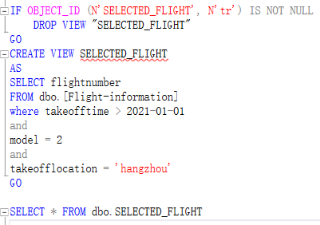
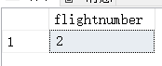

(2)用户可能需要查询价格小于200的保险(戴东晖）
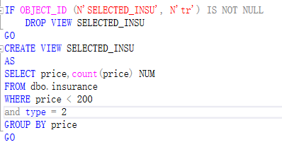
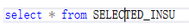
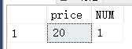
(3)创建实付金额视图（薛可欣）
因为在预订航班时,除了机票外,旅客还要考虑行李价格和保险以及平台折扣,公式为：实付金额=座位价格+行李价格+保险价格-折扣
if object_id(N' Final_price')is not null
drop view Final_price
go
create view Final_price(travellername,seatcost,offmoney,luggageprice,insuranceprice,finalprice)
as
select t.travellername,fs.seatcost,d.offmoney,l.overweightfee,i.price,fs.seatcost-d.offmoney+l.overweightfee+i.price as final
from discount d,Traveller t,[Flight-seat] fs,myOrder o,luggage l,insurance i
where d.offmoney in
(select d.offmoney
from Traveller t,discount d,myOrder o
where t.IDnumber= o.IDnumber and o.IDnumber=d.IDnumber)
and t.IDnumber=d.IDnumber
and o.seatID=fs.SeatID
and t.IDnumber= o.IDnumber
and l.IDnumber=t.IDnumber
and i.PaymentID=t.IDnumber
with check option;
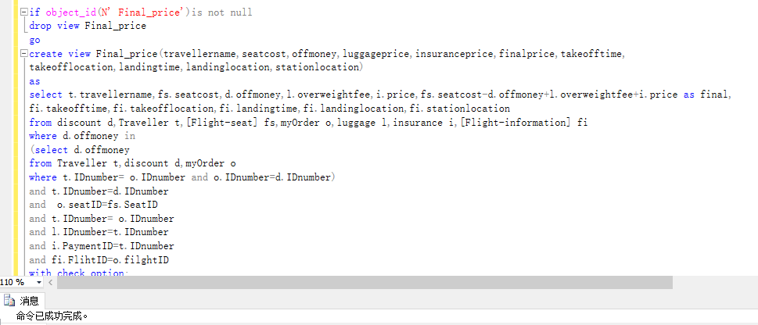

（4）未出行订单（薛可欣）
保存了用户未来要完成的订单。用户可以在平台上查询自己还没有完成的订单,了解未来乘机的相关信息
if object_id(N' Futureorders')is not null
drop view Futureorders
go
create view Futureorders(travellername,IDnumber,orderID,FlihtID,takeofftime,takeofflocation,landingtime,landinglocation,
stationlocation,finalprice,freebaggageallowance)
as
select t.travellername,t.IDnumber, o.orderID,fi.FlihtID,fi.takeofftime,fi.takeofflocation,fi.landingtime,
fi.landinglocation,fi.stationlocation,fp.finalprice,l.freebaggageallowance
from Traveller t,myOrder o,luggage l,[Flight-information] fi,Final_price fp
where t.IDnumber=o.IDnumber
and o.luaggageID=l.consignmentID
and o.filghtID=fi.FlihtID
and t.travellername=fp.travellername
and fi.landingtime>GETDATE()
with check option;
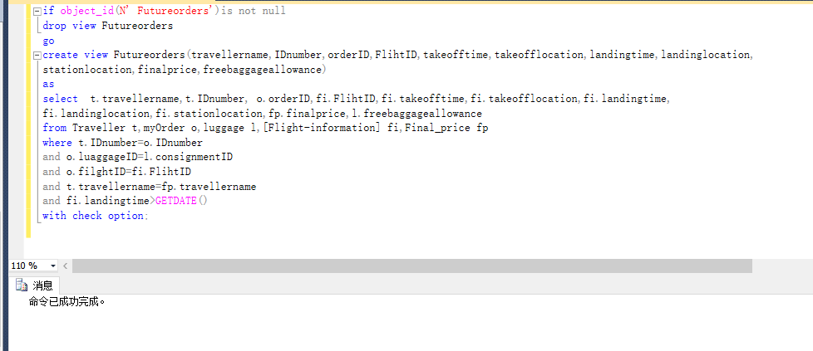
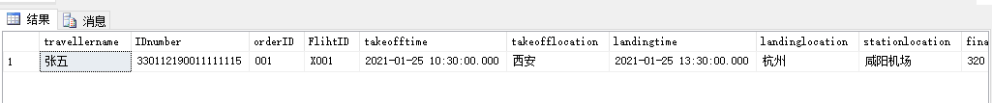
（5）历史订单（薛可欣）
保存了用户历史出行的消息
if object_id(N' Historyorders')is not null
drop view Historyorders
go
create view Historyorders(travellername,IDnumber,orderID,FlihtID,takeofftime,takeofflocation,landingtime,landinglocation,
stationlocation,finalprice,freebaggageallowance)
as
select t.travellername,t.IDnumber, o.orderID,fi.FlihtID,fi.takeofftime,fi.takeofflocation,fi.landingtime,
fi.landinglocation,fi.stationlocation,fp.finalprice,l.freebaggageallowance
from Traveller t,myOrder o,luggage l,[Flight-information] fi,Final_price fp
where t.IDnumber=o.IDnumber
and o.luaggageID=l.consignmentID
and o.filghtID=fi.FlihtID
and t.travellername=fp.travellername
and fi.landingtime<GETDATE()
with check option;
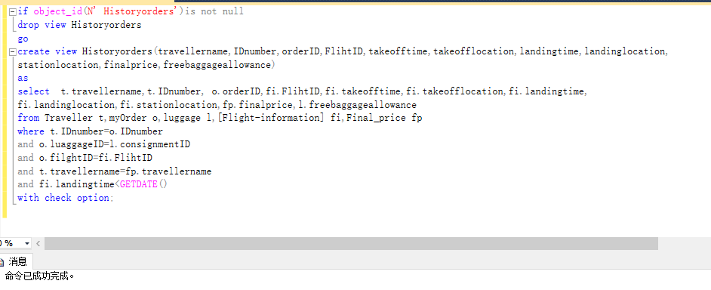
(6)管理员对航班进行查询、修改的管理员操作视图
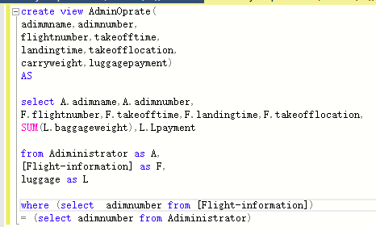

（7）查询航班座位信息（薛可欣）
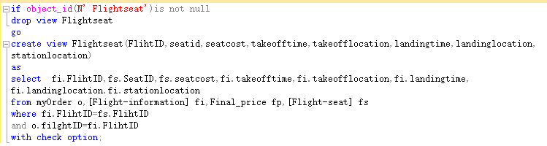

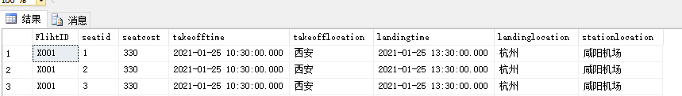
（8）查询座位id以及已选此座的个人信息（毛锐）
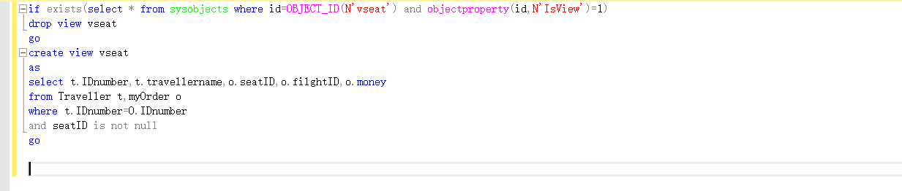

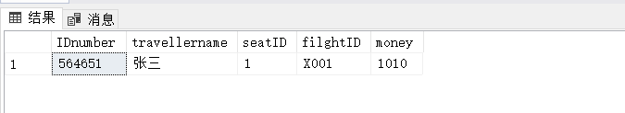

7.3存储过程或触发器的创建
存储过程
1.旅客在上飞机前可能需要托运行李,这时候可能需要插入行李的记录。（戴东辉）
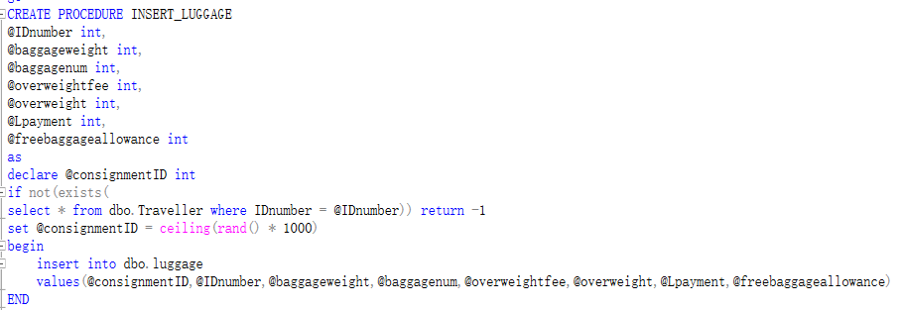
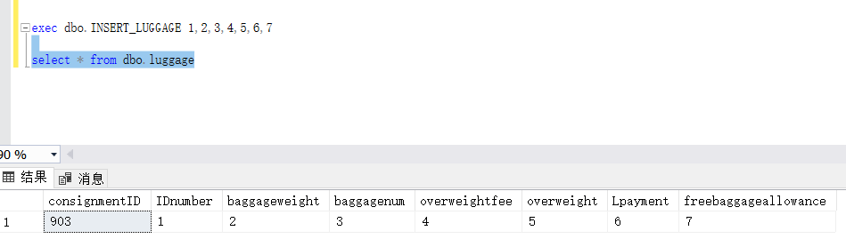

2.机票的价格经常变动,所以有时候需要涨价,使用游标在存储过程中修改机票价格,比如将 A001航班的座位价格提高20%（薛可欣）
if (exists(select * from sys.objects where name='updateseatcost'))
drop proc updateseatcost
go
create procedure updateseatcost
as
declare empcost cursor for
select fi.seatcost,fi.FlihtID
from [Flight-seat] fi
declare @increment decimal(5,1)
declare @thefid char(20)
open empcost
fetch next from empcost into @increment,@thefid
while(@@FETCH_STATUS=0)
begin
if @thefid='X001'
set @increment=0.1
else if @thefid='A001'
set @increment=0.2
update [Flight-seat]
set seatcost=seatcost*(1+@increment)
where FlihtID=@thefid
fetch next from empcost into @increment,@thefid
end
close empcost
deallocate empcost
go

exec updateseatcost
原先的价格：
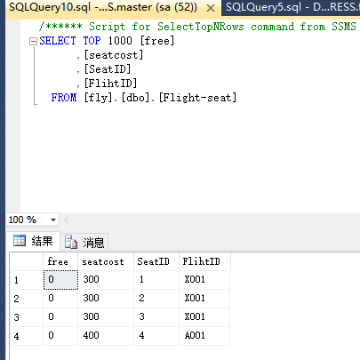
涨价之后的价格：
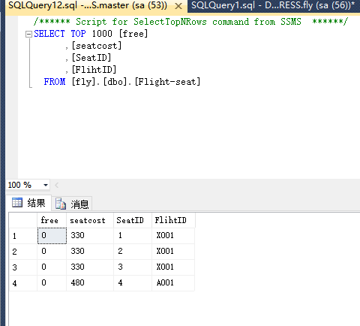

3.机票有时候也需要将降价,比如将A001的机票打九折（薛可欣）
if (exists(select * from sys.objects where name='updateseatcostdown'))
drop proc updateseatcostdown
go
create procedure updateseatcostdown
as
declare empcost cursor for
select fi.seatcost,fi.FlihtID
from [Flight-seat] fi
declare @increment float
declare @thefid char(20)
open empcost
fetch next from empcost into @increment,@thefid
while(@@FETCH_STATUS=0)
begin
if @thefid='A001'
set @increment=0.9
update [Flight-seat]
set seatcost=seatcost*@increment
where FlihtID=@thefid
fetch next from empcost into @increment,@thefid
end
close empcost
deallocate empcost
go

exec updateseatcostdown
原先的价格：

降价之后的价格：
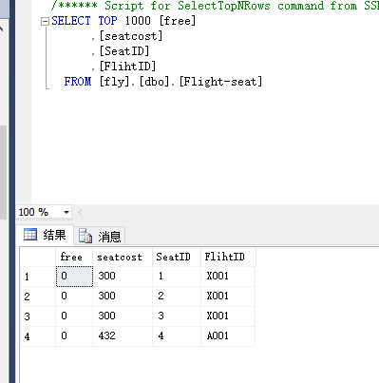

4.判断旅客是否存在,若存在,查询一个旅客参加了几个保险,还在有效期内的有几份（薛可欣）
if (exists(select * from sys.objects where name='trajoininsurance'))
drop proc trajoininsurance
go
create procedure trajoininsurance
@tra_id varchar(20)
as
declare
@tra_exist varchar(20),
@count varchar(20),
@count2 varchar(20)
select @tra_exist=count(*)
from Traveller t
where t.IDnumber=@tra_id
if @tra_exist=0
print @tra_id+ '不存在'
else
begin
select @count=count(*)
from Traveller t,insurance i
where @tra_id=i.PaymentID and t.IDnumber=@tra_id
if @count=0
begin
print @tra_id+'参加保险份数为'+@count
return 0
end
else
begin
select @count2=count(*)
from Traveller t,insurance i
where @tra_id=i.PaymentID and t.IDnumber=@tra_id and i.endtime>GETDATE()
print @tra_id+'参加保险份数为'+@count+' 其中还在有效期内的份数为 '+@count2
return @count
end
end

exec trajoininsurance @tra_id=330112190011111111
exec trajoininsurance @tra_id=330112190011111115

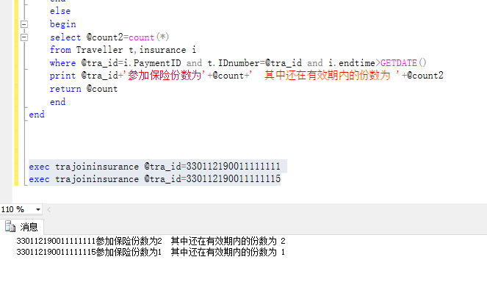
5.插入新的保险类型时,可以使用该存储过程。（戴东晖）
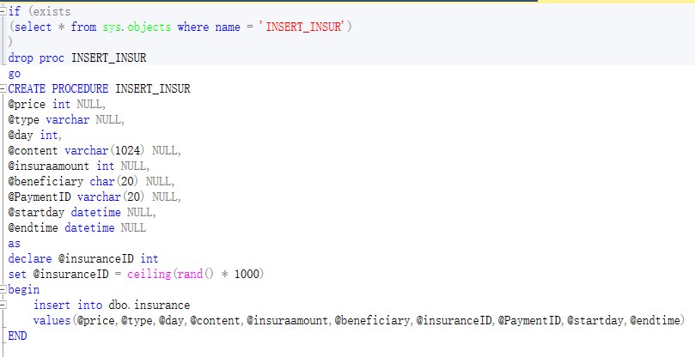
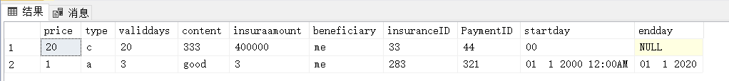

6.实现查询所有旅客信息（毛锐）

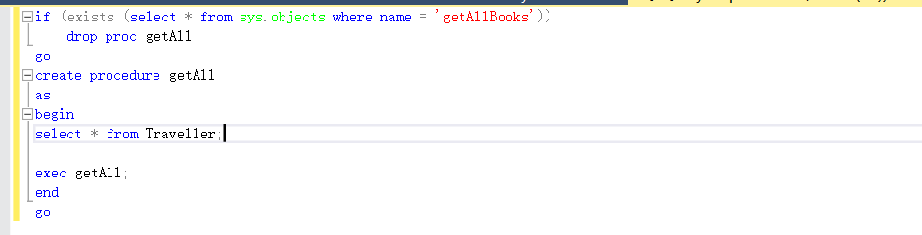
7.插入航班信息（戴东晖）
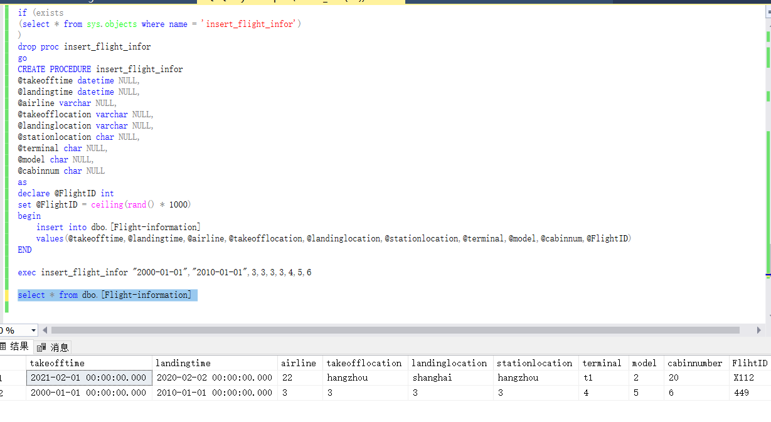
8.更新航班信息（戴东晖）
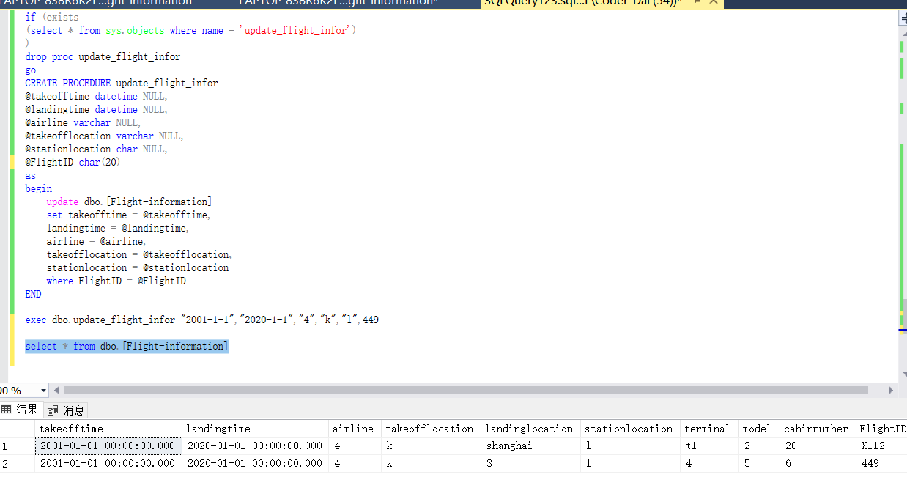

触发器
1.当更新某个用户的优惠券金额时,那么它的支付订单的金额也要改变。（戴东晖）
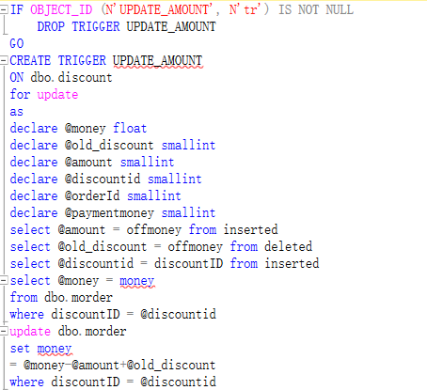

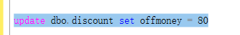
原来的(折扣金额为0)
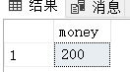
执行过后的
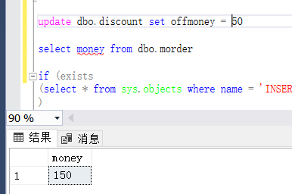

2.修改保险类型自动修改保险价格（毛锐）
create trigger tri_orderupdate
on insurance
for update
as
if update(type)
if (select type from inserted)='安全保险'
update insurance
set price=30
where insuranceID=(select insuranceID from inserted)
else if update(type)
if (select type from inserted)='延误保险'
update insurance
set price=20
where insuranceID=(select insuranceID from inserted)
else if update(type)
if (select type from inserted)='退票保险'
update insurance
set price=10
where insuranceID=(select insuranceID from inserted)

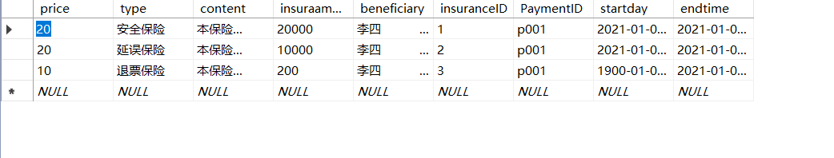
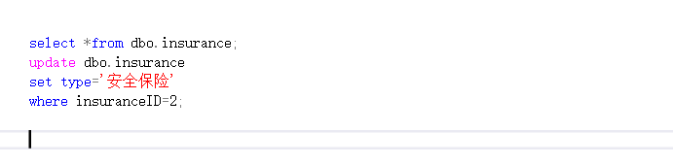
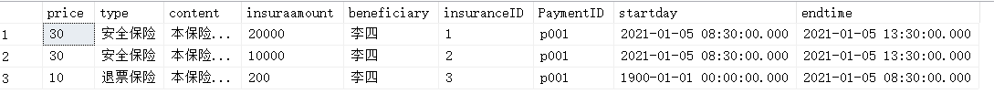
3.当删除优惠时,订单里的金额也需要更新。（戴东晖）
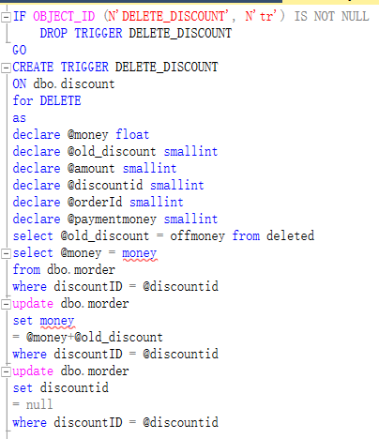
前:
后:

4.当用户购买超重行李额时,行李中的超重重量和订单中的金额也会随之改变（薛可欣）
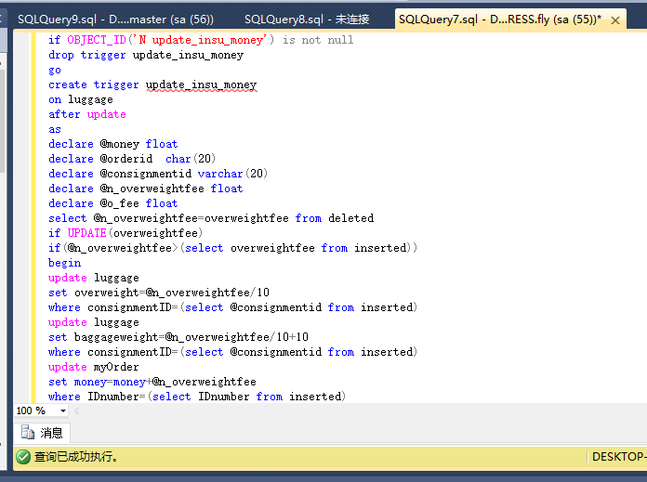
购买前
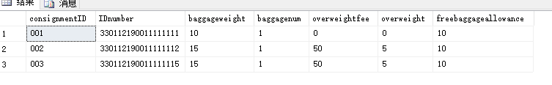
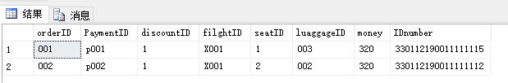
购买后
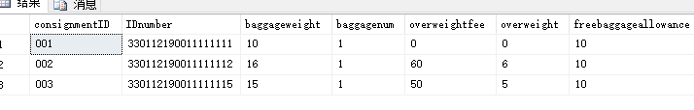
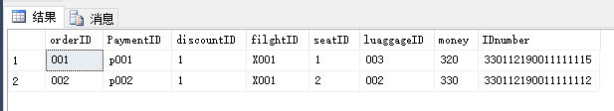
5.如果用户想注销账号,检测是否还有未完成订单,如果有则不能注销（薛可欣）
if OBJECT_ID('N deletetra') is not null
drop trigger deletetra
go
create trigger deletetra
on traveller
after delete
as
begin
if exists (
select *
from Futureorders
inner join deleted on Futureorders.IDnumber=deleted.IDnumber)
begin
print '有出行计划未完成,不能删除'
rollback transaction
end
end
go
delete Traveller where IDnumber='330112190011111113'
delete Traveller where IDnumber='330112190011111115'
注销前
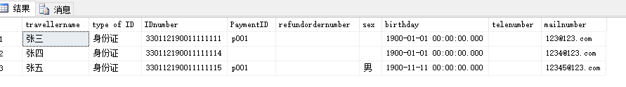

注销后
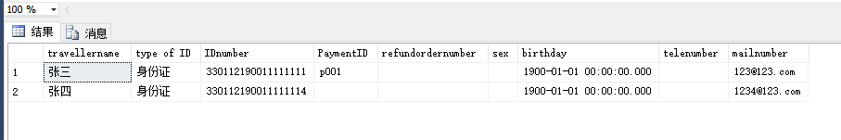
7.管理员修改相关信息后更新最后修改的管理员号（张琦智）
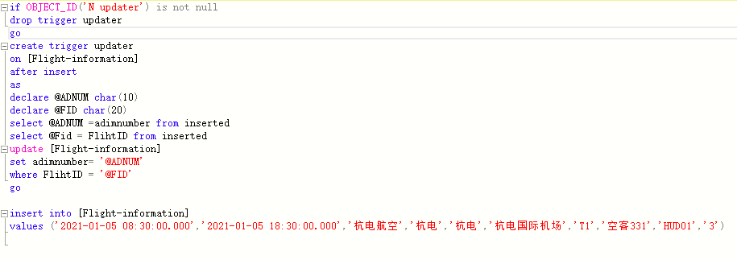
效果
8.管理员账号注销,账号密码置空,保留管理员编号（张琦智）
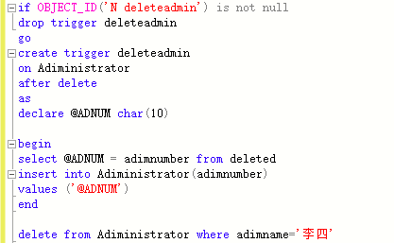
修改前
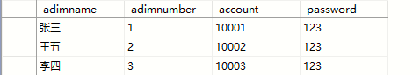
修改后
