Tracing Financialization in Critical Metal Markets: Correlations, Bubbles, and Dynamic Linkages
Barbara Będowska-Sójkaª* and Michał Kasperek^{b}
ªDepartment of Econometrics, Poznan University of Economics and Business, Poznan, Poland; ^{b}, Munich, Germany
*corresponding author: barbara.bedowska-sojka@ue.poznan.pl
Provide short biographical notes on all contributors here if the journal requires them.
Tracing Financialization in Critical Metal Markets: Correlations, Bubbles, and Dynamic Linkages
The global shift toward a net-zero economy has intensified demand for critical metals, namely copper, lithium, cobalt, and nickel, essential to clean energy technologies. This paper investigates the financialization of these metals, exploring the existence of bubbles and comovements of the price series. We use a comprehensive dataset spanning from July 2021 to July 2025 from multiple sources. To assess market integration and price dynamics, we apply correlation networks, detect bubbles in prices, test cointegration and estimate the dynamic conditional correlations. Results reveal varying degrees of financialization: copper exhibits mature, globally integrated markets with relatively coherent behaviour of prices from different sources, nickel demonstrates strong long-term relationships, lithium shows the strongest tendency to create bubbles, while the cobalt market is the least integrated out of these four. The study highlights different levels of financialization, with speculative trading playing a role in the less developed markets of lithium and cobalt. As demand accelerates, metal-related financial instruments are expected to proliferate, deepening market integration and liquidity.
Keywords: Critical metals, Financialization, Speculative bubbles, Market integration, Dynamic conditional correlations, Battery metals;
Subject classification codes: include these here if the journal requires them

Introduction
The transition to a net-zero emissions economy has become imperative in the face of climate change. Net-zero refers to the balance between the amount of greenhouse gases emitted into the atmosphere and the equivalent amount being removed, resulting in no net increase in overall greenhouse gas levels. Climate change and the global transition toward a net-zero economy increase the demand for some metals critical to this process and make the pricing and financialization of these new strategic assets ever more important. In this paper, we investigate the speculative and financial dynamics of four metals critical to the green transition - lithium, copper, cobalt, and nickel. Specifically, we address three interconnected questions: to what extent do speculative bubbles emerge in the price series of these metals, what are the long-run equilibrium relationships governing price dynamics within returns of different assets in each metal group, and what short-run co-movement patterns characterise the most liquid of these markets.
Over the past two decades, commodity markets have become an increasingly popular asset class in investment portfolios, often with limited connection to hedging physical exposures (Tang and Xiong, 2012; Cheng and Xiong, 2014; Restrepo et al., 2023a; Orhangazi, 2008). Given their central role in the traditional economy, energy commodities such as oil and gas have attracted considerable scholarly attention in the context of financialization and financial market integration Szafranek et al., 2023; Czudaj, 2019; Papież et al., 2022). By contrast, critical metal markets have received considerably less academic attention. While energy commodities such as oil and gas are well-established portfolio components, widely studied as hedges and safe havens (Al-Nassar et al., 2023; Ciner et al., 2013), and precious metals such as gold and silver are deeply integrated into financial markets (Zaremba, 2015; Mensi et al., 2022), the financialization of critical metals remains underexplored — and varies substantially across the four metals examined in this study. The limited availability of trading instruments for some of these metals likely contributes to a lower awareness of their price sensitivities and cross-asset dependencies. This paper tries to fill this gap.
We use price data drawn from multiple sources and exchanges, covering the period from July 2021 to July 2025. To capture the richness of each metal’s pricing landscape, we compile multiple price series per metal from exchanges, such as the London Metal Exchange, COMEX, and the Shanghai Futures Exchange, and other data providers. Our methodology combines several complementary approaches: we assess cross-metal correlations to identify the most interconnected price series, apply the GSADF test of (Phillips et al., 2015) to detect speculative bubbles, conduct cointegration tests to uncover long-term equilibrium relationships within each metal market, and estimate DCC models to track time-varying dynamics between the most correlated price pairs. Together, these methods allow us to evaluate the degree of market integration and the extent of financialization across these strategically important metals.
This study makes several contributions to the understanding of the financialization of critical metals, cobalt, copper, lithium and nickel. First, we provide a comprehensive comparative analysis by focusing on the existence of bubbles across these four metals using a unified methodological framework. By doing that, we address a gap in the literature that has largely focused on individual metals or traditional commodities (Wang et al., 2023; Restrepo et al., 2023a; Ozgur et al., 2021). Second, we gather and analyse multiple price series per metal from diverse sources, ranging from established exchanges to specialised data providers. This enables us to verify the foundational assumptions of the Law of one Price on these particular markets (Bertone et al., 2015), according to which commodity prices are perfectly arbitraged, at least in the long run (Ardeni (1989); Sarno et al. (2004)). Following Ardeni (1989), who verified the law of one price using a cointegration approach, we conduct the procedure for each metal series separately and show that the cointegration for particular metals varies. Additionally, we enrich the cointegration approach by including detected bubbles and verify how noise impacts the long-run relationship. Third, in addition to the analysis of long-run relationships, we also examine short-term dependencies. We estimate dynamic conditional correlations and examine their levels and whether they are stable over time. We find the highest correlations for copper, and the lowest for cobalt and lithium. Fourth, we examine an integration of particular series from our four markets by applying a network analysis. This allows us to indicate central and peripheral metals in the system, consisting of 16 series, four for each of the four metals. By combining these methods, we provide the empirical evidence of varying financialization levels across metals. We also shed light on how these markets transition from purely physical to financially integrated assets.
Our findings offer practical implications for investors, policymakers, and industry participants regarding pricing reliability, diversification potential, and arbitrage opportunities in the context of the global energy transition. The rest of the paper is organised as follows: Section 2 provides the literature review, Section 3 presents data and methodology, and Section 4 shows empirical results. Section 5 concludes the study.

Literature review
Financialization refers to the increasing role and influence of financial investors and instruments in commodity markets, and its intensity varies considerably across different commodities (Domanski and Heath, 2007). It manifests through several key features. First, prices increasingly decouple from fundamental supply and demand conditions, becoming more sensitive to macroeconomic factors, investor sentiment, and their correlation with traditional financial assets such as bonds and stocks (Cheng and Xiong, 2014; Basak and Pavlova, 2016. This dynamic tends to generate higher volatility than that observed in physical markets and can ultimately give rise to speculative bubbles. Second, the introduction of new asset classes, such as ETFs for metals, has allowed investors to gain exposure to metal markets without physically handling those metals (Orhangazi, 2008). The more actively ETFs and other financial instruments are issued for a given metal, the more advanced its financialization process becomes, bringing with it a greater presence of speculative investors and commodity futures indexes (Seddon, 2020). Third, the correlation between commodities — both spot and derivatives — and traditional equities tends to increase as financialization deepens (Tang and Xiong, 2012). Consequently, the price of a metal may surge or collapse not because of shifts in its own supply and demand fundamentals, but because it is being deployed by large financial players as a safe haven, a speculative instrument, or a tool for portfolio diversification (Tang and Xiong, 2012.
There is an ongoing debate about whether financialization distorts commodity prices and contributes to the formation of price bubbles. While some studies suggest that financial speculation can amplify price movements (Dufrénot et al., 2026; Schmidt, 2017), others argue that fundamental supply and demand effects can still predominate even in highly financialised markets (Guzmán and Silva, 2018; Alzahrani et al., 2014). At the same time, financialization can play a constructive role by providing liquidity to hedgers and improving risk sharing across markets. These constructive effects operate through mechanisms that directly bear on the Law of One Price, which posits that identical assets traded across different venues should converge to a single price once frictions are accounted for, with arbitrage serving as the primary enforcement mechanism (Ardeni, 1989; Bertone et al., 2015. Financialization tends to support this convergence by deepening liquidity, lowering transaction costs, and tightening the linkages between spot and futures prices, all of which accelerate arbitrage corrections and facilitate cross-market price alignment (Tang and Xiong, 2012). In the context of critical metals such as copper, nickel, cobalt, and lithium, this implies that growing financial investor participation may have strengthened the co-movement between price series sourced from different exchanges or benchmarks.
However, financialization also introduces forces that can systematically undermine the Law of One Price. When price movements are driven by financial flows, herding behaviour, or speculative episodes rather than physical supply and demand, cross-market price gaps may persist even in otherwise integrated markets (Sarno et al., 2004). Financialization reshapes traditional storage economics by injecting a financial premium into commodity pricing that does not respond to physical arbitrage in the conventional sense, and index-investor activity has been shown to affect spot prices and inventories in ways that decouple prices from fundamentals. These dynamics are particularly relevant for critical metals, where thin markets — especially in lithium and cobalt — amplify the distortionary potential of speculative capital. The explosive price episodes identified in these series may therefore reflect precisely such non-fundamental deviations. Periods in which financialization temporarily suspends the arbitrage logic underlying the Law of One Price, before mean reversion eventually reasserts long-run equilibrium.
The financialization of critical metals has received relatively limited scholarly attention, with existing studies varying considerably in scope, methodology, and data sources. Some studies focus on individual metals (Wojewska et al., 2024; Lyócsa et al., 2017; Restrepo et al., 2023b; Cortazar et al., 2024), while others examine several simultaneously (Restrepo et al., 2023a; Swarup and Kushwaha, 2023; Jiang et al., 2025; Ozgur et al., 2021. Data availability and quality represent a recurring challenge in this literature, particularly for less-established markets.
Boer et al. (2023) note that historical lithium data poses significant measurement problems, as the metal was not traded on public exchanges for an extended period, resulting in a more complex pricing structure compared to metals like copper and nickel. Li et al. (2023) similarly highlights the inconsistency of trusted data sources across metals, a challenge that is especially pronounced for cobalt and lithium.
Studies examining multiple metals simultaneously reveal important patterns of market integration. Restrepo et al. (2023b) find that copper and lithium exhibit higher levels of market integration than nickel and cobalt, as reflected in stronger connectedness indices and price co-movements. .Jiang et al. (2025) document a long-term equilibrium between oil prices and critical metal prices, suggesting that these markets are increasingly integrated into the broader commodity landscape. Su et al. (2023) indicate that although low lithium prices negatively impact oil prices, the status of oil cannot be underestimated.
The role of speculation has also attracted attention. Romani and Casoli (2024) find that demand for certain critical metals is partly driven by speculative trading rather than actual industry needs, and identify the Global Financial Crisis of 2007/08 as a significant driver of price disruption across these markets. In this aspect, we should mention the extreme nickel price spike in March 2022, which was caused by the Ukrainian-Russian conflict and led to the short squeeze and the LME nickel suspension (Malhotra et al., 2026).
Taken together, the existing literature reveals pronounced heterogeneity across critical metals in terms of data availability, market structure, and degree of financialization — with copper being the most developed and liquid, while lithium, cobalt, and nickel present distinct challenges. This heterogeneity underscores the need for a unified comparative framework, which this study aims to provide.

Data and Methodology

Data
Metal markets differ fundamentally from equity, bond, or cryptocurrency markets in that they involve the trading of physical commodities or derivatives based on them, primarily futures and options. Trading occurs on major commodity exchanges such as the London Metal Exchange (LME), COMEX (the Commodity Exchange operated by the CME Group), and the Shanghai Futures Exchange (SHFE), as well as through over-the-counter markets and bilateral contracts. Both the LME and COMEX report Fastmarkets prices, the independent assessments used in physical spot and forward contracts but they differ in geographic focus. The LME has been the global benchmark for physical trades, while COMEX has served as a US-centric, financially oriented market often used for speculative hedging. Recently, the LME has also provided financial instruments such as forwards for cobalt or lithium hydroxide. The SHFE is a leading futures exchange in China, specialising in domestic metal contracts, with copper futures among the largest in the world. The additional source of metal prices are: (1) the Shanghai Metals Market (SMM), which is a leading Chinese metals market information provider and research company, (2) the Wuxi Stainless Steel Exchange (henceforth WUXI) which publishes price assessments based on the Chinese market and quotes them in USD per metric ton, and (3) Antaike (antaike.com), a leading Chinese metal information provider. Beyond direct exposure via physical delivery or futures contracts, investors can also access metal markets through ETFs, which track the performance of a commodity index or basket without requiring physical handling.
Among the four metals, copper-related financial instruments have the longest history of trade, followed by nickel. The instruments based on lithium and cobalt are relatively new, with the first ones launched in 2021. These differences are reflected by data quality and availability. As Boer et al. (2023) note, the absence of exchange-based trading for lithium over an extended historical period has resulted in a fragmented and inconsistent pricing record. Li et al. (2023) similarly highlights the lack of standardised data sources across critical metals, necessitating reliance on specialised databases and regional market reports for certain series.
In order to address the question of the stage of financialization of different metals, we gathered four price series per metal from a range of sources, covering the period from 2021-07-19 to 2025-07-21. Copper is the most accessible and liquid, with well-established spot and futures contracts available on the London Metal Exchange (LME), COMEX, Shanghai Metals Market (SMM), and the Shanghai Futures Exchange (SHFE). Nickel and cobalt are also tradable on the LME through both physically settled and cash-settled contracts, though physical delivery occurs in only a small fraction of cobalt contracts in practice. In the case of nickel, we utilise LME forward contracts, the SHFE future prices, as well as the WUXI futures. For cobalt, we gather prices from the LME, COMEX, and WUXI. Lithium presents the most complex case. It exists in three distinct product forms - spodumene, lithium carbonate, and lithium hydroxide - of which the latter two are most relevant for battery production (Wang et al., 2023). Also, it is not tradable as a physical asset on the LME, and cash-settled futures for lithium hydroxide have only been available since July 2021. Thus, we utilise the COMEX, LME and Antaike hyfroxide prices. Additionally, for each metal, we use data from a single source, dailymetalprice.com, an independent data provider. This multi-source approach allows us to assess data consistency across providers and identify the leading series for each metal. A summary of all series and their sources is provided in Table 1.
INSERT TABLE 1 ABOUT HERE

In the next steps, we utilise either logarithms of metal prices or logarithmic returns. Table 2 provides the descriptive statistics for the daily log returns of four groups of critical metals: cobalt (CO), copper (CU), lithium (LI), and nickel (NI).
Across all metals, the mean daily returns are close to zero or slightly negative, which reflects the general market tendency between July 2021 and July 2025. The highest volatility is observed in the lithium series LIDALY, which has a standard deviation of 4.6%. In contrast, copper returns are generally the least volatile, particularly the CUSHFE series, which has the lowest standard deviation in the sample (0.9%). Nickel exhibits consistently high volatility across its series, with the standard deviations for NILMEX and NIDALY reaching 2.8%.
The minimum and maximum values reveal the presence of extreme daily movements in all markets. Notably, the lithium series LIDALY recorded both the largest positive daily return (81.4%) and the most significant single-day loss (-98.6%). The nickel market also experienced massive price spikes, with NILMEX and NIDALY showing maximum daily returns of 50.8% and 42.3%, respectively.
The interquartile ranges (Q1 to Q3) for several cobalt and lithium series (specifically COCOMX, CODALY, LICOMX, and LILMEX) are notably narrow, with the 25th and 75th percentiles rounding to zero. This suggests frequent periods of zero price change, which is strongly corroborated by the last column (ZeroPct) showing the percentage of zero returns in the whole sample. For these specific assets, the proportion of zero returns is exceptionally high, ranging from 64.3% (LILMEX) to 87.7% (CODALY). As ZeroPct serves as a proxy for liquidity, its higher values indicate thin markets where price discovery is frequently interrupted by a lack of transactions . In contrast, the copper and nickel series, along with the COWUXI and LIDALY series, show much lower ZeroPct values and wider, more symmetric interquartile ranges, consistent with more continuously traded and liquid markets.
INSERT TABLE 2 ABOUT HERE

Methods
The methodology proceeds in four steps, each addressing a distinct aspect of metal market financialization. We begin by examining unconditional correlations among the price series within each metal market separately. To facilitate interpretation, we visualise these correlations using a network representation, in which each node corresponds to one price series and each edge reflects the pairwise correlation between two series. As a centrality measure, we apply strength, defined as the sum of all correlations associated with a given node. Series with higher strength are more interconnected within the system. Edge width in the visualisation is proportional to the magnitude of the correlation. This step serves a dual purpose: it reveals the integration structure within each metal’s pricing landscape and allows us to identify the most representative series for subsequent analysis.
To detect speculative bubbles in the price series, we apply the recursive unit root testing framework of . The idea is to detect bubbles by identifying periods of explosive price behaviour through a right-tailed ADF test:
$$Δ y_{t} = μ + δ y_{t-1} + ε_{t}, ε_{t} ∼ N\left(0, σ^{2}\right)$$
where the null hypothesis assumes a random walk ($H_{0}:δ=0$), and the alternative hypothesis assumes an explosive autoregressive process ($H_{1}:δ>0$). The earlier Supremum ADF (SADF) test of Phillips et al. (2011) introduced an expanding window approach but remains susceptible to the swamping effect, whereby historical volatility or large price collapses can obscure subsequent bubble episodes. The Generalised SADF (GSADF) test addresses this by employing a double-recursive windowing mechanism that varies both the start and end points of the estimation subsample, allowing the model to identify multiple bubble cycles within a single time series. To ensure reliable inference, the algorithm imposes a minimum window size, typically set as $r_{0}=0.01+1.8/\sqrt{T}$ providing a robust basis for date-stamping the origination and termination of exuberant market phases.
Next, we examine long-run relationships among the price series using the Johansen vector cointegration test. The underlying idea is that, even if individual series follow random walks, a linear combination of them may remain stable over time, pointing to the existence of a long-run equilibrium. Two series are considered cointegrated if they drift together such that their linear combination — commonly referred to as the error term — is stationary, implying that any short-run deviations are temporary and self-correcting. In this context, the absence of cointegration between price series representing the same metal can be interpreted as a signal of accelerating financialization, suggesting that different pricing sources are increasingly driven by financial rather than fundamental forces. For the cointegration analysis, all daily price series were transformed using natural logarithms. The optimal lag length for the underlying Vector Autoregressive (VAR) models was determined separately for each pair using the Akaike Information Criterion (AIC), with a maximum of 10 lags, and applied consistently to both the baseline model and the extended model containing exogenous dummy variables.
The Johansen procedure relies on the maximum likelihood estimation of a Vector Error Correction Model (VECM). To accommodate the exogenous structural dummies, the VECM is specified as:
$$Δy_{t}=Πy_{t-1}+\sum_{i=1}^{p-1}{Γ_{i}Δy_{t-i}}+ΦD_{t}+μ+ϵ_{t}$$
where $y_{t}$ is a $k ×1$ vector of endogenous non-stationary variables, $Δ$ is the first difference operator, $Γ_{i}$ represents the coefficient matrices for the short-term dynamics, and $ϵ_{t}$ is a vector of white noise error terms. Following standard practice for financial price series, the model was specified with a restricted constant ($μ$), allowing for an intercept in the cointegrating equation but no linear trend in the data. The matrix $D_{t}$ contains the strictly exogenous structural dummies representing explosive bubble periods; dummies for series exhibiting no bubble episodes were excluded to prevent perfect multicollinearity.
The essential component of this model is the $k × k$ coefficient matrix $Π$, which conveys information regarding the long-run cointegrating relationships. If the rank of $Π$ is $r$ (where $0 < r < k$), it can be decomposed into two $k ×r$ matrices, $α$and $β$, such that $Π=αβ^{'}$. Here, $β$ represents the matrix of long-run cointegrating coefficients, and $α$ serves as the adjustment matrix dictating the speed at which the system returns to equilibrium. To test for long-run market integration and formally determine the number of cointegrating vectors ($r$), we employed the Johansen Trace statistic:
$$J_{\text{trace}}\left(r\right)=-T\sum_{i=r+1}^{k}{\ln\left(1-\hat{λ_{i}}\right)}$$
where $T$ is the sample size and $\hat{λ_{i}}$ is the $i-$th largest estimated eigenvalue of the matrix $Π$. The Trace statistic tests the null hypothesis of $r$ cointegrating relations against the alternative of $k$ cointegrating relations (a fully stationary system).
Finally, we employ the Dynamic Conditional Correlation GARCH model of to examine time-varying linkages between price series. The model assumes that the return process $r_{t}$, conditional on the information set $F_{t-1}$, follows a multivariate normal distribution with mean zero and conditional covariance matrix${ H}_{t}$, decomposed as:
$$H_{t}=D_{t}R_{t}D_{t}$$
where $D_{t}$ is a diagonal matrix of conditional standard deviations estimated from univariate GARCH processes, while $R_{t}$ is the time-varying correlation matrix. This separation allows individual asset volatility to be modelled before estimating cross-asset dependencies. The dynamics of $R_{t}$ are governed by a proxy matrix$Q_{t}$:
$$Q_{t}=\left(1-α-β\right)\overline{Q}+αz_{t-1}z_{t-1}^{'}+βQ_{t-1}$$
where $z_{t}=D_{t}^{-1}r_{t}$ are standardised residuals, $\overline{Q}$is their unconditional covariance matrix, and the scalar parameters $α$ and $β$ capture the impact of short-term innovations and correlations persistence, respectively. These parameters must be non-negative and satisfy the stationarity condition $α+ β< 1$. The correlation matrix is recovered as
$$R_{t}=\text{diag}{\left(Q_{t}\right)}^{-1/2}Q_{t}\text{diag}{\left(Q_{t}\right)}^{-1/2}$$
ensuring all entries remain within $<-1,1>$. Rising and increasingly persistent dynamic correlations between return series of the same metal would suggest growing co-movement driven by financial rather than fundamental forces.

Empirical results

The correlation network
The network shown in Figure 1 allows us to visualise the strength of connections between different metals. The network visualises the market integration and segmentation across the 16 commodity series. The graph is constructed using a force-directed layout algorithm (Fruchterman-Reingold), which pulls highly correlated assets together while pushing independent assets apart. Edge thicknesses reflect the connection strength, derived from the inverse Euclidean distance of the correlation matrix. Node size is proportional to network centrality (strength), indicating the asset’s overall connectivity within the system. Node fill denotes the commodity group: copper (light grey), nickel (dark grey), lithium (medium light grey), and cobalt (white). Weak correlations (lower than the 75th percentile) are thresholded out to emphasise structurally strong linkages.
The network topology vividly illustrates a core-periphery structure within the analysed markets, though with notable intra-group dynamics and linkages. Traditional industrial metals, specifically copper (e.g., CUCOMX, CULMEX) and nickel (e.g., NILMEX, NIDALY) benchmarks, form a dense, highly interconnected core positioned at the top of the network. This central cluster is characterised by substantially larger node sizes and thick edges, confirming the efficient price transmission and strong integration of these assets. In contrast, the battery metals (lithium and cobalt) are relegated to the periphery of the network at the bottom and outer edges. However, rather than being completely unstructured, they exhibit distinct sub-cluster connectivity. For instance, there are notably thick edges connecting specific markets, such as the strong link between COLMEX and CODALY, as well as an isolated pairing between LILMEX and LICOMX. Their node sizes are visibly smaller than those of copper and nickel, reflecting their lower centrality and prominence in the broader commodity complex. Furthermore, while these battery metals are heavily segmented, they do not operate entirely independently of the core. Certain nodes act as fragile bridges; for example, LIDALY displays a visible connection back to the nickel cluster via NIDALY. Conversely, other nodes like LIANTH and COWUXI appear almost entirely isolated. This suggests that while lithium and cobalt are significantly driven by idiosyncratic factors and regional fragmentation, specific benchmarks still maintain a minimal, measurable degree of integration with the broader industrial metals market.
INSERT FIGURE 1 ABOUT HERE

Speculative bubbles
In the next step, we conduct the bubble detection test. The results of the GSADF test on all series are presented in Table 3, which shows the number of days in the bubble period and the number of bubbles. The frequency and duration of upward speculative bubbles vary significantly across the analysed metals and exchanges. Lithium exhibits the most pronounced explosive behaviour. The LIANTH series stands out with the highest total duration of 105 days across 4 distinct episodes, while LIDALY and LILMEX also show substantial bubble activity (95 and 90 days, respectively). Cobalt is the second market most prone to speculative bubbles, particularly on the COWUXI and COLMEX series, which recorded the highest frequency of episodes (7 and 4 bubbles, totalling 70 and 68 days, respectively). Conversely, the copper and nickel markets demonstrate remarkable stability with very limited explosive upward dynamics. Copper is the least prone to bubbles; the CUCOMX and CUDALY series experienced absolutely no upward bubble episodes, and CULMEX recorded a negligible duration of just 2 days. Similarly, while the nickel series each recorded 1 or 2 bubble episodes, these were extremely short-lived, with the total duration ranging merely from 2 to 10 days across the entire analysed period.
INSERT TABLE 3 ABOUT HERE
Figure 2 shows the dynamics of the price process and periods in which bubbles are detected.
INSERT FIGURE 2 ABOUT HERE

Cointegration - Johansen method
In the next step, we conduct the cointegration tests for each of the four metal series. If the prices of a given metal are not cointegrated, this might be a sign of market fragmentation or financialization. Table 4 shows the results of the Johansen test for vector cointegration. To fully understand the market dynamics, we conducted the test twofold: first, using the raw data, and second, by filtering out the impact of speculative bubbles. To filter the raw series, we use a dummy variable for bubble episodes as an exogenous variable.
Looking first at the raw data, the results reveal varying levels of integration across the metals and highlight clear price discovery leaders. Cobalt shows a cointegration rank of $r=2$, while lithium and nickel are the most highly integrated with $r=3$. Copper appears to be the most fragmented market in its raw state, with a rank of only $r=1$. By analysing the $α$ coefficients, which indicate the speed of adjustment toward the long-run equilibrium, we can identify which markets lead and which follow. The follower has the highest absolute adjustment speed (Max $α$), while the leader has the slowest (Min $α$). In the raw data, a more nuanced pattern emerges: Chinese physical markets and specific trading platforms act as price leaders, while other financial exchanges and daily benchmarks act as followers. Specifically, COCOMX leads the cobalt market, NISHFE leads nickel, and CUSHFE and LIDALY lead copper and lithium, respectively. Conversely, regional daily benchmarks (CODALY and CUDALY) act as the followers chasing the leaders for cobalt and copper, while COMEX (LICOMX) and the LME (NILMEX) chase the lithium and nickel markets. This suggests that without accounting for speculative noise, price discovery dynamics are highly metal-specific rather than universally dominated by either physical or financial markets.
When we filter the models by introducing the exogenous bubble variable, the underlying market dynamics become clearer, and the distorting impact of speculative episodes is exposed. For cobalt, the formal cointegration rank remains unchanged at $r=2$, but the trace statistic for $r≤1$ increases notably (from 37.76 to 40.49). This indicates that filtering out speculative noise pushes the cobalt market toward stronger underlying integration. Furthermore, accounting for bubbles confirms the stability of its price discovery structure: COCOMX remains the clear long-term leader, and CODALY remains the follower, though the follower’s overall speed of adjustment increases notably (from -0.169 to -0.244). For nickel, while the rank remains $r=3$, the trace statistic for $r=0$ more than doubles (jumping from 129.82 to 302.28). This suggests that nickel’s underlying integration is incredibly strong but is being heavily suppressed by speculative noise. Additionally, the adjustment speed for the follower (NILMEX) increases dramatically from -0.098 to -0.334. This means that once the bubble noise is removed, the LME nickel price corrects toward the common trend more than three times faster. In contrast, copper and lithium show only minor changes between the raw and filtered models, maintaining their original ranks ($r=1$ and $r=3$, respectively). This confirms earlier findings that copper is a highly financialised and liquid metal; its price discovery mechanism is so robust that speculative bubbles cannot obscure its long-run cointegration. For lithium, the fact that filtering for bubbles did not drastically alter its high integration rank suggests that its market structure is not primarily distorted by speculation. Instead, its price discovery is likely driven by physical or structural factors, such as specific chemical grades, long-term bilateral contracts, and the lack of a single dominant global benchmark.
INSERT TABLE 4 ABOUT HERE

Dynamic Conditional Correlation Models
In this section, we present results from the dynamic conditional correlation (DCC) models. The analysis reveals distinct patterns of market integration and decoupling across metals. Due to the limited liquidity of lithium and cobalt-related instruments, we estimate models for copper and nickel, which are high-liquidity markets.
The copper-based assets exhibit a stark contrast between Western and Asian exchange integration. Correlations for pairs such as CUCOMX–CULMEX and CUDALY–CUCOMX demonstrate high levels of integration, consistently fluctuating above the 0.8 threshold. This suggests efficient price discovery and robust arbitrage mechanisms between the London Metal Exchange (LME) and the CME Group (COMEX). Conversely, correlations involving the Shanghai Futures Exchange (CUSHFE) are significantly lower and more volatile, primarily ranging between 0.0 and 0.4. This indicates a degree of regional decoupling, likely driven by Chinese regulatory frameworks, export duties, and distinct local supply-demand fundamentals.
INSERT FIGURE 3 ABOUT HERE

The Nickel market displays higher sensitivity to liquidity shocks compared to Copper. While the NIDALY–NILMEX pair typically maintains high correlation, it experienced a profound collapse (dipping below 0.0) during the late 2022 to early 2023 period. This anomaly likely reflects the extreme volatility and liquidity crises that characterised the Nickel market during that timeframe. Correlations between Asian benchmarks (NISHFE, NIWUXI) remain moderate and unstable, further suggesting that Nickel price transmission is less efficient than that of Copper across global borders.
INSERT FIGURE 4 ABOUT HERE

A robust DCC-GARCH estimation for the lithium and cobalt series is precluded by the inherent characteristics of their respective data. Both markets are characterised by low trading frequency and a high incidence of zero-return days. These properties resulted in a computationally singular covariance matrix. The lack of sufficient price movement prevented the log-likelihood function from reaching convergence. Consequently, to maintain the statistical integrity of the multivariate analysis, these commodities were excluded from the dynamic correlation framework in favour of more liquid benchmarks.
To complement the intra-metal analysis, a multivariate cross-commodity DCC-GARCH framework is employed to investigate the dynamic linkages among the four one-source benchmarks: copper (CUDALY), nickel (NIDALY), lithium (LIDALY), and cobalt (CODALY). The primary objective of this approach was to test for the existence of a unified energy transition asset class and to evaluate whether macroeconomic shocks spillover symmetrically across both mature and emerging industrial metals. We estimate the GARCH-DCC model for these four series.
INSERT FIGURE 5 ABOUT HERE

The empirical results reveal a profound degree of market segmentation within the commodity sector. As shown in Figure 5, the pairing of traditional base metals (copper and nickel) exhibits a robust and highly dynamic conditional correlation, confirming their shared sensitivity to global macroeconomic cycles, interest rate fluctuations, and broader financial market sentiment. In stark contrast, all cross-commodity pairs involving lithium and cobalt display flat correlation trajectories that persistently oscillate around zero.
These near-zero correlations yield a critical economic insight: lithium and cobalt remain fundamentally disconnected from the broader macro-financial cycle. This pronounced lack of "financialization" suggests that the pricing mechanisms in these emerging markets might be almost entirely driven by idiosyncratic, localised supply-chain disruptions and specific industry policies (e.g., EV subsidy shifts), rather than systemic global trends. Consequently, these findings highlight that the battery metals sector has not yet integrated into the traditional commodity market. From a portfolio management perspective, this orthogonal pricing behaviour implies that lithium and cobalt offer substantial diversification benefits against traditional industrial commodities.

Conclusions
The accelerating global commitment to clean energy technologies, particularly the widespread adoption of electric vehicles (EVs) and the expansion of renewable energy storage solutions, has profoundly reshaped the demand landscape for specific mineral commodities. Lithium, copper, nickel, and cobalt stand out as indispensable materials in this energy transition, making their market dynamics, price formation, and supply chain stability subjects of intense academic and industrial scrutiny.
In this paper, we detected bubbles in four price series for each of the four metals under study, after which we examined both the long-run and short-run dynamics within each metal group. Long-run equilibrium relationships are assessed through cointegration analysis applied to the full cross-section of all four metals, while the short-run analysis of dynamic conditional correlations (DCC-GARCH) is restricted to copper and nickel. All analyses are conducted at a daily frequency to maintain consistency with the bubble detection process. However, this choice also exposes a structural limitation of lithium and cobalt markets: their thin trading characteristics produce a high frequency of zero returns at the daily interval, which introduces numerical singularities during multivariate GARCH estimation that would bias dynamic correlation results. The superior liquidity and continuous price discovery mechanisms of copper and nickel make these markets the appropriate scope for the short-run DCC analysis, while long-run equilibrium relationships are robustly estimated for all four metals.
Growing demand pressures are expected to spur the development of new financial instruments tied to these metals, with consequent gains in market integration and liquidity. This research contributes to the limited literature on critical metal financialization and underscores their strategic importance in the green transition. Our findings offer practical insights for investors and policymakers, emphasising the need for reliable pricing sources and the potential for arbitrage and portfolio diversification.

Acknowledgment
We acknowledge financial support from the National Science Centre, Poland, under grant no. 2024/53/B/HS4/03300 for the project titled ’Critical Metal Pricing Dynamics in the Transition to a Net Zero Economy: Exploring Financial Market Interdependencies’.
We want to express our gratitude to the participants of the 2nd Modern Finance Conference in Warsaw, Poland (2025) and the SAFA Conference in Cape Town, South Africa (2026) for their valuable suggestions and comments.
The authors used Claude (Sonnet 4.5, Anthropic) to assist with language editing and proofreading of the manuscript. The tool was applied to improve the clarity, flow, and grammatical accuracy of the text. Additionally, Claude and Google Gemini 3.1 Pro were used to assist with the development and debugging of code written in R and Python. All scientific content, interpretation of results, and conclusions remain solely the work of the authors.

Conflict of interest
There are no relevant financial or non-financial competing interests to disclose.

References
Al-Nassar, N. S., Boubaker, S., Chaibi, A., and Makram, B. (2023). In search of hedges and safe havens during the COVID19 pandemic: Gold versus Bitcoin, oil, and oil uncertainty. The Quarterly Review of Economics and Finance, 90:318–332.
Alzahrani, M., Masih, M., and Al-Titi, O. (2014). Linear and non-linear granger causality between oil spot and futures prices: A wavelet based test. Journal of International Money and Finance, 48:175 – 201
Ardeni, P. G. (1989). Does the law of one price really hold for commodity prices? American Journal of Agricultural Economics, 71(3):661–669.
Basak, S. and Pavlova, A. (2016). A Model of Financialization of Commodities. The Journal of Finance, 71(4):1511–1556.
Bertone, S., Paeglis, I., and Ravi, R. (2015). (how) has the market become more efficient? Journal of Banking Finance, 54:72–86.
Boer, L., Pescatori, A., and Stuermer, M. (2023). Energy transition metals: Bottleneck for net-zero emissions? IMF Working Paper 23/217, International Monetary Fund.
Będowska-Sójka, B. (2021). Is liquidity wasted? The zero returns on the Warsaw Stock Exchange. Annals of Operations Research, 297:37–51. Special Issue: Networks and Risk Management.
Cheng, I.-H. and Xiong, W. (2014). Financialization of commodity markets. Annual Review of Financial Economics, 6:419–41.
Ciner, C., Gurdgiev, C., and Lucey, B. M. (2013). Hedges and safe havens: An examination of stocks, bonds, gold, oil and exchange rates. International Review of Financial Analysis, 29:202–211.
Cortazar, G., Enberg, M. V., and Ortega, H. (2024). Forecasting commodity prices using futures: The case of copper. In COnference Proceedings: European Financial Management Association 2025.
Czudaj, R. L. (2019). Crude oil futures trading and uncertainty. Energy Economics,
80:793–811.
Domanski, D. and Heath, A. (2007). Financial investors and commodity markets. Bank of International Settlements Quarterly Review, pages 53–67.
Dufrénot, G., Ginn, W., and Pourroy, M. (2026). Climate change impacts on commodity price stability through changing enso patterns. World Development, 197.
Engle, R. (2002). Dynamic conditional correlation: A simple class of multivariate generalized autoregressive conditional heteroskedasticity models. Journal of Business & Economic Statistics, 20(3):339–350.
Guzmán, J. I. and Silva, E. (2018). Copper price determination: fundamentals versus non-fundamentals. Mineral Economics, 31(3):283 – 300.
Jiang, Z., Dong, X., and Yoon, S.-M. (2025). Impact of oil prices on key energy mineral prices: Fresh evidence from quantile and wavelet approaches. Energy Economics, 145:108461.
Li, X., Sengupta, T., Si Mohammed, K., and Jamaani, F. (2023). Forecasting the lithium
mineral resources prices in China: Evidence with Facebook Prophet (Fb-P) and Artificial Neural Networks (ANN) methods. Resources Policy, 82:103580.
Lyócsa, , Molnár, P., and Todorova, N. (2017). Volatility forecasting of non-ferrous metal futures: Covariances, covariates or combinations? Journal of International Financial Markets, Institutions and Money, 51:228–247.
Malhotra, P., Kumar, S., Gubareva, M., and Mendes, J. Z. (2026). Dynamic nexus of clean energy metals, energy commodities and traditional assets: Multidimensional techniques and portfolio analysis. Research in International Business and Finance, 81:103182.
Mensi, W., Vo, X. V., and Kang, S. H. (2022). Upward/downward multifractality and efficiency in metals futures markets: The impacts of financial and oil crises. Resources Policy, 76:102645.
Orhangazi, (2008). Financialization and the US Economy. New directions in modern economics series. Edward Elgar Publishing, Cheltenham, UK.
Ozgur, O., Yilanci, V., and Ozbugday, F. C. (2021). Detecting speculative bubbles in metal prices: Evidence from gsadf test and machine learning approaches. Resources Policy, 74:102306.
Papież, M., Rubaszek, M., Szafranek, K., and Śmiech, S. (2022). Are European natural gas markets connected? A time-varying spillovers analysis. Resources Policy, 79:103029.
Phillips, P. C., Shi, S., and Yu, J. (2015). Testing for multiple bubbles: Historical episodes of exuberance and collapse in the s&p 500. International Economic Review, 56(4):1043–1078.
Phillips, P. C. B., Wu, Y., and Yu, J. (2011). Explosive behavior in the 1990s nasdaq: When did exuberance escalate asset values? International Economic Review, 52(1):201–226.
Restrepo, N., Ceballos, J. C., and Uribe, J. M. (2023a). Risk spillovers of critical metals firms. Resources Policy, 86:104135.
Restrepo, N., Uribe, J. M., and Guillen, M. (2023b). Price bubbles in lithium markets around the world. Frontiers in Energy Research, 11.
Romani, I. G. and Casoli, C. (2024). Understanding the future of critical raw materials for the energy transition: Svar models for the u.s. market. Working Paper CEEPR WP 2024-05, MIT Center for Energy and Environmental Policy Research (CEEPR).
Sarno, L., Taylor, M. P., and Chowdhury, I. (2004). Nonlinear dynamics in deviations from the law of one price: a broad-based empirical study. Journal of International Money and Finance, 23(1):1–25.
Schmidt, T. P. (2017). Financialization of commodities and the monetary transmission mechanism. International Journal of Political Economy, 46(2-3):128 – 149.
Seddon, J. (2020). Merchants against the bankers: the financialization of a commodity market. Review of International Political Economy, 27:525 – 555.
Su, C., Shao, X., Jia, Z., Nepal, R., Umar, M., and Qin, M. (2023). The rise of green energy metal: Could lithium threaten the status of oil? Energy Economics, 121.
Swarup, S. and Kushwaha, G. S. (2023). Nickel and cobalt price volatility forecasting using a self-attention-based transformer model. Applied Sciences, 13(8).
Szafranek, K., Papież, M., Rubaszek, M., and Śmiech, S. (2023). How immune is the connectedness of European natural gas markets to exceptional shocks? Resources Policy, 85:103917.
Tang, K. and Xiong, W. (2012). Financialization and commodity markets. Journal of Financial Economics, 109(1):3–27.
Wang, X.-Q., Qin, M., Moldovan, N.-C., and Su, C.-W. (2023). Bubble behaviors in lithium price and the contagion effect: An industry chain perspective. Resources Policy, 83:103725.
Wojewska, A. N., Staritz, C., Tröster, B., and Leisenheimer, L. (2024). The Criticality of Lithium and the Finance-Sustainability Nexus: Supply-Demand Perceptions, State Policies, Production Networks, and Financial Actors. The Extractive Industries and Society, 17:101416.
Zaremba, A. (2015). Is financialization killing commodity investments? The Journal of Alternative Investments, 18(1):66–91.

Table 1 Data sources with metal-prefixed tickers.
Name | Ticker | Data source | Unit or maturity | Exchange or Insitute
COBALT
CO spot prices | CODALY | DMSP | USD/lb | –
CO Forward | COLMEX | Bloomberg | 1M | LME
CO WUXI | COWUXI | Reuters | CNY/kg | WUXI
CO COMEX | COCOMX | Reuters | 3M | COMEX
COPPER
CU spot prices | CUDALY | DMSP | USD/lb | –
CU Future 1M | CUCOMX | Reuters | 1M | COMEX
CU Composite Forward | CULMEX | Reuters | 3M | LME
CU Future | CUSHFE | Reuters | 1M | SHFE
LITHIUM
LI Carbonate Spot | LIDALY | DMSP | USD/lb | –
LI Hydroxide Future | LICOMX | Reuters | 1M | COMEX
LI Hydroxide Forward | LILMEX | Bloomberg | USD/t 3M | LME
LI Hydroxide | LIANTH | Reuters | USD/t | ANTAIKE
NICKEL
NI Spot Prices | NIDALY | DMSP | USD/lb | –
NI Forward | NILMEX | Bloomberg | 3M | LME
NI Future | NISHFE | Reuters | 1M | SHFE
NI Future | NIWUXI | Reuters | 1M | WUXI

Note: The table presents series, data sources, tickers used in the study and the sample periods. We create tickers for each series; the first two letters indicate the metal, the rest describing the source of the data. DMSP stands for the Daily Metal Spot Prices available on https://www.dailymetalprice.com/. LME stands for the London Metal Exchange, COMEX is for the Commodity Exchange, SHFE is the Shanghai Futures Exchange, and WUXI is the Wuxi Stainless Steel Exchange.

Table 2 Descriptive Statistics of Metal Price Returns
Ticker | Mean | Std | Min | Q1 | Q3 | Max | ZeroPct
COCOMX | -0.000 | 0.020 | -0.118 | 0.000 | 0.000 | 0.182 | 87.908
CODALY | -0.000 | 0.014 | -0.162 | 0.000 | 0.000 | 0.139 | 87.524
COLMEX | -0.000 | 0.014 | -0.164 | -0.000 | 0.000 | 0.140 | 19.098
COWUXI | -0.000 | 0.015 | -0.089 | -0.006 | 0.004 | 0.123 | 11.228
CUCOMX | 0.000 | 0.016 | -0.094 | -0.009 | 0.010 | 0.126 | 7.390
CUDALY | 0.000 | 0.016 | -0.105 | -0.009 | 0.010 | 0.133 | 0.096
CULMEX | 0.000 | 0.013 | -0.065 | -0.007 | 0.008 | 0.069 | 0.288
CUSHFE | 0.000 | 0.009 | -0.054 | -0.004 | 0.005 | 0.041 | 1.152
LIANTH | -0.000 | 0.017 | -0.142 | -0.001 | 0.000 | 0.180 | 54.415
LICOMX | -0.001 | 0.027 | -0.154 | 0.000 | 0.000 | 0.189 | 80.806
LIDALY | -0.000 | 0.046 | -0.986 | -0.003 | 0.002 | 0.814 | 6.046
LILMEX | -0.001 | 0.024 | -0.190 | 0.000 | 0.000 | 0.176 | 61.516
NIDALY | -0.000 | 0.028 | -0.163 | -0.012 | 0.011 | 0.423 | 2.879
NILMEX | -0.000 | 0.028 | -0.162 | -0.012 | 0.011 | 0.508 | 0.192
NISHFE | -0.000 | 0.019 | -0.128 | -0.009 | 0.008 | 0.116 | 0.096
NIWUXI | -0.000 | 0.019 | -0.157 | -0.009 | 0.009 | 0.154 | 1.919
Note: This table presents descriptive statistics for the daily log-returns of the analysed metal series from 2021-07-20 to 2025-07-21. Mean, Std (standard deviation), Min, Max, and quartiles (Q1, Q3) provide a summary of the return distributions. ZeroPct represents the percentage of days with zero returns in the total sample, serving as a proxy for market illiquidity and trading inactivity.
The analysis conducted requires all series to be of equal length. This is why we fill missing observations using cubic spline interpolation.

Table 3 Summary of speculative bubble episodes
Cobalt | COCOMX | CODALY | COLMEX | COWUXI
Days in Bubble | 6 | 38 | 68 | 70
Number of Bubbles | 1 | 3 | 4 | 7
Copper | CUCOMX | CUDALY | CULMEX | CUSHFE
Days in Bubble | 0 | 0 | 2 | 39
Number of Bubbles | 0 | 0 | 1 | 2
Lithium | LIANTH | LICOMX | LIDALY | LILMEX
Days in Bubble | 105 | 4 | 95 | 90
Number of Bubbles | 4 | 1 | 5 | 6
Nickel | NIDALY | NILMEX | NISHFE | NIWUXI
Days in Bubble | 10 | 9 | 7 | 2
Number of Bubbles | 1 | 1 | 2 | 1

TABLE 4: Results of the Johansen Cointegration Tests
Trace Statistics Max |α| Min |α|
Metal r r = 0 r ≤ 1 r ≤ 2 r ≤ 3 Follower Leader

COBALT 2 74.45*** 37.76** 19.10* -0.169 -0.002
CODALY COCOMX
COPPER 1 209.65*** 14.49 0.313 0.008
CUDALY CUSHFE
LITHIUM 3 174.19*** 102.34*** 42.29*** 0.71 -0.154 0.017
LICOMX LIDALY
NICKEL 3 129.82*** 66.53*** 24.25** 1.91 -0.098 0.001
NILMEX NISHFE

COBALT_F 2 75.65*** 40.49** 19.49* -0.244 -0.034
CODALY COCOMX
COPPER_F 1 213.94*** 18.26 0.309 0.004
CUDALY CUSHFE
LITHIUM_F 3 167.54*** 97.97*** 41.40*** 3.43 -0.159 0.012
LICOMX LIDALY
NICKEL_F 3 302.28*** 74.20*** 31.73*** 3.77 -0.334 0.076
NILMEX NISHFE
Note: Trace statistics test : cointegration rank = vs : rank .", Significance: is for , for , and for ." Max = follower (fastest adjustment); Min = leader (slowest adjustment).")
Our results demonstrate that the inclusion of exogenous dummy variables to account for period-specific price exuberance does not change the true cointegration rank in metal markets.

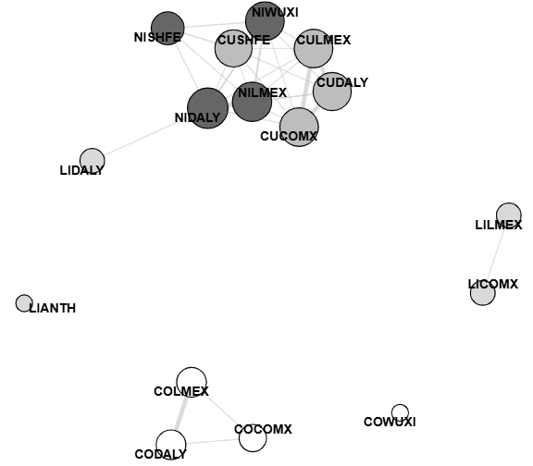
Figure 1 The Correlation Network

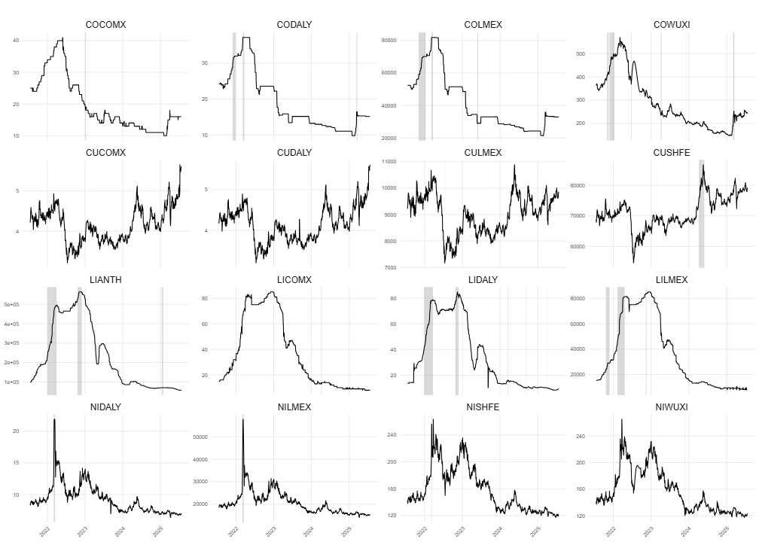
Figure 2 The metal price series and bubble periods detected with the GSADF test

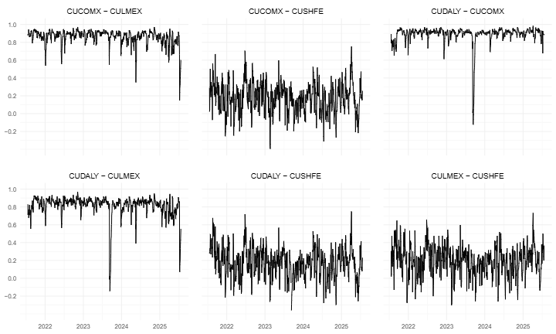
Figure 3 The estimates of the dynamic conditional correlations for four copper series

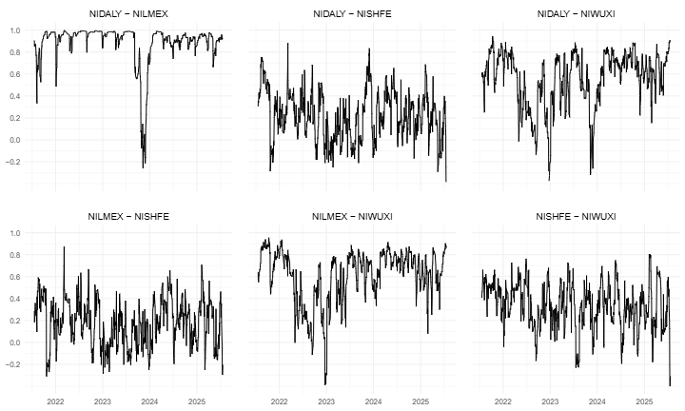
Figure 4 The estimates of the dynamic conditional correlations for four nickel series

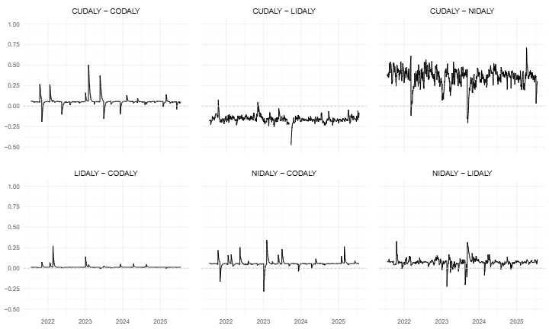
Figure 5 The estimates of the dynamic conditional correlations for four different metal

https://www.lme.com/
https://www.cmegroup.com/company/comex.html
https://www.shfe.com.cn/eng/
While the precise formula for calculating prices is not available, it is said to be compiled as part of their broader metal price series. According to their archive page, these nickel prices are “spot and/or closing prices gathered from a variety of sources” and may be delayed up to one business day

