Rust Programming Language

Slobodan Klentikov 151539

Rust is a simple, efficient and time-saving application that has been designed from the ground-up to prevent faults and keep data secure. This reduces the amount of code you need to write, freeing up time to work on other projects.

Rust is a multi-paradigm systems programming language focused on safety, especially safe concurrency. Rust is syntactically similar to C++, but is designed to provide better memory safety while maintaining high performance.
Rust was originally designed by Graydon Hoare at Mozilla Research, with contributions from Dave Herman, Brendan Eich, and others. The compiler is free and open-source software dual-licensed under the MIT License and Apache License 2.0.
Rust was the "most loved programming language" in the Stack Overflow Developer Survey for 2016, 2017, and 2018.

Projects:
1. Snake
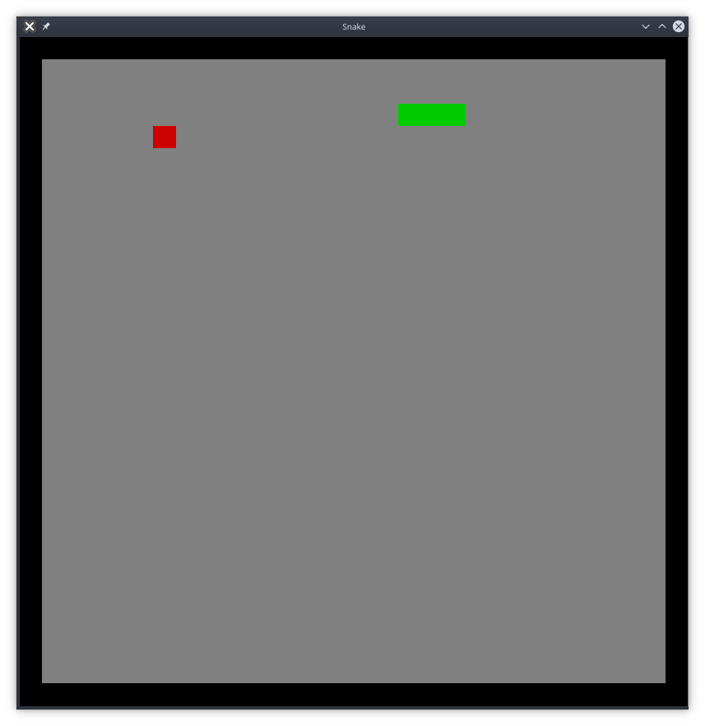
Crates used:
rand
piston_window

2. Open ports scanner
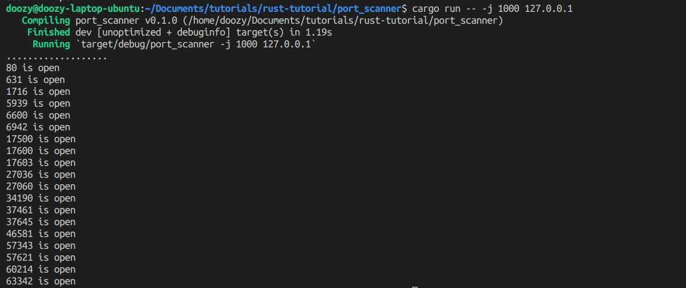

3. Pong game
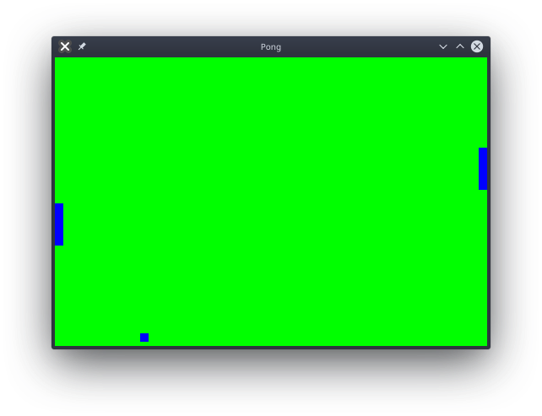
Crates used:
piston
piston2d-graphics
pistoncore-glutin_window
piston2d-opengl_graphics

