Meeting content

Date: 10/24/2025
Group Member: Haocheng, Mary
Content:
Discussed about the UI design and color palette.
Outcome:
AI designed UI: https://www.figma.com/make/dg1kxBP3l6cAlsIuKOib5Y/Data-Dashboard-UI-Pattern-Library?node-id=0-1&t=Gno28ymgATEBSoCH-1

Color palette options:
(Currently both Haocheng and Mary prefer option3)

Font:
Montserrat: bold 700 is close to the logo font
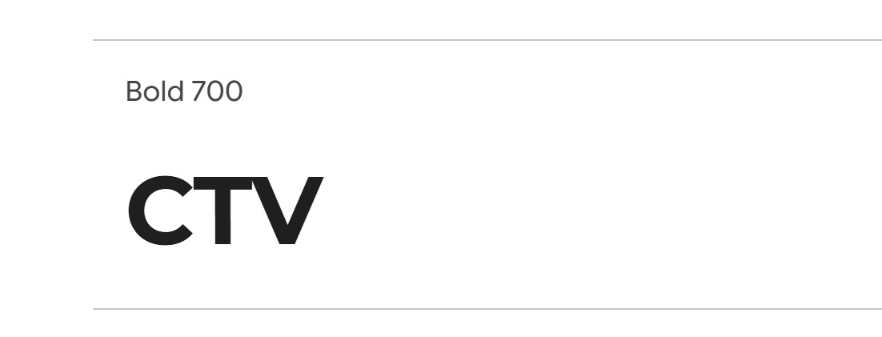

Next meeting date: 11am,10/28/2025
Date: 10/28/2025
Group members: Haocheng, Mary, Pedro
Content: Discussed the project 1 requirements, UI lib looks and feels and assigned the task for each group member.
Outcomes:
UI chart design duty:
Mary: chart 1 -3
Pedro: chart 4-6
Haocheng: chart 7- 9

Pedro: Asking Professor if we can use Image(styled chart prototype) as placeholder for the chart, since we cannot code the styled chart so far => done, just use image as placeholder!!!

Haocheng: double check the color with the color theme
Haocheng: structural of the UI lib
Pedro: colors content, and elements content
Mary: content of the typography

CSS class conversion:
Haocheng: h_xxxx
Pedro: p_xxxx
Mary: m_xxxx
CSS lib: BootStrap
Next meeting: Monday 11 am, Nov 3rd, 2025

