**128-port I2C I/O expander**

**Rev 1.1, Gert van Loo, 8 August 2014**

**Fen Logic Ltd.**

# Introduction

The GNU GPLv3 license is applicable to this manual and the related databases:

*Copyright © 2014 Fen Logic Ltd.*

*This document and the related databases are free: you can redistribute it and/or modify it under the terms of the GNU General Public License as published by the Free Software Foundation, either version 3 of the License, or any later version. This document and the related databases are distributed in the hope that it will be useful, but WITHOUT ANY WARRANTY; without even the implied warranty of MERCHANTABILITY or FITNESS FOR A PARTICULAR PURPOSE. See the GNU General Public License for more details. You should have received a copy of the GNU General Public License along with this database. If not, see http://www.gnu.org/licenses/*

Thus like with the Gnu software, you can replicate this hardware, make derivatives etc. All I ask is that the original designer (Fen Logic Ltd.) gets mentioned in any direct or indirect copies of this work. Note that the GPLv3 mentions: "The GNU General Public License is a free, copyleft license for software and other kinds of works.". For contact about this document and/or the databases: info@fenlogic.com.

## Why a free design?

I was using three MCP23017 I2C I/O expander device in a different design. Just for fun I made a schematic for a 128-port I/O expander. I was curious how big it would be so after a short stint I had most of the PCB done as well. I realised that there where no commercial possibilities for this. Maybe a maximum of 1000 customers[1]. Therefore I decided to make the design open-source. That would most likely make it a 'self assembly' project. I know that most self assembly users do not like surface mount components, thus I did a small re-spin , replacing all surface mount components with thru-hole ones. The full database is on github: gertvanloo/multio. There you will find the schematics, PCB files, a copy of this manaul and all the gerbers. I might order a few hundred PCB's and put them on Ebay but I have not done that yet (8-Aug-2014) .Enjoy!

## Disclaimer

To make this board as flexible as possible this manual describes all the possible options. Beware that this is not a do-it-yourself kit for somebody who has no knowledge of electronic whatsoever. You get a schematic and this manual, as well as all the design files. From there you are on you own. However as the data is in github somebody else might take the time to add some text on you how to build it.

## Revision

This description is for a new revision. I have not built that revision but the schematics have not changed much, so I am sure this one will works as well, or even better then the prototype. If you happen to have one of the original prototypes PCBs you will find that they differ slightly from the pictures in the manual.

# Supply

A lot of I/O means potentially a lot of electrical power. Thus the I/O expander can use a considerable amount of current. The actual current drawn from the power supply depends mostly on what is connected to the board. Each output port can drive or sink 25 mA. Each chip can drive maximum of 150mA. With 8 devices that is a maximum current of 1.2 Amps.

If the board is used to drive a lot of outputs at high current you must use an external supply.

## Heat

The board has a simple linear regulator. If that is used it can generate a lot of heat. The amount of heat generated depends on the following factors:

* The input voltage (Vin)
* The current consumption (I)
* The selected operating voltage.

The formula for the generated energy in the form of heat is:

**W = Vd* I**

Vd is the voltage drop across the regulator (The difference between the input voltage and the output voltage). The following table shows some example values:

|  |  |  |  |  |  |
| --- | --- | --- | --- | --- | --- |
| **Vin** | **Vboard** | **Vdrop** | **I (A)** | **Power** | **Hot** |
| 6 | 5 | 6-5=1 | 0.6 | 1*0.6 = 0.6W |  |
| 5 | 3.3 | 5-3.3=1.7 | 0.6 | 1.7*0.6=1.02W |  |
| 7.5 | 5 | 7.5-5=2.5 | 0.6 | 2.5*0.6=1.5W |  |
| 7.5 | 3.3 | 7.5-3.3=4.2 | 0.6 | 4.2*0.6=2.52W |  |
| 6 | 5 | 6-5=1 | 1.2 | 1*1.2 = 1.2W |  |
| 5 | 3.3 | 5-3.3=1.7 | 1.2 | 1.7*1.2=2.04W |  |
| 7.5 | 5 | 7.5-5=2.5 | 1.2 | 2.5*1.2=3W |  |
| 7.5 | 3.3 | 7.5-3.3=4.2 | 1.2 | 4.2*1.2=5.04W |  |

The regulator will need a heat sink, even if you are burning away only 0.6W. The maximum values in the table will require a huge heat sink and it will still get ***hot!*** In that case it is better to select a lower input voltage. The following To-220 heat sink can cope with about 3W and it then still gets ***hot*** to ~50C (With an environment temperature of ~21 C).

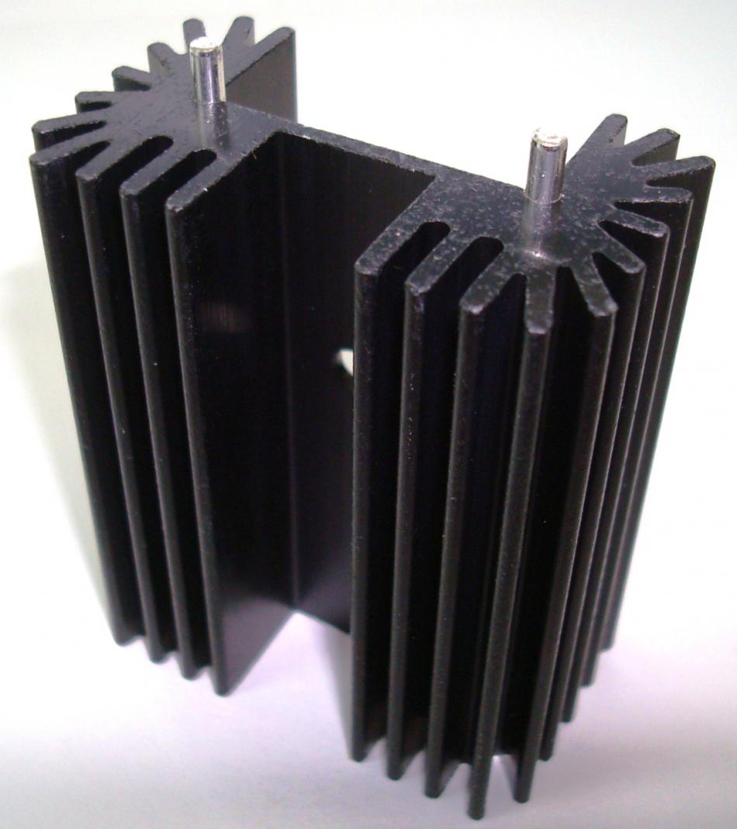

Of course you can select an external supply which has the right voltage (5V or 3V3) from the start in which case you can omit the on-board regulator at all.

# Options

The nice thing about do-it-yourself is that you can adapt the design to your specific needs. In this case the design can be adapted in several ways.

* Operating voltage: Can be 3V3 or 5V.
* Power supply: 3V3 or 5V from Raspberry-Pi or an external supply.
* How to connect the I/Os
* Select the number of ports: 32, 64, 96 or 128.

Each of these options requires a different set of components and for the power supply you must solder some wire bridges on the PCB.

## Voltage

The I/O expander chip itself can work from 2.0V to 5.5V but the design is only set up to work from 3.3 or 5 Volts. In case the I/O expander runs of 5V the design needs I2C level converters. These are present on the boards as well. If the design runs of 3V3 the I2C level converters must be bypassed.

## Power

The design can take power from three sources:

* The Raspberry-Pi 3V3
* The Raspberry-Pi 5V
* An external supply (Direct or regulated)

**The Raspberry-Pi 3V3**

Beware that the Raspberry-Pi 3V3 will not be sufficient to power the whole board. Thus if you use the 3V3 of the Raspberry-Pi you should use only a reduced number of ports. I would say about 2 extra IC's (32 ports). Even if you have one expander IC you should still be careful how much load you put on each output pin. To run of the Pi 3V3 supply you must make a wire connection indicated by the red bar below:

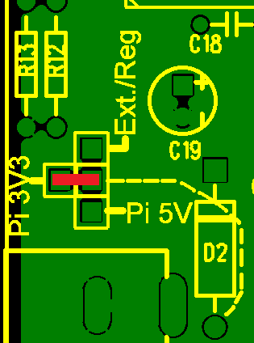

**The Raspberry-Pi 5V**

The Raspberry-Pi 5V has a bit more power. How much it has spare depends on many factors, the current consumption of your USB ports is an important one. In general it should be able to supply power to 2-4 expander ICs. To run of the Pi 5V supply you must make a wire connection indicated by the red bar below:

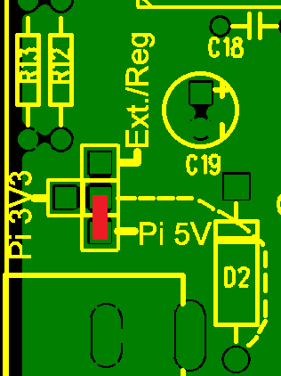

In this case you do not need to install the components for the I2C level shifters.

**External supply**

For a large number of I/O port you should get an external supply. The external supply can be used in two ways: with or without the on-board regulator. If you want to use

**External supply with the on board regulator**

If you mount the components for the on-board regulator, you can use an external supply in the range of 4V[2]..7.5V. To use the board with an external supply and the on-board regulator you must make a wire connection indicated by the red bar below:

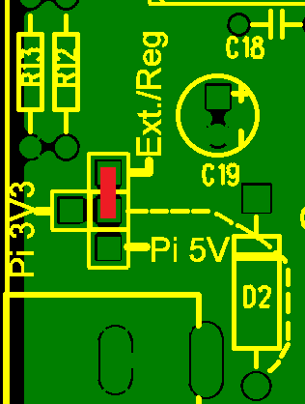

Without any adaptations the supply goes to the on-board regulator. Using R12 and R13 you can set the regulator to produce 3V3 or 5V. In the latter case you must also mount the I2C level translation logic.

**External supply without on board regulator**

Without on-board regulator the external supply is mostly likely be 3.3Volts or 5Volts. In the latter case you must also mount the I2C level translation logic. To use an external regulator you must make a connection between the power socket and the main board input. The diagram below shows which connection to make.

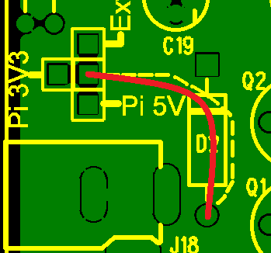

That wire bypassed the polarity projection diode. Therefore you must make sure the polarity of the supply is the right way around (middle pin is plus) or you risk damaging all the electronics on the board.

## Connect the I/Os

The input/output ports come out on a series of 9 holes[3] 3.5mm apart. There are multiple type of connectors which fit that footprint. You can also omit a connector completely and solder wires directly into the holes. In fact the price of the whole board can increase drastically if you use expensive I/O connectors.

## Number of Ports

The PCB is designed in four sections each holding 32 I/O ports. The board will work if not all I/O expander sections are assembled. Sometimes there may be mechanical requirements which make that the board is too big. In that case you can reduce the size by cutting of one or more ***unused*** sections. The edges will need some careful filing to prevent short circuits. The board has dashed lines indication where you can cut the excessive part off. I have NOT tried that so you do so at your own risk.

# Parts

Depending on what you decided to use you will need to obtains the necessary parts. The parts list has been split in sections:

Basic: The parts you will always need. e.g.: the connector to the Raspberry-Pi and the cable.

I/O: All the parts to assemble ***one*** I/O section. That is a section which provides 32 I/O pins. The board has four of those sections.

I2C level shifter: The parts for the I2C level converter. This is only needed if you run the board from 5V. If you run the board from 3V3 you need two small wires to bypass the converter. See .

Regulator: The parts requires to use the on-board regulator

Note that the whole project will be come *significantly* cheaper if you order the boards and the parts for more then one at a time.

General:

* Al resistors are through-hole 1/8 W
* All 220nF capacitor have a pitch of 5.08mm
* The two electrolytic capacitors can have a value in the range of 100uF to 470uF. The case is radial, 2.5 mm wire pitch (2.54 will work too), external diameter between 5 and 8 mm.

Part numbers.

Using the part numbers is at your own risk. You should check the actual parts versus what you think you need when purchasing the parts. For many parts there are alternatives even from the same vendor. e.g. each vendor has at least 200 types of LED which you can use.

Also depending on the vendor, some numbers are associated with more then one part.

**Basic parts list:**

|  |  |  |  |  |  |  |
| --- | --- | --- | --- | --- | --- | --- |
| **Description** | **#** | **Farnell** | **Digikey** | **RS** |  |  |
| J1: 2x13 header** | **1** | 1852886 | S1012EC-26-ND | 670-3471 |  |  |
| 2x13 IDT press connector** | **2** | 2215239 | 3030-26-0101-99-ND | 625-7404 |  |  |
| Flat cable 8-26 wires, ~ | **1** | 1310339 | MD08R-5-ND | 289-9846 |  |  |
| R3,R14,R16: 2700 Ohm | **3** | 1700238 2329488  9341226 | CF18JT2K70CT-ND | 131-306 |  |  |
| R15: 6800 Ohm | **1** | 1700247 2329548 9339663 | CF18JT6K80CT-ND | 707-7735 |  |  |
| D1: 5mm LED | **1** | 2335729  2335725 1461624 | C5SMF-RJS-CT0W0BB1-ND | 228-5821 |  |  |
| C21: 220nF | **1** | 2395774 2332986RL | SR215E224MAT-ND | 699-5131 |  |  |

**The boards needs only 8 wires so you can use a 2x4 header and a fitting IDT press connector instead.

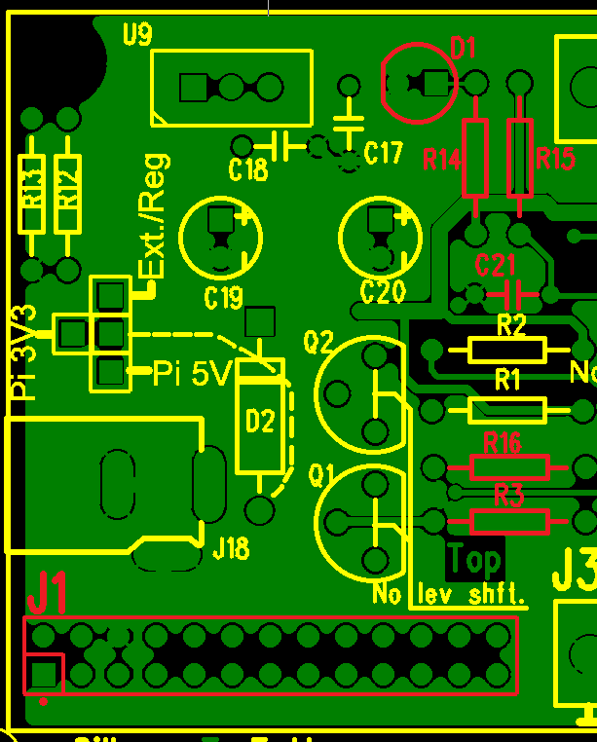

**I/O section parts list:**

|  |  |  |  |  |  |  |
| --- | --- | --- | --- | --- | --- | --- |
| **Description** | **#** | **Farnell** | **Digikey** | **RS** |  |  |
| U10..U17: MCP23017 | **2** | 1332088 | MCP23017-E/SP-ND | 403-806 |  |  |
| C9,C10,: ~220nF | **2** | 2395774 2332986RL | SR215E224MAT-ND | 699-5131 |  |  |
| Terminal 3 pins 3.5mm pitch  (Optional) | **12** | 1708075 | ED2741-ND | ??? |  |  |
| Terminal 9 pins 3.5mm pitch  (Optional) | **4** | 1787784 | ED1521-ND | ??? |  |  |

The number (#) is for one set of circuits (32 ports). You need to multiply the numbers above by 4 to fully assemble the I/O expander for 128 ports!

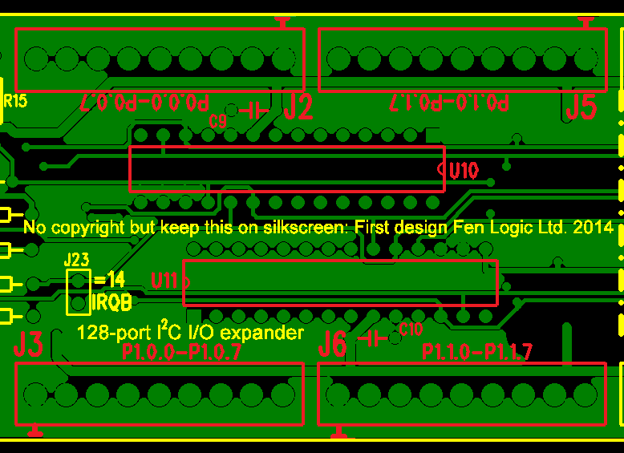

**I2C level shifter parts list:**

|  |  |  |  |  |  |  |
| --- | --- | --- | --- | --- | --- | --- |
| **Description** | **#** | **Farnell** | **Digikey** | **RS** |  |  |
| Q1,Q2: Small signal NFET e.g. 2N7000 | **2** | 9845178 1017689 | 2N7000TACT-ND | 739-0224 |  |  |
| R1,R2: ~2700 Ohms | **2** | 1700238 2329488  9341226 | CF18JT2K70CT-ND | 131-306 |  |  |

The type of NFET used for Q1 and Q2 is not very critical. There are hundreds of NFETs which can be used. Most small-signal NFETs will do. These are the four components required to install the I2C level shifters:

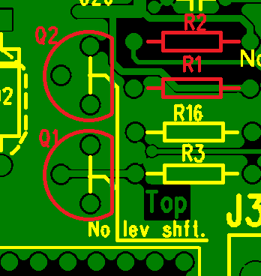

**I2C bypass.**

If you do not need the I2C level shifters, because you operate the I/O expander board at 3.3Volts, you ***must*** bypass the I2C level shifters using two wires instead of the Q1 and Q2 parts. This is indicated with the two red bars below:

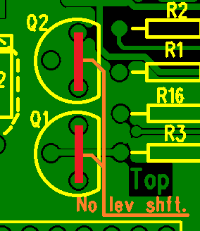

**Regulator parts list:**

|  |  |  |  |  |  |  |
| --- | --- | --- | --- | --- | --- | --- |
| **Description** | **#** | **Farnell** | **Digikey** | **RS** |  |  |
| IC LM317 TO-220 case | **1** | 9756027 2144307 | LM317TGOS-ND | 516-6240 |  |  |
| R12 240 Ohms | **1** | 9341587 9342885 | S240QCT-ND | 707-7616 |  |  |
| For 5V:R13≈715 Ohm** | **1** | 1563255 1083234 | 715XBK-ND | 754-6878 |  |  |
| For 3.3V :R13≈390 Ohm** | **1** | 1700231 2329519 | CF14JT390RCT-ND | 131-205 |  |  |
| C ~220nF | **2** | 2395774 2332986RL | SR215E224MAT-ND | 699-5131 |  |  |
| C ~100µF..470µF  Radial, 2mm pitch 2.5(4)mm | **2** | 2068745 2068729 | P963-ND 493-1269-ND | 711-0933 |  |  |
| Power socket | **1** | 1854514 | CP-058B-ND ?? | 487-836 ?? |  |  |
| Heat sink (Size depends on power configuration) | **1** | 1710627 | 345-1085-ND | - | - | - |

Read the section about the power supply if you are uncertain as to if you need a regulator or not.

** My experience is that with the correct calculated resistor value the LM317 output voltage is lower then what the datasheet says. I suggest you always round the value of R13 up.

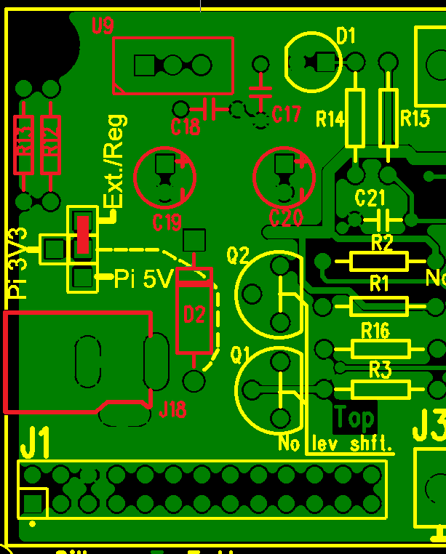

**Full parts list:**

This is the parts list for a ***fully*** assembled board. That is 128 ports including 3V3 or 5 V regulator

| **Description** | **#** | **Farnell** | **Digikey** | **RS** |  | |  |
| --- | --- | --- | --- | --- | --- | --- | --- |
| J1: 2x13 header  or  2x4 | **1** | 1852886  ??? | S1012EC-26-ND  ??? | 670-3471  ??? |  | |  |
| 2x13 IDT press connector  or  2x13 and 2x4 | **2** | 2215239  ??? | 3030-26-0101-99-ND  ??? | 625-7404 |  | |  |
| Flat cable 8-26 wires, ~ | **1** | 1310339 | MD08R-5-ND | 289-9846 |  | |  |
| R1,R2,R3,R14,R16: 2700 Ohm | **5** | 1700238 2329488  9341226 | CF18JT2K70CT-ND | 131-306 |  | |  |
| R15: 6800 Ohm | **1** | 1700247 2329548 9339663 | CF18JT6K80CT-ND | 707-7735 |  | |  |
| D1: 5mm LED | **1** | 2335729  2335725 1461624 | C5SMF-RJS-CT0W0BB1-ND | 228-5821 |  | |  |
| Cx: 220nF | **11** | 2395774 2332986RL | SR215E224MAT-ND | 699-5131 |  | |  |
| U10..U17: MCP23017 | **8** | 1332088 | MCP23017-E/SP-ND | 403-806 |  | |  |
| Terminal 3 pins 3.5mm pitch (Optional)  or  Terminal 9 pins 3.5mm pitch (Optional) | **48**  **16** | 1708075  1787784 | ED2741-ND  ED1521-ND | ??? |  | |  |
| Q1,Q2: Small signal NFET e.g. 2N7000 | **2** | 9845178 1017689 | 2N7000TACT-ND | 739-0224 |  |  | | |
| IC LM317 TO-220 case | **1** | 9756027 2144307 | LM317TGOS-ND | 516-6240 |  |  | | |
| R12 240 Ohms | **1** | 9341587 9342885 | S240QCT-ND | 707-7616 |  |  | | |
| For 5V:R13≈715 Ohm** | **1** | 1563255 1083234 | 715XBK-ND | 754-6878 |  |  | | |
| For 3.3V :R13≈390 Ohm** | **1** | 1700231 2329519 | CF14JT390RCT-ND | 131-205 |  |  | | |
| C ~100µF..470µF  Radial, 2mm pitch 2.5(4)mm | **2** | 2068745 2068729 | P963-ND 493-1269-ND | 711-0933 |  |  | | |
| Power socket | **1** | 1854514 | CP-058B-ND ?? | 487-836 ?? |  |  | | |
| Heat sink (Size depends on power configuration) | **1** | 1710627 | 345-1085-ND | - | - | - | | |

1. That sounds like a lot but believe me: it is not worth bringing out a simple product like this if you expect to sell a 1000 of them.
2. You can use 4V only if you set up the regulator for 3.3Volts. When using a 5V regulator use an external supply of 6V or higher.
3. 8 Holes for the signals and one hole for the ground.