Data Cube: "bimodal.dat"
Indexing method: (1,1) is the first pixel. The first number is row, second is col.
Target Location: (5,3) { In (x,y) indexing, (0,0) first pixel - the target location is (2,4) }
Target Data (Band 1 2 3 4 …): 3591 4733 4793 4577 ….
Target strength: p=1%
Target implant: x'=x+pt
Algorithm in use: 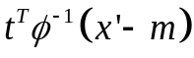
where:
t is the target.
is the covariance matrix of (x-m). (no target implanted in any of the pixels).
x is the data.
m is the mean of the data, obtained from 8 closest neighbors (around the edges - 3 or 5 neighbors).
Target spectrum:
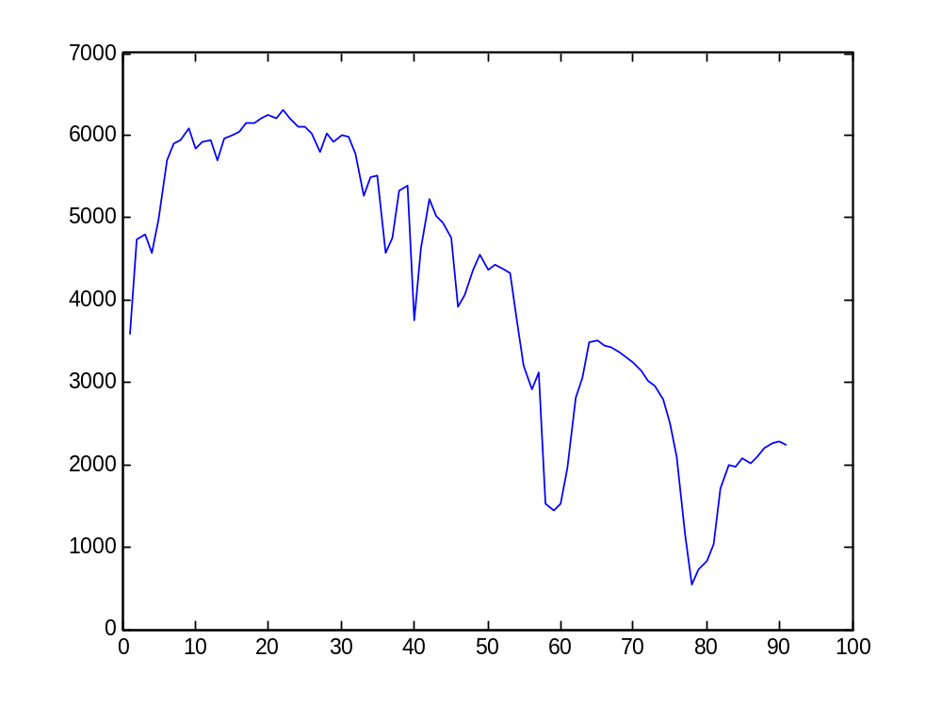
To start, compare the values of (x'-m) for the following pixels locations, for the first band:
Pixel location | NT | WT
(5,5) | -56.75 | -20.84
(10,10) | -53 | -17.1
(15,15) | 21.875 | 57.78
(20,20) | -36.62 | -0.715

Now, compare the results of :
Pixel location | NT | WT
(5,5) | 166.21 | 629.74
(10,10) | -100.16 | 363.37
(15,15) | -36.19 | 427.34
(20,20) | -78.05 | 385.48

Generated Histograms, with 100 subdivisions:
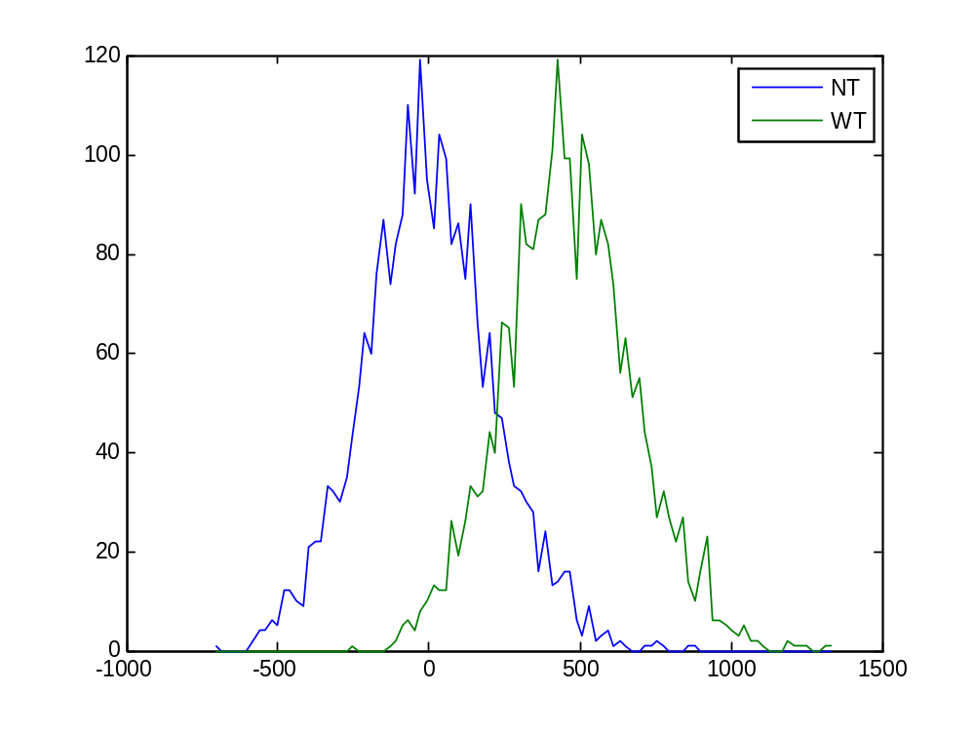
ROC Curve, for th=0.1
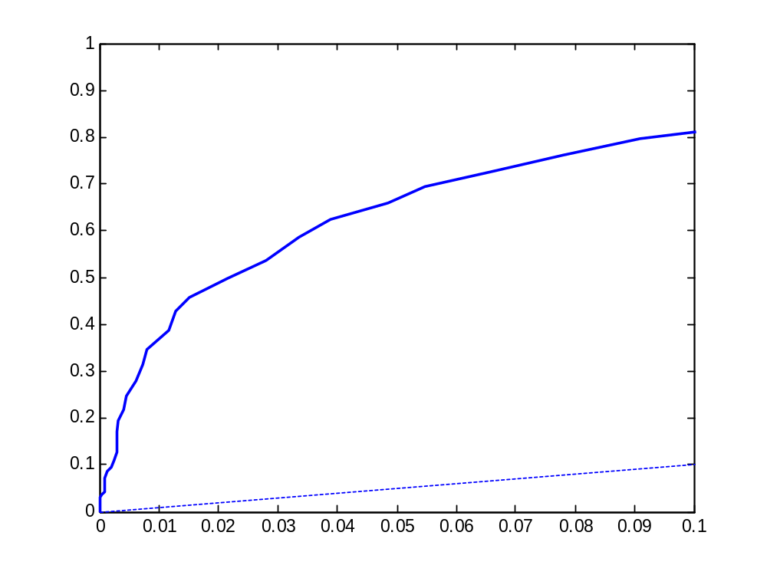
A Values (Calculated as whole area minus the triangle area created by Pd=Pfa line):
0.001 -> 0.0429
0.01 -> 0.2276
0.1 -> 0.5988

