

Gym Membership Management System
Built Like
a System.

E2 – Software Modeling and Design Specifications

Academic Year 2025-2026

1
. UML class Diagram -> “What is the system made of?”
The UML Class Diagram below presents the main classes of the Gym Membership Management System, including their attributes, methods, and relationships (associations, aggregations).
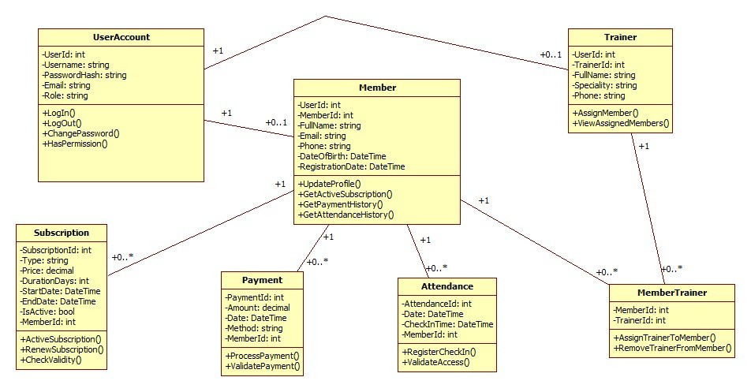
Figure 1 – UML Class Diagram
We added a UserAccount class to handle login and roles, like Admin, Receptionist, Trainer, and Member. Depending on the role, a user can be linked to a Member or a Trainer, but not necessarily to both. The main functionality is around Members, Trainers, Subscriptions, Payments, and Attendance. A member can have multiple subscriptions, payments, and attendance records, which is why we use one-to-many relationships. The connection between Members and Trainers is many-to-many, so we used an extra class called MemberTrainer to manage that. We didn’t use inheritance because each class has a different role in the system and they don’t really extend each other.
Key relationships:
- UserAccount – Member / Trainer: One-to-one: each member or trainer has exactly one user account for authentication.
- Member – Subscription: One-to-many: a member can have multiple subscriptions over time.
- Member – Payment: One-to-many: a member can make multiple payments.
- Member – Attendance: One-to-many: a member can have multiple attendance records.
- Member – MemberTrainer: Many-to-many through MemberTrainer: a member can be assigned to multiple trainers.
- Trainer – MemberTrainer: Many-to-many through MemberTrainer: a trainer can be assigned to multiple members.
2.0 Application Architecture Description -> “How is the system built?”
The system follows a 3-tier layered architecture separating concerns into Presentation, Business Logic, and Data Access layers, ensuring modularity, maintainability and separation of responsabilities.

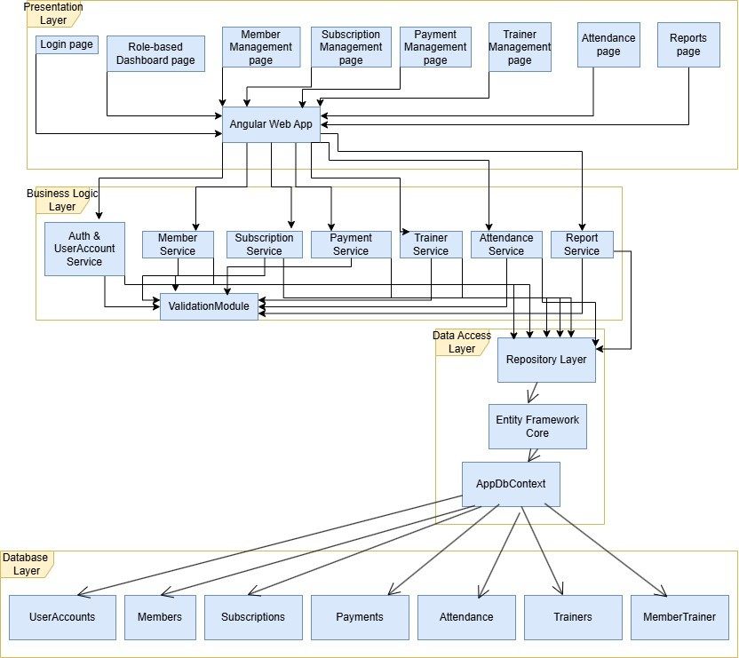
Figure 2 – Architecture Diagram
Layer descriptions:
- Presentation Layer (Angular Web App): Contains all UI pages: Login, Role-based Dashboard, Member Management, Subscription Management, Payment Management, Trainer Management, Attendance, and Reports.
- Business Logic Layer (.NET Services): Contains the core services: Auth & UserAccount Service, Member Service, Subscription Service, Payment Service, Trainer Service, Attendance Service, and Report Service. All services interact with a shared ValidationModule to ensure data integrity.
- Data Access Layer (Repository + EF Core): Implemented using the Repository Pattern on top of Entity Framework Core. The AppDbContext manages the connection and entity mapping to the SQL Server database.
- Database Layer (SQL): SQL Server database with tables: UserAccounts, Members, Subscriptions, Payments, Attendance, Trainers, MemberTrainer.

2.1 Entity-Relationship Diagram (ERD) -> “How is the data stored?”

The ERD below shows the database structure with all entities, primary keys, foreign keys, and relationships between tables.

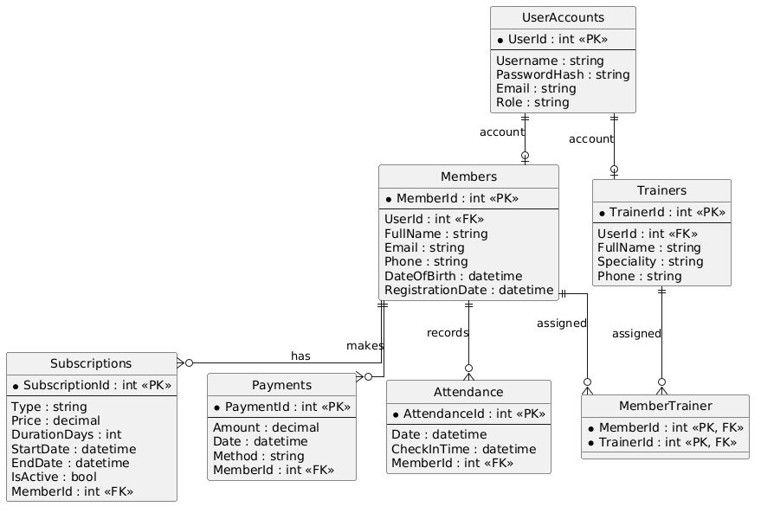
Figure 3 – Entity-Relationship Diagram (ERD)

2.2 Use Case Diagram -> “What does the system do?”

The Use Case Diagram illustrates the interactions between the system actors (Admin, Receptionist, Trainer, Member) and the available system functionalities.

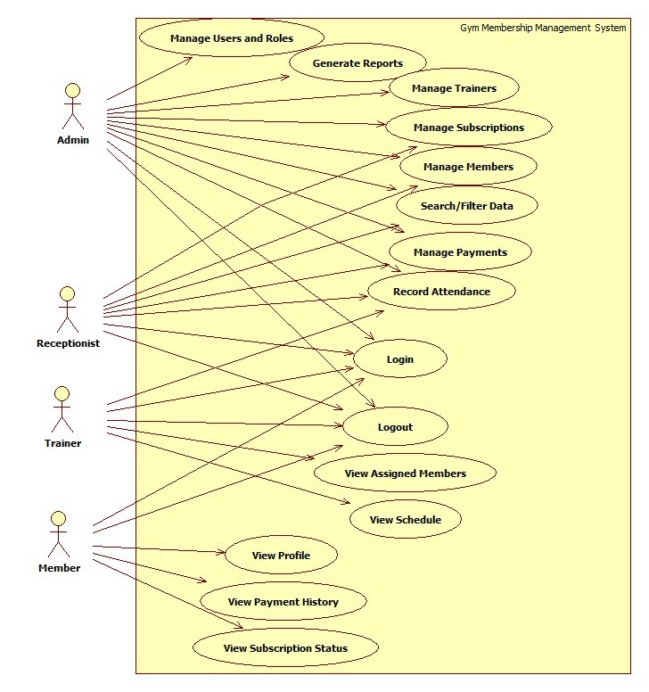
Figure 4 – Use Case Diagram
Actor descriptions:
- Admin: Manage members, trainers, subscriptions, payments, attendance, reports, and users/roles.
- Receptionist: Add and update members, view subscriptions, register payments, and check attendance.
- Trainer: View assigned members, view schedule, and record attendance/sessions.
- Member: View personal profile, subscription status, and payment history.

3. Graphical User Interface Design
The user interface is designed using Angular with Figma mockups as the design reference. The application includes the following main windows/pages:
**[PICTURES]**
- Login Page - authentication form with username and password fields.
- Sign up Page - …
- Role-based Dashboard - overview of key metrics, accessible based on user role.
- Member Management Page - list, add, edit, delete, and search members.
- Subscription Management Page - manage subscription plans and member subscriptions.
- Payment Management Page - track and process payments.
- Trainer Management Page - manage trainers and their assigned members.
- Attendance Page - record and view gym check-ins.
- Reports Page - generate and filter reports by date range, status, or plan type.
**…just some ideas – depends on which pages are you done with till MAY 8th**
[ Login Page and App Shell mockups designed in Figma by Salajanu Mircea Vasile – Frontend Developer]

4
. Description of the Main Classes
The following table describes each main class, its role in the system, and its key responsibilities:

Class | Role | Responsibilities
UserAccount | Authentication & Access Control | Manages user credentials and roles (Admin, Receptionist, Trainer, Member).  Handles login, logout, password management, and access permissions.
Member | Core Domain Entity | Represents a gym member. Stores personal details and links to  subscriptions, payments, attendance records, and assigned trainers.
Subscription | Membership Management | Tracks the type, price, duration, and validity of a member's subscription.  Ensures only active subscriptions are used.
Payment | Financial Transactions | Records payment transactions made by members.  Processes and validates payments linked to subscriptions.
Attendance | Check-in Tracking | Records each gym visit by a member. Validates access based on active  subscription status.
Trainer | Trainer Management | Stores trainer details and specialization. Allows viewing and managing  assigned members.
MemberTrainer | Many-to-Many Relationship | Junction entity linking members to their assigned trainers. Manages  assignment and removal of trainers for members.

5
. Test Plan
The test plan defines the key test cases for the system. Each test case specifies the feature being tested, the input values used, and the expected result. Tests are defined by the QA Engineer (Luidort Zsuzsa).
**just examples complete as you think**
TC# | Feature | Input Values | Expected Result
TC01 | Login – valid credentials | Username: admin  Password: Admin123! | Authenticated; redirected to Dashboard.
TC02 | Login – invalid password | Username: admin  Password: wrongpass | Error message; user not authenticated.
TC03 | Login – empty fields | Username: (empty)  Password: (empty) | Validation error; login not attempted.
TC04 | Add Member – valid data | FullName: Ion Popescu  Email: ion@test.com  Phone: 0740123456 | Member added and visible in the list.
TC05 | Add Member – duplicate e | mailEmail already in DB | Error: 'Email already in use'; not saved.
TC06 | Add Member – missing fiel | dsFullName: (empty) | Validation error; member not saved.
TC07 | Subscription – add valid pl | anType: Monthly  Price: 50  Duration: 30 days | Subscription plan saved in the list.
TC08 | Subscription – invalid price | Price: -10 | Validation error: price must be positive.
TC09 | Payment – process valid p | aymentAmount: 50  Method: Cash  MemberId: 1 | Payment recorded; subscription updated.
TC10 | Attendance – valid check-in | MemberId: 1 (active subscription) | Check-in recorded with correct timestamp.
TC11 | Attendance – expired subs | criptionMemberId with expired subscription | Access denied; check-in not recorded.
TC12 | Trainer – assign to member | TrainerId: 2  MemberId: 1 | Trainer-member link created.
TC13 | Reports – filter by date ran | geStart: 01/01/2026  End: 31/01/2026 | Only records within range displayed.
TC14 | Role access – Receptionist | Login as Receptionist | Access to Members, Attendance, Payments only.
TC15 | Logout | User clicks Logout | Session cleared; redirected to Login page.

E2 - Software Modeling and Design Specifications | Gym Membership Management System
Academic Year 2025–2026
Built Like a System.

