

Gym Membership Management System
Team: “GymTech”

Built Like
a System.

E2 – Software Modeling and Design Specifications

Academic Year 2025-2026

1
. UML class Diagram -> “What is the system made of?”
The UML Class Diagram below presents the main classes of the Gym Membership Management System, including their attributes, methods, and relationships (associations, aggregations).
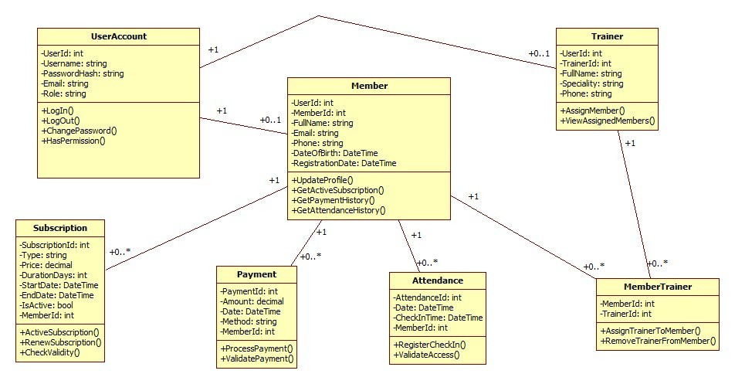
Figure 1 – UML Class Diagram
We added a UserAccount class to handle login and roles, like Admin, Receptionist, Trainer, and Member. Depending on the role, a user can be linked to a Member or a Trainer, but not necessarily to both. The main functionality is around Members, Trainers, Subscriptions, Payments, and Attendance. A member can have multiple subscriptions, payments, and attendance records, which is why we use one-to-many relationships. The connection between Members and Trainers is many-to-many, so we used an extra class called MemberTrainer to manage that. We didn’t use inheritance because each class has a different role in the system and they don’t really extend each other.
Key relationships:
- UserAccount – Member / Trainer: One-to-one: each member or trainer has exactly one user account for authentication.
- Member – Subscription: One-to-many: a member can have multiple subscriptions over time.
- Member – Payment: One-to-many: a member can make multiple payments.
- Member – Attendance: One-to-many: a member can have multiple attendance records.
- Member – MemberTrainer: Many-to-many through MemberTrainer: a member can be assigned to multiple trainers.
- Trainer – MemberTrainer: Many-to-many through MemberTrainer: a trainer can be assigned to multiple members.

2.0 Application Architecture Description -> “How is the system built?”
The system follows a 3-tier layered architecture separating concerns into Presentation, Business Logic, and Data Access layers, ensuring modularity, maintainability and separation of responsabilities.

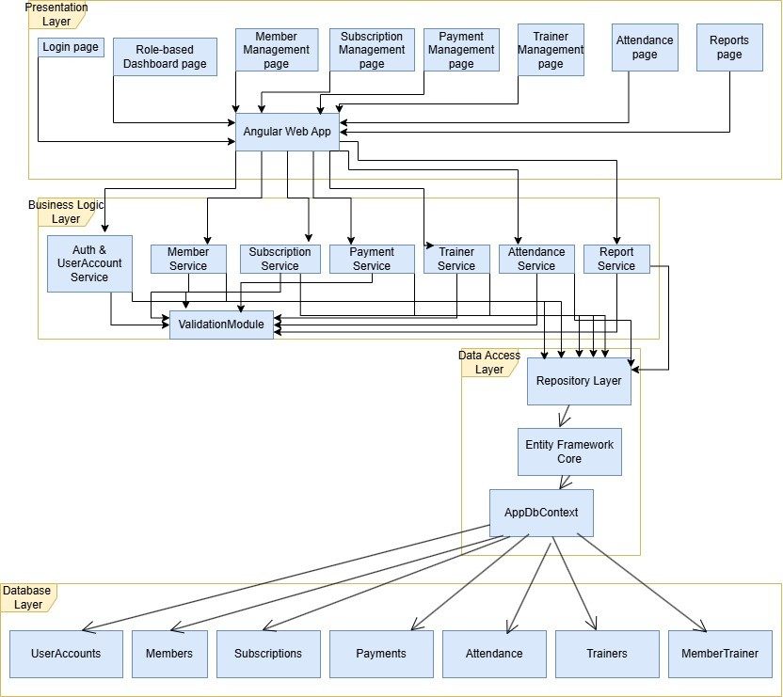
Figure 2 – Architecture Diagram
Layer descriptions:
- Presentation Layer (Angular Web App): Contains all UI pages: Login, Role-based Dashboard, Member Management, Subscription Management, Payment Management, Trainer Management, Attendance, and Reports.
- Business Logic Layer (.NET Services): Contains the core services: Auth & UserAccount Service, Member Service, Subscription Service, Payment Service, Trainer Service, Attendance Service, and Report Service. All services interact with a shared ValidationModule to ensure data integrity.
- Data Access Layer (Repository + EF Core): Implemented using the Repository Pattern on top of Entity Framework Core. The AppDbContext manages the connection and entity mapping to the SQL Server database.
- Database Layer (SQL): SQL Server database with tables: UserAccounts, Members, Subscriptions, Payments, Attendance, Trainers, MemberTrainer.

2.1 Entity-Relationship Diagram (ERD) -> “How is the data stored?”

The ERD below shows the database structure with all entities, primary keys, foreign keys, and relationships between tables.

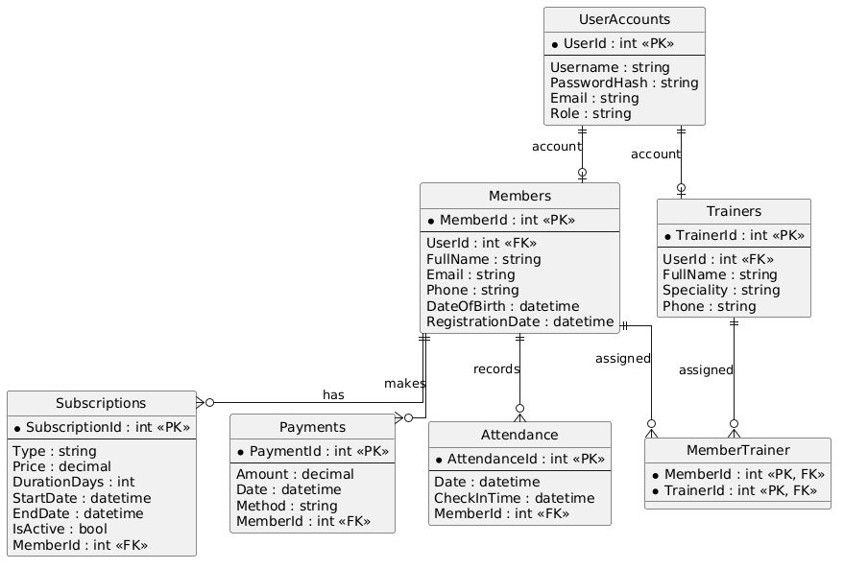
Figure 3 – Entity-Relationship Diagram (ERD)

2.2 Use Case Diagram -> “What does the system do?”

The Use Case Diagram illustrates the interactions between the system actors (Admin, Receptionist, Trainer, Member) and the available system functionalities.

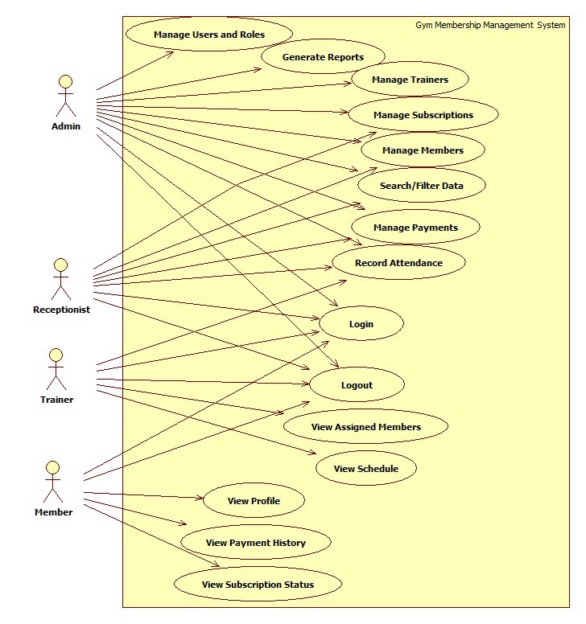
Figure 4 – Use Case Diagram
Actor descriptions:
- Admin: Manage members, trainers, subscriptions, payments, attendance, reports, and users/roles.
- Receptionist: Add and update members, view subscriptions, register payments, and check attendance.
- Trainer: View assigned members, view schedule, and record attendance/sessions.
- Member: View personal profile, subscription status, and payment history.

3. Graphical User Interface Design
The user interface is designed using Angular with Figma mockups as the design reference. The application includes the following main windows/pages:
The GymTech application features a modern, responsive user interface with a dark theme and pink accents. The UI is optimized for different user roles (Admin, Member, Trainer, Receptionist) with role-specific dashboards and navigation menus. All interfaces follow consistent design principles ensuring professional appearance and intuitive user experience.

3.1 Sketches and Mockups of Application Windows

A. Authentication Pages

Login Page
Route: /login
Layout: Two-column layout with gym background image on left, login form on right
Components:
- Welcome panel with application branding and description (70% width)
- Login form with username/email and password fields (30% width)
- "Log In" button with pink accent (#e91e63)
- "Sign up here" link for new user registration
Color Scheme: Dark theme (#1a1a1a) with pink accents (#e91e63)
Description: Provides secure entry point for authenticated users with clear visual hierarchy and intuitive form layout. 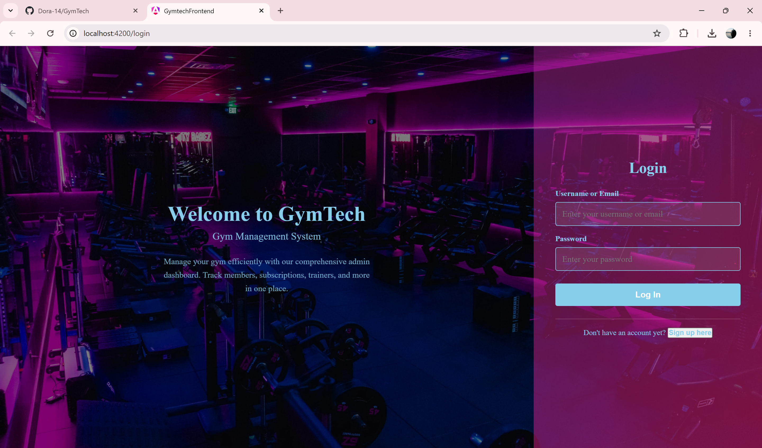

Sign-up Page
Route: /login (signup mode)
Layout: Same two-column layout as login page
Components:
- Registration form with 6 input fields: First Name, Last Name, Email, Phone, Password, Confirm Password
- "Create Account" button
- "Login Here" link for existing users
- Client-side form validation
Description: Allows new users to register with comprehensive account information collection and validation.
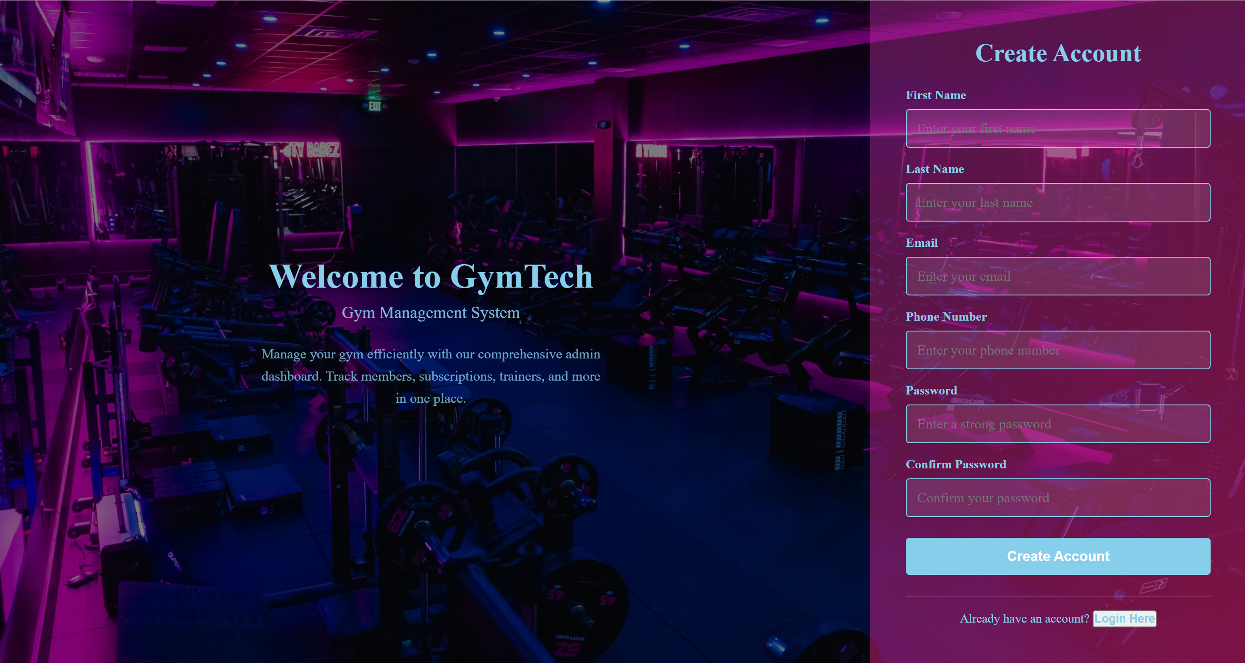

B. Dashboard Pages (Role-Based)

Admin Dashboard
Route: /dashboard
Target User: Administrator
Layout Components:
- Top Navigation Bar: Logo, dashboard type, user greeting, logout button
- Left Sidebar: Feature navigation with icon-based menu items
- Main Content Area: Welcome card with system overview
- Stat Cards: Total Members, Active Trainers, Monthly Revenue
Navigation Sections: Dashboard Home, Generate Reports, Search & Filter, Record Attendance, Manage Members, Manage Trainers, Manage Subscriptions, Manage Payments, Manage Users & Roles
Description: Central hub for gym administrators to manage all system features and monitor key metrics. Complete access to all features and data.
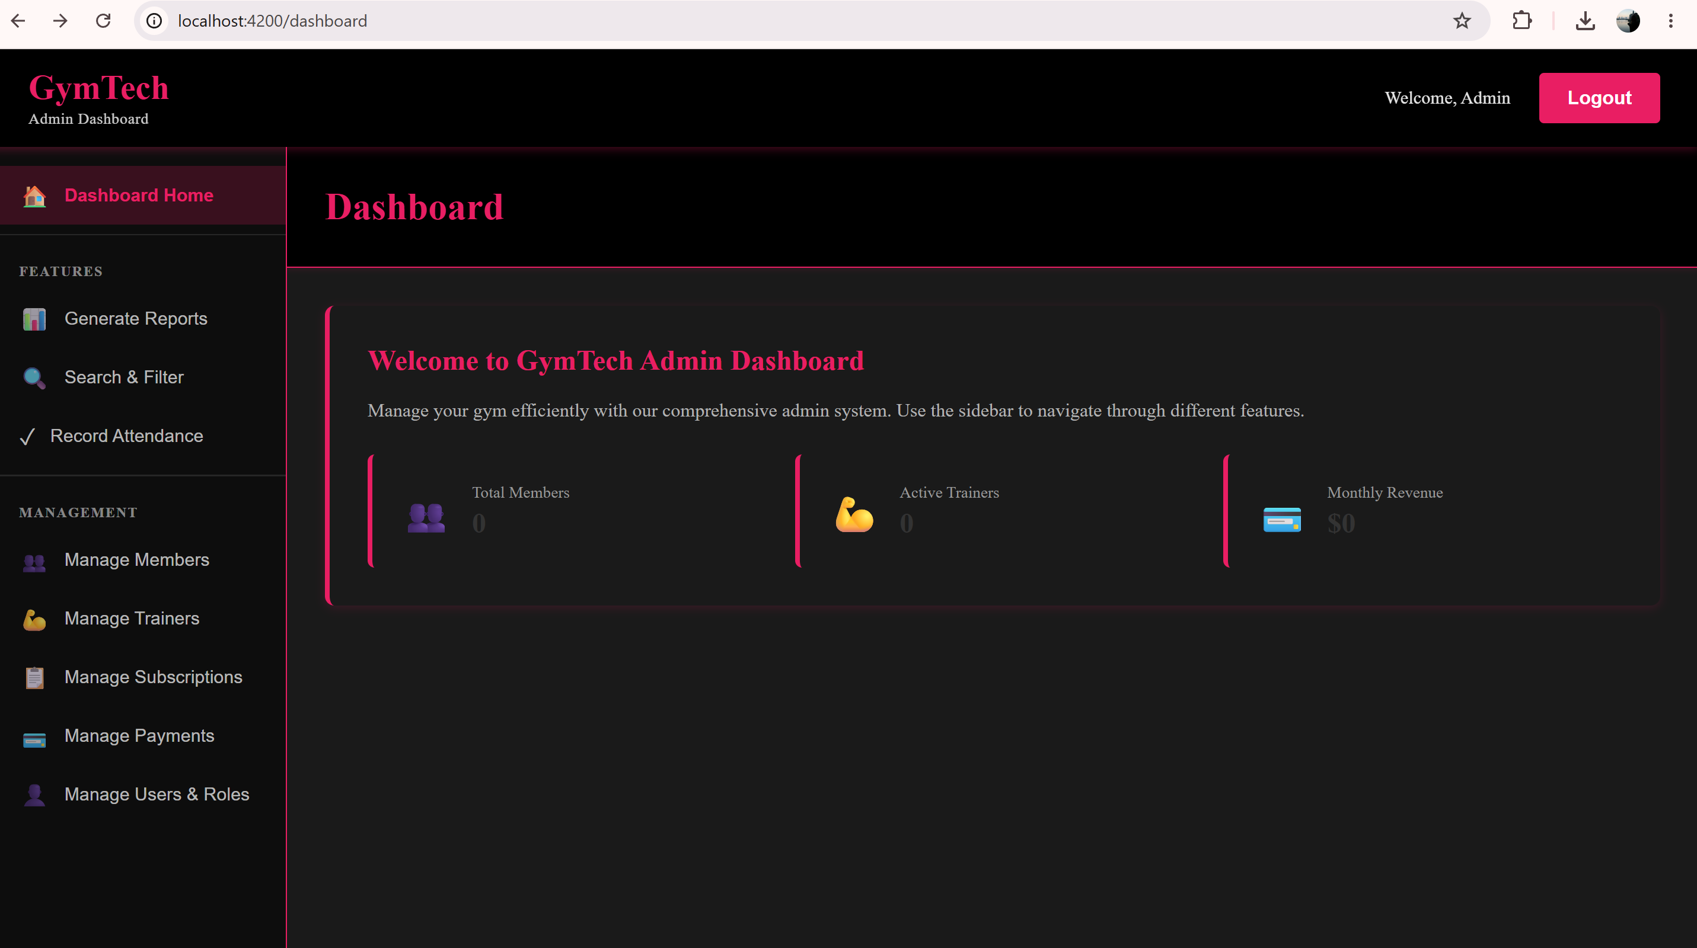

Member Dashboard
Route: /member-dashboard
Target User: Gym Member
Layout Components:
- Simplified navigation sidebar
- Welcome card with membership information
- Stat Cards: Current Subscription, Days Remaining, Next Payment Due
Navigation Sections: Dashboard Home, View Profile, Subscription Status, Payment History
Description: Personal dashboard for members to track membership status, view subscription details, and manage account information.

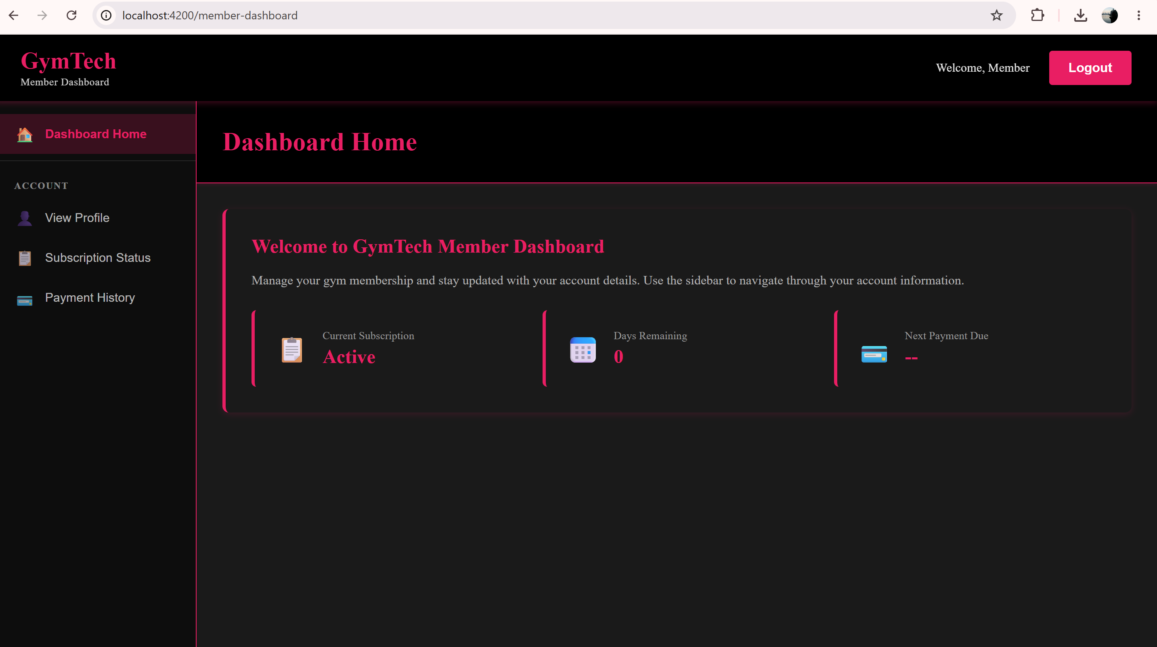

Trainer Dashboard
Route: /trainer-dashboard
Target User: Trainer
Layout Components:
- Training-focused navigation sidebar
- Training metrics display
- Stat Cards: Assigned Members, Sessions Today, Upcoming Sessions
Navigation Sections: Dashboard Home, Assigned Members, Record Attendance, View Schedule
Description: Specialized interface for trainers to manage assigned members, schedule sessions, and track training activities.

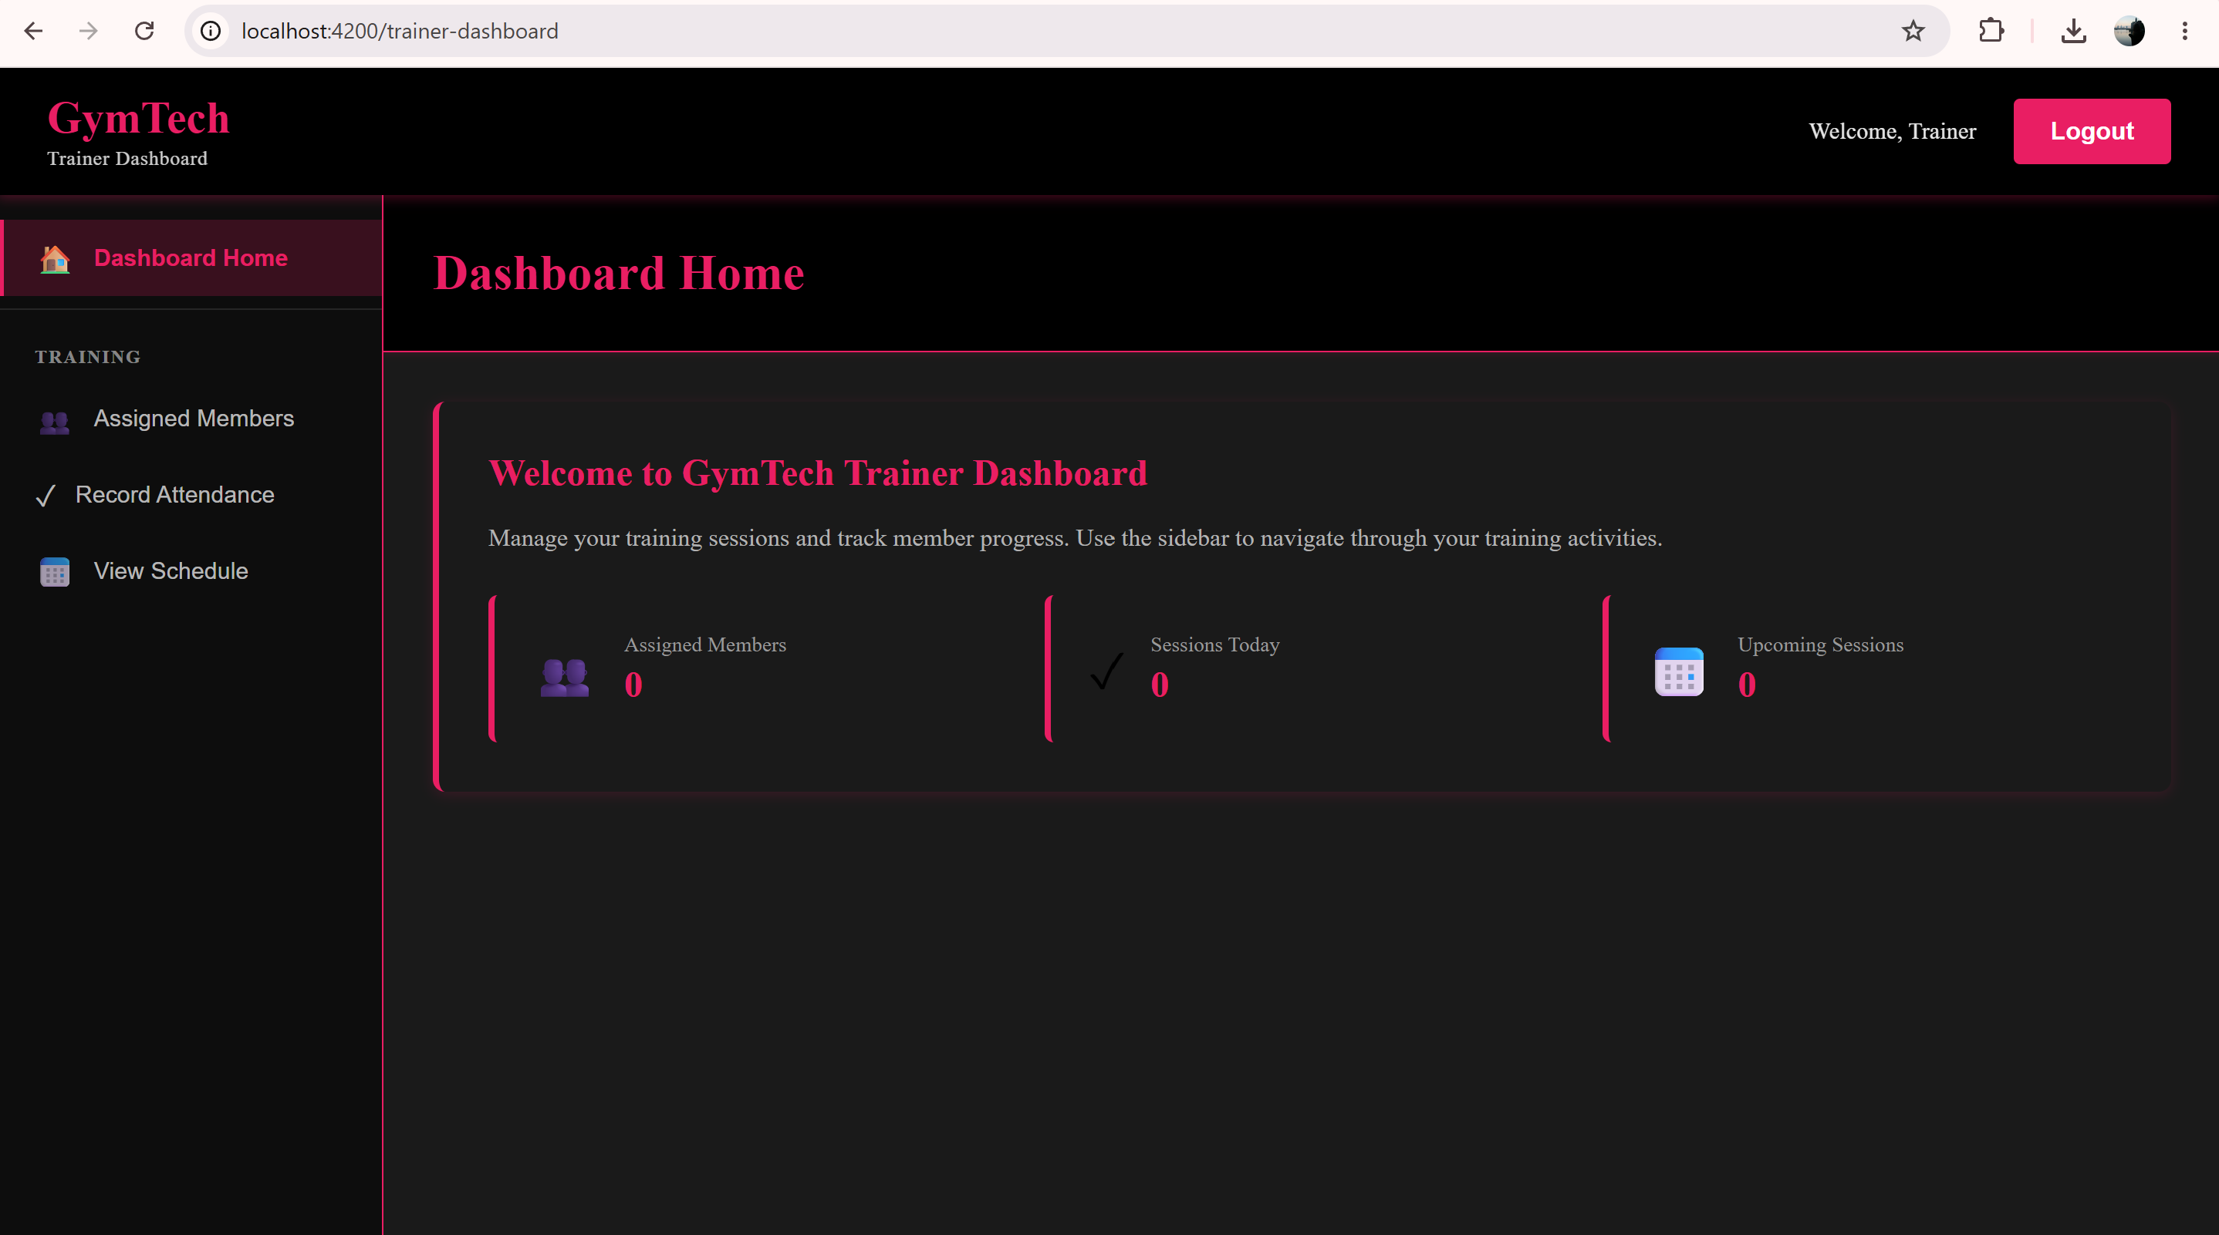

Receptionist Dashboard
Route: /receptionist-dashboard
Target User: Receptionist
Layout Components:
- Operations-focused navigation sidebar
- Daily operational metrics
- Stat Cards: Total Members, Today's Attendance, Pending Payments
Navigation Sections: Dashboard Home, Manage Members, Manage Subscriptions, Search & Filter, Record Attendance, Manage Payments
Description: Operational interface for receptionists to manage daily gym activities, member check-ins, and payment processing.
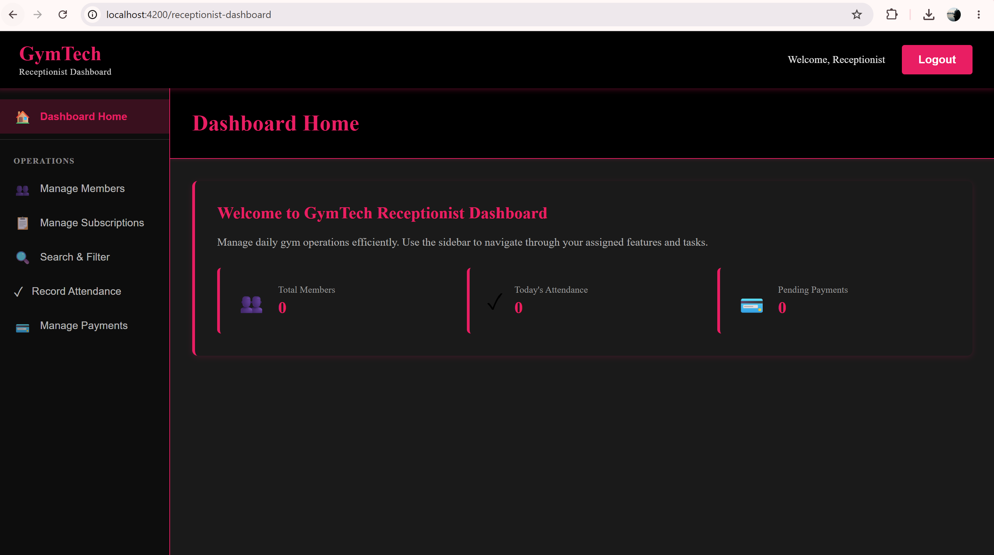

3.2 Design System Specifications

Color Palette
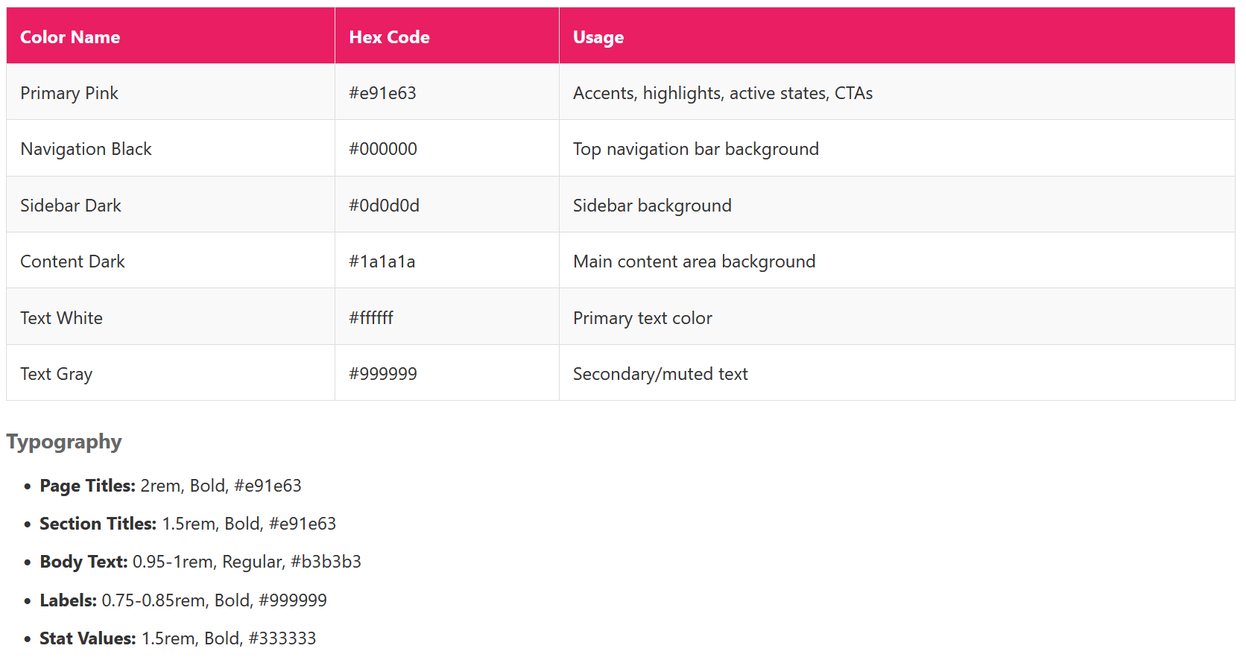

4
. Description of the Main Classes
The following table describes each main class, its role in the system, and its key responsibilities:

Class | Role | Responsibilities
UserAccount | Authentication & Access Control | Manages user credentials and roles (Admin, Receptionist, Trainer, Member).  Handles login, logout, password management, and access permissions.
Member | Core Domain Entity | Represents a gym member. Stores personal details and links to  subscriptions, payments, attendance records, and assigned trainers.
Subscription | Membership Management | Tracks the type, price, duration, and validity of a member's subscription.  Ensures only active subscriptions are used.
Payment | Financial Transactions | Records payment transactions made by members.  Processes and validates payments linked to subscriptions.
Attendance | Check-in Tracking | Records each gym visit by a member. Validates access based on active  subscription status.
Trainer | Trainer Management | Stores trainer details and specialization. Allows viewing and managing  assigned members.
MemberTrainer | Many-to-Many Relationship | Junction entity linking members to their assigned trainers. Manages  assignment and removal of trainers for members.

5
. Test Plan
Testing Strategy and Objectives:
The testing phase for the GymTech system ensures that all core functionalities, specifically authentication and user role navigation, operate according to the design specifications. The primary objective is to verify that the application remains stable across different user sessions and that role-based data remains isolated.

The strategy consists of three main approaches:
Unit Testing (Frontend): Automated suites are used to validate the logic of individual components. By employing service mocking (Stubs), components are tested in isolation to verify navigation and form behavior independently of the backend API.

Service Testing (Backend): The backend services are verified separately through unit tests to ensure data integrity, database connectivity, and the correct handling of CRUD operations for members and staff.
Manual Validation: Manual checks are performed to ensure high-quality user experience. This includes verifying browser-level constraints, such as required field enforcement, and ensuring responsive layout consistency across various device sizes.

TC# | Feature | Input Values | Expected Result
FE-01 | Login | Verify the component initializes correctly without errors. | expect(component).toBeTruthy() is true.
FE-02 | Login | Check that the login form is the first thing a user sees. | currentPage is 'login' and title contains "Login".
FE-03 | Login | Ensure standard username and password fields exist in the HTML. | input[type="text"] and input[type="password"] are present.
FE-04 | Login | Simulate the login action and check if it targets the dashboard. | routerStub.lastNavigatedUrl matches '/dashboard'.
FE-05 | Signup | Call goToSignup() and check if the form title changes. | Form title updates to "Create Account".
FE-06 | Signup | Verify all 6 registration fields are rendered in the DOM. | All IDs (#signup-firstname, #signup-email, etc.) are found.
FE-07 | Signup | Verify that every signup field is marked as required. | hasAttribute('required') is true for all 6 fields.
FE-08 | Signup | Click "Login Here" on the signup form to go back. | currentPage resets to 'login' and title reflects the change.
FE-09 | Dashboard | Test navigation between Admin specific features (Reports, Members, etc.). | activeFeature updates and getPageTitle() returns matching title.
FE-10 | Dashboard | Check visibility of member-specific cards (Subscription, Days Remaining). | Specific stat-cards are present in the DOM.
FE-11 | Dashboard | Verify unique headers and stat cards for these specific roles. | Displays "Assigned Members" (Trainer) or "Attendance" (Receptionist).
FE-12 | Global Dashboard | Trigger the logout function from any dashboard. | User is redirected to '/login' and console logs logout.
FU-01 | UI | Manual: Try to login or sign up with all fields empty. | Browser blocks the action with a "Please fill out this field" tooltip.
FU-02 | UX | Manual: Enter an invalid email address format (e.g., "adminatgym"). | HTML5 validation prevents submission and requests an '@' symbol.
FU-03 | UX | Manual: Click "Coming Soon" features like Reports or Payments. | UI displays the appropriate "Coming Soon" empty-state message.
FU-04 | UI | Manual: Change browser window | Sidebar and cards re-align or stack to fit the smaller screen.
FU-05 | Security | Manual: Type into the password field. | Characters are obscured (dots/stars) for privacy.
BE-01 | MemberService | Retrieves an existing member by ID | Returns Member object
BE-02 | MemberService | Queries for an ID that doesn't exist | Returns null
BE-03 | MemberService | Adds a new member to the context | Returns Member object
BE-04 | MemberService | Updates fields for an existing member | State marked as Modified
BE-07 | MemberService | Deletes a member record | Record removed
BE-06 | MemberService | Attempts to delete a non-existing ID | No error (No-op)
BE-08 | MemberController | Retrieves member for valid ID | Returns 200 OK
BE-09 | MemberController | Queries for invalid ID | Returns 404 Not Found
BE-10 | MemberController | Adds member via POST | Returns 201 Created
BE-11 | MemberController | Deletes member via DELETE | Returns 204 No Content
BE-12 | Member | Input invalid email format (e.g., "name@com") | Validation fails; returns error
BE-13 | Member | Input non-numeric phone or length $\neq$ 10 | Validation fails; returns error
BE-14 | Member | Input a future date for birthday | Validation fails; returns error
BE-15 | AdminUser | Verify format and required status for Admin | Validation fails if empty or malformed
BE-16 | AdminUser | Input numeric value instead of string for Name | Validation fails; type mismatch error
BE-17 | Trainer | Input empty string for trainer name | Validation fails; "Required" error
BE-18 | Trainer | Input phone number with letters | Validation fails; format error
BE-19 | Subscription | Set EndDate earlier than StartDate | Validation fails; logical date error
BE-20 | Subscription | Input negative number for DurationDays | Validation fails; range error
BE-21 | Payment | Input negative value (e.g., -50.00) | Validation fails; must be positive
BE-22 | Payment | Input invalid date format or future date | Validation fails; format/range error
BE-23 | Common | Verify name fields are valid strings | Validation fails on non-string input

*FE – frontend tests
*FU – frontend user tests
*BE – backend tests

6. Other Relevant Information

The application is planned as a role-based Gym Membership Management System. Different user roles will have different access rights inside the application:
- Admin – manages the entire system;
- Receptionist – manages members and subscriptions;
- Trainer – views assigned members and schedule;
- Member – views personal information and subscription details.
The project uses a layered structure with:
- Angular for the frontend,
- ASP.NET Core Web API for the backend,
- Entity Framework Core for database communication,
- SQL Server for data storage.
GitHub is used for collaboration and task management between team members, while Swagger is used for testing the backend endpoints during development.
At the current stage, the main diagrams, database structure, and core backend entities are completed. Frontend pages and dashboard mockups are also prepared for the next implementation steps.

E2 - Software Modeling and Design Specifications | Gym Membership Management System
Academic Year 2025–2026
Built Like a System.

